**[Display/maintenance allowed with restrictions](http://scn.sap.com/message/5844784" \l "5844784)**

This question has been **Answered.**

[myahsam wong](http://scn.sap.com/people/myahsam.wong)Steel

[myahsam wong](http://scn.sap.com/people/myahsam.wong)

Jul 23, 2008 9:10 AM

Hi all,

What is the main usage for "display/maintenance allowed with restrictions". What kind of restrictions?

I was asked to make the fields which are not the KEY in the table to non-editable.

Please advise whether this is possible?

Thanks.

[Isabel Bautista](http://scn.sap.com/people/isabel.bautista)

**Correct Answer**by [Isabel Bautista](http://scn.sap.com/people/isabel.bautista)  on Jul 29, 2008 5:59 PM

Ok, then you can do this:

1.- go to se11 and insert the name of your table. Display

2.- Go to "Utilities"->Table maintenace generator and look the name of function group.

3.- go to se80 and insert the name of your function group. Double click on your screen and click the button "Layout". This show the image of dynpro of sm30. Double click in the column that you want it is non-editable and in your atributes check "only output".

With this, all fields will be non-editable but you will can delete and add lines in the table.

Regards

[**See the answer in context**](http://scn.sap.com/thread/974560#5890381)

* 7737 Views
* Topics: [abap](http://scn.sap.com/community/abap/tags" \l "/?tags=abap)

Average User Rating

(0 ratings)

* **[Re: Display/maintenance allowed with restrictions](http://scn.sap.com/message/5844810" \l "5844810)**

[Rudra Prasanna Mohapatra](http://scn.sap.com/people/rudraprasanna.mohapatra)Silver

[**Rudra Prasanna Mohapatra**](http://scn.sap.com/people/rudraprasanna.mohapatra)Jul 23, 2008 9:13 AM ([in response to myahsam wong](http://scn.sap.com/thread/974560#5844784))

this can be achieved with help of EVENTs

go to utility--> Table Maintainance Generater.

Then go to environment> events.

There u can write you own code to put restriction in TMG

* + [Alert Moderator](http://scn.sap.com/message-abuse!input.jspa?objectID=5844810&objectType=2)

* + Like ([0](http://scn.sap.com/thread/974560))

* **[Re: Display/maintenance allowed with restrictions](http://scn.sap.com/message/5844813" \l "5844813)**

[Raghavender Poosarla](http://scn.sap.com/people/raghavender.poosarla)Silver

[**Raghavender Poosarla**](http://scn.sap.com/people/raghavender.poosarla)Jul 23, 2008 9:14 AM ([in response to myahsam wong](http://scn.sap.com/thread/974560#5844784))

Hi,

Display/maintenance allowed to limited extent

Usage of standard table maintenance tools is allowed to a limited extent:

Transaction SE16 allows the display function for this Dictionary object, but no maintenance.

Generation of a maintenance dialog for this Dictionary object is possible using transaction SE54.

Transaction SM30 does not allow maintenance and display functions for this Dictionary object

Note: The generated dialog can be included in view clusters (data maintenance through transaction SM34) or called within a program through the function module View_Maintenance_Call.

Raghav

* + [Alert Moderator](http://scn.sap.com/message-abuse!input.jspa?objectID=5844813&objectType=2)

* + Like ([0](http://scn.sap.com/thread/974560))

* + **[Re: Display/maintenance allowed with restrictions](http://scn.sap.com/message/5845113" \l "5845113)**

[saslove sap](http://scn.sap.com/people/saslove.sap)Silver

[**saslove sap**](http://scn.sap.com/people/saslove.sap)Jul 23, 2008 4:28 PM ([in response to Raghavender Poosarla](http://scn.sap.com/thread/974560#5844813))

Hi u can see the resrictions in that field by pressing F1 help

Below is the limited extensions mentioned in that table.

SEE LET It helps you

Display/maintenance allowed to limited extent

Usage of standard table maintenance tools is allowed to a limited extent:

Transaction SE16 allows the display function for this table/view, but no maintenance.

Generation of a maintenance dialog for this table/view is possible through transaction SE54.

Transaction SM30 does not allow maintenance and display functions for this table/view.

Note: The generated dialog can be included in view clusters (data maintenance through transaction SM34) or called within a program through the function module View_Maintenance_Call.

.

**\[removed by moderator\]**

Regards

Sas

Edited by: Jan Stallkamp on Jul 23, 2008 4:25 PM

* + - [Alert Moderator](http://scn.sap.com/message-abuse!input.jspa?objectID=5845113&objectType=2)

* + - Like ([0](http://scn.sap.com/thread/974560))

* + - **[Re: Display/maintenance allowed with restrictions](http://scn.sap.com/message/5849332" \l "5849332)**

[myahsam wong](http://scn.sap.com/people/myahsam.wong)Steel

[**myahsam wong**](http://scn.sap.com/people/myahsam.wong)Jul 23, 2008 3:09 PM ([in response to saslove sap](http://scn.sap.com/thread/974560#5845113))

Hi all,

I am still very confusing after all the explanation. Sorry for that.

Hopefully my explanation below would make more clearer.

I have created a z-table with some KEY fields and non-KEY fields.

After all, I have manually inserted some data into the z-table for testing purposes.

I have also created the table/view maintanance by using transaction code SM30, let's call it ZSM30_ZTABLE.

Whenever I transact the transaction code ZSM30_ZTABLE, I will see the list of records which I created earlier for testing purposes. The KEY fields are in non-editable (grey colour), whereas non-KEY fields are in editable (white colour).

My question is, is it possible to set those non-KEY fields to be **non-editable** fields?

Thanks in advance.

* + - * [Alert Moderator](http://scn.sap.com/message-abuse!input.jspa?objectID=5849332&objectType=2)

* + - * Like ([0](http://scn.sap.com/thread/974560))

* + - * **[Re: Display/maintenance allowed with restrictions](http://scn.sap.com/message/5850286" \l "5850286)**

[Isabel Bautista](http://scn.sap.com/people/isabel.bautista)Steel

[**Isabel Bautista**](http://scn.sap.com/people/isabel.bautista)Jul 23, 2008 4:51 PM ([in response to myahsam wong](http://scn.sap.com/thread/974560#5849332))

You can create a new transaction (se93) type transaction with parameters.

In transaction put sm30, check "skip initial screen", in the "Deafult values" add VIEWNAME with the name of your table and add SHOW with value "X".

When you execute the transaction, appear tha sm30 of your table display, all fields will be non-editable.

* + - * + [Alert Moderator](http://scn.sap.com/message-abuse!input.jspa?objectID=5850286&objectType=2)

* + - * + Like ([0](http://scn.sap.com/thread/974560))

* + - * + **[Re: Display/maintenance allowed with restrictions](http://scn.sap.com/message/5855158" \l "5855158)**

[myahsam wong](http://scn.sap.com/people/myahsam.wong)Steel

[**myahsam wong**](http://scn.sap.com/people/myahsam.wong)Jul 24, 2008 9:46 AM ([in response to Isabel Bautista](http://scn.sap.com/thread/974560#5850286))

Hi Isabel Bautista,

Really thanks for your inputs.

The maintenance view table is all fields with non-editable even for those non-KEY fields.

I am sorry to say that it is only answered partially, because my users are requesting for deleting record in the maintenance view table, but on other hand not allowed for editing the fields like what I have done and mentioned.

Do you think this is possible?

Thanks all.

[Alert Moderator](http://scn.sap.com/message-abuse!input.jspa?objectID=5855158&objectType=2)

Like ([0](http://scn.sap.com/thread/974560))

Correct Answer[**Re: Display/maintenance allowed with restrictions**](http://scn.sap.com/message/5890381#5890381)

[Isabel Bautista](http://scn.sap.com/people/isabel.bautista)Steel

[**Isabel Bautista**](http://scn.sap.com/people/isabel.bautista)Jul 29, 2008 5:59 PM ([in response to myahsam wong](http://scn.sap.com/thread/974560#5855158))

Ok, then you can do this:

1.- go to se11 and insert the name of your table. Display

2.- Go to "Utilities"->Table maintenace generator and look the name of function group.

3.- go to se80 and insert the name of your function group. Double click on your screen and click the button "Layout". This show the image of dynpro of sm30. Double click in the column that you want it is non-editable and in your atributes check "only output".

With this, all fields will be non-editable but you will can delete and add lines in the table.

Regards

[Alert Moderator](http://scn.sap.com/message-abuse!input.jspa?objectID=5890381&objectType=2)

Like ([0](http://scn.sap.com/thread/974560))

**[Re: Display/maintenance allowed with restrictions](http://scn.sap.com/message/5891875" \l "5891875)**

[myahsam wong](http://scn.sap.com/people/myahsam.wong)Steel

[**myahsam wong**](http://scn.sap.com/people/myahsam.wong)Jul 30, 2008 2:59 AM ([in response to Isabel Bautista](http://scn.sap.com/thread/974560#5890381))

Hi Isabel Bautista,

Thanks for your clear explanation. Really help me alot.

Thanks a million.

[Alert Moderator](http://scn.sap.com/message-abuse!input.jspa?objectID=5891875&objectType=2)

Like ([0](http://scn.sap.com/thread/974560))

**[Re: Display/maintenance allowed with restrictions](http://scn.sap.com/message/14687603" \l "14687603)**

[Bruno Esperança](http://scn.sap.com/people/bruno.esperanca)Silver

[**Bruno Esperança**](http://scn.sap.com/people/bruno.esperanca)Jan 15, 2014 4:36 PM ([in response to myahsam wong](http://scn.sap.com/thread/974560#5891875))

Hi,

One small detail I would like to mention. This should be documented and maybe a warning should be put in the table title/description, as if in the future if there is a modification to this table and the developer is not aware of changes directly in the generated code, he will regenerate the table maintenance screens and will not perform these modifications (this has happened to me in the past).

Regards,

Bruno

[Alert Moderator](http://scn.sap.com/message-abuse!input.jspa?objectID=14687603&objectType=2)

Like ([0](http://scn.sap.com/thread/974560))

* **[Re: Display/maintenance allowed with restrictions](http://scn.sap.com/message/5844935" \l "5844935)**

http://scn.sap.com/people/guest/avatar/46.png

**Guest**Jul 23, 2008 9:24 AM ([in response to myahsam wong](http://scn.sap.com/thread/974560#5844784))

Hi,

Maintaining Table:

A table can be maintained using different transactions like SM30 or SE16. However, options have been provided for the user to restrict this maintenance.

Three options have been provided:

1. Display/Maintenance allowed with restrictions.

2. Display/Maintenance allowed.

3. Display/Maintenance not allowed.

Third option just displays the table attributes and its respective fields but will completely restricts the user even for display of the table contents.

**Data Browser/Table View Maintenance**  
You can use the flag for database views, projection views, maintenance views, maintenance view variants, and tables in the Dictionary maintenance (SE11).

The flag is not provided for help views, because help views are mainly used for search purposes.

The options provided in the dropdown list box *Data Browser/Table View Maintenance* have the following effects:

|  |  |  |  |  |
| --- | --- | --- | --- | --- |
|  | Display in Data Browser (SE16) | Maintenance in Data Browser | Maintenance and Display in Table View Maintenance (SM30) | Generation of a Table Maintenance Dialog (SE54) |
| *Display/Maintenance allowed with restrictions* | X | - | - | X 2 |
| *Display/Maintenance allowed* | X 1 | X 1 | X | X 2 |
| *Display/Maintenance not allowed* | - | - | - | - |

1 If a maintenance dialog exists, it is called.   
2 If generation of a table maintenance dialog (SE54) is possible, the generated dialog can be included in view clusters (data maintenance using transaction SM34) or be called within a program using function module VIEW_MAINTENANCE_CALL, similar to the call of transaction SM30.   
For maintenance views and maintenance view variants only the options*Display/Maintenance allowed*and*Display/Maintenance allowed with restrictions*are offered. The option*Display/Maintenance not allowed*is not offered since the only purpose of the view types is to generate an interface. The option*Display/Maintenance not allowed*would not allow this.

**Structure of a Collective Search Help**

A collective search help combines several elementary search helps. The user can thus choose one of several alternative search paths with a collective search help.

When you define a collective search help, you only have to specify the search helps that are to be combined in the collective search help. In the input help, the values are transported between the elementary search help selected by the user and the input template using the collective search help. This is why a collective search help also has an interface for transporting the values.

**Interface of the Collective Search Help**

Like an

[elementary search help](http://help.sap.com/saphelp_nw70/helpdata/en/cf/21ee38446011d189700000e8322d00/content.htm), a collective search help has an interface of import and export parameters. The data is exchanged between the screen template and the parameters of the assigned elementary search helps using this interface.

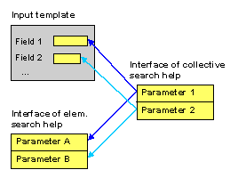

**Assigned Search Helps**

A collective search help comprises several elementary search helps. It combines all the search paths that are meaningful for a field.

The interface parameters (import and export parameters) of the included search helps must be assigned to the parameters of the collective search help. Not all of the parameters need to be assigned, that is the assignment can be open for some of the parameters.

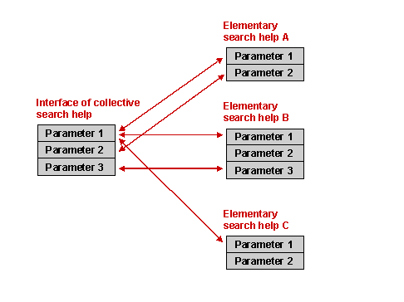

Both elementary search helps and other search helps can be included in a collective search help. If other collective search helps are contained in a collective search help, they are expanded to the level of the elementary search helps when the input help is called.

**Example for Search Helps**

Each customer of a carrier (see

[Flight Model](http://help.sap.com/saphelp_nw70/helpdata/en/cf/21f304446011d189700000e8322d00/content.htm)) or of a travel agency has a customer number. You want to find a search option for this customer number.

The user must be offered two different search paths.

* The user should be able to search for the customer number using the customer data, such as the name and address.
* The user should be able to search for the customer number using existing customer bookings.

You can provide the required search option by creating a

[collective search help](http://help.sap.com/saphelp_nw70/helpdata/en/cf/21ee45446011d189700000e8322d00/content.htm) SCUSTOM. Two [elementary search helps](http://help.sap.com/saphelp_nw70/helpdata/en/cf/21ee38446011d189700000e8322d00/content.htm) SCUSTOM_NAME (for searching with the customer data) and SCUSTOM_BOOK (for searching with the existing bookings) are created for the actual search paths. These elementary search helps are included in the collective search help.

**Elementary Search Help SCUSTOM_NAME**

This elementary search help should enable you to search for the customer number using the name and address (street, city, country). All this data is contained in table SCUSTOM. Table SCUSTOM must therefore be selected as the selection method of the elementary search help.

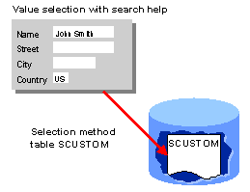

You now have to decide which fields of the selection method are needed for the input help process. These are the fields that should appear either in the dialog box for restricting values or in the hit list.

In the dialog box for restricting values, the user should be able to restrict values with the customer’s name and address, i.e. the fields for the street, city and country. These fields as well as the customer’s number (the information to be found must always be in the hit list) should appear in the hit list. The fields ID, NAME, STREET, CITY and COUNTRY of table SCUSTOM must be included in the search help as parameters.

The parameter ID is declared to be an import parameter. A pattern entered in the corresponding field of a screen template can therefore be used directly for the value selection. Restrictions for the other parameters of the search help must be entered in the dialog box for value selection.

All the parameters of the search help are declared to be export parameters. As a result, all the parameters of the hit list can be returned to the screen template if the corresponding fields are available there.

**Elementary Search Help SCUSTOM_BOOK**

This elementary search help should enable you to search for the customer number using existing customer bookings. The flight data for the booking (flight number, date of flight, city of departure, city of arrival) and the name of the customer should be used for the search here. This data is distributed on the tables SBOOK (bookings), SCUSTOM (name) and SPFLI (cities of departure and arrival). The following graphic shows the relationship between the relevant tables, that is the existing foreign key relationships.

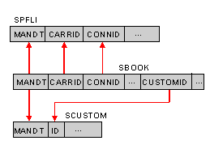

In this case a database view SCUS_BOOK must be created on these three tables (see

[Example for Views](http://help.sap.com/saphelp_nw70/helpdata/en/96/c296e5aeab11d194f300a0c929b3c3/content.htm)) as selection method. The tables in the view (join) are linked as defined by the existing foreign key relationships (see [Foreign Key Relationship and Join Condition](http://help.sap.com/saphelp_nw70/helpdata/en/cf/21ec84446011d189700000e8322d00/content.htm)).

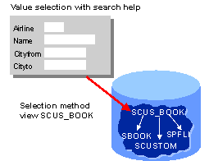

In the dialog box for restricting values, the user should be able to restrict the search for booking data with the carrier ID, customer name, city of departure and city of arrival The flight date and of course the customer number should also be displayed in the hit list. Fields CARRID, FLDATE, CUSTOMID, NAME, CITYFROM and CITYTO of view SCUS_BOOK must be included in the elementary search help as parameters of the search help.

The parameter CUSTOMID is declared to be an import parameter. All the parameters of the search help are export parameters.

**Collective Search Help SCUSTOM**

The two elementary search helps are now included in the collective search help. You must now allocate the parameters of the elementary search helps to the parameters of the collective search help.

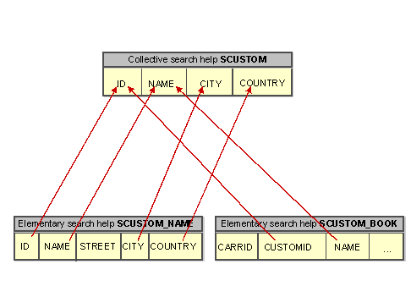

The parameter ID of the collective search help is marked as an import parameter. All the parameters are export parameters. The values can thus be copied from the hit list to the screen template.

**Attaching the Search Help**

In order to be able to use the search help SCUSTOM in screen templates, the attachment of the search help (see

[Attaching Search Helps with Screen Fields](http://help.sap.com/saphelp_nw70/helpdata/en/cf/21ee93446011d189700000e8322d00/content.htm)) must be defined.

**Attaching to the Check Table SCUSTOM**

The search help should be available for all the fields that are checked against table SCUSTOM. The search help therefore must be attached to table SCUSTOM. The search help parameters must therefore be assigned to the key fields of table SCUSTOM.

The parameter ID of search help SCUSTOM is here assigned to the field ID of table SCUSTOM in this field assignment. No assignment is possible for all other parameters of the search help (NAME, CITY and COUNTRY) since table SCUSTOM does not contain this information as key fields.

**Attaching to a Field of Table SCUSTOM**

In order that the search help is available when the field SCUSTOM-ID is directly copied to the input template, you have to attach the search help to this field.

With this type of attachment, all the parameters of the search help can be assigned to the corresponding fields of the table.

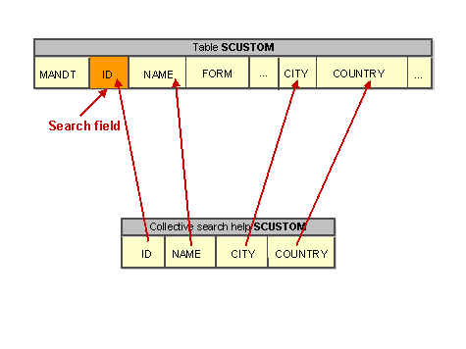

**Structure of an Elementary Search Help**

An elementary search help defines the standard flow of an input help. You can define the following components of this flow in the search help:

* where does the data displayed in the hit list come from (selection method)
* what information should be displayed in the dialog box for value selection and in the hit list (search help parameters)
* what field contents can be taken into account for hit list selections and which values in the hit list can be returned to the screen fields (search help parameters)
* what dialog steps should be executed in the input help (dialog behavior)

**Selection Method**

The possible input values displayed for a field in the hit list are determined at runtime by database selection.

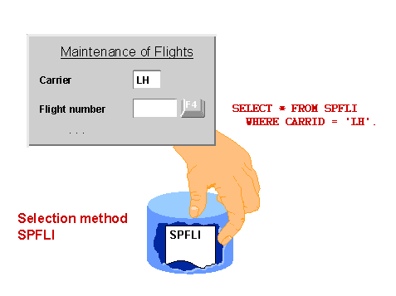

If all the data required in the hit list comes from one single table, you only have to select this table (or a projection view on this table) as selection method. If there is a

[text table](http://help.sap.com/saphelp_nw70/helpdata/en/cf/21ea9e446011d189700000e8322d00/content.htm) for the table, its fields are also available in the input help. A table entry is linked with the corresponding text by the existing foreign key.

If the data needed in the hit list comes from more than one table, you must link these tables with a view (database view or help view). This view must be defined as the selection method.

If the underlying tables are client-specific, the client field must be contained in the view. Otherwise selection for the input help would be for all clients.

**Search Help Parameters**

A search help has an interface consisting of parameters. These parameters define the fields of the selection method that should be used in the input help.

A parameter of the search help must correspond to each field in the dialog box for value selection and to each field of the hit list. The parameters are copied from the corresponding selection method, that is they always have the same name as the corresponding field of the selection method.

If the search is restricted with a parameter of the search help, this is used in the data selection for formulating a WHERE condition for the field of the selection method with the same name. Vice versa, the parameters of the search help are assigned the contents of the fields of the selection method having the same name.

The search help should not contain any parameters for the clients. In the input help, selection is automatically in the logon client of the user.

A data element must be assigned to each search help parameter, that is a type is always defined for the search help parameters.

A search help can contain further parameters that do not correspond to any field of the selection method. This is normally only necessary if the standard flow of the input help described by the search help still has to be modified by with a

[search help exit](http://help.sap.com/saphelp_nw70/helpdata/en/cf/21ee52446011d189700000e8322d00/content.htm).

**Import and Export Parameters**

When an input help is called, the entries that the user already made in the input template are taken into consideration. For example, if a user calls the input help for the flight number and already specified the carrier, of course only the numbers of flights of this carrier should be offered.

On the other hand, if the user selects one row of the hit list, more than one field of the input template might have to be filled with data from the selected row of the hit list. For example, if the flight number is obtained from the hit list, the city of departure and the destination should also be returned in the screen template.

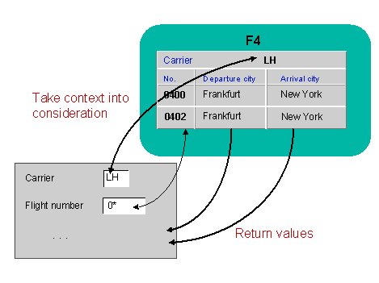

The interface of a search help defines the context data that can be used in the input help and the data that can be returned in the input template.

A parameter of a search help can be classified as:

* **Import parameters:**

Parameters with which context information from the processed input template (screen) may be copied to the help process.

* **Export parameters:**

Parameters with which values from the hit list may be returned to the input template.

A parameter can simultaneously be an input and an export parameter. A search help can also contain parameters that are neither import nor export parameters. Such parameters could be required for the internal input help process, for example.

When you

[attach a search help](http://help.sap.com/saphelp_nw70/helpdata/en/cf/21ee93446011d189700000e8322d00/content.htm), you must define where the import parameters of the search help get their values from and the fields in which the contents of the export parameters are returned. See also [Value Transport for Input Helps](http://help.sap.com/saphelp_nw70/helpdata/en/35/bdb6e2c48411d1950800a0c929b3c3/content.htm).

**Description of the Online Behavior**

The online behavior defines the steps executed in the input help process and the structure of the hit list and dialog box for value selection.

The

[dialog type](http://help.sap.com/saphelp_nw70/helpdata/en/cf/21ee6c446011d189700000e8322d00/content.htm) defines whether or not the dialog box for value selection should be displayed. If you want to skip the dialog box for value selection, the hit list is displayed directly after calling the input help.

When you define an elementary search help, you can define how the dialog box for value selection and the hit list should look. For example, you can define the position of a parameter in the dialog box for value selection here. The column position in which the values of a parameter are displayed in the hit list can also be defined here.

**See also:**

[Creating Elementary Search Helps](http://help.sap.com/saphelp_nw70/helpdata/en/cf/21ee5f446011d189700000e8322d00/content.htm)

Two types of Search Help

1.Elementry Search Help:An elementary search help defines the standard flow of an input help. You can define the following components of this flow in the search help:

--where does the data displayed in the hit list come from (selection method)

--what information should be displayed in the dialog box for value selection and in the hit list (search help parameters)

--what field contents can be taken into account for hit list selections and which values in the hit list can be returned to the screen fields (search help parameters)

--what dialog steps should be executed in the input help (dialog behavior)

2.Collective Search Help: A collective search help combines several elementary search helps. The user can thus choose one of several alternative search paths with a collective search help.

When you define a collective search help, you only have to specify the search helps that are to be combined in the collective search help. In the input help, the values are transported between the elementary search help selected by the user and the input template using the collective search help. This is why a collective search help also has an interface for transporting the values.

A view is a logical view on one or more tables, that is, a view is not actually physically stored, instead being derived from one or more other tables.

In the simplest case, this derivation process can involve simply suppressing the display of one or more fields from a table (projection) or transferring only certain records from a table to the view (selection). More complicated views can be assembled from several tables, with individual tables being linked using the relational join operation.

Use

Logical views for the application permitting direct access to the data can be generated with the definition of view. The structure of such a view is defined by specifying the tables and fields involved in the view.

types of view:

PROJECTION VIEW

DATABASE VIEW

HELP VIEW

MAINTENANCE VIEW

**Views**

Data about an application object is often distributed on several tables. By defining a view, you can define an application-dependent view that combines this data. The structure of such a view is defined by specifying the tables and fields used in the view. Fields that are not required can be hidden, thereby minimizing interfaces. A view can be used in ABAP programs for data selection.

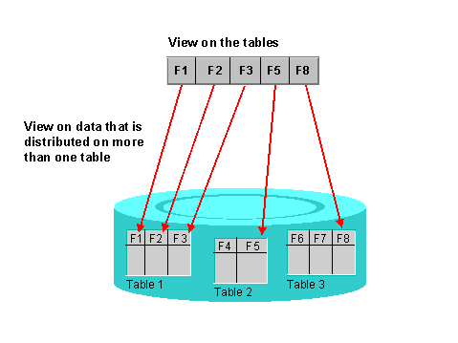

The data of a view is derived from one or more tables, but not stored physically. The simplest form of deriving data is to mask out one or more fields from a base table (projection) or to include only certain entries of a base table in the view (selection). More complicated views can comprise several base tables, the individual tables being linked with a relational join operation. See also

[Join, Projection and Selection](https://help.sap.com/saphelp_nw70/helpdata/en/cf/21ec6a446011d189700000e8322d00/content.htm).

The base tables of the view must be selected in the first step of a view definition. In the second step, these tables must be linked by defining the join conditions. It is also possible to use the join condition from a foreign key defined between the tables (see

[Foreign Key Relationship and Join Condition](https://help.sap.com/saphelp_nw70/helpdata/en/cf/21ec84446011d189700000e8322d00/content.htm)). In the third step, you must select the fields of the base tables to be used in the view. Selection conditions that restrict the records in the view can be formulated in the fourth step.

Four different view types are supported. These differ in the way in which the view is implemented and in the methods permitted for accessing the view data.

[Database views](https://help.sap.com/saphelp_nw70/helpdata/en/cf/21ecab446011d189700000e8322d00/content.htm) are implemented with an equivalent view on the database.

[Projection views](https://help.sap.com/saphelp_nw70/helpdata/en/cf/21ecc5446011d189700000e8322d00/content.htm) are used to hide fields of a table (only projection).

[Help views](https://help.sap.com/saphelp_nw70/helpdata/en/cf/21ecd2446011d189700000e8322d00/content.htm) can be used as selection method in [search helps](https://help.sap.com/saphelp_nw70/helpdata/en/cf/21ee2b446011d189700000e8322d00/content.htm).

[Maintenance views](https://help.sap.com/saphelp_nw70/helpdata/en/cf/21ecdf446011d189700000e8322d00/content.htm) permit you to maintain the data distributed on several tables for one application object at one time.

Database views implement an **inner join**. The other view types implement an **outer join** (see

[Inner and Outer Join](https://help.sap.com/saphelp_nw70/helpdata/en/cf/21ec77446011d189700000e8322d00/content.htm)).

The join conditions for database views can be formulated using equality relationships between any base fields. The join conditions for the other view types must be obtained from existing foreign keys. Tables therefore can only be combined in a maintenance view or help view if they are linked to one another with foreign keys.

The

[maintenance status](https://help.sap.com/saphelp_nw70/helpdata/en/cf/21ec91446011d189700000e8322d00/content.htm) defines whether you can only read data with the view or whether you can also insert and change data with it.

**See also:**

[Example for Views](https://help.sap.com/saphelp_nw70/helpdata/en/96/c296e5aeab11d194f300a0c929b3c3/content.htm)

[Creating Views](https://help.sap.com/saphelp_nw70/helpdata/en/cf/21ecf9446011d189700000e8322d00/content.htm)

[Deleting Views](https://help.sap.com/saphelp_nw70/helpdata/en/cf/21ed54446011d189700000e8322d00/content.htm)

This is often asked in an interview about the types of views:   
    
The followings are different types of views:

- Database View   (SE11)

Database views are implement an inner join, that is, only records of the primary table (selected via the join operation) for which the corresponding records of the secondary tables also exist are fetched. Inconsistencies between primary and secondary table could, therefore, lead to a reduced selection set.

In database views, the join conditions can be formulated using equality relationships between any base fields. In the other types of view, they must be taken from existing foreign keys. That is, tables can only be collected in a maintenance or help view if they are linked to one another via foreign keys.

- Help View    ( SE54)

Help views are used to output additional information when the online help system is called.

When the F4 button is pressed for a screen field, a check is first made on whether a matchcode is defined for this field. If this is not the case, the help view is displayed in which the check table of the field is the primary table. Thus, for each table no more than one help view can be created, that is, a table can only be primary table in at most one help view.

- Projection View

Projection views are used to suppress or mask certain fields in a table (projection), thus minimizing the number of interfaces. This means that only the data that is actually required is exchanged when the database is accessed.

A projection view can draw upon only one table. Selection conditions cannot be specified for projection views.

- Maintenance View   ( SE54 )

Maintenance views enable a business-oriented approach to looking at data, while at the same time, making it possible to maintain the data involved. Data from several tables can be summarized in a maintenance view and maintained collectively via this view. That is, the data is entered via the view and then distributed to the underlying tables by the system.

Databaase view:

    Can be used instead of Inner Joins in ABAP program

    Cannot update multiple tables at a time.

Maintenance view:

   Cannot be used in ABAP Open SQL statments . Only thru Table maintenance (SM30) we can update the Data.

  Can update multiple tables at a time.

Maintenance views offer easy ways to maintain complex application objects.

Data distributed on several tables often forms a logical unit, for example an application object, for the user. You want to be able to display, modify and create the data of such an application object together. Normally the user is not interested in the technical implementation of the application object, that is in the distribution of the data on several tables.

A maintenance view permits you to maintain the data of an application object together. The data is automatically distributed in the underlying database tables. The maintenance status determines which accesses to the data of the underlying tables are possible with the maintenance view.

All the tables in a maintenance view must be linked with foreign keys, that is the join conditions for maintenance views are always derived from the foreign key (see  Foreign Key Relationship and Join Condition). You cannot directly enter the join conditions as for database views.

Data about an application object is often distributed on several database tables. A database view provides an application-specific view on such distributed data.

Database views are defined in the ABAP Dictionary. A database view is automatically created in the underlying database when it is activated.

Application programs can access the data of a database view using the database interface. You can access the data in ABAP programs with both OPEN SQL and NATIVE SQL. However, the data is actually selected in the database. Since the join operation is executed in the database in this case, you can minimize the number of database accesses in this way. Database views implement an inner join

When a table is created you need to set enhancement catagory. The reason for encancement catagory is to say what type of fields you can have in your table. For the SAP tables when you want to make enhancements( adding your own fields- append structure)what type of field you can add it depends on how they set the enhancement catogary. 1> Can be enhanced deep: You can have any type of fields and if it is a standard table you can add any type of field whether it may be a character type, reference type or even a table type ( deep means structure within structure) fields. 2>Can be enhanced (character-type or numeric): Now you can add only flat data type fields not a reference type or deep structures ( a table type within a table). 3>Can be enhanced (character-type) : In a table for which this technical attribute is set you can have only character type fields and in standard tables you can enhance it by adding only character type fields not even integer or float or packed.(C, N, D and T are the character type fields and your table should contain these type of fields.). 4>Cannot be enhanced: This table cannot be enhanced means you cannot add further fields into this table.

|  |  |  |
| --- | --- | --- |
| Question | What are dynamic modifications of a screen? explain in detail? | |
| ***Question Submitted By*:: SAP ABAP** | | |
| I also faced this Question!! | | Answer Posted By |
| Answers were Sorted based on User's Feedback | | |
|  |  | |
| **Answer** # [1](http://www.allinterview.com/viewpost/436664/change-screen-based-user-actions-using-at-selection-out-put-event-referance-http.html) | Change Screen based on user actions....this can be done by using AT SELECTION-SCREEN OUT PUT event....  Referance: http://www.sapnuts.com/courses/core-abap/classical-reports/classical-report-events.html   |  |  |  | | --- | --- | --- | | **Is This Answer Correct ?** | **7 Yes** | 0 No | | **Ashokabap** |
|  | | |
|  |  | |
| **Answer** # [2](http://www.allinterview.com/viewpost/435303/based-user-action-screen-changed-eg-let-take-scenario-check-box-five-field-requi.html) | based on the user action the screen should be changed. eg. let us take a scenario there is a check box and five field in a screen. my requirement is when the check box is checked first two fields should be disabled and other field should be enabled.  so to achieve this action function code should be written to the check box. when the user checks the check box. the function code will be triggered.  if the function code is triggered then the screen field of the first two field should be set as 0.and other screen field should be set input as 1.this is a way if dynamic modification of screen   |  |  |  | | --- | --- | --- | | **Is This Answer Correct ?** | **6 Yes** | 1 No | |  |

Factory calendar contain company specific dates such as alternate working Saturdays, Plant shutdown etc.  
  
You can create your company factory calendar via transaction code 'SCAL'.  
Assignment of the factory calendar by plant is done in transaction code 'SM30 - V_T001W'.  
  
An example of a SAP application that uses the factory calendar is the SAP MRP modules.  
  
Assuming that you have a specified an alternate working Saturday, MRP will postponed the planned orders to the next working day if it happened to falls on a non-working Saturday.  
  
Function module related to Factory calculator are  
1.FACTORYDATE_CONVERT_TO_DATE   
2.DATE_CONVERT_TO_FACTORYDATE