Background / Loneliness in hospitals
Loneliness increases the risk of premature death by 26 per cent, and is associated with higher rates of depression, high blood pressure and dementia. Three-quarters of GPS say they see up to five lonely people a day. If someone is admitted to hospital and already has existing feelings of loneliness, how do we ensure their mental and physical health doesn’t further deteriorate? The road to recovery isn’t any easy one and no one should have to face it alone.

Aim / Novel uses if date of birthday
Birthday Wish is an application that will facilitate patient communication within hospitals on their birthday; using the app users can receive and send out kind birthday messages or make direct calls to patients – given a patient has opted to use the service upon admission.

Method / Design process
1) Idea – I wanted to make an app that would benefit the most vulnerable and greatest amount of people.
2) Specification – I needed to use the GOSH database in some way, due to time constraints I chose to access limited patient data – first name, last name and date of birth.
3) Visual Design – Pencil sketches and a system architecture diagram, see Figure 1.
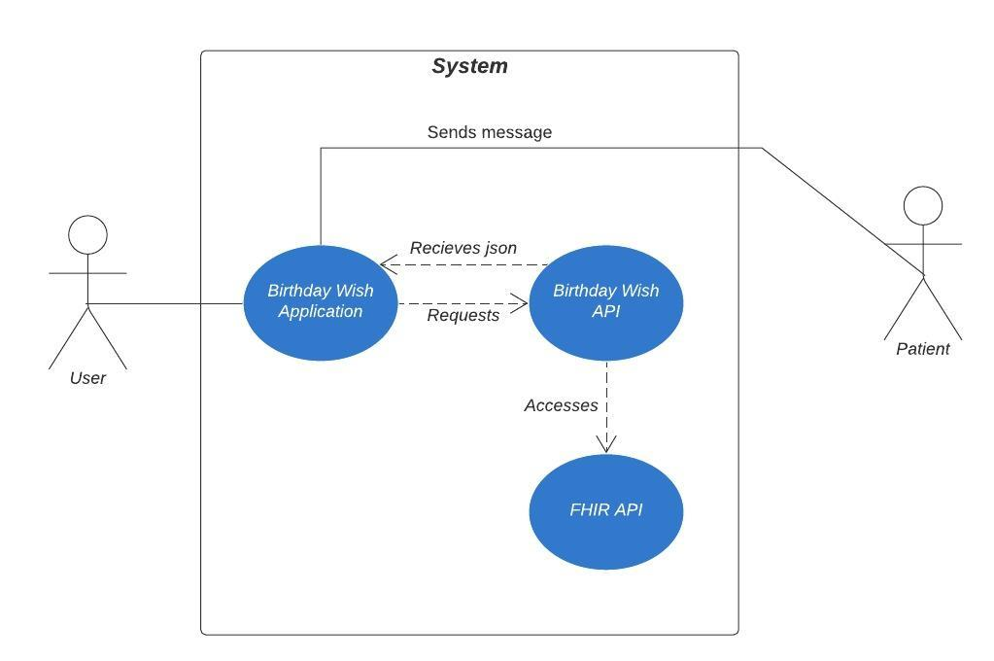
4) Development – For the backend I used python flask to create my API and python tkinter for the frontend.

Results / Product Features
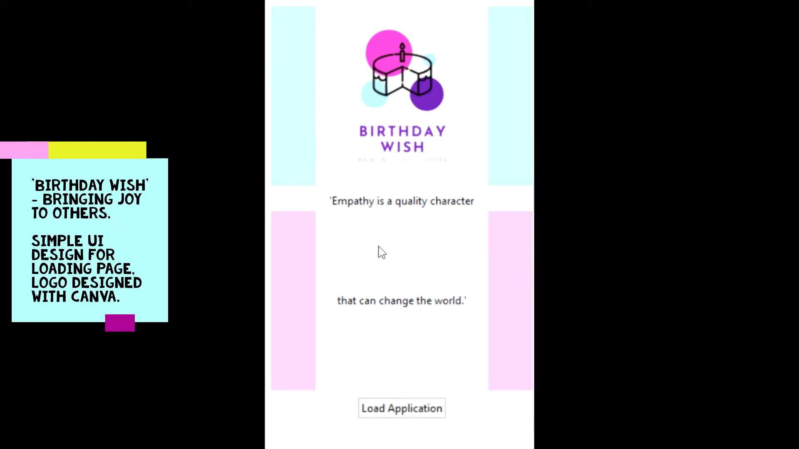

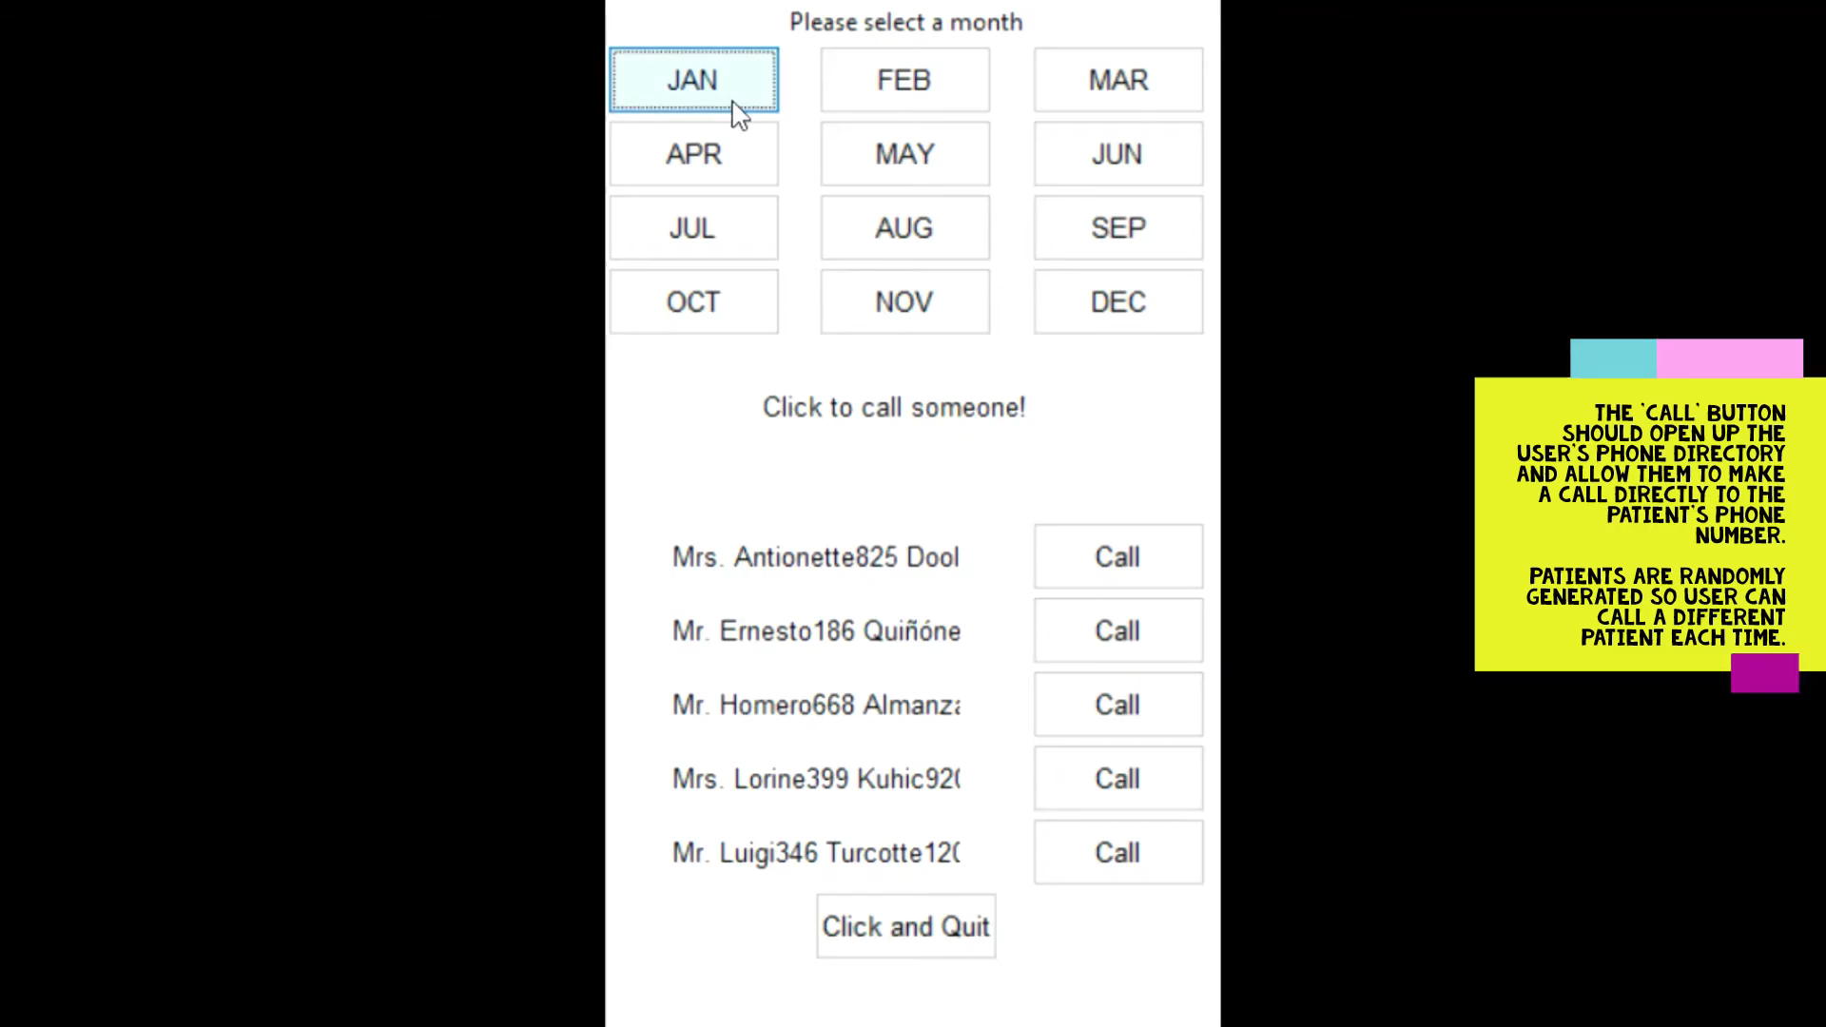
Discussion / Ease of use
For accessibility I try to make the buttons as big as possible and went with a very minimal design. However, the font I used could be larger and bolder.

Conclusion / Scalability
This app is the bare backbone of the application. The User Interface can heavily be developed and also the ‘Call’ button does not make any calls at the moment. The software I used to make this application is not what is normally used to develop mobile apps, so this app can be scaled to a different IOS or Android app development platform such as Swift or Android Studio.

Word Count, excluded bold text and images: 310

Sources:
https://www.local.gov.uk/about/news/loneliness-initiatives-cutting-emergency-hospital-admissions-20-cent
https://github.com/munakaghamelu/GOSH-FHIRworks2020-BirthdayWish

