FHIR Birthday Wish

Brief Bio:

A mobile application to help combat potential loneliness in a hospital environment.

Write-up:

Terminally ill patients may not have family or friends to regularly check and take care of them. The aim of ‘Birthday Wish’ is to pose an application that can be used to communicate with patients in hospitals on their birthday; using the app users can receive and send out nice birthday messages or directly call patients, if patients opt to have their phone numbers readily available on the app.

The app has a simple UI as its main goal is to facilitate short term communication, with the idea that users will form long lasting relationships with patients by continuing visiting them physically after initial contact.

I created an API that accesses GOSH FHIR hospital records by retrieving and sorting each patient based on their birth month. Using flask for my backend and tkinter for my frontend.

Images:

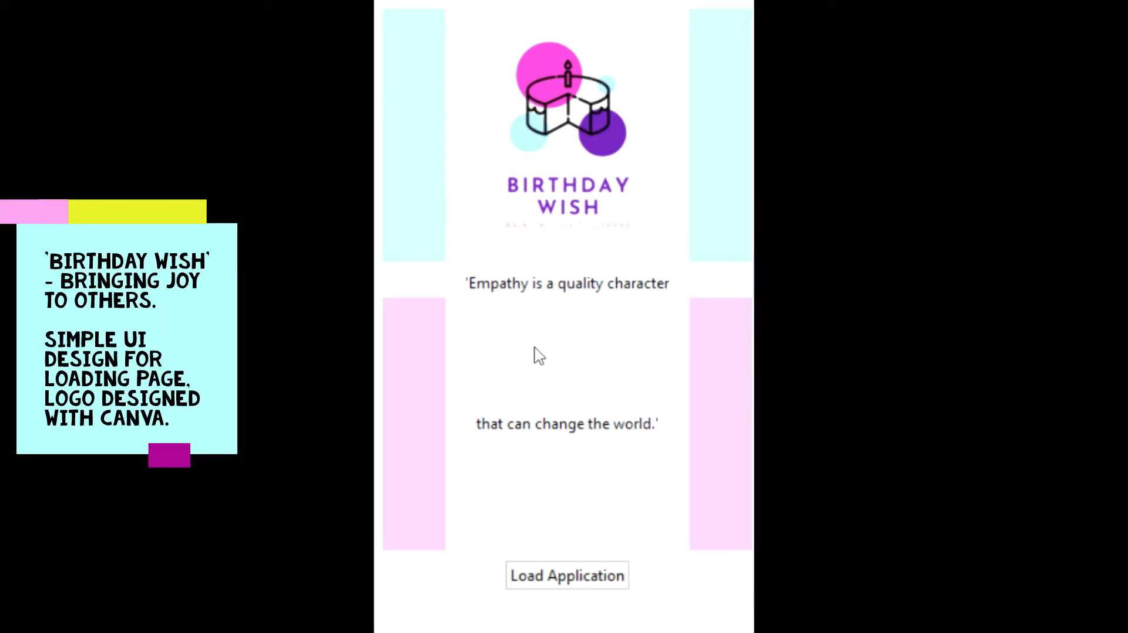

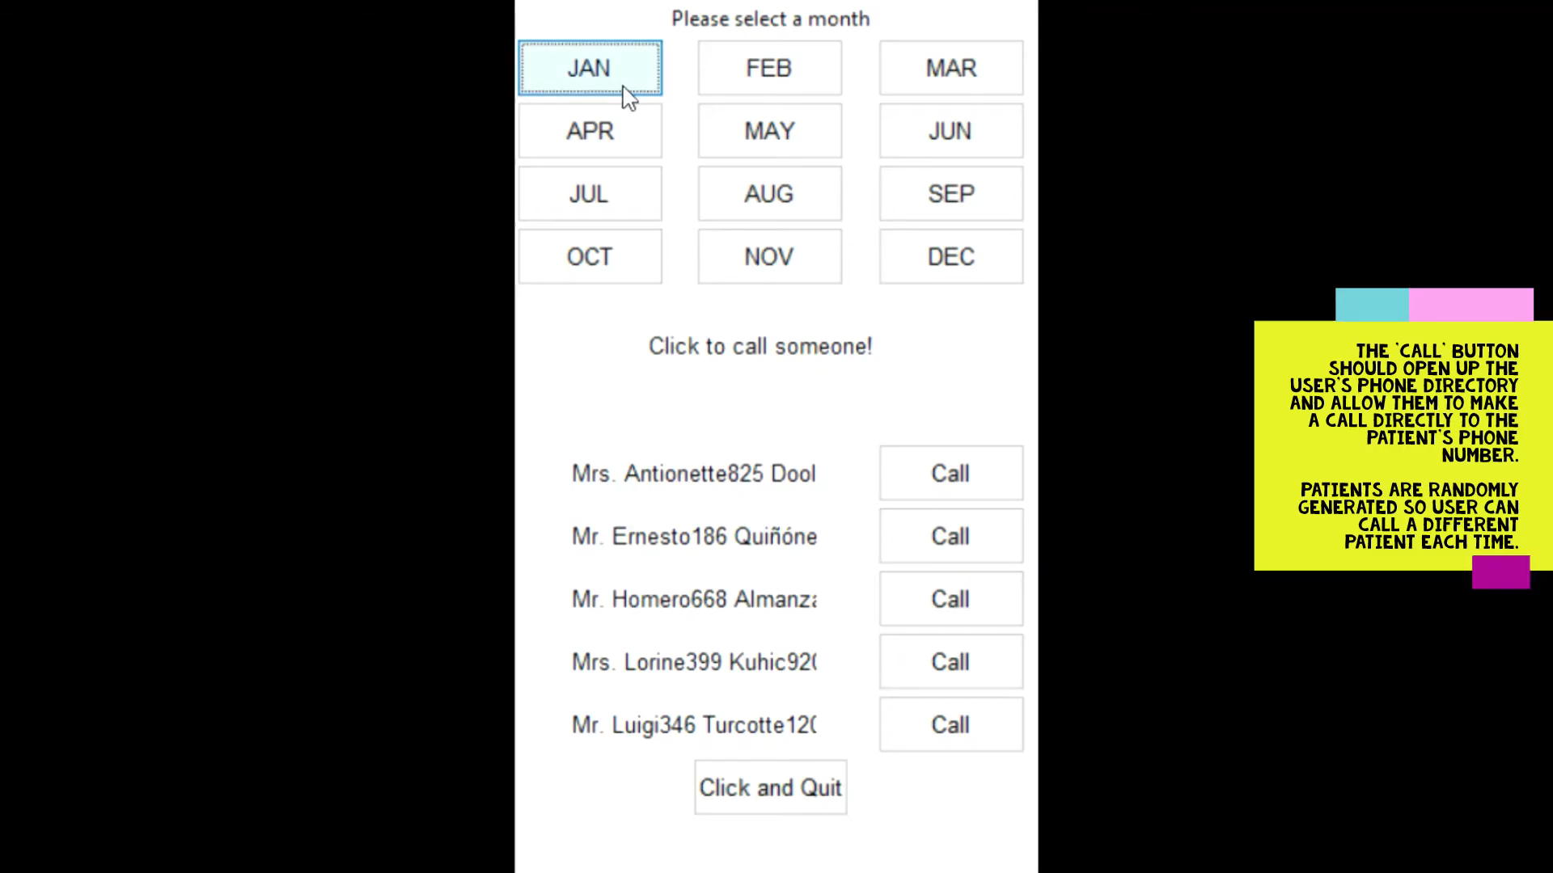
Video:
https://www.youtube.com/watch?v=tz6C3PisDiQ

System Architecture Diagram

