Notes for IEP Legal report:

1. Table of agreed deliverables of project components, milestones and quality gates, who will work on them and when (Moscow list, and additional task list?)
2. 1000 words
   1. Potential liabilities in work
      1. Privacy and personal information, what should be safe guarded? Recording of dancers. Storing in the cloud? Databases? How will mistakes be rectified? Can sue for damages…
      2. DPA Principles; what data is handled, why is it needed, how is it used, who will get it, for what purpose and for how long. Personal data should be accurate and adequate, relevant and timely for purpose intended, not more extensive than necessary for purposes known and authorised, secure e.g. face recognition software, does it record the dancers face? Keywords: data subject, personal data, data controller (purposes and way personal data is processed), data processor (person who processes data on behalf of the data controller), automatically processed
      3. Misuse of software, could be vulnerable to viruses/worms/trojans, hacking via open ports
      4. Security plans of client to keep the software safe and personal data, determine what users are present, ensure security activities are carried out, preventative measures are implemented, what system monitoring is performed and how,
      5. What defects may arise?
      6. What is expected?
      7. Health and safety risks of the software?
      8. Disability discrimination act, we must make sure our software doesn’t discriminate. Can skeletal tracking work for people with disabilities? Visual, hearing, motor and cognitive.
      9. 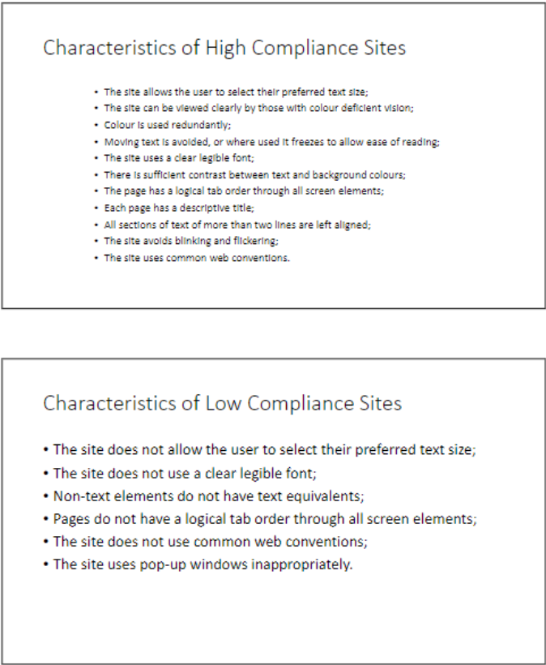
   2. Intellectual property, e.g. open source usage of materials, components derived from the Asset, “compare” source code agreement types and defend to client why we think ours is best
      1. Are you using copyrighted software? Educational purposes, bought from unity store
      2. Is it trademarked? Branding? A word or phrase, symbol or logo?, use as an adjective with little annotation ‘TM’
      3. Is it patented? Protects an idea of making something, do we really need this?
      4. Are they trade secrets?
      5. Creative commons license; attribution (licensees may copy, distribute, display and perform the work and make derivative works based on it only if they give the author or licensor the credits in the manner specified by these), share alike (licenses may distribute derivative works under a license identical to the license that governs the original work), non-commercial (licensees may copy, distribute, display and perform the work and make derivative works based on it only for non-commercial purposes)
      6. Source code agreement: proprietary (not for us because you can’t modify the code, only bought the right to use it), shareware (limited time they can use software, can’t use it for financial gain, like a free trial, getting out to customers to try), freeware (distributed without demanding a fee, available as fully functional software for an unlimited period, ownership restrained by its developer, developer can later change from freeware to paid produce, distributed without source code to stop modification by its users, freely copied but not sold), OSS (download it, use it and distribute it to others, also see the code, can see and edit the source code), COTS (components off the shelf, common libraries and APIs for integration, negative makes the library size fairly large)
      7. 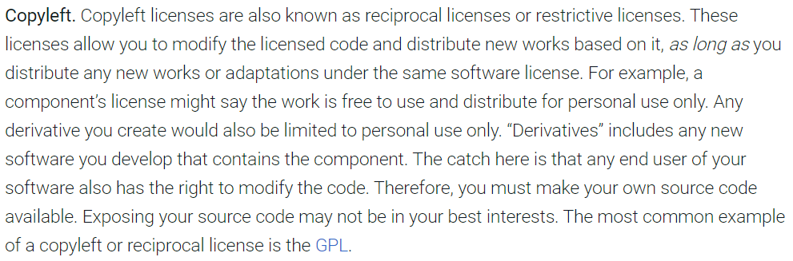
      8. <https://www.synopsys.com/blogs/software-security/5-types-of-software-licenses-you-need-to-understand/>
   3. Data privacy considerations
   4. Sustainability statement on how we are going to make the system efficient and maximised available resources
      1. How can we ensure the Kinects use less energy?
      2. What is the current CPU load of plugging in a Kinect to one laptop?
      3. What type of laptop do we recommend?
      4. What is the CPU load whilst running the unity application?

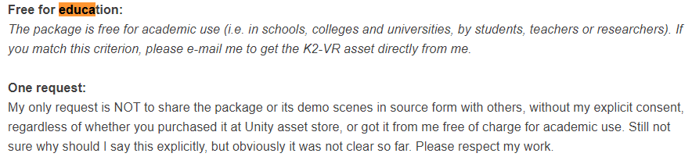

<https://rfilkov.com/2016/05/07/kinect-v2-mobile-vr-examples/comment-page-1/>

1. Hackathon

* Check CPU usage when plugging in one Kinect to laptop <https://www.techwalla.com/articles/how-to-check-cpu-usage>
* <https://social.msdn.microsoft.com/Forums/en-US/94a88937-4822-40c1-b18e-ee939b08a5ff/why-the-cpu-utilizaiton-of-kinect-for-windows-v2-is-so-high-?forum=kinectv2sdk>