NETWORK SCANNING USING NMAP
Practical Documentation
Tool | Nmap 7.95
Platform | Kali Linux
Target used in lab | 10.0.2.2

1. Aim
To perform network scanning using Nmap and demonstrate host discovery, port scanning, service and version detection, operating-system detection, NSE script scanning, firewall detection, and scan-report generation.

2. Tools / Requirements
- Kali Linux
- Nmap 7.95
- Terminal
- Authorized local lab target (10.0.2.2)

3. Nmap Verification
Nmap was verified on Kali Linux using the following command:
nmap --version
The installed version was Nmap 7.95, confirming that Nmap was available and ready for the practical.

4. Host Discovery
Command:
nmap -sn 10.0.2.0/24
Observation: The -sn option performs host discovery without a normal port scan. The lab scan identified three active hosts: 10.0.2.2, 10.0.2.3 and 10.0.2.15.
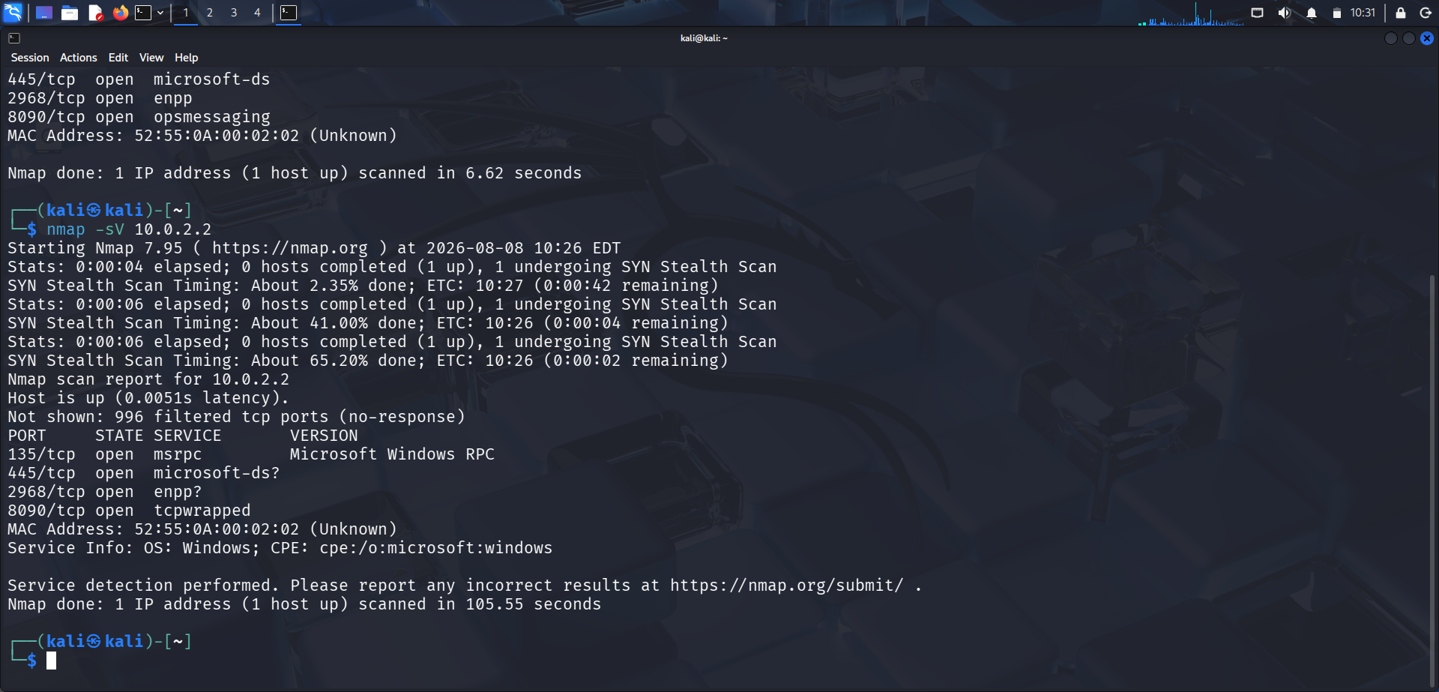
Screenshot 1 – Host Discovery

5. Port Scanning
Command:
nmap 10.0.2.2
Observation: The scan identified open TCP ports including 135, 445, 2968 and 8090 on the selected lab target.
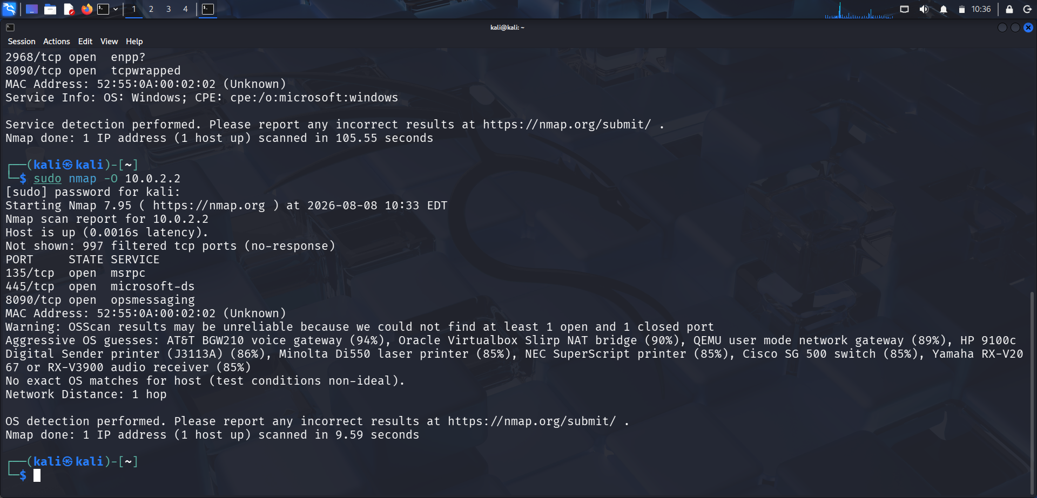
Screenshot 2 – Port Scanning

6. Service and Version Detection
Command:
nmap -sV 10.0.2.2
Observation: The -sV option attempts to identify services and their versions on open ports. The result identified Microsoft Windows RPC on port 135 and provided additional service/OS information.
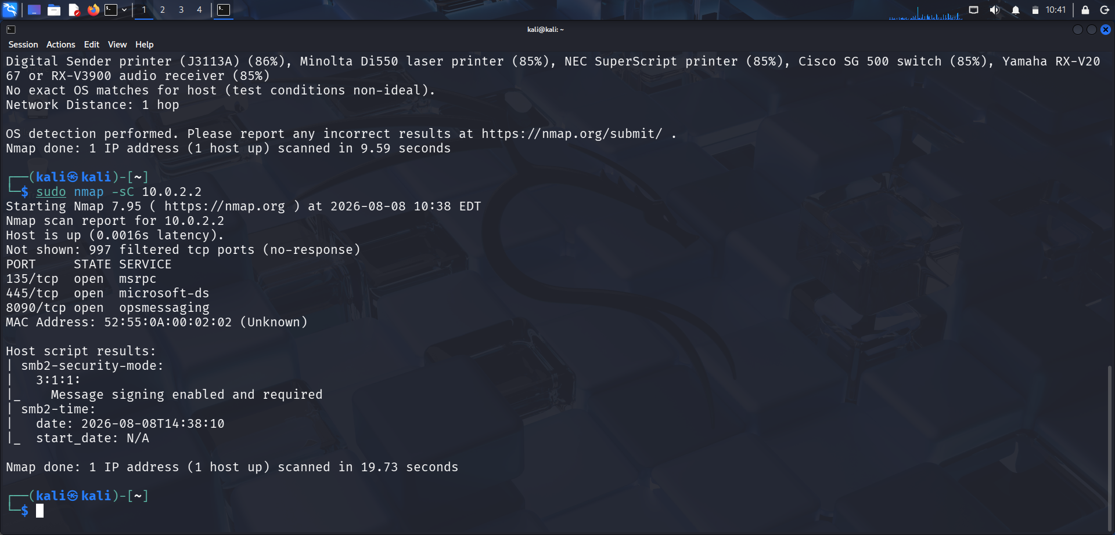
Screenshot 3 – Service and Version Detection

7. OS Detection
Command:
sudo nmap -O 10.0.2.2
Observation: The -O option performs operating-system detection. In this lab, Nmap reported that the OS result may be unreliable because the target did not provide enough information for a confident match.
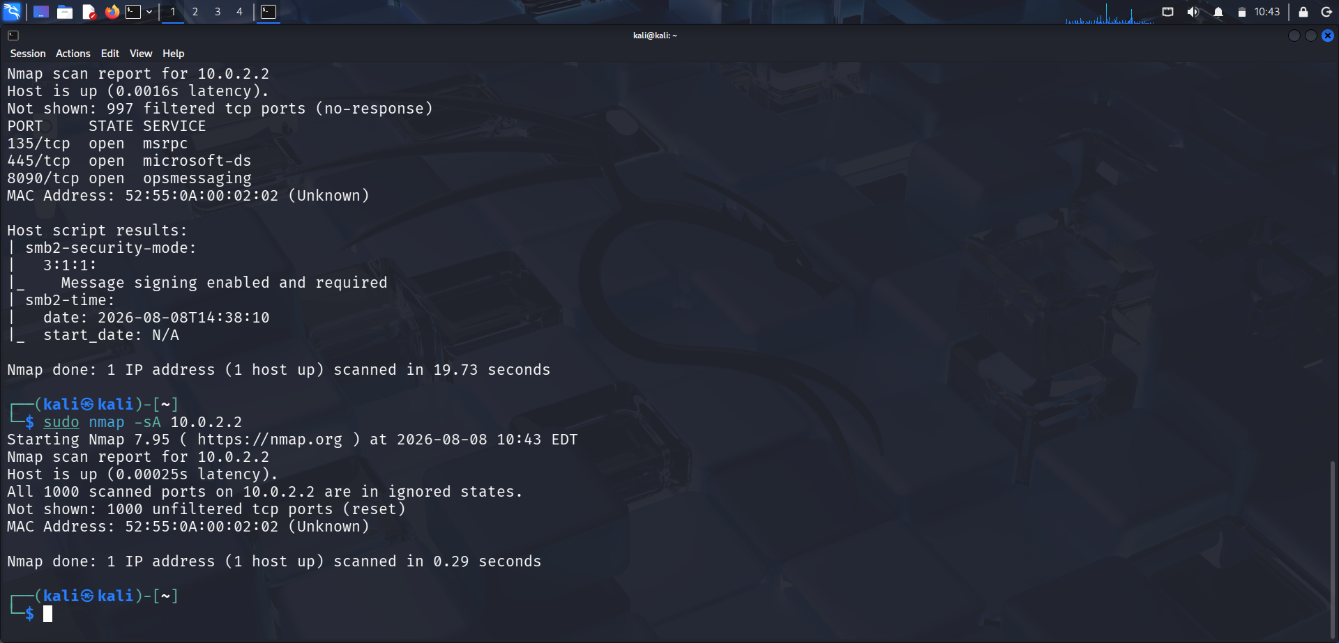
Screenshot 4 – OS Detection

8. NSE Script Scanning
Command:
sudo nmap -sC 10.0.2.2
Observation: The -sC option runs Nmap's default NSE scripts. The result included SMB2 security-mode and SMB2 time information.
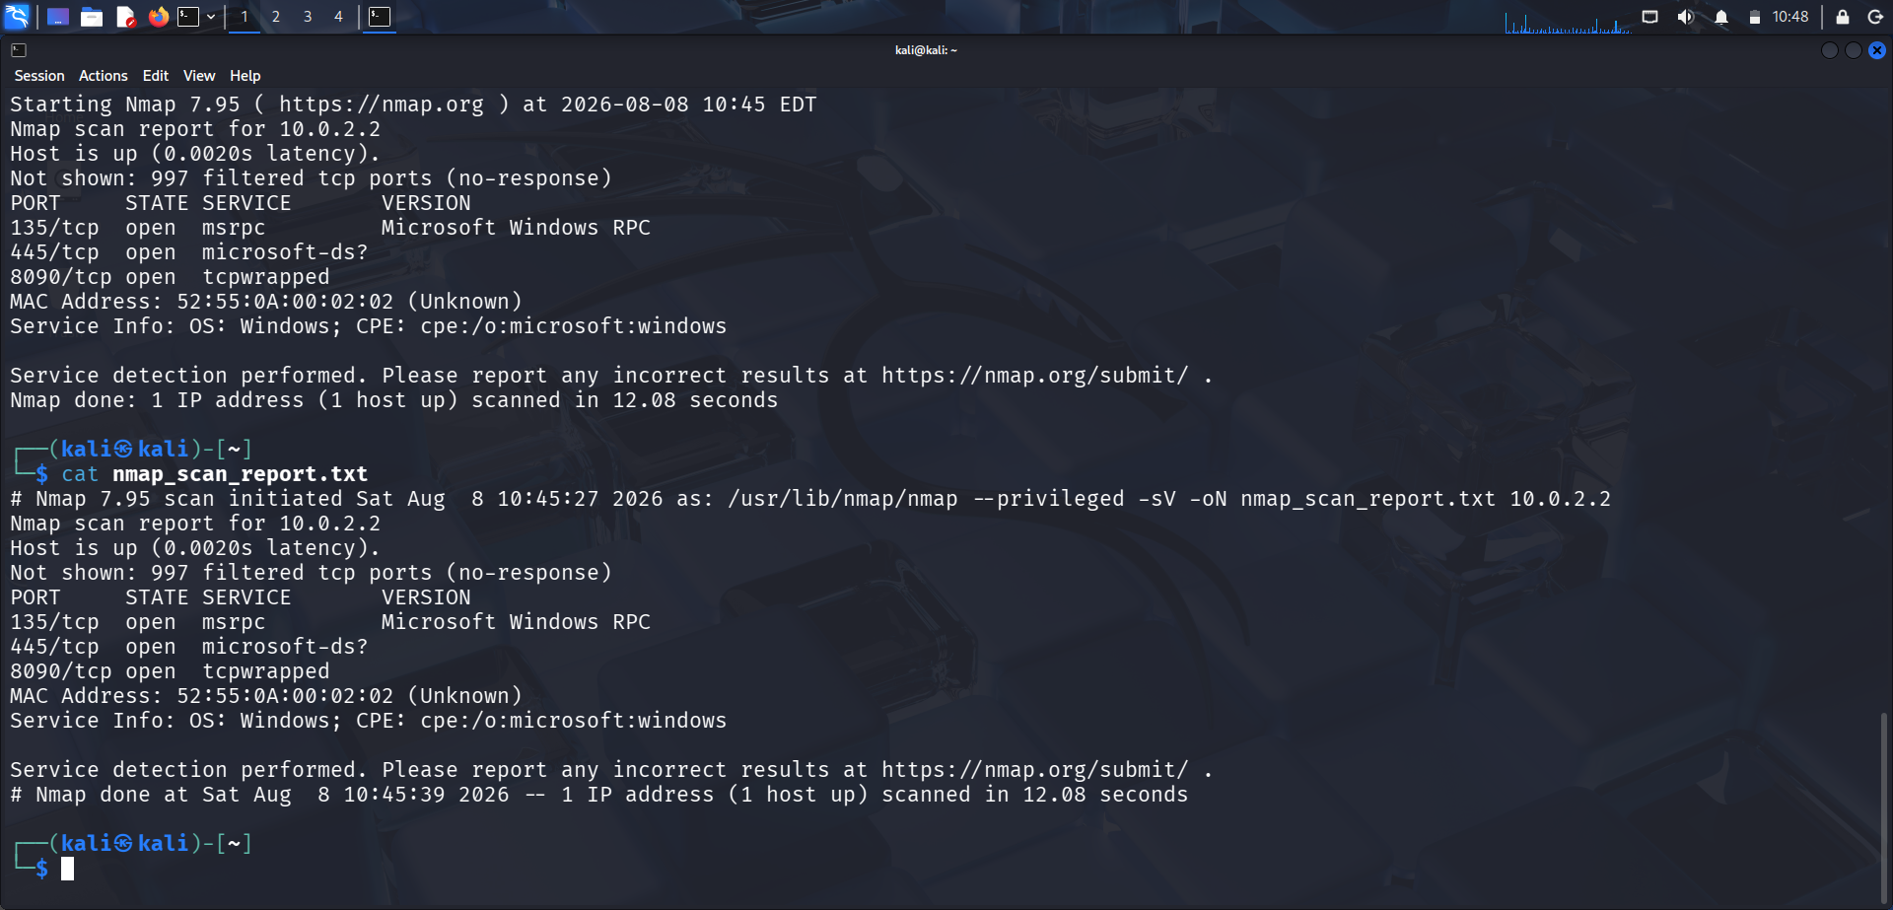
Screenshot 5 – NSE Script Scanning

9. Firewall Detection
Command:
sudo nmap -sA 10.0.2.2
Observation: The -sA option performs an ACK scan. The result reported the scanned ports as unfiltered (reset), providing information about packet filtering behavior.
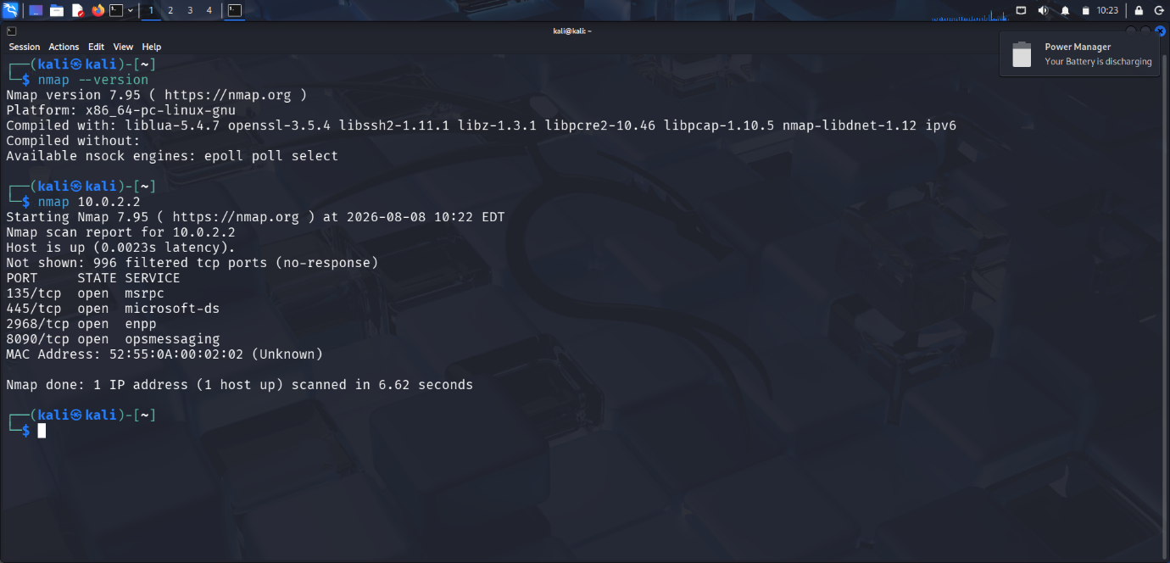
Screenshot 6 – Firewall Detection

10. Scan Report Generation
Command:
nmap -sV 10.0.2.2 -oN nmap_scan_report.txt
Observation: The -oN option saves the scan output in normal text format. The generated report recorded the host status, filtered ports, open ports, services, and service/OS information.

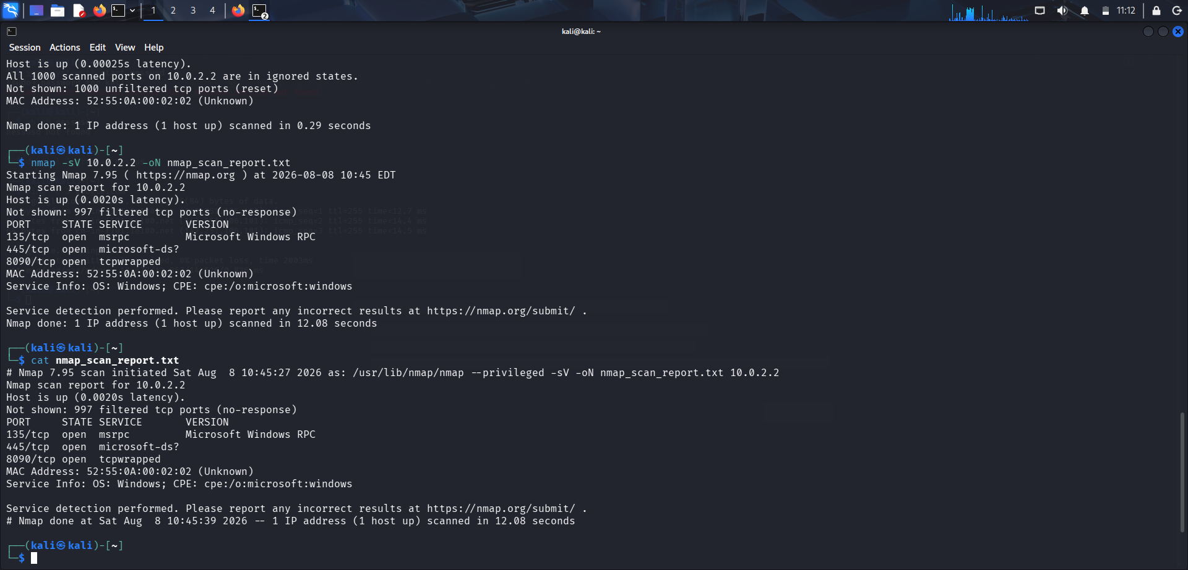
Screenshot 7 – Scan Report Generation

11. Result
The Nmap practical was completed in the authorized local lab environment. Host discovery, port scanning, service/version detection, OS detection, NSE script scanning, firewall detection, and normal-format scan-report generation were demonstrated.

12. Conclusion
Nmap was successfully used as a network-scanning and enumeration tool. The practical demonstrated how different Nmap options can be used to discover active hosts, identify open ports and services, gather OS-related information, run NSE scripts, examine filtering behavior, and save scan results for documentation.

