LINUX LOG ANALYSIS PRACTICAL
Kali Linux | Documentation with Screenshots

1. Objective
To inspect Linux system logs, review login-session records, and identify authentication-related events using Kali Linux.

2. Tools Used
Kali Linux Terminal, journalctl, grep, who, and last.

3. Procedure
- Inspected the /var/log/ directory.
- Used who to view the current logged-in session.
- Used last -n 10 to review recent login-session records.
- Searched auth.log for 'failed password' messages.
- Queried the SSH service journal and filtered journal entries for authentication-related terms.
- Prepared a text file containing observations and conclusions.

4. Findings and Analysis
- Older authentication-failure messages appeared for lightdm and xfce4-screensaver-dialog.
- The SSH service query returned '-- No entries --' in the captured output.
- Two matching records in the current-day filtered query were sudo command records generated while running the search. They are not confirmed failed login attempts.
- The evidence does not establish malicious activity; log entries should be interpreted in context.

5. Screenshots / Practical Evidence
Screenshot 1: Authentication log analysis.
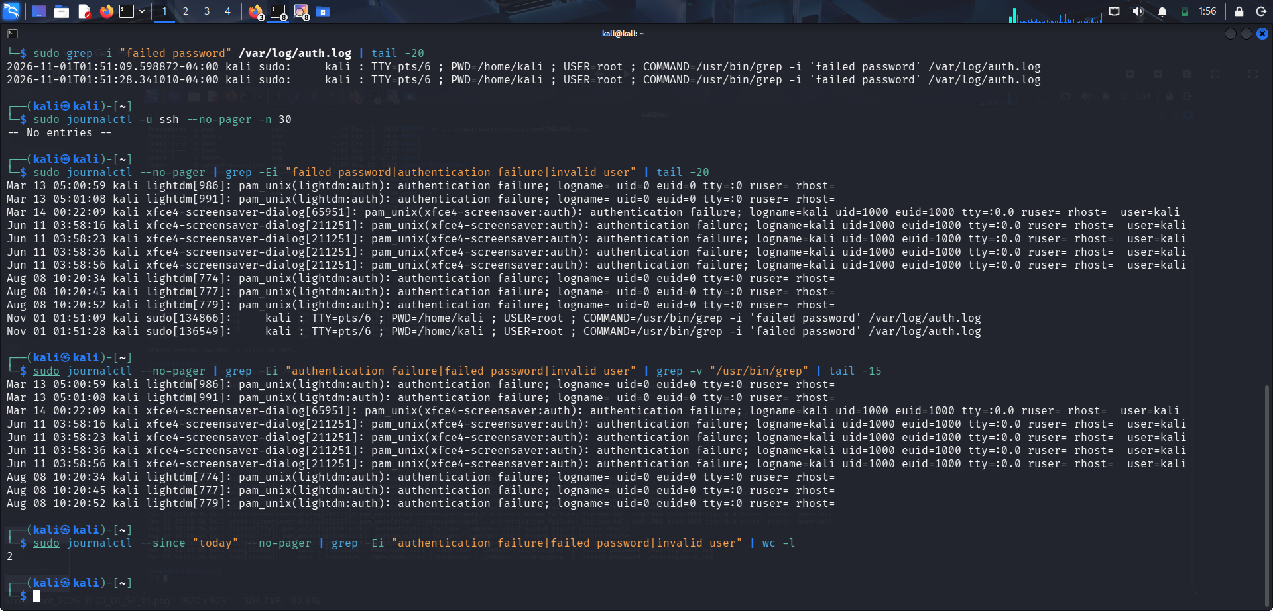

Screenshot 2: Commands and observations file.
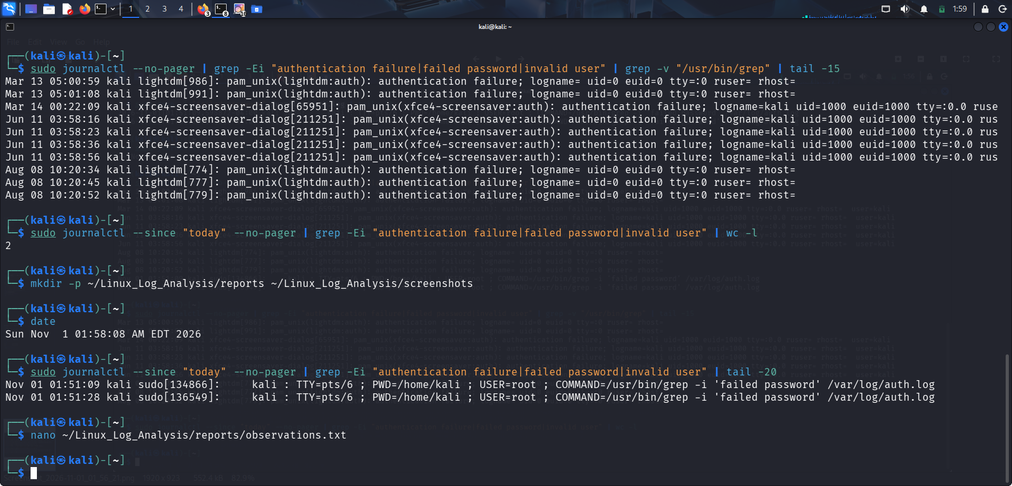

Screenshot 3: Observations and screenshot utility.
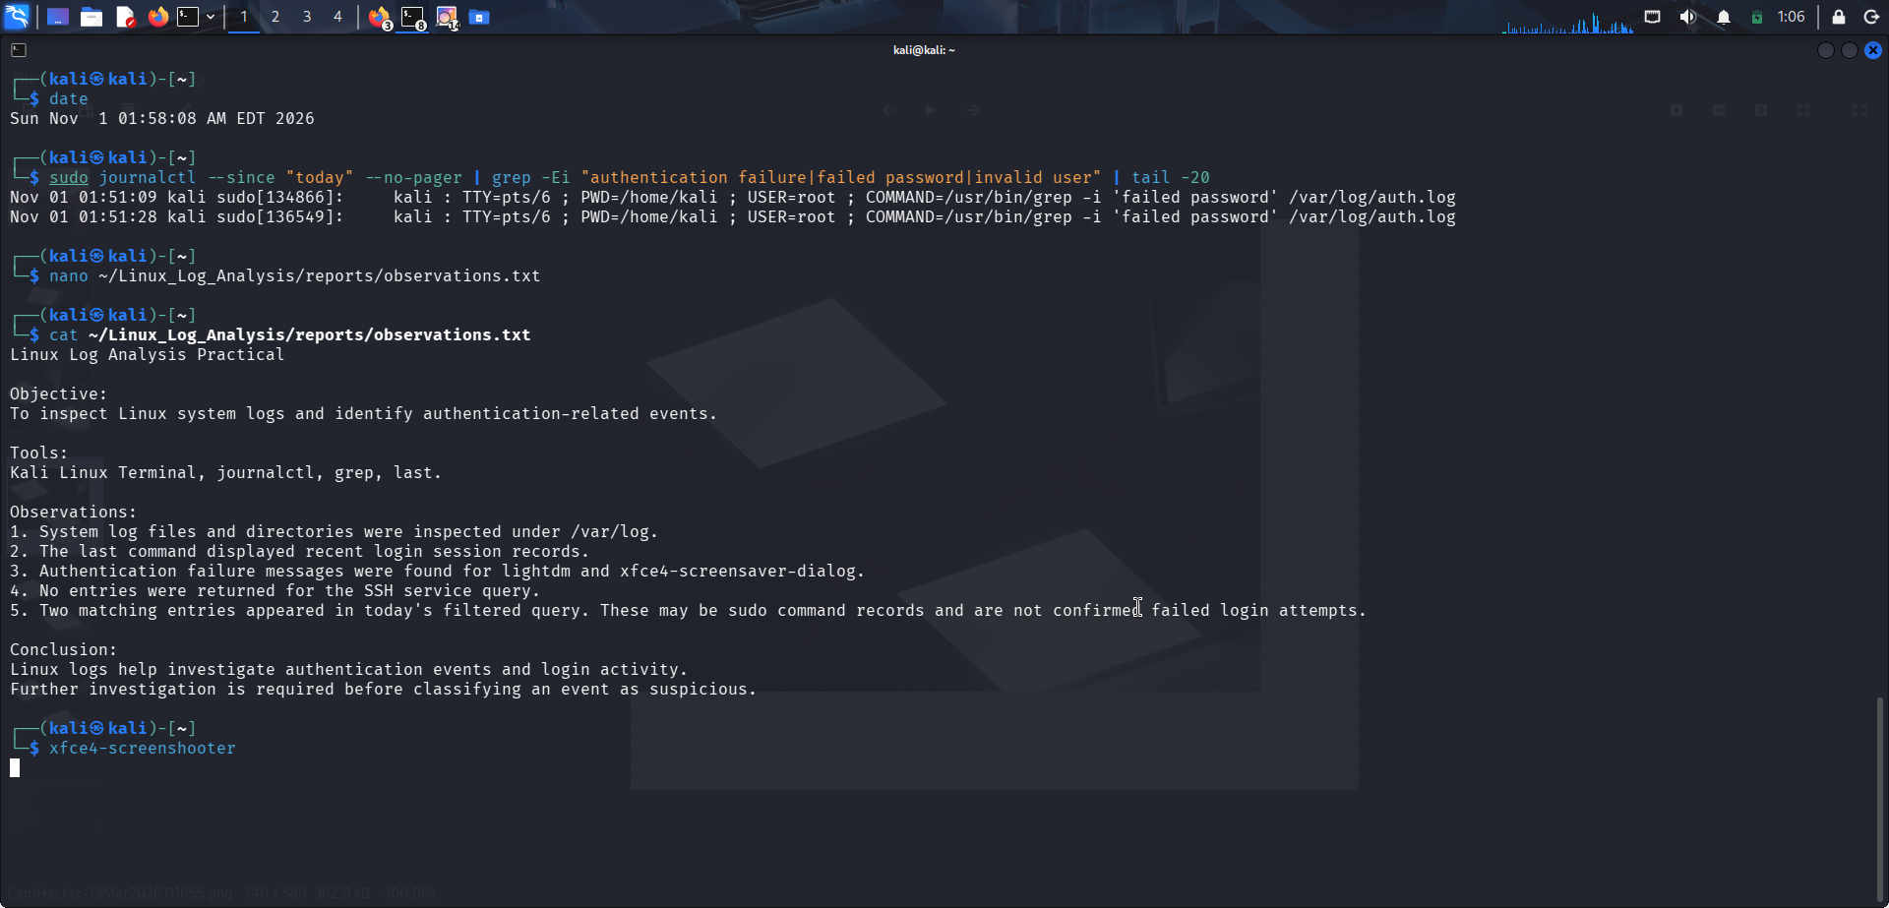

6. Conclusion
Linux log analysis helps investigate login sessions and authentication events. This practical identified older desktop-login/screen-lock authentication failure messages. The visible current-day matches were sudo search-command records, not confirmed failed logins. Further contextual investigation is needed before classifying an event as suspicious.

7. Commands Used
ls -lh /var/log/
who
last -n 10
sudo grep -i 'failed password' /var/log/auth.log | tail -20
sudo journalctl -u ssh --no-pager -n 30
sudo journalctl --no-pager | grep -Ei 'failed password|authentication failure|invalid user' | tail -20

