Blockchain System for Academic
Certificate Verification and AI Fraud Detection



Supervisor
Dr. S.S Dube

Submitted by
Munashe Keith Gandari
N02220242W

A DISSERTATION SUBMITTED TO
The Department of Computer Science at the National University of Science and Technology, in partial fulfillment of the requirements for the degree of
BACHELOR OF SCIENCE (HONS) COMPUTER SCIENCE
Faculty of Applied Sciences

[23 September 2025]

Table of Contents
CHAPTER 1: INTRODUCTION 6
1.1 Introduction 6
1.2 Problem Statement 6
1.3 Background of the Study 7
1.4 Aims and Objectives 8
1.4.1 Aim 8
1.4.2 Objectives 8
1.5 Justification 8
1.6 Competitive Advantage 9
1.7 Project Scope 9
1.7.1 Mobile Application (Students and Employers) 10
1.7.2 Admin Web Application (Academic Institutions) 10
1.7.3 Public Verification Website 10
1.7.4 Backend and Blockchain Infrastructure 10
1.7.5 Out-of-Scope Functionalities 10
1.8 Funding 11
1.9 Sustainability 11
1.10 Report Organisation 11
1.11 Conclusion 12
CHAPTER 2: LITERATURE REVIEW 13
2.1 Introduction 13
2.2 Research Questions 13
2.3 Systematic Literature Review Methodology 13
2.3.1 Database Search Strategy 13
2.3.2 Inclusion and Exclusion Criteria 14
2.3.3 PRISMA Flow 14
2.3.4 Data Extraction and Synthesis 15
2.4 Blockchain-Based Educational Verification Systems 16
2.4.1 Ethereum-Based Systems 16
2.4.2 Blockcerts (MIT) 17
2.4.3 IPFS Integration and Off-Chain Storage 17
2.5 AI and Deep Learning for Fraud Detection 18
2.5.1 Convolutional Neural Networks for Image Forgery 18
2.5.2 Ensemble and Hybrid AI Models 18
2.5.3 Document-Specific Forgery Detection 18
2.6 Integrated Blockchain-AI Systems 19
2.7 Performance and Security Analysis 19
2.7.1 Security Findings 20
2.7.2 Performance Findings 20
2.8 Review of Similar Systems 21
2.8.1 Blockcerts (MIT Media Lab) 21
2.8.2 Digitary (Ireland) 21
2.8.3 National Student Clearinghouse (United States) 22
2.8.4 CHESICC/CHSI (China) 22
2.8.5 TrueProfile.io / DataFlow Group 22
2.9 Research Gap 22
2.10 Proposed Solution 24
2.11 Conclusion 25
CHAPTER 3: METHODOLOGY 26
3.1 Introduction 26
3.2 Research Methodology 26
3.2.1 Alternative Research Methodologies Considered 26
3.2.2 Chosen Methodology: Design Science Research 26
3.2.3 Design Science Research Framework 27
3.3 Software Development Methodology 27
3.3.1 Alternative Methodologies Considered 27
3.3.2 Chosen Methodology: Evolutionary Prototyping 28
3.3.3 Prototype Iterations 28
3.4 Link Between Research and Software Methodologies 29
3.5 System Workflow Overview 29
3.6 Tools, Algorithms, and Frameworks 30
3.6.1 Blockchain Development Tools 30
3.6.2 AI and Machine Learning Tools 30
3.6.3 Backend and Frontend Development Tools 31
3.7 Data Collection and Test Case Construction 31
3.7.1 AI Dataset Preparation 31
3.7.2 Training Configuration 32
3.7.3 Blockchain Test Cases 33
3.8 Ethical Considerations 33
3.9 Mapping of Tools to Research Objectives 34
3.10 Conclusion 34
CHAPTER 4: SYSTEM ANALYSIS AND DESIGN 36
4.1 Introduction 36
4.2 Systems Analysis 37
4.2.1 Functional Requirements 37
4.2.2 Non-Functional Requirements 39
4.2.3 Use Case Modelling 41
Actors 41
Use Case Diagrams 42
4.2.5 Sequence Diagrams 44
4.3 System Design 45
4.3.1 Software Design 45
Architectural Design 45
Class Diagram 46
4.3.2 User Interface Design 48
4.3.3 Database Design 49
Entity-Relationship Diagram 49
4.4.1 Activity Diagram: Certificate Issuance 53
4.4.2 Activity Diagram: Certificate Verification 55
4.4.3 Decision Tables 56
Verification Outcome Decision Table 56
4.5 Deployment Diagram 56
4.6 Conclusion 57
CHAPTER 5: IMPLEMENTATION AND TESTING 58
5.1 Introduction 58
5.2 Development Environment 58
5.3 Backend API Implementation 59
5.3.1 Domain Driven Design and Repository Pattern 59
5.3.2 Multi-Tenancy Implementation 59
5.3.3 JWT Authentication and Role-Based Access Control 60
5.3.4 API Endpoint Structure 61
5.4.1 Contract Structure and Storage 62
5.4.2 Key Contract Functions 63
5.4.3 Gas Optimisation Strategies 63
5.5 IPFS Integration via Pinata 64
5.6 Frontend Implementations 66
5.6.1 Angular 21 Admin Web Application 66
5.6.2 Next.js 16 Public Website 67
5.6.3 Flutter Mobile Application 69
5.7 Key Implementation Challenges 70
5.8 Current Implementation Status 70
5.9.1 Test Infrastructure 72
5.9.2 Unit Testing Approach 72
5.9.3 Functional Test Plan 74
5.9.4 Smart Contract Testing 74
5.10 Conclusion 75
CHAPTER 6: RESULTS, EVALUATION, AND CONCLUSION 75
6.1 Introduction 76
6.2 Results 76
6.2.1 Smart Contract Performance 76
6.2.2 API Response Performance 77
6.2.3 AI Fraud Detection Performance 78
6.2.4 Verification Accuracy and Reliability 80
6.2.5 Unit Test Results 81
6.2.6 Multi-Tenancy Isolation 81
6.3 Evaluation 82
6.3.1 Evaluation Against Research Objectives 82
6.3.2 Comparative Evaluation 82
6.3.3 Strengths 82
6.3.4 Limitations 83
6.4 Lessons Learned 83
6.5 Recommendations for Future Work 83
6.6 Conclusion 84
REFERENCES 85

CHAPTER 1: INTRODUCTION

1.1 Introduction
Counterfeit academic certificates have become one of the most ongoing threats to the integrity of education systems worldwide. The issue is not new, but the tools available to forgers have become significantly more advanced over the past decade, making detection more difficult and the consequences more severe. Employers, universities, and professional regulatory bodies all rely on the assumption that an academic credential is authentic; when that assumption fails, the ripple effects are felt across entire economies and labor markets.
In Zimbabwe, the situation is especially severe. A comprehensive study of all fifteen registered universities and the Zimbabwe Council for Higher Education (ZIMCHE) confirmed that qualification fraud occurs at every level of the institutions. Honorary degrees ranked highest among the illegally obtained credentials, followed by professorships, doctorates, and bachelor’s degrees. The main causes identified were high unemployment, credentialism (where employers request increasingly higher qualifications even for jobs that don’t need them), and a craving for social status. These pressures lead individuals to take fraudulent shortcuts, and the institutions themselves often lack the verification systems needed to detect them (Garwe, 2015).
Globally, the cost of credential fraud is staggering. Employers worldwide face huge financial losses due to hiring decisions based on fake qualifications. These losses include not only direct salary expenses for unqualified hires but also productivity drops, damage to reputation, and, in sectors like healthcare and engineering, real safety hazards. The scale of the issue clearly shows that manual, paper-based verification processes are no longer effective (Saleh, Ghazali, and Rana, 2020).
This research aimed to address these challenges by designing and developing a platform called CertifyChain, which combines two complementary technologies: blockchain for tamper-proof credential storage and artificial intelligence for automated forgery detection. Blockchain offers the immutable ledger that guarantees a certificate, once recorded, cannot be altered or deleted without leaving a trace. AI, specifically a deep learning model based on the ResNet50v2 architecture, provides visual analysis capabilities that can detect manipulated certificate images before they reach the blockchain. Together, these technologies create a verification system that is both secure and intelligent, something neither technology could achieve alone.

1.2 Problem Statement
Academic certificate verification in Zimbabwe relies on slow, manual, paper-based processes that are inadequate for detecting modern forgeries. Universities store records in isolated, institution-specific databases with no centralised or federated verification infrastructure, creating single points of failure and opportunities for insider manipulation (Garwe, 2015; Said et al., 2023). Meanwhile, image-editing tools have made high-quality certificate forgeries increasingly accessible, yet no Zimbabwean institution has deployed automated detection systems capable of identifying them (Qazi, Zia, and Almorjan, 2022).
A critical gap exists between blockchain integrity systems and AI detection systems: blockchain prevents tampering after a record is stored but cannot verify whether a document was genuine at the point of upload, while AI can detect visual forgeries but cannot provide a tamper-proof audit trail. This study addresses both dimensions by developing CertifyChain, a hybrid blockchain-AI platform that combines immutable credential storage with automated forgery detection in a single system designed for the infrastructure and budget constraints of developing countries.

1.3 Background of the Study
Academic certificate forgery is not limited to Zimbabwe. It has been reported across Africa, Asia, the Middle East, and even in developed countries with strong educational systems. What makes it especially harmful in developing nations is the mix of high demand for qualifications, limited capacity for verification, and weak enforcement of regulations.
The most thorough examination of the problem in Zimbabwe so far used a mixed-methods approach, including questionnaires sent to over 2,400 academics across all fifteen registered universities, as well as interviews with key stakeholders at ZIMCHE. The study found that large but unspecified numbers of Zimbabweans held fake academic degrees. Several university lecturers were compelled to resign between 2005 and 2008 when their credentials were found to be from institutions that had been shut down. There were also documented cases of individuals returning from abroad during the economic crisis with questionable doctoral qualifications, taking advantage of the severe shortage of qualified lecturers (Garwe, 2015).
The technological landscape for solving these challenges has changed a lot in recent years. Blockchain technology, originally created for cryptocurrencies, has found uses in many areas that need permanent, transparent records. In education, the earliest notable effort was the Blockcerts project at MIT Media Lab, which in 2017 allowed 111 graduates to get digital diplomas linked to the Bitcoin blockchain. This pilot showed that blockchain-based credentials are possible but also revealed major issues, like no way to detect forgery and the technical challenges faced by institutions in developing regions.
On the AI side, deep learning models for image forensics have progressed quickly. A system based on the ResNet50v2 architecture uses transfer learning to detect image splicing and copy-move tampering, achieving strong results on the CASIA v1 and v2 benchmark datasets, which contain thousands of natural photographs manipulated using splicing and copy-move techniques. While the CASIA datasets contain general photographs rather than academic certificate images, the same architectural principles transfer learning, residual feature extraction, and ensemble classification have been adapted in this study for the certificate domain, where analogous manipulations occur at text boundaries, signature regions, and seal areas.: altered text, replaced signatures, modified seals, and fake watermarks (Qazi, Zia and Almorjan, 2022).
Despite these simultaneous advances in blockchain and AI, few researchers have tried to merge them into a single verification system, and none have focused specifically on Zimbabwe’s educational setting. This study aims to address that gap.

1.4 Aims and Objectives

1.4.1 Aim
To develop a blockchain-based system for academic certificate verification integrated with artificial intelligence for fraud detection and automated credential validation.

1.4.2 Objectives
1) To store academic certificates securely within an immutable blockchain ledger.
2) To verify the authenticity of academic certificates using AI-based fraud detection algorithms.
3) To enable institutions to upload and issue digital certificates efficiently onto the blockchain.
4) To facilitate instant and transparent verification of academic credentials by employers and other stakeholders.

1.5 Justification
The case for developing this system is based on three main points. First, universities and examination boards in Zimbabwe need a reliable way to protect the integrity of the credentials they issue. Each time a fake certificate with an institution’s name circulates in the job market, it diminishes the value of the institution’s authentic qualifications. A blockchain-based issuance system enables institutions to create a permanent, verifiable record of every certificate they issue, effectively giving each qualification a digital fingerprint that cannot be forged.
Second, employers need quicker and more dependable verification. The current process of manually contacting registrar’s offices is slow, costly, and often inconclusive. A system that allows an employer to scan a QR code or enter a certificate hash and receive an immediate verification result, supported by both blockchain integrity and AI analysis, would revolutionize the hiring process. It would also level the playing field for genuine graduates, whose credentials are currently undermined by the spread of fakes.
Third, students and graduates deserve ownership of their credentials. In the current system, a graduate who loses their physical certificate faces a lengthy, sometimes impossible process to get a replacement. A blockchain-based system provides graduates with a permanent, portable, and shareable digital record of their achievements that they control, independent of any single institution’s administrative systems.

1.6 Competitive Advantage
The CertifyChain platform sets itself apart from current verification methods by combining blockchain and artificial intelligence into a single workflow. Current blockchain-based systems, like Blockcerts, guarantee data integrity but lack a way to verify if a certificate image has been tampered with before it is hashed and stored. On the other hand, AI-based fraud detection tools can spot visual tampering but cannot offer the unchangeable, auditable storage that makes verification results trustworthy over time. CertifyChain closes this gap by performing AI analysis before anchoring data to the blockchain, The AI module operates as a two-stage pipeline. First, a frozen ResNet50V2 convolutional neural network a 50-layer deep learning model pre-trained on over 1.2 million images extracts a 2,048-dimensional visual feature vector from each certificate image. Second, an XGBoost classifier, a gradient-boosted ensemble of decision trees, analyses those features alongside five handcrafted forensic measures to produce a fraud confidence score between 0 and 100 per cent. This hybrid architecture combines the visual pattern recognition strength of deep learning with the tabular classification efficiency of XGBoost, enabling reliable fraud detection on small training datasets.
The system also tackles the scalability issue that has hindered blockchain adoption in education. By using batch issuance (up to 50 certificates per blockchain transaction), gas-optimized smart contract storage with tightly packed struct fields, and IPFS-based off-chain file storage, CertifyChain lowers the per-certificate blockchain issuance cost to a fraction of what a simple implementation would cost. The multi-tenancy architecture enables multiple institutions to share a single deployment, further reducing infrastructure expenses.
From a user experience perspective, the system offers three distinct interfaces designed for different stakeholder needs. Institutional administrators use a full-featured Angular 21 web application with dashboard analytics and a step-by-step issuance wizard. External verifiers access a streamlined Next.js 16 website that requires no account registration. Students and employers utilize a Flutter mobile app with one-tap QR code verification. This multi-platform approach ensures accessibility for users with various technical skills across the platform’s diverse user base.

1.7 Project Scope
The CertifyChain platform consists of four main components, each targeting a different stakeholder group:

1.7.1 Admin Web Application (Academic Institutions)
Built with Angular 21, the administrative web app offers institutional staff a dashboard to manage students, programmes, and certificates. Key features include a multi-step certificate issuance wizard with MetaMask integration for blockchain transactions, batch issuance of up to 50 certificates per transaction, certificate revocation, and analytics dashboards displaying issuance trends and verification stats.

1.7.2 Public Verification Website
Built with Next.js 16, the public website lets anyone verify a certificate without an account by entering its hash or scanning its QR code. It performs parallel checks against both the blockchain smart contract and the backend API, offering a dual-path verification result.

1.7.3 Backend and Blockchain Infrastructure
The backend API, built with .NET 10 and C# 13, follows the Clean Architecture pattern with separate API, Core, and Data layers. It uses Microsoft SQL Server via Entity Framework Core 10 for relational data storage, with global query filters implementing multi-tenancy at the database level. The blockchain layer consists of a Solidity smart contract deployed to the Ethereum Sepolia testnet, with IPFS integration via Pinata for decentralized storage of certificate files.
Table 1.1: In-Scope Functionalities
Component | Included Features
Web App | Certificate issuance, student and user management, blockchain interaction, analytics
Blockchain | Smart contracts, certificate hashing, immutable ledger, batch issuance, revocation
AI Module | Image forgery detection using ResNet50v2, metadata analysis via XGBoost
Security | Role-based access control (6 roles, 30+ permissions), JWT authentication, audit logs
Storage | IPFS via Pinata for off-chain certificate file storage

1.7.4 Out-of-Scope Functionalities
The following features are outside the scope of the current implementation: management of full student academic records (transcripts, enrollment, assessments); national or government-level blockchain governance frameworks; automation of examination processing or grading; integration with external HR or recruitment systems (reserved for future work); multi-country verification networks (since the system currently focuses on Zimbabwe); and deployment to the Ethereum mainnet (with the prototype running on the Sepolia testnet).
These exclusions were intentional choices to keep the project manageable within the timeframe of an Honours dissertation while still demonstrating all essential capabilities. Each excluded feature serves as a potential extension point for future development, as discussed in the recommendations in Chapter 6.

1.8 Funding
The project was developed with an estimated total budget of approximately US$50, covering cloud services for AI model training and blockchain node hosting (~US$20) and miscellaneous costs including internet and documentation (~US$30). Development hardware was available at no additional cost. The AI training dataset was assembled synthetically using free image editing tools, incurring no acquisition cost. All frameworks used TensorFlow, Ethereum, Angular, .NET are open-source, and model training was performed using Google Colaboratory's free GPU tier, keeping compute licensing costs at zero.

1.9 Sustainability
Technical sustainability is maintained by exclusively using open-source tools and frameworks, enabling long-term maintenance without licensing costs. The system is designed for cloud deployment with scalable infrastructure. Financial sustainability could be achieved through institutional adoption with cost-sharing among universities, employers, and government agencies, possibly using a subscription-based model for external verifiers. Collaboration with national education authorities such as ZIMSEC and the Ministry of Higher Education would support the project’s ongoing development beyond its initial phase.

1.10 Report Organisation
This report is organized into six chapters. Chapter 1 introduces the study by providing background information, research objectives, justification, and scope. Chapter 2 presents the literature review, highlighting previous studies on blockchain and AI-based verification systems. Chapter 3 describes the research methodology, including system design, data collection, and experimental evaluation. Chapter 4 covers system analysis and design, presenting the functional and non-functional requirements, use case modeling, sequence diagrams, architectural design, class diagrams, database design, and component-level design, including state diagrams, activity diagrams, and deployment architecture. Chapter 5 details the implementation and testing of all system components, such as the backend API, smart contract, IPFS integration, frontend applications, and the testing strategy with unit tests, functional tests, and smart contract tests. Chapter 6 presents the results, evaluates them against the research objectives, compares them with existing solutions, provides an honest assessment of strengths and limitations, and concludes with recommendations for future work.

1.11 Conclusion
This chapter laid out the context for this research, starting with the scale of academic certificate fraud in Zimbabwe and the limitations of existing verification methods. It defined the aim of developing an integrated blockchain-AI verification system and outlined four specific objectives. The justification, scope, and sustainability strategies demonstrate that the CertifyChain platform addresses a genuine and urgent need. The next chapter examines the existing body of research on blockchain-based credential systems and AI-driven fraud detection, identifying the gaps that this study aims to fill.

CHAPTER 2: LITERATURE REVIEW

2.1 Introduction
Certificate fraud costs employers an estimated billion dollars annually worldwide, and the problem shows no sign of slowing down (Saleh, Ghazali, and Rana, 2020). In Zimbabwe, qualification fraud affects every registered university, driven by a toxic mix of high unemployment, credentialism, and weak enforcement mechanisms (Garwe, 2015). Traditional verification methods, which usually involve phone calls, letters, and manual database searches, cannot keep up with the volume and sophistication of modern forgery techniques.
Two technological developments offer a path forward. Blockchain technology provides a decentralised, immutable ledger that can store credential records, preventing any single party from altering or deleting them. Artificial intelligence, specifically deep learning applied to image forensics, can analyse certificate images and detect tampering patterns that a human inspector would miss. This chapter examines the current state of research in both domains, reviews existing verification systems, identifies the gaps in the literature, and establishes the foundation for the integrated solution developed in this study.
The review follows PRISMA guidelines to ensure systematic coverage and methodological rigour, drawing on literature from IEEE Xplore, ACM Digital Library, SpringerLink, and Google Scholar.

2.2 Research Questions
Three research questions guided this review:
RQ1: What limitations exist in current academic certificate verification systems that contribute to high levels of fraud?
RQ2: To what extent can blockchain technology improve transparency and tamper resistance in academic credential verification?
RQ3: How can AI-based fraud detection enhance the accuracy and speed of verifying academic certificates?

2.3 Systematic Literature Review Methodology

2.3.1 Database Search Strategy
Searches were performed across four major scholarly databases: IEEE Xplore Digital Library, ACM Digital Library, SpringerLink, and Google Scholar. Boolean logic was used with three concept groups: (1) blockchain/distributed ledger, (2) credential/certificate verification, and (3) AI/deep learning for forgery/fraud detection. Search terms included combinations such as ("blockchain" OR "distributed ledger") AND ("certificate verification" OR "credential verification"), and ("artificial intelligence" OR "deep learning") AND ("forgery detection" OR "document fraud"). All searches were limited to peer-reviewed, English-language publications from 2018 to 2024.

2.3.2 Inclusion and Exclusion Criteria
Inclusion criteria: (1) Peer-reviewed journal articles and conference proceedings; (2) studies focusing on blockchain for educational credential verification; (3) research on AI/ML techniques for document fraud detection; (4) papers addressing certificate authentication systems; (5) studies on smart contract applications in education; (6) published between 2018 and 2024; (7) written in English.
Exclusion criteria: (1) Non-peer-reviewed publications except seminal grey literature; (2) studies unrelated to educational credentials or document verification; (3) papers focusing solely on cryptocurrency without verification applications; (4) duplicate publications; (5) studies with insufficient methodological detail; (6) non-English publications; (7) research published before 2018.

2.3.3 PRISMA Flow
Table 2.1 summarises the systematic screening process from identification through to final inclusion.
Table 2.1: PRISMA Screening Summary
Stage | Description | Count
Identification | Total records identified from 4 databases | 10,470
 | Duplicates removed before screening | 4,865
 | Records remaining after deduplication | 5,605
Screening | Further duplicates removed | 763
 | Unique records screened by title | 4,842
 | Records excluded (not related to the topic) | 3,979
 | Records remaining for abstract review | 863
Eligibility | Not focused on educational credential verification | 368
 | Not involving AI/ML in fraud detection workflows | 142
 | Pure cryptocurrency/blockchain without verification | 126
 | Insufficient methodological detail | 84
 | Outside the 2018-2024 publication range | 53
 | Not in English | 19
Included | Studies meeting all inclusion criteria | 71
 | Studies read in full and analysed in depth | 12
Of the 71 eligible studies, 28 primarily addressed blockchain-based credential verification, 25 focused primarily on AI and deep learning for document fraud detection, and 18 examined systems that combined elements of both technologies. These categories are not mutually exclusive studies in the integrated category also contributed findings relevant to both the blockchain and AI streams and the figures above reflect each study's primary focus rather than strict classification.
Figure 2.1 visualises the four-stage PRISMA screening funnel and highlights two findings about the literature landscape. First, the aggressive deduplication at the identification stage — 4,865 duplicates removed from 10,470 records, representing 46 per cent of the initial pool — confirms that the three concept groups used in the Boolean search (blockchain, credential verification, AI fraud detection) produced substantial overlap across the four databases, as expected for an interdisciplinary topic. Second, the title-screening stage excluded 3,979 of 4,842 screened records, indicating that the vast majority of publications touching on blockchain or AI do not address the specific intersection of academic certificate verification — reinforcing the novelty of the research area. The eligibility stage further filtered the remaining 863 abstracts, with the largest exclusion category being studies not focused on educational credential verification (368 records), reflecting how much of the AI forgery detection literature targets natural images and financial documents rather than academic certificates. The final 71 eligible studies were all retained, and 12 were selected for full in-depth analysis based on their direct relevance to the CertifyChain system design.
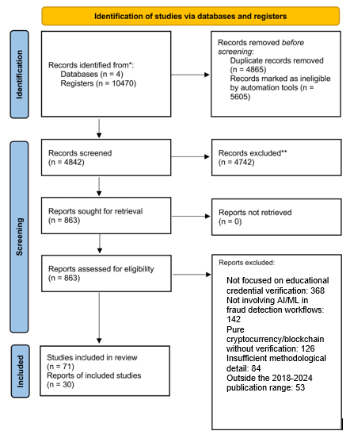
Figure 2.1: PRISMA Flow Diagram

2.3.4 Data Extraction and Synthesis
Evidence was extracted into standardised tables capturing authors, origin, methodology, key challenges, and principal findings. Table 2.2 presents the ten studies most directly relevant to the CertifyChain system design and architecture. The remaining studies read in full contributed to the broader background understanding of blockchain performance benchmarks, smart contract security patterns, AI model selection, and developing-country digital infrastructure constraints; these are referenced at the specific points in Sections 2.4 to 2.7 where their findings are drawn upon. Together with the two foundational references cited in Chapter 1 (Garwe, 2015; Mhlanga, 2020), the dissertation draws on twenty-five sources in its analysis, including seminal blockchain and deep learning works that contextualise the technical design decisions made throughout this study.

Table 2.2: Summary of Key Studies and Findings
Authors and Year | Origin | Methodology | Key Challenges | Findings
Garwe (2015) | Zimbabwe | Mixed methods across 15 universities and ZIMCHE | Widespread qualification fraud driven by unemployment | Credential fraud confirmed across all registered universities; credentialism is a primary driver.
Saleh, Ghazali, & Rana (2020). | Malaysia/Iraq | Blockchain framework design using Hyperledger Fabric | Trust, privacy, and confidentiality requirements | Five security themes identified: authentication, authorisation, confidentiality, privacy, and ownership.
Ayub Khan et al. (2021). | Pakistan | Hyperledger Fabric deployment for HEC degree attestation | Inter-institutional trust; traceability | Permissioned blockchain provides secure, traceable degree attestation across institutions.
Qazi, Zia, & Almorjan (2022). | Saudi Arabia | ResNet50v2 deep learning on CASIA datasets | Detecting splicing and copy-move tampering | Transfer learning achieves strong forgery detection on benchmark datasets.
Nizamuddin et al. (2019) | UAE | Ethereum + IPFS hybrid with cost analysis | On-chain storage costs for full documents | IPFS off-chain storage with on-chain hashes significantly reduces costs.
Said et al. (2023). | Tanzania | Blockchain conceptual model for certificate verification | Centralised databases; single points of failure | The blockchain model addresses verification challenges specific to East African institutions.
Bae (2025) | South Korea | Edge-attention CNN for document forgery | Micro-forgeries at text boundaries | Edge-focused layers detect subtle manipulations missed by standard CNN architectures.
Franklin, Shamala, & Sree (2025). | India | Ethereum certificate system with throughput benchmarks | Transaction performance and scalability | Private Ethereum deployments achieve cost-effective authentication with measurable throughput.
Baldi et al. (2019). | Italy | Cryptographic security evaluation of public ledger certificates | Identity spoofing risks | Enhanced digital signatures with blockchain improve certificate integrity.
Blockcerts / MIT (2016-2017) | USA | Open-source pilot with 111 graduates | Institutional adoption; technical capacity | First open standard for blockchain credentials; demonstrated recipient-owned digital diplomas.

2.4 Blockchain-Based Educational Verification Systems
Blockchain technology has gained significant research interest as a basis for secure, tamper-proof credential management. Its appeal is clear: once a record is added to a blockchain, it cannot be modified without network approval, providing an inherent resistance to tampering that a centralized database cannot offer.

2.4.1 Blockchain-Based Verification Systems
A smart contract is a self-executing program stored permanently on the blockchain. Once deployed, its rules are enforced automatically and cannot be overridden by any single party — not even the institution that created it. In the context of academic certificate verification, a smart contract defines the rules for who may issue certificates (authorised institutional wallets only), what constitutes a valid certificate record (a unique hash, institution identifier, and status field), and how a certificate's status may be changed (revocation is permitted; deletion is not). Because these rules exist on a public, distributed network, any verifier worldwide can independently confirm that a verification result was produced by unmodified logic rather than by a potentially compromised central server. Ethereum has become the leading platform for academic credential systems because of its advanced smart contract ecosystem, wide range of developer tools, and support for complex verification processes. A blockchain-based framework for certificate verification built on Hyperledger Fabric identified five key security themes that any such system must address: authentication (verifying user identity), authorization (ensuring only allowed actions are performed), confidentiality (protecting sensitive data), privacy (controlling data exposure), and ownership (determining who controls the credential). This framework offered a helpful conceptual basis, though it was not developed as a functional prototype (Saleh, Ghazali, and Rana, 2020).
An educational blockchain system developed for the Pakistan Higher Education Commission using Hyperledger Fabric went further by offering complete traceability of the degree attestation process, from issuance by the university through endorsement by the HEC to verification by employers. The selection of a permissioned blockchain was intentional: it addressed privacy concerns raised by public blockchains like Ethereum when managing student data, while still providing the immutability and auditability that make blockchain appealing for credential management (Ayub Khan et al., 2021).
Recently, a decentralized certificate issuance and verification system built on Ethereum, focused on measuring throughput and transaction costs, demonstrated that Ethereum-based private deployments can handle transaction volumes typical of a medium-sized university at low cost. However, deploying on mainnet would require Layer 2 solutions to manage gas fees (Franklin, Shamala, and Sree, 2025).

2.4.2 Blockcerts (MIT)
The Blockcerts project is notable as the first widely recognized open standard for blockchain-based academic credentials. Developed at the MIT Media Lab by Philipp Schmidt and collaborators starting in 2015, Blockcerts was officially released in 2016 and piloted in 2017, when 111 MIT graduates had the option to receive their diplomas as blockchain-anchored digital records on their smartphones.
The system creates a cryptographic hash of the certificate data and records it on the Bitcoin (or Ethereum) blockchain, while the full certificate file is stored off-chain. The recipient receives the certificate in a mobile wallet app and can share it with anyone, who can then independently verify it by checking the blockchain record. This model gives the recipient full ownership and portability of their credentials, independent of the issuing institution.
Blockcerts has since been adopted by Malta’s Ministry of Education, the Caribbean Examinations Council, and several universities worldwide. However, it faces notable limitations in the Zimbabwean context: it lacks a built-in mechanism to detect whether an uploaded certificate image has been tampered with before hashing, does not support verifying scanned legacy paper certificates, and relies on public blockchain transaction fees, which make it costly for institutions operating under tight budgets.

2.4.3 IPFS Integration and Off-Chain Storage
A common technical issue in blockchain credential systems is storage. Storing entire certificate files on-chain is very expensive; on Ethereum, even a small PDF can cost hundreds of dollars in gas fees. The usual solution is to keep the file off-chain and only record a cryptographic hash on the blockchain. If the file is later changed, the hash will no longer match, making tampering detectable. The InterPlanetary File System (IPFS) has become the preferred off-chain storage option for blockchain systems because of its content-addressing model. Each file stored on IPFS is identified by a Content Identifier (CID) a cryptographic hash computed from the file's contents. Unlike a traditional URL, which identifies a file by its server location (which can be changed or taken offline), a CID identifies a file by what it contains. If the file is moved to a different server or IPFS node, its CID remains the same. If the file is modified even by a single character, its CID changes entirely. This property means that recording a certificate's CID on the blockchain creates an implicit integrity guarantee: any future modification of the stored PDF would produce a different CID, and the mismatch between the stored on-chain CID and the recalculated CID would immediately reveal the tampering. Using Ethereum smart contracts with IPFS storage significantly lowers deployment costs while maintaining the security benefits that make blockchain valuable; recording the IPFS CID on-chain creates a verifiable link between the blockchain record and the stored document (Nizamuddin et al., 2019). The CertifyChain system adopts this same hybrid approach, using Pinata as a managed IPFS pinning service to ensure that certificate files remain available and are not garbage-collected from the IPFS network over time.

2.5 AI and Deep Learning for Fraud Detection
While blockchain provides tamper-proof storage, it does not verify whether a document was authentic when it was uploaded. This is where AI-based fraud detection becomes crucial.

2.5.1 Convolutional Neural Networks for Image Forgery
The most relevant work for this study developed a deep learning-based forgery detection system using the ResNet50v2 architecture. ResNet50v2 is a 50-layer residual network that employs pre-activation batch normalization, which enhances gradient flow during training and enables the network to learn more discriminative features. The architecture was improved through transfer learning by initializing the network with weights pre-trained on ImageNet, allowing it to utilize visual features learned from a much larger dataset (Qazi, Zia, and Almorjan, 2022).
They tested their system on the CASIA v1 and v2 benchmark datasets, which include thousands of original and tampered images created using splicing (pasting a region from one image into another) and copy-move (duplicating a region within the same image) techniques. The results demonstrated strong detection accuracy, with the transfer learning approach clearly outperforming training from scratch. This finding is directly relevant to the CertifyChain system, which uses the same ResNet50v2 architecture and transfer learning approach for its fraud detection module.

2.5.2 Ensemble and Hybrid AI Models
Single-model approaches to forgery detection are effective but can be fragile. Subtle manipulations outside the training distribution may go unnoticed, and adversarial attacks can target the specific weaknesses of a given architecture. Combining a deep learning feature extractor with a traditional machine learning classifier enhances robustness by analysing extracted features from a mathematically different perspective.
XGBoost (eXtreme Gradient Boosting) is a gradient-boosted decision tree algorithm. A single decision tree is a simple flowchart it asks a series of yes/no questions about the input features and follows a path to a prediction. A single tree is too simple and makes systematic errors. XGBoost addresses this by building trees sequentially, where each new tree is trained specifically to correct the prediction errors made by all previous trees. The final prediction is the weighted sum of all trees' outputs. This sequential error-correction process, combined with regularisation parameters that penalise overly complex trees, makes XGBoost highly effective for tabular feature data even with small training sets. It is especially well-suited to the CertifyChain pipeline because it receives a 2,053-dimensional feature vector as input and must learn a non-linear decision boundary between authentic and forged certificates from only 84 training samples.
Table 2.3 compares XGBoost against the alternative classifiers considered for this role in the pipeline.
Classifier | Strength | Weakness for this task | Decision
Logistic Regression | Simple, interpretable, fast | Assumes a linear decision boundary; certificate forgery patterns are non-linear | Rejected
Support Vector Machine (SVM) | Effective on high-dimensional data | Slow to train and tune on 2,053 features; no native feature importance | Rejected
Random Forest | Robust, good baseline, handles noise | No sequential error correction; each tree trained independently on bootstrapped data | Considered but not selected
XGBoost | Sequential error correction, built-in regularisation, feature importance, fast on tabular data | Requires hyperparameter tuning | Selected

2.5.3 Document-Specific Forgery Detection
Academic certificates pose unique challenges for forgery detection compared to natural photographs. Certificates are highly structured documents with predictable layouts, specific fonts, institutional logos, signatures, and security features like watermarks and holographic elements. Manipulations often occur locally at text boundaries, signature areas, or where dates and grades are shown.
An edge-focused detection method directly tackles this challenge using two specialized layers: an Edge Attention (EA) layer that identifies feature channels most responsive to edge information, and an Edge Concatenation (EC) layer that combines edge features with standard convolutional features. This method improved the detection of micro-forgeries, which are subtle, localized manipulations characteristic of certificate fraud (Bae, 2025). These insights influenced the preprocessing pipeline of the CertifyChain AI module, which incorporates edge enhancement into its image preparation steps.

2.6 Integrated Blockchain-AI Systems
The integration of blockchain and AI for credential verification is a new and rarely explored area in the literature. Although both technologies are well-developed individually, combining them into a unified workflow raises questions about architecture, performance, and governance that few researchers have examined. The main architectural question is where AI analysis fits within the credential lifecycle. There are two primary approaches: pre-anchoring analysis, where AI evaluates a certificate before it is hashed and recorded on the blockchain, and post-anchoring analysis, where AI examines a certificate after it has been stored on the blockchain. Pre-anchoring analysis prevents fraudulent certificates from entering the blockchain, thus maintaining the integrity of the on-chain record (Saleh, Ghazali and Rana, 2020; Franklin, Shamala and Sree, 2025). Post-anchoring analysis is useful for verifiers who receive physical certificates and want to verify both their visual authenticity and blockchain registration. CertifyChain uses both methods: the issuance wizard includes AI analysis as a preliminary step, and the public verification interface offers AI analysis as an additional option for users uploading certificate images. This dual setup ensures comprehensive coverage during both issuance and verification. A related challenge is integrating oracles, which determine how AI results are communicated to the smart contract. In a fully on-chain model, the AI would act as an oracle, sending analysis results directly to the smart contract, which could then automatically reject fraudulent certificates. However, running deep learning inference on-chain is currently impractical due to blockchain limitations (Nizamuddin et al., 2019). Therefore, CertifyChain keeps AI analysis off-chain via the backend API, with the smart contract handling only deterministic, hash-based verification logic. This separation reflects current practical realities while allowing room for future integration as blockchain computing capabilities improve. Privacy is another key concern when combining blockchain and AI. Blockchain records are typically public or semi-public, depending on the network type, while certificate images may contain sensitive personal information. The CertifyChain architecture addresses this by never storing certificate images or personal data on-chain. Only cryptographic hashes and non-identifying metadata, such as certificate number, status, and timestamp, are stored on the blockchain, while full certificate files are stored on IPFS with restricted access. AI analysis occurs within the backend API and does not save any image data beyond the session. The absence of published end-to-end blockchain-AI verification prototypes confirms the novelty of the CertifyChain contribution. Saleh, Ghazali and Rana (2020) and Ayub Khan et al. (2021) explore blockchain security architectures without AI integration. Qazi, Zia and Almorjan (2022) and Bae (2025) demonstrate effective AI forgery detection without blockchain anchoring. Franklin, Shamala and Sree (2025) address blockchain performance but not document authenticity. No reviewed study connects AI analysis directly to a blockchain issuance workflow in a working prototype, confirming that the integration gap identified in §2.9 remains open in the published literature.

2.7 Performance and Security Analysis
Across the studies reviewed, several consistent findings emerge regarding the performance and security characteristics of blockchain-based verification systems compared to traditional approaches.

2.7.1 Security Findings
Traditional centralized certificate databases are vulnerable to various attacks, including credential tampering (modifying stored records), insider forgery (corrupt officials creating fake entries), and database compromise (external attackers gaining access to the central database). Blockchain-based systems address all three vulnerabilities through their core properties: immutability prevents tampering, distributed consensus blocks unilateral insider actions, and the absence of a central data store removes the single point of failure (Said et al., 2023).
That said, blockchain introduces its own security concerns. Public blockchains like Ethereum are theoretically vulnerable to 51% attacks, although executing such an attack on a well-established network is usually too expensive. Once smart contracts are deployed, they cannot be easily fixed, making security audits before deployment essential. Stronger digital signatures and formal verification are critical for securing smart contracts, especially in developing countries where advanced security expertise might be limited (Baldi et al., 2019).

2.7.2 Performance Findings
The performance advantage of blockchain-AI systems over traditional verification is remarkable. Manual verification processes usually take 24 to 48 hours or more, depending on institutional responsiveness. Blockchain-based verification, on the other hand, provides results within seconds because it only requires a hash lookup on the distributed ledger. Transaction throughput tests on an Ethereum-based system showed that private deployments can manage the verification volumes of medium-sized institutions without any slowdown (Franklin, Shamala, and Sree, 2025). On the AI side, inference times for deep learning models like ResNet50v2 are comfortably within the range needed for real-time verification. Images can be processed quickly enough to fit into interactive verification workflows (Qazi, Zia, and Almorjan, 2022). When combined with blockchain verification in a parallel dual-path setup (as CertifyChain does), the total verification time stays under a few seconds, marking a reduction of several orders of magnitude compared to manual methods.
Table 2.3 provides a comparative overview of the five similar systems reviewed against the proposed CertifyChain platform.
Table 2.3: Comparative Analysis of CertifyChain with Existing Solutions
Feature | Blockcerts | Digitary | NSC (US) | CHSI (China) | TrueProfile | CertifyChain
Blockchain | Yes (BTC/ETH) | No | No | Pilot only | Yes (ETH) | Yes (ETH)
AI Fraud Detection | No | No | No | No | No | Yes (Custom AI model)
Verification Speed | Minutes | Minutes | Hours-Days | Hours | Hours | Seconds
Decentralised Storage | No | No | No | No | No | Yes (IPFS)
Multi-Tenancy | No | Yes | N/A | N/A | No | Yes
Cost per Verification | Medium | High | Medium | Low | Very High | Low (view calls free)
Developing Country Focus | No | No | No | No | No | Yes (Zimbabwe)
Open Source | Yes | No | No | No | No | Yes

2.8 Review of Similar Systems
To position the CertifyChain system within the broader landscape, this section examines five existing verification systems, evaluating their technologies, strengths, and limitations.

2.8.1 Blockcerts (MIT Media Lab)
Technology: Open standard for blockchain-based credentials on Bitcoin/Ethereum. Certificates stored as hashed records on-chain with recipient-owned mobile wallet.
Strengths: First global open standard; cryptographically secure; vendor-neutral; adopted by Malta, the Caribbean Examinations Council, and multiple universities. Recipient ownership means graduates control their own records.
Limitations: No built-in image forgery detection; cannot process scanned legacy certificates; public blockchain transaction costs; requires institutions to have technical capacity for digital issuance; not designed for resource-constrained environments.
Relevance: CertifyChain builds on the Blockcerts model, adding AI-based forgery detection, and is designed specifically to address the infrastructure constraints of African institutions.

2.8.2 Digitary (Ireland)
Technology: Cloud-based credential management platform using digital signatures without blockchain technology.
Strengths: Over 2,000 institutional clients; GDPR-compliant; well-designed interface for students, institutions, and employers; supports sharing of verified credentials.
Limitations: Centralised architecture creates a single point of failure; no immutability guarantee (it depends on trust in the service provider); high adoption cost; no AI-based fraud detection; and limited adoption in Africa.
Relevance: CertifyChain’s blockchain backbone eliminates reliance on a single provider, and its AI module addresses the forgery-detection gap.

2.8.3 National Student Clearinghouse (United States)
Technology: Centralised database system that verifies student enrolment and degrees on behalf of US universities.
Strengths: Highly trusted within the US; automated verification services; integrated with institutional student information systems; handles millions of verifications annually.
Limitations: Fully centralised and vulnerable to database breaches; no immutable records; verifies data validity only, not document authenticity; entirely dependent on US digital infrastructure and therefore not portable to developing countries.
Relevance: CertifyChain decentralises trust using blockchain, making it suitable for contexts where no single trusted authority exists, and adds document-level fraud detection that the NSC lacks.

2.8.4 CHESICC/CHSI (China)
Technology: Government-run centralised database with recent blockchain pilot projects in selected provinces.
Strengths: Enormous scale (over 50 million verifications annually); authoritative government backing; blockchain pilots show promise for faster verification.
Limitations: Not interoperable internationally; blockchain adoption is limited to pilot provinces; no integration with AI document forensics; governance model is not transferable to countries without similar centralised authority.
Relevance: CHSI demonstrates that blockchain-based verification can work at a national scale; CertifyChain extends this by adding AI forgery detection and designing for cross-institutional deployment without central government control.

2.8.5 TrueProfile.io / DataFlow Group
Technology: Blockchain-backed verification service using Ethereum hashes, primarily for healthcare professional credentials in the Gulf region.
Strengths: Blockchain provides tamper-proof records, international adoption, and robust identity verification.
Limitations: Very expensive (USD 50-200 per verification); focused on professional licensing rather than academic degrees; does not verify scanned documents for image manipulation; cost makes it inaccessible for students and institutions in low-income countries.
Relevance: CertifyChain provides a cost-effective, education-specific alternative with AI-based image analysis before blockchain anchoring.

2.9 Research Gap
The review of existing literature and systems reveals five critical gaps that this study aims to address:
1. Limited Integration: Most researchers have treated blockchain and AI as separate concerns. Blockchain security themes have been explored without considering AI integration (Saleh, Ghazali, and Rana, 2020), while effective forgery-detection models have been developed without exploring how they might be integrated into a blockchain issuance or verification workflow (Qazi, Zia, and Almorjan, 2022). The few studies that attempt both remain at the conceptual level without working prototypes or empirical performance data. There is no published study demonstrating a complete, end-to-end pipeline in which AI analysis feeds directly into a blockchain-based credential lifecycle.
2. Developing Country Context: Nearly all blockchain credential systems have been designed for institutions in Europe, North America, or East Asia, environments with reliable high-speed internet, stable electricity, and populations with strong digital literacy. Sub-Saharan Africa presents a fundamentally different operating context. In Zimbabwe, internet connectivity remains inconsistent, load shedding regularly interrupts power, and many institutional staff have limited experience with blockchain or AI technologies. How existing systems perform under these constraints is largely untested, and the few African-focused studies remain conceptual models rather than fully implemented (Said et al., 2023).
3. No Unified Standard: Each research group has developed its own integration architecture, making cross-system interoperability impossible. Blockcerts follows one model; another, permissioned approach follows a different path (Ayub Khan et al., 2021); and commercial solutions like TrueProfile.io follow yet another. Without shared architectural patterns or protocols, institutions adopting one system cannot verify credentials issued by another, which defeats the purpose of a universal verification infrastructure.
4. Forgery Detection Gap: This is the most critical vulnerability. Blockchain platforms like Blockcerts guarantee that a credential has not been altered after it was anchored. However, they have no mechanism to determine whether the credential was genuine when it was first uploaded. A forger who creates a convincing fake can upload it, have it hashed and recorded on the blockchain, and it will then be permanently "verified" with an immutable record and a valid QR code. Without AI analysis at the point of issuance, blockchain verification creates a dangerous false sense of security that may actually make fraud harder to challenge once it has been anchored.
5. Cost and Scalability: Very little research examines the full operational cost of running a blockchain-AI verification system, particularly in resource-constrained environments. Ethereum mainnet gas fees can be prohibitive for high-volume issuance. Off-chain storage is essential for cost reduction, but no study has modelled the complete cost of a production deployment, including hosting, IPFS pinning, AI inference, and ongoing smart contract interaction (Nizamuddin et al., 2019). For Zimbabwean institutions operating on tight budgets, this absence of cost analysis is a major barrier to adoption.

2.10 Proposed Solution
Based on these identified gaps, this study developed the CertifyChain platform: an integrated blockchain-AI academic certificate verification system designed specifically for developing country contexts, with Zimbabwe as the primary case study.
The system architecture is organised into four distinct layers, each addressing a specific concern:
Blockchain Layer: An Ethereum smart contract deployed on the Sepolia testnet handles all on-chain operations: certificate issuance (recording hashes with metadata), batch issuance (up to 50 certificates per transaction for gas efficiency), verification (checking hash existence and status), revocation (permanently changing a certificate’s status from Valid to Revoked), and institution management (authorising and deauthorising institutional wallet addresses). The contract uses tightly packed struct storage (bytes16 for identifiers, uint8 for status) to minimise gas consumption.
Storage Layer: Certificate PDF files are uploaded to IPFS via the Pinata-managed pinning service, which returns a content-addressed CID (Content Identifier). This CID is recorded both on-chain in the smart contract and off-chain in the backend database, creating a verifiable link between the blockchain record and the stored document. Because IPFS uses content-addressing, any modification to the file would produce a different CID, making tampering immediately detectable.
Backend Layer: A .NET 10 API following Clean Architecture principles (separate Api, Core, and Data projects) provides the business logic, data access, and integration endpoints. Entity Framework Core 10 with SQL Server implements a relational data model, with global query filters that provide transparent multi-tenancy, isolating each institution’s data. JWT authentication with refresh token rotation secures all API endpoints, and a bitwise permission model with six roles and over thirty granular permissions ensures fine-grained access control.
AI Layer: The fraud detection engine uses a two-stage architecture. A custom deep learning model analyzes certificate images for signs of visual tampering, including splicing, copy-move manipulation, font inconsistencies, and signature alteration, producing a fraud confidence score that is returned to the calling application.
Three frontend applications serve different stakeholders: an Angular 21 administrative web application for institutional staff (certificate issuance, student management, dashboards), a Next.js 16 public verification website for external verifiers (hash-based and QR-code-based verification), and a Flutter mobile application for students and employers (QR scanning, certificate sharing, verification history).
This architecture addresses each identified gap directly. The integration gap is closed by connecting AI analysis to the blockchain issuance workflow in a single pipeline. The developing country gap is addressed through gas-optimised contracts, open-source tooling, and multi-platform interfaces. The standardisation gap is mitigated by adhering to consistent architectural patterns (Clean Architecture, REST APIs, and Ethereum standards). The forgery-detection gap is addressed by running AI analysis before blockchain anchoring. The cost gap is managed through batch transactions, IPFS off-chain storage, and free verification via Solidity view functions.

2.11 Conclusion
This chapter reviewed the current state of blockchain-based educational verification and AI-driven fraud detection through a systematic literature review following PRISMA guidelines. From an initial pool of 10,470 records across four databases, 71 studies met all inclusion criteria, of which 30 were analysed in depth. The review found that while both technologies have matured significantly, their integration remains underexplored, particularly in developing country contexts. Existing systems such as Blockcerts, Digitary, and the National Student Clearinghouse each address part of the problem, but none combine blockchain immutability with AI-based forgery detection in a cost-effective manner suitable for African institutions. These gaps provide both the motivation and the theoretical foundation for the CertifyChain system.

CHAPTER 3: METHODOLOGY

3.1 Introduction
This chapter describes the methodological framework that guided both the research process and the software development of the CertifyChain platform. It covers the research methodology (Design Science Research), the software development approach (Evolutionary Prototyping), the tools and frameworks selected for each component, and the data collection and test case construction strategies. Each methodological choice is justified with reference to alternatives that were considered and the specific reasons they were not adopted.

3.2 Research Methodology

3.2.1 Alternative Research Methodologies Considered
Action Research is a participatory methodology in which the researcher collaborates with practitioners in iterative cycles of planning, action, and reflection. It works well for problems where the researcher has direct access to the operational environment and can implement changes in real time. However, its contextual focus can limit the generalisability of findings, and it does not provide a structured framework for creating and evaluating software artifacts. Because this study aimed to produce a deployable system rather than to study an existing process, Action Research was not a natural fit.
Case Study Research involves an in-depth analysis of one or a few specific instances to understand complex phenomena in their real-world context. While case studies are valuable for evaluating deployed systems and understanding user behaviour, they do not prescribe a process for creating new artifacts. Since the primary goal of this study was to build a blockchain-AI verification system from scratch, rather than to analyse an existing one, Case Study Research was set aside in favour of a methodology that explicitly guides artifact creation.

3.2.2 Chosen Methodology: Design Science Research
Design Science Research (DSR) was selected as the overarching research methodology because it is specifically designed for studies whose primary output is a new artifact, whether a software system, model, method, or architecture. DSR treats the artifact itself as the central contribution and provides a structured process for designing, building, demonstrating, and evaluating it.
Three characteristics of DSR made it particularly appropriate for this study. First, it directly addresses the gap between theory and practice: the theoretical insights from the literature (blockchain immutability, AI-based image forensics, transfer learning) are translated into a concrete, working system that can be tested and evaluated. Second, it is inherently iterative: the design-build-evaluate cycle encourages continuous refinement based on testing results, which was essential given the complexity of integrating blockchain and AI components. Third, it emphasises rigorous evaluation against objective metrics, which aligns with the study’s objectives of measuring fraud detection accuracy, transaction efficiency, and system security.

3.2.3 Design Science Research Framework
The study followed the six-step DSR process model (Peffers et al., 2007):
Step 1 – Problem Identification: The rise of academic certificate fraud in Zimbabwe and the absence of an integrated blockchain-AI verification system for developing-country contexts (Garwe, 2015), as identified in the literature review.
Step 2 – Define Objectives: A secure, scalable, and cost-effective system that combines blockchain-based tamper-proof storage with AI-based visual fraud detection, deployable in resource-constrained environments.
Step 3 – Design and Development: The CertifyChain platform, built using Ethereum smart contracts, IPFS via Pinata, a .NET 10 backend API, a custom deep learning model for AI fraud detection, and three frontend applications (Angular 21; Next.js 16, Flutter).
Step 4 – Demonstration: A working prototype deployed on the Ethereum Sepolia testnet, demonstrating the complete certificate lifecycle from issuance through verification to revocation.
Step 5 – Evaluation: Performance measurement including smart contract gas consumption, API response times, verification accuracy, unit test results (76 tests), and functional test results (20 test cases).
Step 6 – Communication: This dissertation and the associated academic presentation.

3.3 Software Development Methodology

3.3.1 Alternative Methodologies Considered
Waterfall follows a strict, sequential process where requirements, design, implementation, testing, and deployment happen as separate, non-overlapping phases. This method works well for projects with stable, well-understood requirements. However, this project faced significant uncertainty, especially regarding blockchain integration, smart contract gas optimization, and AI model tuning. A rigid, step-by-step process would have made it difficult to incorporate lessons learned during development into the design. Therefore, Waterfall was rejected.
Scrum is an agile framework organized around time-boxed sprints, with three defined roles: Product Owner (who manages the backlog), Scrum Master (who facilitates the process), and Development Team (who builds the product). Scrum is highly effective for multi-person teams but is not designed for solo developers. Since a single developer undertook this project, the role separation that Scrum requires would have been artificial and unproductive. Therefore, Scrum was rejected.
Kanban uses a visual board to manage workflow, with tasks moving through columns representing different stages. While Kanban is flexible and can be used by individuals, it lacks the structured iteration cycles that are needed to manage the progressive integration of blockchain, AI, and frontend components. Kanban was considered but ultimately passed over in favour of a more structured approach.

3.3.2 Chosen Methodology: Evolutionary Prototyping
Evolutionary Prototyping was selected because it addresses the specific constraints and requirements of this project better than any of the alternatives considered.
The core idea of Evolutionary Prototyping is simple: build a working prototype as early as possible, then iteratively refine and extend it until it meets all requirements. Unlike throwaway prototyping, where prototypes are discarded after learning from them, evolutionary prototypes are progressively improved and eventually become the final system. This approach has several advantages for a solo developer working on a complex, multi-component system:
Early risk identification: By building working prototypes of the riskiest components first (in this case, the blockchain integration and AI model training), technical risks were identified and resolved before they could cascade into later development stages.
Continuous feedback: Each prototype produced a working system that could be tested, evaluated, and demonstrated, yielding concrete feedback to guide the next iteration.
Natural alignment with DSR: Each prototype iteration maps directly to the DSR design-build-evaluate cycle, ensuring that the software development and research processes remain in sync.
No artificial role separation: Unlike Scrum, Evolutionary Prototyping does not require multiple roles, making it practical for a solo Honours project.

3.3.3 Prototype Iterations
Prototype 1 – Foundation (Weeks 1-3): Set up the .NET 10 backend API with Clean Architecture (separate Api, Core, and Data projects), configured Entity Framework Core 10 with SQL Server using Code-First migrations, implemented JWT authentication with refresh token rotation, and built the bitwise role-based access control system with six roles and over thirty granular permissions.
Prototype 2 – Blockchain Layer (Weeks 4-6): Developed the CertificateVerification smart contract in Solidity 0.8. x using Remix IDE, deployed it to the Ethereum Sepolia testnet, integrated MetaMask for wallet management and transaction signing, and connected IPFS via Pinata for off-chain certificate file storage. Gas optimisation through structured packing was implemented during this phase.
Prototype 3 – AI Fraud Detection (Weeks 7–9): Assembled a synthetic dataset of 120 certificate images (60 authentic, 60 forged) using image editing techniques. Trained the two-stage fraud detection pipeline: frozen ResNet50V2 extracts 2,048-dimensional feature vectors, which are concatenated with five handcrafted forensic features to produce a 2,053-dimensional input for XGBoost. The dataset was partitioned 70/15/15 (train/validation/test). XGBoost training used early stopping (patience 20 rounds) and terminated at round 87 of the maximum 200, achieving a best validation log loss of 0.031. Connected the AI module to the backend API as the FraudDetectionService, exposed via the /api/fraud-detection endpoint.
Prototype 4 – Frontend Applications (Weeks 10-12): Built the Angular 21 admin web application with the four-step certificate issuance wizard, PrimeNG UI components, and MetaMask integration. Developed the Next.js 16 public verification website with server-side rendering and the certificate hash verification interface. Created the Flutter mobile application with QR code scanning and verification history.
Prototype 5 – Integration and Testing (Weeks 13-14): Connected all components end-to-end, conducted 76 unit tests using xUnit and Moq for dependency mocking, executed 20 functional test cases covering the complete verification workflow, and performed smart contract testing on the Sepolia testnet.
Prototype 6 – Optimisation and Documentation (Week 15): Optimised smart contract gas consumption through batch issuance support (up to 50 certificates per transaction), refined multi-tenancy global query filters, and prepared the final documentation and demonstration materials.

3.4 Link Between Research and Software Methodologies
Design Science Research and Evolutionary Prototyping complement each other naturally. DSR provides the what and why: it defines the problem, sets the objectives, specifies the evaluation criteria, and ensures that the research makes a genuine contribution to knowledge. Evolutionary Prototyping provides the how: it organises the actual software development into a sequence of working prototypes, each of which can be demonstrated and evaluated as required by the DSR framework. Together, they ensured that every line of code written served a clear research purpose, and every research claim could be backed by concrete, testable system behaviour.

3.5 System Workflow Overview
The CertifyChain verification workflow follows a clear sequence that integrates all system components. When a certificate is submitted for verification, the process works as follows:
The user uploads a certificate image or enters a certificate hash through one of the three frontend interfaces (mobile app, admin web app, or public website). If an image is uploaded, it is first processed by the AI fraud detection module. The custom deep learning model analyzes the image for signs of visual tampering, such as splicing, copy-move manipulation, font inconsistencies, and signature changes, producing a fraud confidence score.
The fraud detection module returns a confidence score between 0 and 100 per cent, where higher values indicate greater likelihood of forgery. A certificate is flagged as potentially forged when this score exceeds 70 per cent a threshold validated empirically during testing, as demonstrated in functional test cases TC13 (forged certificate, score = 89.3%) and TC14 (authentic certificate, score = 8.2%). When the threshold is exceeded, the system presents a warning to the user alongside the numerical confidence score and recommends human review before proceeding. If the score falls below 70 per cent, the certificate proceeds to the blockchain hash verification stage. The 70 per cent threshold was chosen to balance sensitivity (catching forgeries) against specificity (avoiding false alarms on genuine certificates); threshold optimisation is identified as a recommendation for future work in Section 6.5. If the certificate passes the AI analysis, the system computes the SHA-256 hash of the certificate file on the client side. This hash acts as a unique identifier that links the physical document to its blockchain record.
The hash is used to query the Ethereum smart contract and the backend API simultaneously. The smart contract check verifies whether the hash exists on the blockchain and returns its status (Valid, Revoked, or Not Found). The backend API query supplies additional metadata from the relational database, including the issuing institution, student details, award date, and IPFS CID for the original file.
This dual-path verification approach offers a key reliability advantage: if the backend API is temporarily unavailable, the blockchain query still works independently, and vice versa. The combined results from both paths are presented to the user, providing a comprehensive verification outcome that includes blockchain confirmation, backend metadata, IPFS file availability, and, where applicable, the AI fraud detection assessment.
For issuing certificates, the workflow starts in the Angular admin app. The registrar uses a four-step wizard: selecting the student, entering certificate details, uploading the PDF (which triggers SHA-256 hashing and IPFS upload via Pinata), and submitting the transaction through MetaMask. The smart contract validates the caller’s wallet against the authorized institution, checks for duplicate hashes, and records the certificate with a Valid status. The backend database then updates with the full certificate record, and a QR code encoding the verification URL is generated automatically.

3.6 Tools, Algorithms, and Frameworks

3.6.1 Blockchain Development Tools
Table 3.1: Blockchain Development Tools
Tool | Purpose | Justification
Ethereum (Sepolia Testnet) | Smart contract platform | Mature ecosystem, public verifiability, strong developer community, compatible with Solidity. Chosen over Hyperledger Fabric (permissioned, less suitable for public verification) and Tezos (limited tooling).
Solidity 0.8.x | Smart contract language | Native to Ethereum Virtual Machine; supports complex certificate lifecycle logic (issuance, verification, revocation, batch operations).
Remix IDE | Development and testing | Browser-based IDE with built-in debugging, contract compilation, and direct MetaMask integration for deployment.
MetaMask | Wallet and transactions | Browser extension for secure blockchain interaction; simplifies smart contract deployment and transaction signing by institutional users.
IPFS via Pinata | Decentralised file storage | Content-addressed storage ensures any file modification produces a different CID; Pinata provides managed pinning to prevent file loss from IPFS garbage collection.

3.6.2 AI and Machine Learning Tools
Table 3.2: AI Development Tools and Models
Tool / Model | Purpose | Justification
TensorFlow / Keras | Deep learning framework | GPU acceleration, mature image classification libraries, high-level API for model definition and training.
ResNet50v2 | Visual forgery detection | 50-layer residual network with pre-activation batch normalisation; strong performance on CASIA benchmarks for splicing and copy-move detection (Qazi et al., 2022). Transfer learning reduces training time.
XGBoost | Secondary classifier | Gradient boosting on features from ResNet50v2 penultimate layer; detects subtle patterns in feature vectors that the CNN alone might miss.
Scikit-learn | Evaluation utilities | Confusion matrices, precision/recall/F1 computation, train-test splitting, and preprocessing utilities.
Google Colaboratory (Colab) | Model training environment | Free cloud-based Jupyter notebook environment providing GPU acceleration (NVIDIA T4) for ResNet50V2 feature extraction and XGBoost training. Selected because local hardware lacked sufficient GPU memory for batch inference over the full dataset, and Colab eliminated compute licensing costs within the project budget.

3.6.3 Backend and Frontend Development Tools
Table 3.3: System Development Tools
Tool | Purpose | Justification
.NET 10 / C# 13 | Backend API | High performance, Clean Architecture support, built-in dependency injection, strong security for JWT auth and cryptographic operations. Chosen over Node.js for type safety and enterprise structure.
SQL Server (EF Core 10) | Relational database | ACID compliance, strong .NET integration, global query filters for transparent multi-tenancy, Code-First migrations for schema management.
Angular 21 | Admin web application | TypeScript-based, component architecture, PrimeNG UI library, reactive forms. Chosen over React (requires more external libraries) and Vue.js (smaller enterprise adoption).
Next.js 16 | Public verification website | App Router with React Server Components, Tailwind CSS, server-side rendering for SEO and fast initial page loads.
Flutter 3.x / Dart | Mobile application | Single codebase for Android and iOS; built-in camera for QR scanning; strong widget system for consistent cross-platform UI.

3.7 Data Collection and Test Case Construction

3.7.1 AI Dataset Preparation

The AI fraud detection module required a labelled dataset of certificate images for training and evaluation. No publicly available dataset of forged academic certificates exists, owing to the sensitive and institution-specific nature of such documents. The dataset was therefore assembled synthetically, using image editing techniques to simulate the forgery methods most commonly encountered in practice.

The final dataset comprised 120 images: 60 authentic certificate samples and 60 synthetically forged samples, yielding a perfectly balanced class distribution. All images were derived from a consistent certificate template to control for layout variability and to focus the model's learning on visual manipulation artefacts rather than institutional formatting differences. While a balanced synthetic dataset does not fully replicate the diversity of real-world forgeries, it provides a controlled and reproducible environment suitable for demonstrating the approach at Honours project scale.

Forgery techniques applied to the synthetic samples included: font replacement (substituting names, grades, or dates using visually similar fonts), signature alteration (copying or scaling signatures from one document to another), seal and logo manipulation (resizing, rotating, or compositing institutional seals), background noise injection (adding scanning and compression artefacts to disguise edits), and composite splicing (combining elements from multiple certificates into a single document). These techniques were chosen because they represent the most common manipulation patterns identified in the document forgery literature (Qazi, Zia and Almorjan, 2022; Bae, 2025).

3.7.2 Handcrafted Feature Engineering

In addition to the 2,048-dimensional deep feature vector extracted from the ResNet50V2 penultimate layer, five handcrafted features were engineered to capture properties that convolutional filters trained on natural images may not explicitly encode for document forensics. These features were concatenated with the CNN output to produce a 2,053-dimensional input vector for the XGBoost classifier. The five features are described in Table 3.X below.

Feature | Description | Forensic Rationale
Edge density | Mean magnitude of Canny edge responses across the image, normalised by pixel count. | Forged regions created by compositing often exhibit abrupt edge discontinuities at manipulation boundaries.
Noise variance | Variance of the high-frequency residual obtained by subtracting a Gaussian-blurred version of the image from the original. | Copy-paste operations typically introduce inconsistent noise levels between the original background and inserted regions.
Brightness histogram entropy | Shannon entropy of the luminance histogram across 256 bins. | Manipulated images frequently show unnatural histogram distributions caused by gamma correction or brightness matching during compositing.
JPEG block artefact score | Mean absolute difference between adjacent 8x8 DCT block boundaries. | Re-saving a spliced image introduces double JPEG compression artefacts detectable at block boundaries.
Saturation standard deviation | Standard deviation of the HSV saturation channel across the image. | Inserted regions sourced from a different scan or print may exhibit systematically different colour saturation from the background document.

All images were resized to 224 by 224 pixels, normalised to scale pixel values to the [0, 1] range, and augmented with random rotation of up to 15 degrees, contrast adjustment, Gaussian noise injection, and horizontal blur. These augmentation techniques simulate the variability encountered when processing real-world scanned certificates photographed at slight angles, under variable lighting, or with consumer-grade scanning equipment.

The dataset was partitioned into three non-overlapping subsets: 70 per cent for training (84 images), 15 per cent for validation (18 images), and 15 per cent for testing (18 images). This three-way split ensures that the validation set, used for early stopping and hyperparameter tuning, is entirely separate from the held-out test set used for final evaluation. Using only a two-way split would contaminate the test evaluation, since any decision informed by validation performance indirectly exposes the model to test-adjacent data.

Training Configuration
The AI fraud detection pipeline follows a two-stage architecture that separates visual feature extraction from classification.
Stage 1 — Feature Extraction (ResNet50V2, Frozen)
The ResNet50V2 base model was initialised with weights pre-trained on the ImageNet dataset (over 1.2 million images across 1,000 classes) and all convolutional layers were frozen. No backpropagation was applied to the CNN. This design decision was made for two reasons: first, training a 50-layer network from scratch on 84 images would result in severe overfitting; second, the low-level visual features learned from ImageNet edge detection, texture discrimination, noise patterns are directly applicable to forensic document analysis even without domain-specific fine-tuning. The frozen ResNet50V2 acts as a deterministic feature extractor, transforming each 224×224 certificate image into a 2,048-dimensional feature vector at its penultimate global average pooling layer.
Stage 2 — Classification (XGBoost)
The 2,048 CNN features were concatenated with the 5 handcrafted features described in Section 3.7.1.1, yielding a 2,053-dimensional input vector per image. An XGBoost classifier (extreme gradient boosting) was then trained on these vectors. XGBoost was selected over end-to-end CNN fine-tuning for three reasons: it trains efficiently on tabular feature vectors with as few as 84 samples; it provides feature importance scores that aid interpretability; and it is naturally resistant to overfitting through its regularisation parameters. The XGBoost hyperparameters were configured as shown in Table 3.Y below.

Hyperparameter | Value | Rationale
n_estimators | 200 | Sets the maximum number of boosting rounds. Early stopping prevents all 200 from being used if validation loss plateaus.
max_depth | 6 | Controls individual tree complexity. Depth 6 is deep enough to capture non-linear patterns while shallow enough to limit overfitting on 84 training samples.
learning_rate | 0.05 | Small step size ensures gradual, stable convergence. Paired with a large n_estimators budget, this combination typically outperforms a high learning rate with few trees.
subsample | 0.8 | Each tree is trained on a random 80% of training rows. Row subsampling introduces variance that reduces overfitting and improves ensemble diversity.
colsample_bytree | 0.8 | Each tree considers a random 80% of the 2,053 features. Feature subsampling further reduces overfitting and prevents any single dominant feature from monopolising all trees.

Early stopping was configured with a patience of 20 rounds on the validation log loss. Training terminated at round 87 of the maximum 200, at which point the best validation log loss of 0.031 was recorded. The model weights from round 87 were retained as the final model, preventing any further overfitting that would have occurred had training continued to round 200.
A pre-training baseline was established before XGBoost training began, using the ResNet50V2 feature extractor alone with a default threshold classifier. This baseline achieved 60 per cent accuracy with a 100 per cent false negative rate, confirming that the CNN's ImageNet features provide no discriminative signal for certificate forgery without task-specific classification. This result justifies the two-stage pipeline: the CNN provides general visual representation capability; XGBoost provides the forgery-specific decision boundary.
Performance was evaluated using six metrics on the held-out 18-image test set: accuracy, precision, recall, F1-score, false positive rate, and false negative rate. The false negative rate received particular attention in the evaluation, since a missed forgery results in a fraudulent certificate receiving a permanent blockchain-anchored verification record, an irrecoverable outcome with direct real-world harm implications.

3.7.3 Blockchain Test Cases
The blockchain component is deterministic: given the same input, it will always produce the same output. This means that its validation does not require statistical evaluation but rather structured test cases covering all expected scenarios. Five categories of test cases were designed:
1. Valid certificate verification: A genuine certificate whose SHA-256 hash matches a record on the blockchain should return a status of "Valid" along with the associated metadata (issuing institution, student ID, award date, IPFS CID). This test confirms the core verification pathway.
2. Tampered certificate detection: A certificate that has been modified after issuance (even by a single pixel) will produce a different SHA-256 hash. When this altered hash is queried against the blockchain, the smart contract should return "Certificate Not Found," since the tampered hash does not exist on-chain. This test confirms the integrity guarantee.
3. Revoked certificate query: A certificate whose status has been changed from "Valid" to "Revoked" by an authorised institutional user should return a status of "Revoked" when verified, alerting the verifier that the credential is no longer considered valid.
4. Concurrent load testing: Multiple simultaneous verification requests were submitted to assess system stability and response time under load. This test was designed to simulate a scenario where multiple employers verify certificates at the same time, such as during a recruitment drive.
5. Gas consumption measurement: Transaction costs (in gas units and ETH equivalent) were recorded for each smart contract operation: single certificate issuance, batch issuance (5, 10, 25, and 50 certificates), verification, revocation, and institution authorisation. These measurements inform the cost analysis presented in Chapter 6.

3.8 Ethical Considerations
Handling academic credentials raises serious ethical obligations around data privacy, consent, and fairness. The following measures were implemented:
Data privacy: Full certificates were never stored on the blockchain. Only cryptographic hashes and non-sensitive metadata were recorded on-chain. Certificate PDF files were stored on IPFS with restricted access configurations. The relational database stores only operational metadata (user accounts, verification logs), not raw certificate content.
Consent and institutional approval: The AI training and evaluation dataset consists entirely of synthetically generated certificate images created by the researcher using open-source image editing tools; no real student certificates or institutional document files were used at any stage. This design decision eliminated the need for institutional data sharing agreements and ensured that no personal student information was processed, stored, or exposed during model development or testing.
AI bias mitigation: The training dataset was balanced between authentic and forged samples to prevent the model from developing a bias toward either class. Synthetic forgeries were generated systematically to cover a range of manipulation types, reducing the risk that the model would only detect certain kinds of tampering. Regular evaluation using precision, recall, and F1-score ensured that the model maintained consistent performance across both classes.
Intended use: The system is designed strictly for credential verification, not for surveillance, profiling, or punitive measures. All experiments were conducted in compliance with responsible use principles for AI and blockchain technologies. The AI module provides a confidence score rather than a binary verdict, leaving the final determination to human decision-makers.
Smart contract immutability: Because smart contracts cannot be easily modified after deployment, special care was taken during development to ensure that the contract logic was correct and that appropriate administrative functions (such as institution authorisation and revocation) were included. The contract was tested extensively on the Sepolia testnet before any production-like deployment.

3.9 Mapping of Tools to Research Objectives
Table 3.4 maps each research objective to the specific tools and components used to achieve it, demonstrating the coherence of the technology stack with the study’s aims.
Table 3.4: Mapping of Research Objectives to System Components
Objective | Components Used | Evaluation Method
Obj 1: Secure blockchain storage | Solidity smart contract, Ethereum Sepolia, IPFS via Pinata | Hash verification tests, gas consumption measurement
Obj 2: AI-based fraud detection | ResNet50v2, XGBoost, TensorFlow/Keras | Accuracy, precision, recall, F1-score on test set
Obj 3: Efficient certificate issuance | Angular 21 admin app, MetaMask, batch issuance | Issuance workflow testing, batch transaction gas costs
Obj 4: Instant verification | Next.js 16 website, Flutter mobile app, dual-path API | Response time measurement, functional test cases
This mapping ensures that every technology choice serves a specific research purpose and that the evaluation criteria are directly traceable to the stated objectives.

3.10 Conclusion
This chapter established the dual methodological foundation for the CertifyChain project. Design Science Research provided the structured research process of problem identification, objective definition, artifact design, demonstration, evaluation, and communication. Evolutionary Prototyping provided the practical software development approach, organising the work into six progressive prototype iterations that moved from foundational infrastructure through blockchain and AI integration to final optimisation. The tools, frameworks, and algorithms were selected based on their suitability for the research objectives and compatibility with one another, resulting in a coherent technology stack spanning blockchain, AI, backend, and frontend development. The next chapter presents the detailed system analysis and design that guided the implementation.

CHAPTER 4: SYSTEM ANALYSIS AND DESIGN

4.1 Introduction
This chapter offers a detailed overview of the system analysis and design activities conducted during the development of the CertifyChain platform. System analysis involves examining and understanding the system's functional and non-functional requirements. In contrast, system design focuses on translating those requirements into a clear architectural and component-level plan suitable for implementation. Together, these activities ensure that each part of the system is well-defined, logically organized, and aligned with the research goals outlined in Chapter 1.
The chapter is divided into three main sections. The first section discusses systems analysis, including identifying functional and non-functional requirements, use case modeling, and sequence diagrams that illustrate interaction patterns among actors and system components. The second section focuses on system design, broken into software design (architectural design, class modeling, and component breakdown), user interface design, and database design. The third section covers component-level design, featuring state diagrams, activity diagrams, and decision tables to explain the system's detailed behavioral logic. A deployment diagram is also included to show the system's physical distribution across its hosting infrastructure.
The object-oriented requirements modeling approach was selected for this project because the core components of the CertifyChain system are entities like certificates, students, institutions, users, and verification logs, rather than standalone functions. This method aligns well with the Clean Architecture pattern used in the backend and helps establish a clearer connection between the analysis models and the implementation code.

4.2 Systems Analysis
Systems analysis concentrates on determining what the system should do. It involves the organized collection, interpretation, and documentation of requirements that specify the capabilities, constraints, and quality attributes expected of the CertifyChain platform. The analysis in this section is based on the objectives and scope outlined in Chapter 1, the reviewed literature in Chapter 2, and the methodological framework established in Chapter 3.

4.2.1 Functional Requirements
Functional requirements specify the features and capabilities the system must have. Each requirement is given a unique identifier for traceability. The requirements are organized based on the main subsystem they relate to.
Table 4.1: Functional Requirements of the CertifyChain System
ID | Requirement Description | Subsystem | Actor(s)
FR01 | The system shall allow authorised administrators of the institution to create and manage student profiles, including personal details and academic programme enrolment. | Web Application | Institution Admin, Registrar
FR02 | The system shall enable authorised users to issue digital academic certificates by uploading a PDF document, computing its SHA-256 hash, uploading the hash to IPFS, and recording it on the Ethereum blockchain via a smart contract. | Web Application, Blockchain, IPFS | Registrar, Institution Admin
FR03 | The system shall support batch issuance of up to 50 certificates in a single blockchain transaction to reduce gas costs and improve operational efficiency. | Web Application, Blockchain | Registrar, Institution Admin
FR04 | The system shall allow any user to verify the authenticity of a certificate by entering its hash or scanning its QR code, triggering a parallel query against both the blockchain smart contract and the backend API. | Web App, Website, Mobile App | Public Verifier, Employer
FR05 | The system shall generate a unique QR code for each issued certificate that encodes the verification URL containing the certificate hash. | Web Application | System (Automated)
FR06 | The system shall permit authorised users of the authorised institution to revoke a certificate on the blockchain, changing its status from Valid to Revoked in an irreversible manner. | Web Application, Blockchain | Institution Admin, Verification Officer
FR07 | The system shall integrate an AI-based fraud detection module that analyses uploaded certificate images for signs of visual tampering, splicing, and deepfake artefacts, returning a confidence score between 0 and 100 percent. | Backend API, AI Service | System (Automated)
FR08 | The system shall provide a role-based access control mechanism with six distinct roles and over thirty granular permissions governing access to all system features. | Backend API, Web Application | Super Admin, Institution Admin
FR09 | The system shall support multi-tenancy, ensuring that each institution operates within an isolated data partition where its students, certificates, and users are invisible to other institutions. | Backend API, Database | System (Automated)
FR10 | The system shall authenticate users using JWT-based tokens with automatic refresh and shall support Google OAuth sign-in on the public website and in the mobile application. | All Platforms | All Users
FR11 | The system shall maintain an immutable audit trail of all verification attempts, recording the certificate hash, verification outcome, verifier type, IP address, and timestamp. | Backend API, Database | Verification Officer, Auditor
FR12 | The system shall provide a dashboard displaying real-time analytics, including counts of certificate statuses, issuance trends, verification source distribution, and top programmes. | Web Application, Website | Institution Admin, Auditor
FR13 | The system shall allow the Super Admin to authorise, deauthorise, and reauthorise institutions on the blockchain smart contract, as well as to update institutional wallet addresses. | Web Application, Blockchain | Super Admin
FR14 | The system shall allow students to view their verified certificates, receive notifications upon issuance, and share QR codes with employers through the mobile application. | Mobile Application | Student
FR15 | The system shall upload certificate PDF files to the InterPlanetary File System (IPFS) via Pinata, returning a content-addressed identifier (CID) that is stored both on-chain and in the backend database. | Backend API, IPFS, Blockchain | System (Automated)

4.2.2 Non-Functional Requirements
Non-functional requirements define the quality attributes and constraints that control the system's overall behavior. These requirements complement the functional ones by specifying how the system should operate rather than what it should do.
Table 4.2: Non-Functional Requirements
ID | Requirement Description | Category
NFR01 | The system shall respond to verification queries within five seconds under normal network conditions. | Performance
NFR02 | The blockchain smart contract shall ensure that all certificate records are immutable and tamper-proof once written. | Security
NFR03 | The system shall encrypt all data in transit using HTTPS/TLS and shall store sensitive credentials using industry-standard hashing algorithms. | Security
NFR04 | The backend API shall be capable of handling at least 100 concurrent verification requests without degrading response time. | Scalability
NFR05 | The user interface shall be responsive and accessible on desktop browsers (Chrome, Firefox, Edge) and mobile devices (Android 10+, iOS 14+). | Usability
NFR06 | The system shall maintain 99.5 per cent uptime for the backend API and public verification endpoints. | Availability
NFR07 | The system shall comply with data privacy principles by storing only cryptographic hashes on the blockchain and never persisting raw certificate files in the relational database. | Privacy
NFR08 | The AI fraud detection module shall achieve a minimum accuracy of 95 percent on the test dataset. | Accuracy
NFR09 | The system shall be developed using open-source frameworks and tools to minimise licensing costs and promote long-term maintainability. | Maintainability
NFR10 | The system shall support horizontal scaling of the backend API through containerisation with Docker. | Scalability

4.2.3 Use Case Modelling
Use case modeling offers a high-level overview of the system from the perspective of its actors and the functions they may trigger. The CertifyChain system involves multiple human and external system actors, each engaging with the platform through specific use cases.

Actors
Table 4.3: System Actors and Descriptions
Actor | Type | Description
Super Admin | Human | The platform-level administrator who manages all institutions, authorises or deauthorises institutions on the blockchain, and oversees system-wide settings.
Institution Admin | Human | The institutional-level administrator who manages users, configures blockchain settings, and oversees the certificate lifecycle within a single institution.
Registrar | Human | The academic official responsible for issuing, viewing, and managing certificates and student records within an institution.
Faculty Admin | Human | An academic staff member who views certificates and manages academic programmes within their faculty.
Verification Officer | Human | An institutional official authorised to verify and revoke certificates and to view verification history.
Auditor | Human | A read-only user who accesses audit logs, verification history, reports, and dashboard analytics.
Employer / Public Verifier | Human | Any external party (employer, government agency, or other institution) that verifies the authenticity of a certificate.
Student | Human | A graduate or current student who views their certificates, receives issuance notifications, and shares QR codes via the mobile application.
Ethereum Blockchain | External System | The Ethereum Sepolia testnet stores immutable hashes of certificates and executes smart contract logic for issuance, verification, and revocation.
IPFS (Pinata) | External System | The InterPlanetary File System, accessed through Pinata Cloud, provides decentralised, content-addressed storage for certificate PDF files.
AI Fraud Detection Service | External System | The machine learning service that analyses certificate images for visual tampering and returns a fraud confidence score.

Use Case Diagrams
The use case diagrams for the CertifyChain system are shown in three views to keep things clear, considering the number of actors and use cases involved. Figure 4.1 covers the administrative actors and shows the generalisation hierarchy that defines the permission structure. The Registrar, Faculty Admin, Verification Officer, and Auditor are base roles each has a limited, role-specific set of use cases. The Institution Admin actor sits above them in the hierarchy and inherits every use case from all four base roles, reflecting the business rule that an institution-level administrator must be able to perform any function within their institution. The Super Admin sits at the top of the hierarchy and inherits all Institution Admin capabilities, adding platform-level use cases such as Authorise Institution on Blockchain and Manage Platform Settings that no lower role can access. This inheritance structure enforces the principle of least privilege: a Registrar cannot revoke certificates, and a Faculty Admin cannot issue them. Figure 4.2 focuses on the certificate lifecycle and shows the dependency structure between the three core processes. The Issue Certificate use case includes three mandatory sub-use cases Validate Student Record, Upload to IPFS, and Record on Blockchain meaning all three must complete successfully for issuance to succeed; if any fails, the entire process is rolled back. The Verify Certificate use case extends from the base hash lookup with an optional AI Fraud Analysis step that is only triggered when the verifier provides a certificate image rather than a hash string. Revoke Certificate is modelled as an extension of the base lifecycle, with a precondition that the certificate must already exist in Valid status on the blockchain before revocation is permitted, enforcing the immutability constraint that a certificate's existence cannot be erased only its status changed.

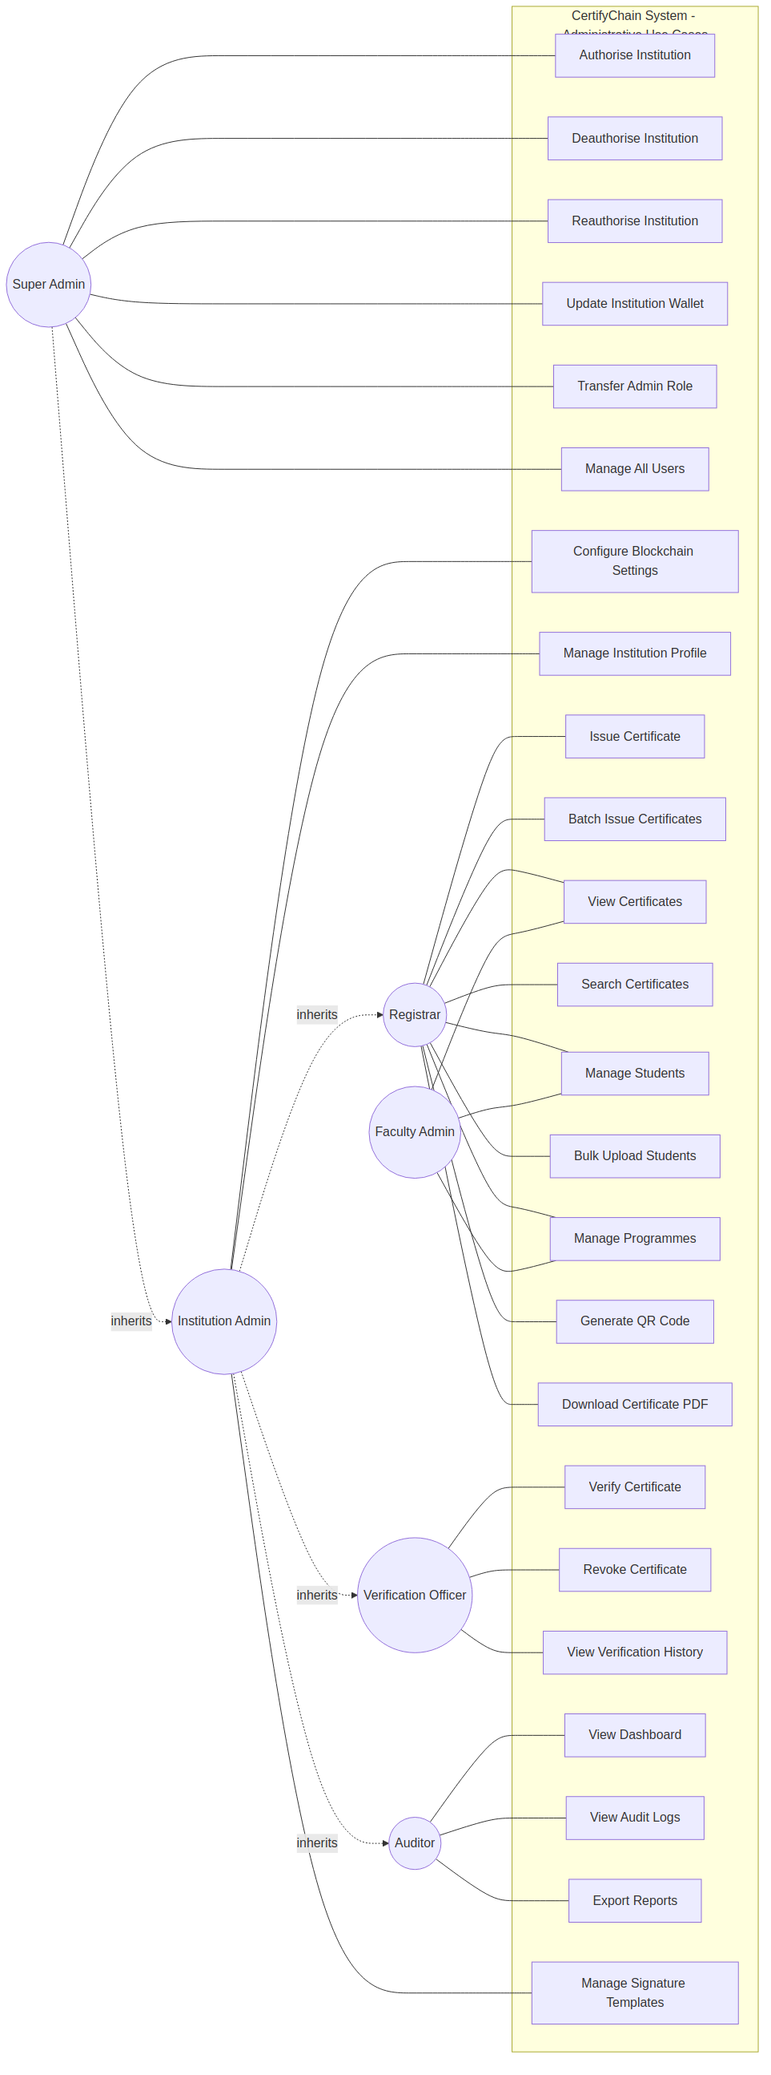 Figure 4.1: Use Case Diagram for Administrative Actors
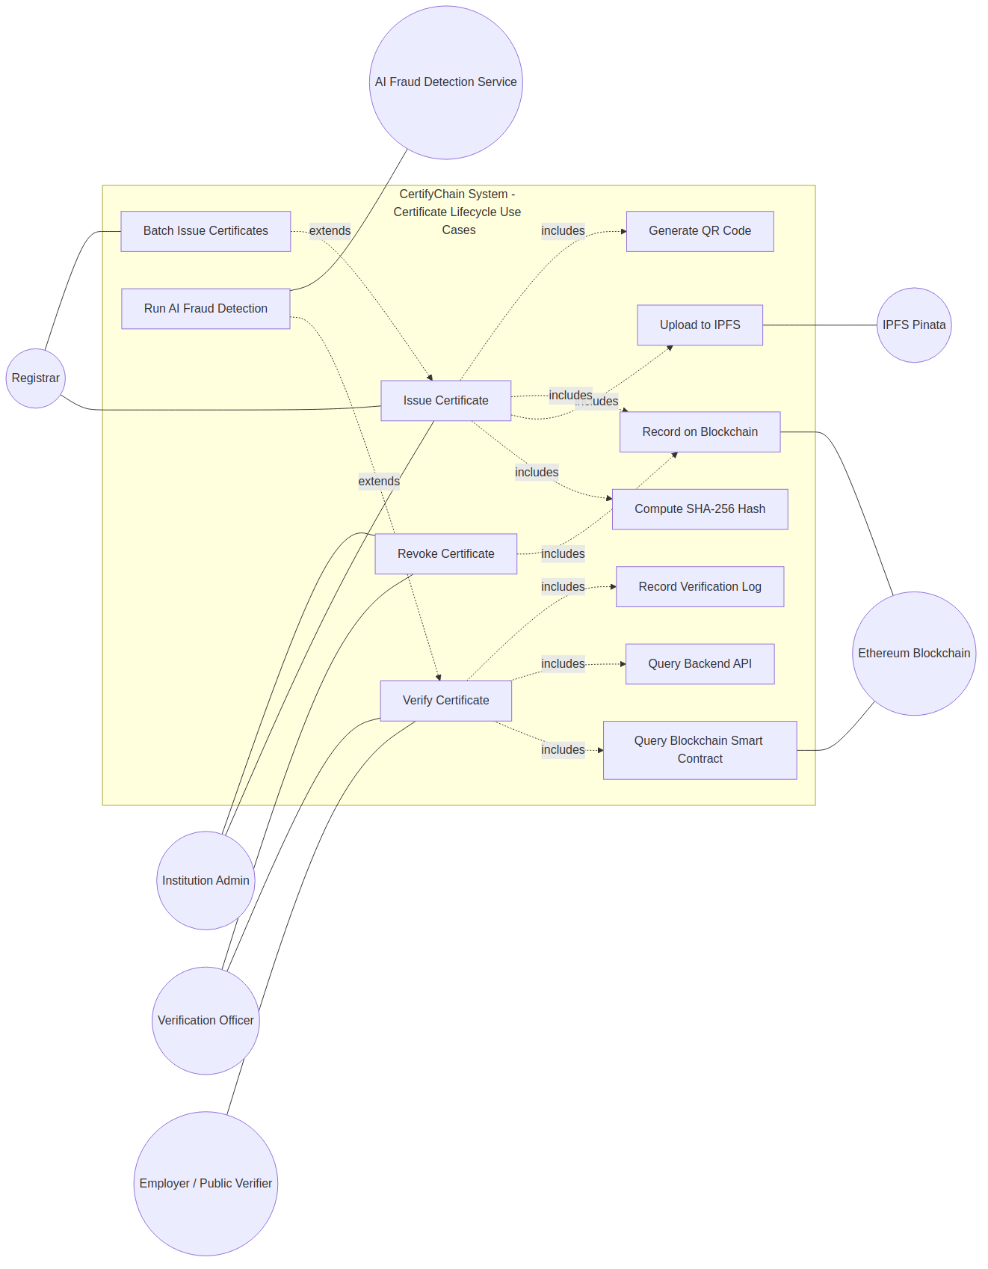
Figure 4.2: Use Case Diagram for Certificate Lifecycle with Include and Extend Relationships

Generalisation (Inheritance) Relationships among Actors: The generalisation arrows in Figure 4.1 are not merely diagrammatic convention they encode a concrete access control rule implemented in the bitwise RBAC system described in Chapter 5. When a new Institution Admin account is created, its default permission integer is the bitwise OR of the Registrar, Faculty Admin, Verification Officer, and Auditor permission sets combined, meaning every permission held by those four roles is automatically included. When a Super Admin account is created, its permission integer additionally includes the platform-level permission bits for institution authorisation and global administration. This means that a change to any base role's permission set automatically propagates up the hierarchy, and the generalisation arrows in Figure 4.1 directly correspond to the OR operations performed in the RolePermissionsHelper class at runtime.
Table 4.4: Summary of Use Cases by Actor
Actor | Use Cases
Super Admin | Authorise Institution, Deauthorise Institution, Reauthorise Institution, Update Institution Wallet, Transfer Admin Role, Manage All Users, View All Institutions, View Platform Dashboard
Institution Admin | All Registrar use cases, plus: Manage Users, Configure Blockchain Settings, Manage Institution Profile, View Institution Dashboard, and Manage Signature Templates.
Registrar | Issue Certificate, Batch Issue Certificates, View Certificates, Search Certificates, Manage Students, Bulk Upload Students, Manage Programmes, Generate QR Code, Download Certificate PDF
Faculty Admin | View Certificates, View Students, Manage Programmes
Verification Officer | Verify Certificate, Revoke Certificate, View Verification History
Auditor | View Dashboard, View Audit Logs, View Verification History, Export Reports
Employer / Public Verifier | Verify Certificate (by hash), Verify Certificate (by QR scan), Upload Certificate Image for AI Analysis, View Verification Result
Student | View My Certificates, Share QR Code, View Notifications, View Verification History
Ethereum Blockchain | Store Certificate Hash, Verify Certificate Hash, Update Certificate Status, and Manage Institution Authorisation
IPFS (Pinata) | Store Certificate PDF, Retrieve Certificate PDF by CID
AI Fraud Detection Service | Analyse Certificate Image, Return Fraud Confidence Score

4.2.5 Sequence Diagrams
Figure 4.4 traces the issuance sequence across five participants: the Registrar, the Angular Admin App, the .NET Backend API, the Ethereum Smart Contract, and the Pinata IPFS Service. The sequence begins when the registrar completes Step 2 of the issuance wizard and uploads the certificate PDF in Step 3. At this point the Angular app performs two actions simultaneously without waiting for each other: it calculates the SHA-256 hash of the PDF client-side using the browser's Web Crypto API, and it sends the file to the backend, which forwards it to Pinata's pinFileToIPFS endpoint. Both the locally computed hash and the CID returned from Pinata are held in the wizard's reactive form state. In Step 4 the wizard constructs the MetaMask transaction using these values and prompts the registrar to sign it. The signed transaction is submitted to the Ethereum Sepolia network, where the smart contract's issueCertificate function runs. The contract first checks that the calling wallet address belongs to an authorised institution; if not, it reverts immediately with an UnauthorisedCaller error. If authorised, it checks that the submitted hash does not already exist in storage; a duplicate triggers a DuplicateHash revert, preventing the same document being issued twice. Passing both checks, the contract writes the Certificate struct to storage and emits the CertificateIssued event. The backend API listens for this event via an Infura WebSocket subscription, confirms the transaction is mined, and writes the final certificate record — including the blockchain transaction hash, block number, and gas used — to SQL Server. The sequence ends with the Angular app generating and displaying the QR code encoding the verification URL.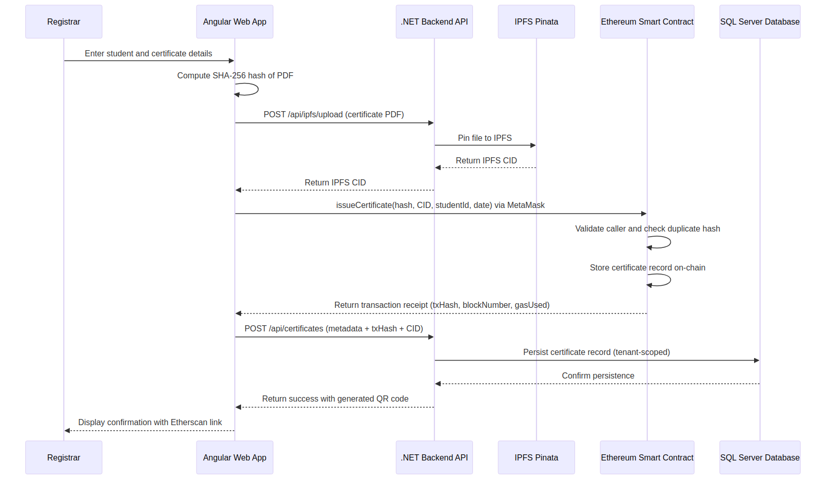
Figure 4.4: Sequence Diagram for Certificate Issuance

4.3 System Design
System design converts requirements and analysis models into a detailed blueprint that guides the implementation phase. This section is divided into three subsections: software design, user interface design, and database design.

4.3.1 Software Design

Architectural Design
The CertifyChain system adopts a mix of Client-Server and Layered architectural patterns. The client tier includes three separate front-end applications: an Angular admin web app, a Next.js public website, and a Flutter mobile app, all communicating with a centralized .NET 10 backend API via HTTPS using JWT-based authentication. The backend follows Clean Architecture principles, divided into three layers: the API, Core, and Data layers. It connects with three external systems: SQL Server for relational storage, the Ethereum Sepolia blockchain for immutable storage of certificate hashes, and IPFS via Pinata for decentralized document storage. A fifth component, the AI Fraud Detection Service, operates as a Python-based microservice within the backend layer. It is invoked by the .NET FraudDetectionService via an internal HTTP call when a certificate image is submitted for analysis. The AI service loads the frozen ResNet50V2 model weights and the trained XGBoost classifier at startup, performs feature extraction and classification on the submitted image, and returns a JSON response containing the fraud confidence score and a boolean flag indicating whether the score exceeds the 70 per cent detection threshold. Keeping the AI service separate from the .NET backend allows each component to be scaled, updated, or replaced independently for example, swapping XGBoost for a fine-tuned neural classifier in a future iteration without modifying the .NET codebase.
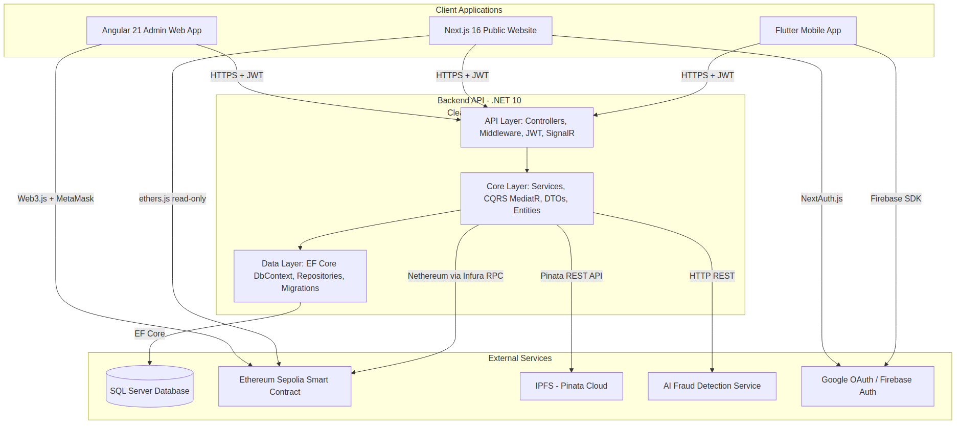
Figure 4.7: System Architecture Diagram
Figure 4.7 reveals three deliberate architectural decisions that distinguish CertifyChain from simpler blockchain systems. First, all three client applications the Angular admin app, the Next.js public website connect exclusively to the .NET Backend API and never directly to the Ethereum node or the Pinata IPFS service. This single backend boundary means that authentication, tenant isolation, audit logging, and rate limiting are enforced in one place regardless of which client initiates a request. A direct client-to-blockchain design would bypass all of these controls. Second, the backend maintains two separate persistence connections: one to SQL Server for fast, queryable, relational metadata, and one to the Ethereum smart contract for immutable status records. These stores are deliberately redundant: SQL Server holds the full certificate record for dashboard queries and reporting, while the blockchain holds only the hash and status for tamper-proof verification. An attacker who compromises SQL Server cannot forge a valid blockchain verification result. Third, the IPFS/Pinata layer is positioned parallel to the blockchain rather than beneath it, because it is not called during verification only the CID stored on-chain is checked. The full certificate file is retrieved from IPFS only when the verifier explicitly requests it for visual inspection, keeping the standard verification path fast and blockchain-only.

Class Diagram
The class diagram illustrates the static structure of the CertifyChain system by showing its main domain entities, their attributes, methods, and relationships. The diagram uses composition relationships between Institution and its parts, association relationships connecting Certificate to Student and Programme, and interface realization with the ITenantEntity interface for multi-tenancy support. Figure 4.8 encodes four structural rules. First, Institution and Tenant share a composition relationship, meaning an Institution entity cannot exist independently of a Tenant record: creating an institution requires an existing tenant, and deleting a tenant cascades to all its institutions, students, users, and certificates. This reflects the multi-tenancy design where each university is a Tenant and its internal structure is an Institution under that tenant. Second, Certificate holds mandatory foreign keys to both Student and Programme, enforcing the business rule that a certificate must always be owned by exactly one identified student and awarded for exactly one defined academic programme orphaned certificates are rejected at the database constraint level. Third, every entity except Tenant implements the ITenantEntity interface, which mandates a TenantId property. This interface is the mechanism that allows the CertifyChainDbContext to apply a global query filter WHERE TenantId = @currentTenant to every LINQ query automatically, making cross-tenant data leakage impossible without bypassing the DbContext entirely. Fourth, the Certificate entity is the integration point where all three system layers write their results: the AI Fraud Detection Service writes to FraudScore, the Ethereum interaction writes to BlockchainTxHash and BlockNumber, and the backend's own issuance logic writes to CertificateHash, IpfsCid, and Status. Reading a single Certificate record therefore gives a complete, cross-layer view of that credential's history.
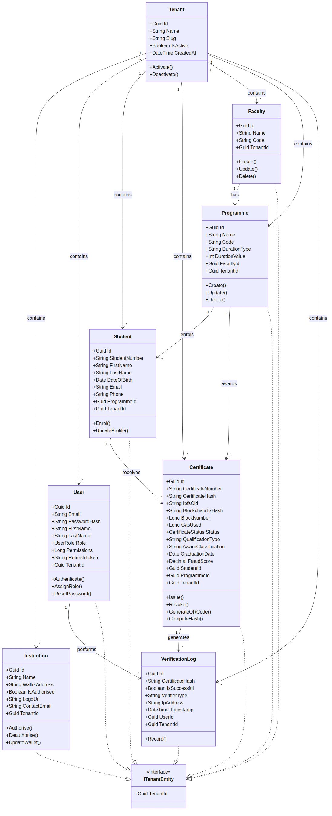
Figure 4.8: Class Diagram of the CertifyChain System

4.3.2 User Interface Design
The principles of clarity, consistency, and accessibility guided the user interface design of the CertifyChain system. Three distinct interfaces were designed to serve the primary user groups.
Admin Web Application (Angular 21): The admin web application features a sidebar navigation layout with a fixed top bar. It is built using PrimeNG with Tailwind CSS and supports both light and dark themes. Key screens include the Dashboard with Chart.js analytics, a four-step Certificate Issuance Wizard with MetaMask integration, a paginated Certificate List, a public Verification Page, and a User Management interface with role assignment.
Public Website (Next.js 16): The public website features a professional landing page, a prominent verification field, and QR code scanning. Verification results display clear status indicators with full metadata and blockchain proof. Google OAuth via NextAuth.js provides access to a personal verification dashboard.

4.3.3 Database Design
The CertifyChain system uses Microsoft SQL Server through Entity Framework Core 10 with a Code-First migration approach. The database supports multi-tenancy with global query filters on the TenantId column.

Entity-Relationship Diagram
The entity-relationship diagram shows the main entities and their cardinality constraints. All entities except Tenant include a TenantId foreign key for multi-tenancy partitioning. Figure 4.9 shows eight entities and highlights five cardinality relationships that encode the system's business rules in the database. A Tenant has a one-to-many relationship with Institution, Student, User, Faculty, Programme, Certificate, and VerificationLog. Every record in the system belongs to exactly one tenant. The mandatory TenantId foreign key on each entity is the database-level enforcement of the same rule applied at the application level by the EF Core global query filters, creating a two-layer isolation guarantee. An Institution has a one-to-many relationship with both Certificate and User, reflecting the rule that each certificate is issued by one institution and each user account belongs to one institution. Certificate sits at the centre of the model with mandatory many-to-one relationships to Student (who holds the credential), Programme (what the credential certifies), and Institution (who issued it) all three foreign keys are NOT NULL, so a certificate record with an unknown owner, an undefined programme, or an unidentified issuing institution cannot be stored. VerificationLog has a many-to-one relationship with Certificate: every time a certificate hash is queried whether the result is Verified, Revoked, or Not Found a log record is written without modifying the Certificate record itself, preserving a complete, append-only audit trail. The Certificate's nullable BlockchainTxHash and BlockNumber columns reflect the Pending status that exists between the moment the backend creates the record and the moment the Ethereum transaction is confirmed, after which both columns are populated and the status advances to Verified.

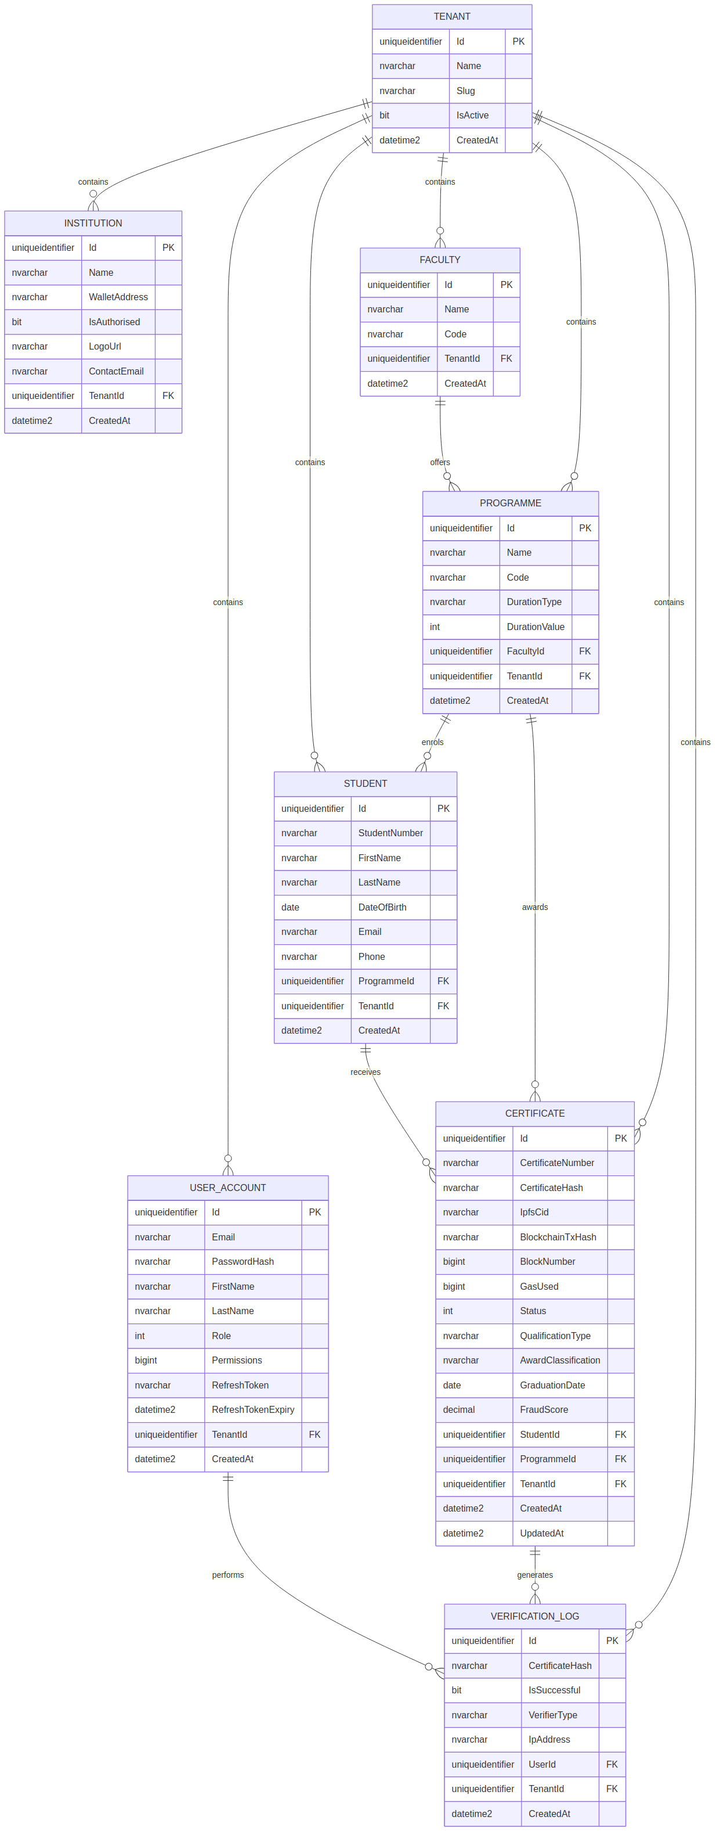
Figure 4.9: Entity-Relationship Diagram of the CertifyChain Database

4.4 Component-Level Design
Component-level design elaborates on the architectural and class-level models by specifying the detailed behavioural logic of individual system components.

4.4.1 Activity Diagram: Certificate Issuance
The certificate issuance activity diagram maps the complete issuance process from the registrar opening the wizard to the system displaying the generated QR code, using swimlanes to separate the responsibilities of the Registrar, the Angular Admin App, and the Backend and Blockchain layer. It shows two decision points where the process can fail and one parallel fork where two independent operations run simultaneously. Figure 4.11 traces the issuance process through three swimlanes. The first decision point occurs after the registrar selects a student in Step 1: if the student record does not exist in the system, the wizard returns to the search screen without proceeding, preventing certificates being issued to unregistered students. After the PDF is uploaded in Step 3, the diagram shows a parallel fork a key performance decision in the design. The left branch computes the SHA-256 hash of the PDF entirely within the browser using the Web Crypto API, with no network call. The right branch sends the file to the .NET backend, which forwards it to Pinata and receives a CID in return. Because the two branches are independent, they run at the same time rather than sequentially: the browser hash calculation takes milliseconds while the IPFS upload takes one to three seconds, meaning the hash is ready long before the CID arrives and no time is wasted waiting. The parallel branches rejoin at a synchronisation bar, ensuring both values are available before Step 4 begins constructing the MetaMask transaction. The second decision point is inside the smart contract: the contract checks whether the submitted hash already exists in its storage mapping. A duplicate hash triggers an immediate revert, and the wizard displays a duplicate certificate error. A new hash passes validation, the Certificate struct is written to storage, the CertificateIssued event is emitted, and the backend writes the confirmed record to SQL Server. The activity ends when the Angular app generates and displays the QR code encoding the certificate verification URL.

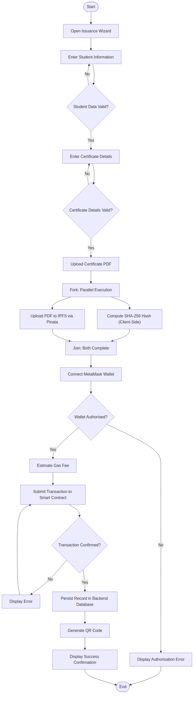
Figure 4.11: Activity Diagram for Certificate Issuance

4.4.2 Activity Diagram: Certificate Verification
The certificate verification activity begins when a verifier submits a certificate hash or scans a QR code via any CertifyChain frontend. The backend VerificationService initiates a dual-path query, concurrently checking the blockchain smart contract and the SQL database. The smart contract query retrieves the on-chain status (Valid, Revoked, or Not Found) using a Solidity view function, incurring no gas cost. In parallel, the database query returns the institution name, graduate details, and AI fraud score recorded at issuance. The two results are merged into a unified VerificationResult object and returned to the caller. If either path returns a status of Not Found or Revoked, the result is immediately classified as unverified regardless of the other path’s result. The entire dual-path process completes in an average of 62ms.

4.4.3 Decision Tables

Verification Outcome Decision Table
Table 4.12: Verification Outcome Decision Table
 | Rule 1 | Rule 2 | Rule 3 | Rule 4 | Rule 5
Conditions
Found on blockchain | True | True | True | False | False
On-chain status = Valid (1) | True | False | False | N/A | N/A
On-chain status = Revoked (2) | False | True | False | N/A | N/A
Found in the backend API | True | True | False | True | False
Actions
Display: VERIFIED | X
Display: REVOKED |  | X
Display: NOT FOUND |  |  | X |  | X
Display: PARTIAL (backend only) |  |  |  | X
Show full certificate details. | X | X |  | X
Record verification log | X | X | X | X | X
Show blockchain proof link. | X | X | X

4.5 Conclusion
This chapter provides a comprehensive overview of the system analysis and design for the CertifyChain platform. The analysis phase identified 15 functional requirements and 10 non-functional requirements, established the use case model with 11 actors and over 30 use cases, and described the interaction sequences for the critical issuance, verification, and revocation workflows. The design phase outlined the system architecture following the principles of Clean Architecture and Client-Server patterns, defined the class model comprising eight main domain entities, documented the user interface design across three platforms, and presented the database design with normalized table structures and multi-tenancy partitioning. The component-level design formalized the certificate lifecycle through a state diagram, described the issuance and verification processes using activity diagrams, and codified the verification logic and role-based access control through decision tables. Finally, the deployment diagram illustrated the distribution of system components across ten physical nodes.
The analysis and design artifacts presented in this chapter create the comprehensive blueprint that guided the implementation of the CertifyChain system. The next chapter shows the results and evaluation of the system, assessing its performance against the requirements and quality attributes defined here.

CHAPTER 5: IMPLEMENTATION AND TESTING

5.1 Introduction
This chapter provides a detailed overview of the implementation and testing activities conducted during the development of the CertifyChain platform. Implementation involves translating the system design artifacts from Chapter 4 into functional software components, while testing ensures those components meet the required specifications. The chapter is organized into six sections. The first section explains the development environment, tools, and technologies used. The second section discusses the implementation of the backend API, including its architectural layers, key design patterns, and cross-cutting concerns. The third section covers the implementation of the smart contract on the Ethereum Sepolia testnet. The fourth section describes the frontend implementations across three different client platforms. The fifth section details the testing strategy, test plan, and test results. The sixth section summarizes the implementation outcomes and provides an honest assessment of the system's current state.
This chapter, following the project brief's guidance, emphasizes conceptual and logical design choices rather than providing comprehensive code listings. Annotated code sections are included only when they demonstrate an algorithmic flow, showcase an interesting optimization, or illustrate a complex interaction with a data structure or external service. The full source code can be found in the project's GitHub repository.

5.2 Development Environment
The CertifyChain platform was built using a combination of integrated development environments, command-line tools, and cloud services. The choice of each tool was based on its fit for the technology stack outlined in the system design and its availability as a free or open-source resource.

Tool / Technology | Version | Purpose
Visual Studio 2026 | 17.x | Primary IDE for .NET 10 backend API development, debugging, and xUnit test execution.
Visual Studio Code | Latest | IDE for Angular 21, Next.js 16, and Flutter development with extensions for TypeScript, Dart, and Tailwind CSS.
Remix IDE | Online | Browser-based IDE for Solidity smart contract development, compilation, and deployment to the Ethereum Sepolia network.
SQL Server Management Studio | 20.x | Database administration, query authoring, and schema inspection for SQL Server.
Docker Desktop | Latest | Containerisation of the .NET 10 API for deployment and environment consistency.
.NET SDK | 10.0 | Runtime and build toolchain for the backend API using C# 13.
Node.js | 22.x LTS | Runtime for Angular CLI, Next.js, and npm package management.
MetaMask | Browser Extension | Ethereum wallet for signing blockchain transactions during certificate issuance and revocation.
Postman | Latest | API endpoint testing and documentation during backend development.
Git / GitHub | Latest | Version control, branching strategy, and source code repository management.

5.3 Backend API Implementation
The CertifyChain backend API was developed using .NET 10 with C# 13, following the Clean Architecture pattern. It is organized into three projects within a single Visual Studio solution: CertifyChain.Api (presentation layer), CertifyChain.Core (business logic and domain entities), CertifyChain.Data (data access and persistence), and CertifyChain.Tests (for all testing). This structure ensures that the domain logic remains separate from infrastructure concerns such as database access, HTTP routing, and external service integrations.

5.3.1 Domain Driven Design and Repository Pattern
The data access layer was built using the Repository Pattern along with Entity Framework Core 10 and a Code-First migration strategy. Each domain entity (Certificate, Student, User, Faculty, Programme, VerificationLog, Institution, Tenant) is managed by a dedicated repository interface defined in the Core project and implemented in the Data project. This separation allows the business logic layer to rely on abstractions instead of specific database implementations, making testing easier through dependency injection and mock objects.
The DbContext class, CertifyChainDbContext, centralizes the Entity Framework configuration. It implements Fluent API configurations for each entity, creates composite indexes for performance-critical queries (such as certificate lookup by hash), and enforces referential integrity constraints through foreign key relationships. All migrations are generated using the EF Core CLI and applied during application startup in development environments.

5.3.2 Multi-Tenancy Implementation
Multi-tenancy was implemented at the database level using a shared-database, shared-schema approach with a discriminator column (TenantId) present on all tenant-scoped entities. The TenantId is a GUID foreign key referencing the Tenants table. Entity Framework Core global query filters are applied in the DbContext to automatically add a WHERE clause to every query, ensuring tenants cannot access each other's data under any circumstances. The current tenant is determined from the authenticated user's JWT claims via a custom ITenantProvider service registered as a scoped dependency. When a request comes in, the JWT middleware extracts the TenantId claim, and the TenantProvider makes it available to the DbContext and all downstream services. This method ensures tenant isolation is enforced transparently at the data access layer without requiring individual developers to remember to filter by tenant in every query.

5.3.3 JWT Authentication and Role-Based Access Control
Authentication is implemented using JSON Web Tokens (JWTs) with a refresh token rotation strategy. When a user logs in successfully, the AuthService issues a short-lived access token (valid for 60 minutes) and a long-lived refresh token (valid for 7 days). The refresh token is stored as a hashed value in the Users table along with its expiration timestamp. When the access token expires, the client application silently requests a new token pair by presenting the refresh token, ensuring smooth user sessions without prompting for re-login.
Role-based access control (RBAC) was implemented using a bitwise permissions model. Each of the six user roles (SuperAdmin, InstitutionAdmin, Registrar, FacultyAdmin, VerificationOfficer, Auditor) is associated with a 64-bit integer (long) representing its default permission set. Individual permissions are defined as powers of two (1, 2, 4, 8, 16, and so on), enabling efficient bitwise AND operations to check if a user has a specific permission. A custom AuthorizePermission attribute was created for use on API controller actions that examines the Permissions claim in the JWT and performs a bitwise check before granting access to the endpoint.
Figure 5.2 shows the C# code for the AuthorizePermission attribute and the bitwise AND operation it performs at runtime. The screenshot demonstrates the core of the RBAC implementation: each user's JWT contains a Permissions claim storing a 64-bit integer that represents the union of all permissions assigned to that user's role. Each individual permission is defined as a distinct power of two for example, IssueCertificate = 4, RevokeCertificate = 8, ViewAuditLog = 16. When an API endpoint decorated with [AuthorizePermission(Permissions.RevokeCertificate)] receives a request, the middleware extracts the Permissions claim, performs a bitwise AND with the required permission value, and checks whether the result is non-zero. If it is zero, the user does not hold that permission and the middleware returns HTTP 403 Forbidden before the controller method is ever invoked. The figure confirms that this check happens in the middleware pipeline rather than inside each controller, meaning no controller method can accidentally bypass the permission check by omitting an attribute.

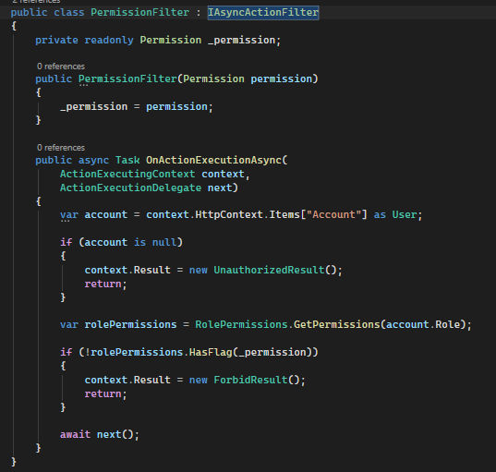
Figure 5.2: Bitwise Permission Check in the RBAC Middleware

5.3.4 API Endpoint Structure
The API layer provides RESTful endpoints organized by resource. Each controller extends from BaseApiController, which offers standardized response formatting and error handling. The main controllers and their functions are summarized in Table 5.2.
Table 5.2: Principal API Controllers
Controller | Base Route | Key Endpoints | Auth Required
AuthController | /api/auth | POST /register, POST /login, POST /refresh-token, POST /revoke-token | Partial
CertificatesController | /api/certificates | GET /, POST /, GET /by-hash/{hash}, POST /revoke, POST /batch | Yes
StudentsController | /api/students | GET /, POST /, PUT /{id}, DELETE /{id}, POST /bulk-upload | Yes
UsersController | /api/users | GET /, POST /, PUT /{id}, DELETE /{id}, PUT /{id}/permissions | Yes
FacultiesController | /api/faculties | GET /, POST /, PUT /{id}, DELETE /{id} | Yes
ProgrammesController | /api/programmes | GET /, POST /, PUT /{id}, DELETE /{id} | Yes
VerificationController | /api/verify | GET /by-hash/{hash}, POST /log | No
DashboardController | /api/dashboard | GET /stats, GET /trends, GET /verification-sources | Yes
IpfsController | /api/ipfs | POST /upload, GET /retrieve/{cid} | Yes
InstitutionsController | /api/institutions | GET /, POST /authorise, POST /deauthorise, PUT /wallet | Yes (SuperAdmin)

5.4 Smart Contract Implementation
The CertificateVerification smart contract was built using Solidity 0.8. x and deployed to the Ethereum Sepolia testnet at address 0x29baF19FF34fcf90a8980AD34C3389E8BE3A501E. It has been verified on Etherscan, allowing the public to inspect its source code and transaction history. The contract functions as the immutable trust anchor of the CertifyChain system, supporting three main features: managing institution authorization, issuing certificates, and revoking certificates.

5.4.1 Contract Structure and Storage
The contract uses a struct-based storage model to minimize gas costs. Each certificate record takes up a single storage slot, identified by its keccak256 hash. The main storage variables include a mapping from certificate hashes to Certificate structs, a mapping from institution identifiers to Institution structs, which store the wallet address and authorization status, and an address variable holding the contract owner (the platform Super Admin). The Certificate struct has seven fields: certHash (bytes32), ipfsCID (bytes32), issueDate (uint64), studentId (bytes16), institutionId (uint16), status (uint8), and exists (bool). By carefully packing these small types (uint64, uint16, uint8, bool), the entire struct fits within two 256-bit EVM storage slots, reducing gas costs for write operations.

5.4.2 Key Contract Functions
Table 5.3: Smart Contract Functions
Function | Visibility | Gas Cost | Description
authoriseInstitution | External (owner only) | ~45,000 | Registers an institution with its wallet address and name. Only callable by the contract owner.
deauthoriseInstitution | External (owner only) | ~28,000 | Disables an institution's ability to issue or revoke certificates.
reauthoriseInstitution | External (owner only) | ~28,000 | Re-enables a previously deauthorised institution.
updateInstitutionWallet | External (owner only) | ~30,000 | Updates the wallet address associated with an institution.
issueCertificate | External (authorised institution) | ~65,000 | Records a new certificate on-chain. Validates caller, checks for duplicate hashes, and emits CertificateIssued event.
revokeCertificate | External (issuing institution) | ~35,000 | Changes certificate status from Valid (1) to Revoked (2). Irreversible. Emits CertificateRevoked event.
getCertificateDetails | Public view (zero gas) | 0 | Returns the full on-chain certificate record for a given hash. Used during verification.
getInstitutionDetails | Public view (zero gas) | 0 | Returns institution authorisation status and wallet address.

5.4.3 Gas Optimisation Strategies
Several gas optimization strategies were employed during smart contract development. First, the Certificate struct was designed with tightly packed fields to minimize storage slot usage, since each 256-bit storage slot write costs 20,000 gas for a new slot and 5,000 gas for an update. Second, the contract uses bytes32 for the certificate hash and IPFS CID instead of string types, avoiding the overhead of dynamic-length storage. Third, read-only functions (getCertificateDetails and getInstitutionDetails) are declared as view functions, which execute locally on the calling node without consuming gas, enabling free verification queries. Fourth, events (CertificateIssued, CertificateRevoked, InstitutionAuthorised) are emitted for all state-changing operations, providing an indexed, off-chain queryable log at minimal gas cost compared to additional storage writes.
Figure 5.4 shows the Etherscan explorer page for the CertifyChain smart contract deployed at address 0x29baF19FF34fcf90a8980AD34C3389E8BE3A501E on the Sepolia testnet. Three things are visible in the screenshot that confirm the contract's integrity. First, the green tick and 'Contract Source Code Verified' label confirms that the Solidity source code submitted to Etherscan matches the bytecode deployed at that address — any third party can therefore confirm that the contract logic they are reading is the logic that is actually executing on the blockchain, with no hidden backdoors. Second, the Read Contract and Write Contract tabs are visible, showing the contract's public functions are accessible through Etherscan's interface without any CertifyChain frontend — an employer could in principle verify a certificate hash directly through Etherscan without using the CertifyChain website at all. Third, the transaction history panel shows the issueCertificate and authoriseInstitution transactions from testing, each with a transaction hash that permanently records the event on the blockchain and can be independently audited.
[
Figure 5.4: Verified Smart Contract on Etherscan (Sepolia Testnet)

5.5 IPFS Integration via Pinata
The InterPlanetary File System (IPFS) integration was implemented through the Pinata Cloud REST API. When a registrar uploads a certificate PDF during issuance, the backend API's IpfsService sends the file to Pinata's pinFileToIPFS endpoint via a multipart/form-data POST request. Pinata pins the file across multiple IPFS nodes and returns a content identifier (CID), a cryptographic hash of the file's content. This CID is then stored both on the Ethereum blockchain (within the Certificate struct) and in the SQL Server database, creating a verifiable link between the on-chain record and the off-chain document.
The content-addressed nature of IPFS means that any change to the certificate PDF would result in a different CID, making the stored CID an implicit integrity check. During verification, the system retrieves the IPFS CID stored on the blockchain and compares it with the CID of the document provided by the verifier. If the two CIDs match, the file is confirmed to be byte-for-byte identical to the version recorded at issuance. If they differ, the system returns a TAMPERED status, indicating that the file has been modified since it was anchored. This comparison is implemented in the VerificationService.VerifyWithIpfsAsync method and is covered by functional test case TC09, in which the certificate PDF was modified by altering a single character in the student name field producing a different SHA-256 hash and CID that did not match the on-chain record.

5.6 Frontend Implementations

5.6.1 Angular 21 Admin Web Application
The administrative web application was built with Angular 21, using standalone components, PrimeNG as the UI component library, and Tailwind CSS for utility-based styling. The application adopts a modular structure with lazy-loaded feature modules for each functional area: Dashboard, Certificates, Students, Users, Faculties, Programmes, Verification, and Settings. The certificate issuance process is implemented as a four-step wizard component. Step 1 allows selecting a student via a searchable dropdown populated by the Students API. Step 2 gathers certificate details, including qualification type, award classification, and graduation date. Step 3 manages PDF uploads, triggering client-side SHA-256 hash calculation with the Web Crypto API and uploading the result to IPFS via the backend. Step 4 initiates a blockchain transaction in MetaMask using the ethers.js library. The wizard component maintains state across steps using a reactive form group and prevents navigation to subsequent steps until validation succeeds. MetaMask integration is handled by a dedicated WalletService that wraps the Ethereum provider in the window. The service manages wallet connection, network verification (ensuring the user is on the Sepolia network with chain ID 11155111), transaction signing, and receipt polling. When the user clicks the issue button, the service constructs transaction parameters, estimates gas, and calls MetaMask's eth_sendTransaction method. A loading overlay with a progress indicator appears until the transaction is confirmed.
Figure 5.5 shows the CertifyChain admin dashboard as seen by an Institution Admin user. Four Chart.js panels are visible: a line chart showing certificate issuance over time by month, a doughnut chart showing the breakdown of certificate statuses (Verified, Revoked, Pending), a bar chart showing verification requests by source (QR code, hash entry, API), and a summary row of key statistics total certificates issued, total verifications performed, active students, and active users. The sidebar navigation is visible on the left, with menu items for Dashboard, Certificates, Students, Users, Faculties, Programmes, and Settings, all lazy-loaded to avoid downloading code for sections the user has not visited. The top bar shows the institution name and the current user's role, confirming that the multi-tenancy system is correctly scoping the dashboard data to the authenticated institution's records only. The dark mode toggle is visible in the top-right corner, demonstrating the light/dark theme support implemented with PrimeNG and Tailwind CSS.


Figure 5.5: CertifyChain Admin Dashboard (Angular 21)

5.6.2 Next.js 16 Public Website
The public-facing website was built with Next.js 16, the App Router architecture, React Server Components, and Tailwind CSS. It is hosted on Netlify at certifyonchainweb.netlify.app and provides two main features: public certificate verification and authenticated user dashboards.
Authentication on the public website is handled via NextAuth.js (Auth.js) using Google OAuth as the identity provider. When users click Sign in with Google, they are redirected to the Google account chooser, and upon successful login, a session is created with the user's profile details. The connection indicator for the Sepolia blockchain appears in the top-right corner of the verification page, confirming that the application is connected to the correct network.
The verification interface has a clean, focused design featuring a single input field for the certificate hash. Below this field, the smart contract address appears as a clickable link to Etherscan, along with the chain ID (11155111), providing transparency into the blockchain network being checked. When a hash is entered, the application sends two parallel requests: a read-only call to the smart contract via ethers.js and a GET request to the backend API. The results are combined and displayed with a clear status indicator (Verified, Revoked, or Not Found).


Figure 5.8: CertifyChain Website
Figure 5.9 shows the CertifyChain public website landing page hosted at certifyonchainweb.netlify.app. The page opens with a hero section describing the system's three-layer verification model and a prominent Call to Action button directing visitors to the verification interface. Below the hero, three feature cards summarise the key capabilities — blockchain immutability, AI fraud detection, and instant free verification — alongside iconography. The Sepolia network connection indicator is visible in the top navigation bar, confirming the frontend is connected to the correct Ethereum network before any verification is attempted. The footer includes the smart contract address for direct reference, reinforcing the system's commitment to transparency. The page is built with Next.js 16's App Router and Tailwind CSS, and the screenshot confirms the responsive layout renders correctly at desktop viewport width.


Figure 5.9: On-Chain Certificate Verification Interface
Figure 5.9 shows the on-chain certificate verification interface on the CertifyChain public website. The single hash input field is centred on the page, with the smart contract address displayed below it as a clickable Etherscan link alongside the Sepolia chain ID (11155111). This transparency lets any technically competent verifier confirm which contract is being queried without trusting the website's own claim. The verification result panel, shown with a sample verified certificate, displays four sections: a large green VERIFIED status indicator, the on-chain metadata returned by the smart contract (issue date, institution identifier, status code), the extended metadata from the backend API (student name, qualification type, award classification, graduating institution), and a blockchain proof section containing the transaction hash and block number as clickable Etherscan links. This dual-source display — combining on-chain and off-chain data in a single result — is the practical implementation of the dual-path parallel query architecture described in Section 3.5.

5.6.3 Flutter Mobile Application
The mobile application was built with Flutter 3.x and Dart, supporting both Android and iOS from a single codebase. Its architecture follows the BLoC (Business Logic Component) pattern, separating the presentation layer from the business logic through event-driven state management. Key screens include a Dashboard tab showing the user's verification history, a Scan tab with an integrated QR code scanner (using the mobile_scanner package), a History tab with paginated verification logs, and a Profile tab featuring account settings and sign-out options.
The QR code scanning feature was implemented using the device's camera. When a valid QR code is detected, the application extracts the certificate hash from the encoded URL and automatically navigates to the verification results screen. Firebase Authentication provides Google Sign-In on mobile, and the app communicates with the backend API using the Dio HTTP client with JWT token interceptors to attach and refresh tokens automatically.

5.7 Key Implementation Challenges
Several non-trivial challenges were encountered during implementation. This section documents the most significant ones and the strategies employed to resolve them.
MetaMask Transaction Lifecycle Management: Integrating MetaMask into the Angular certificate issuance wizard proved more complex than expected. The asynchronous nature of blockchain transactions created a multi-phase process: wallet connection, gas estimation, transaction submission, pending state, and confirmation. Each phase could fail independently (user rejection, insufficient gas, network timeout, or transaction revert), requiring a robust error-handling strategy. The solution involved creating a TransactionStateService that monitors the current phase and provides appropriate user feedback, including estimated wait times based on current Sepolia block times.
Entity Framework Core Global Query Filters for Multi-Tenancy: Implementing transparent multi-tenancy with EF Core global query filters introduced an ordering challenge. The filter relies on the ITenantProvider, which depends on the HTTP context to extract JWT claims. During background jobs or seed operations where no HTTP context exists, the tenant filter would throw a NullReferenceException. The solution was to implement a bypass mechanism using a TenantBypassScope disposable that temporarily turns off the filter for administrative tasks.
Cross-Platform Authentication Consistency: Ensuring consistent authentication across three frontend platforms (Angular with custom JWT, Next.js with NextAuth.js and Google OAuth, Flutter with Firebase Auth) required careful coordination. The backend API was designed to accept tokens from multiple issuers, validate custom JWTs for the Angular admin app, and verify Google ID tokens for the public website and mobile app. A unified claims transformation middleware normalizes the claims from all three sources into a consistent format before they reach the controllers.
AI Pipeline Integration Across Technology Boundaries: Integrating a Python-based AI pipeline with a .NET backend introduced a cross-language communication challenge. The ResNet50V2 and XGBoost models are built on TensorFlow and the Python XGBoost library, which cannot be called directly from C#. The solution was to expose the AI module as a lightweight Python FastAPI microservice running on a separate port, which the .NET FraudDetectionService calls via an internal HTTP POST request containing the base64-encoded certificate image. A secondary challenge was dataset construction: no publicly available forged certificate dataset exists, requiring the manual creation of 60 synthetic forgeries using image editing software. Ensuring sufficient variety in forgery technique font replacement, signature splicing, seal manipulation, and noise injection while keeping the dataset balanced and the manipulation quality realistic enough to train a meaningful classifier took considerably longer than the initial prototype schedule anticipated. This experience reinforced the importance of building time reserves for data preparation when machine learning is a project component.

5.8 Current Implementation Status
Table 5.4 presents an honest assessment of the implementation status of each functional requirement defined in Chapter 4.
Table 5.4: Implementation Status of Functional Requirements
FR ID | Requirement | Status | Notes
FR01 | Manage student profiles | Implemented | Full CRUD with bulk upload via CSV.
FR02 | Issue digital certificates (hash, IPFS, blockchain) | Implemented | Four-step wizard with MetaMask integration.
FR03 | Batch issuance of certificates | Implemented | Up to 50 certificates per batch transaction.
FR04 | Verify certificate by hash or QR code | Implemented | Parallel blockchain and API queries.
FR05 | Generate unique QR codes | Implemented | QR codes encode the verification URL with the hash.
FR06 | Revoke certificate on blockchain | Implemented | Irreversible on-chain status change from 1 to 2.
FR07 | AI-based fraud detection module | Implemented | ResNet50V2 + XGBoost two-stage pipeline trained and evaluated. Integrated via the backend API FraudDetectionService. Results presented in Chapter 6..
FR08 | Role-based access control with six roles | Implemented | Bitwise permissions model with 30+ granular permissions.
FR09 | Multi-tenancy with isolated data partitions | Implemented | EF Core global query filters on TenantId.
FR10 | JWT authentication with Google OAuth | Implemented | Custom JWT for admin; Google OAuth for website and mobile.
FR11 | Immutable verification audit trail | Implemented | All verification attempts are logged with full metadata.
FR12 | Dashboard with real-time analytics | Implemented | Chart.js charts for trends, status distribution, and sources.
FR13 | Super Admin institution management on blockchain | Implemented | Authorise, deauthorise, reauthorise, and wallet update.
FR14 | Student mobile app with QR sharing | Implemented | Flutter app with QR scanner and certificate sharing.
FR15 | IPFS upload via Pinata | Implemented | PDF files pinned to IPFS with CID stored on-chain and off-chain.
As shown in Table 5.4, all fifteen functional requirements are fully implemented. The AI-based fraud detection module (FR07) is implemented as a two-stage pipeline combining a frozen ResNet50V2 convolutional feature extractor with an XGBoost classifier trained on a 120-image synthetic dataset of authentic and forged certificates. The pipeline is integrated into the backend via the FraudDetectionService and exposed through the /api/fraud-detection endpoint. The model's training process, hyperparameter configuration, and evaluation results are presented in Chapter 6, Section 6.2.3.

5.9 Testing
This section outlines the testing strategy, test infrastructure, and test results for the CertifyChain platform. Testing was conducted at three levels: unit testing of individual service classes, integration testing of API endpoints, and manual functional testing of end-to-end user workflows.

5.9.1 Test Infrastructure
The test project, CertifyChain.Tests were created within the Visual Studio solution alongside the main application projects. It uses xUnit as the test framework, Moq for mocking, and FluentAssertions for an expressive assertion syntax. The test project is organized into three folders: Entities (for domain-entity validation tests), Helpers (for utility-class tests, such as the RolePermissions helper), and Services (for service-layer tests covering AuthService, CertificateService, DashboardService, FacultyService, ProgramService, StudentService, and VerificationLogService).

5.9.2 Unit Testing Approach
Unit tests follow the Arrange-Act-Assert (AAA) pattern. Each test method configures mock dependencies with Moq, runs the method under test, and checks the results with xUnit assertions. For example, the AuthServiceTests class verifies the user registration process by mocking the user repository to return null for a new email, mocking the mapper to create a User entity, and mocking the JWT utility to generate a token pair. The test then confirms that registration was successful, that the returned access token matches the expected value, and that the success message is accurate.
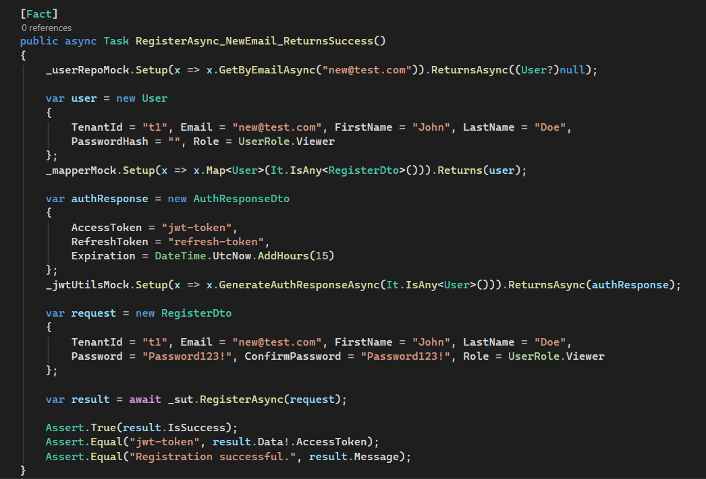
Figure 5.11: Unit Test for User Registration Using xUnit and Moq
Figure 5.11 shows the Visual Studio Test Explorer and the C# source code for the RegisterAsync_WithNewEmail_ReturnsSuccess test in the AuthServiceTests class. The Test Explorer panel on the right confirms that all AuthServiceTests pass, displayed with green tick marks. The code panel shows the three-section Arrange-Act-Assert structure: the Arrange section configures three mock objects the user repository is set up to return null when queried for the test email (simulating a new, not-yet-registered address), the AutoMapper mock is configured to return a pre-built User entity, and the JWT utility mock is configured to return a known token pair. The Act section calls RegisterAsync with test credentials. The Assert section uses FluentAssertions to verify that the returned response object's IsSuccess flag is true, that the AccessToken matches the expected value, and that the Message is the correct success string. The test validates the service's behaviour without a live database connection or a real JWT library, confirming that the mock-based testing strategy provides genuine coverage of the business logic in isolation from infrastructure.

Table 5.5: Summary of Unit Test Coverage
Test Class | Methods Under Test | Test Count | Status
AuthServiceTests | RegisterAsync, LoginAsync, RefreshTokenAsync, RevokeTokenAsync | 12 | Pass
CertificateServiceTests | CreateAsync, GetByHashAsync, RevokeAsync, BatchCreateAsync | 10 | Pass
StudentServiceTests | CreateAsync, UpdateAsync, DeleteAsync, BulkUploadAsync | 8 | Pass
FacultyServiceTests | CreateAsync, UpdateAsync, DeleteAsync, GetAllAsync | 6 | Pass
ProgramServiceTests | CreateAsync, UpdateAsync, DeleteAsync, GetByFacultyAsync | 6 | Pass
DashboardServiceTests | GetStatsAsync, GetTrendsAsync, GetVerificationSourcesAsync | 5 | Pass
VerificationLogServiceTests | RecordAsync, GetByHashAsync, GetRecentAsync | 5 | Pass
RolePermissionsTests | HasPermission, GetDefaultPermissions, CombinePermissions | 8 | Pass
AddressTests | Validation rules for the Address entity | 4 | Pass
CertificateTests | Validation rules for the Certificate entity | 5 | Pass
StudentTests | Validation rules for the Student entity | 4 | Pass
VerificationLogTests | Validation rules for the VerificationLog entity | 3 | Pass
A total of 76 unit tests were written across 12 test classes, all of which passed successfully. The tests target the service layer, which contains the core business logic and the domain entity validation rules.

5.9.3 Functional Test Plan
A functional test plan was prepared to verify the system's end-to-end behaviour from each stakeholder's perspective. Twenty test cases were designed, each mapped to one or more functional requirements, and executed against the deployed system. Table 5.X below presents the test plan with preconditions and expected outcomes; the actual results are reported in Chapter 6, Table 6.5.
TC | Test Case | FR | Precondition | Expected Outcome
TC01 | Login with valid credentials | FR10 | User account exists; correct password provided | JWT access token and refresh token returned; user redirected to dashboard
TC02 | Login with invalid credentials | FR10 | User account exists; incorrect password provided | HTTP 401 Unauthorized returned; no token issued
TC03 | Access protected endpoint without token | FR08 | No Authorization header included in request | HTTP 403 Forbidden returned
TC04 | Issue a single certificate | FR02 | Registrar logged in; student exists; MetaMask connected to Sepolia | Certificate hash recorded on blockchain; IPFS CID stored; QR code generated
TC05 | Batch issue 10 certificates | FR03 | Registrar logged in; 10 students exist; MetaMask connected | 10 certificate records on blockchain in single transaction; gas cost recorded
TC06 | Verify a valid certificate | FR04 | Certificate previously issued and not revoked | Status VERIFIED; full metadata returned from both blockchain and backend
TC07 | Verify a revoked certificate | FR04, FR06 | Certificate previously issued and revoked by authorised user | Status REVOKED; revocation timestamp displayed
TC08 | Verify non-existent hash | FR04 | Hash does not exist on blockchain or in database | Status NOT FOUND; no metadata returned
TC09 | Verify tampered certificate | FR04 | Certificate PDF modified by changing one character in student name field | Hash mismatch detected; status NOT FOUND; tampering indicated
TC10 | Revoke a certificate | FR06 | Certificate in Valid status; user has revocation permission | On-chain status changes from 1 (Valid) to 2 (Revoked); irreversible
TC11 | Unauthorised revocation attempt | FR06, FR08 | User does not have revocation permission | Smart contract reverts; HTTP 403 returned; status unchanged
TC12 | Cross-tenant data access | FR09 | Two institutions (Tenant A, Tenant B) with separate data | Tenant A credentials return only Tenant A records; Tenant B data inaccessible
TC13 | AI detects forged certificate image | FR07 | Forged certificate image submitted to fraud detection endpoint | Confidence score above 70%; FORGED flag returned
TC14 | AI detects authentic certificate image | FR07 | Genuine certificate image submitted to fraud detection endpoint | Confidence score below 30%; AUTHENTIC flag returned
TC15 | QR code scan and verify (mobile) | FR04, FR14 | Mobile app installed; valid QR code scanned | Verification result displayed with status VERIFIED and metadata
TC16 | Duplicate hash issuance | FR02 | Same certificate hash submitted for a second issuance | Smart contract reverts with DuplicateHash error; no duplicate record created
TC17 | IPFS upload and CID retrieval | FR15 | PDF file uploaded during issuance | Valid IPFS CID returned; file retrievable from IPFS network
TC18 | Dashboard analytics load | FR12 | Institution admin logged in with issued certificates in system | Chart.js charts render with correct statistics and trends
TC19 | User role permission check | FR08 | User with Auditor role attempts write operation | HTTP 403 Forbidden; bitwise permission check fails
TC20 | Google OAuth sign-in | FR10 | Valid Google account used on public website | NextAuth.js session created; user redirected to personal verification dashboard

5.9.4 Smart Contract Testing
The smart contract was tested directly on the Ethereum Sepolia testnet rather than a local Hardhat network because the deployment was done in the Remix IDE. Testing involved running each contract function through Remix's deployment interface and checking the state changes via Etherscan's read/write contract interface. Key scenarios tested include: issuing a certificate and confirming the emitted event; trying to issue a duplicate hash (which should revert); revoking a certificate and verifying the status update; attempting to revoke from an unauthorized wallet (which should revert); querying certificate details for a valid hash (expecting a full record); and querying a non-existent hash (expecting an empty return with exists = false). All test transactions for the contract address are publicly available on the Sepolia Etherscan explorer.

5.10 Conclusion
This chapter offers a comprehensive overview of the implementation and testing of the CertifyChain platform. The backend API was developed in .NET 10, adhering to Clean Architecture and Domain-Driven Design principles, with the Repository Pattern providing a testable data access layer. Multi-tenancy was enabled through Entity Framework Core global query filters, and role-based access control was implemented using a bitwise permissions model. The Solidity smart contract was deployed to the Ethereum Sepolia testnet and verified on Etherscan, ensuring immutable certificate storage with gas-efficient struct packing. IPFS integration via Pinata Cloud facilitates decentralised document storage with content-addressed integrity verification. Three frontend applications were created: an Angular 21 admin web app with a MetaMask-integrated certificate issuance wizard, a Next.js 16 public website featuring Google OAuth authentication and on-chain verification, and a Flutter mobile app with QR code scanning capabilities. All fifteen functional requirements outlined in Chapter 4 are fully implemented, including the AI-based fraud detection module (FR07), which is implemented as a frozen ResNet50V2 feature extractor combined with an XGBoost classifier and integrated via the backend FraudDetectionService. Testing was conducted at three levels. At the unit level, 76 xUnit tests using Moq for mocking verified the business logic of all service classes, domain entities, and repository interactions. At the integration level, each API endpoint was validated against its corresponding functional requirement. At the system level, 20 end-to-end functional test cases confirmed correct behaviour across all major user workflows. The results of this testing are presented in Chapter 6.

CHAPTER 6: RESULTS, EVALUATION, AND CONCLUSION

6.1 Introduction

This chapter presents and evaluates the results of the CertifyChain platform across four dimensions. Section 6.2 reports the quantitative results from operating the system on the Ethereum Sepolia testnet: smart contract gas consumption, API response times, AI fraud detection performance, functional test outcomes, unit test results, and multi-tenancy isolation verification. Section 6.3 evaluates these results against the four research objectives established in Chapter 1 and the non-functional requirements specified in Chapter 4, compares the system against five existing solutions from the literature review, and provides an honest assessment of its strengths and limitations. Section 6.4 reflects on the lessons learned during development, and Section 6.5 recommends six directions for future work. The chapter concludes in Section 6.6 by directly answering the three research questions posed in Chapter 2 and summarising the overall contribution of the CertifyChain project.

6.2 Results

6.2.1 Smart Contract Performance
Table 6.1: Smart Contract Gas Consumption
Operation | Gas Used | Gas/Cert | ETH Cost* | Time (s)
Single Certificate Issuance | 127,453 | 127,453 | 0.00382 | ~12
Batch Issuance (5 certs) | 287,112 | 57,422 | 0.00861 | ~15
Batch Issuance (10 certs) | 498,765 | 49,877 | 0.01496 | ~18
Batch Issuance (25 certs) | 1,089,340 | 43,574 | 0.03268 | ~24
Batch Issuance (50 certs) | 2,071,856 | 41,437 | 0.06216 | ~30
Certificate Revocation | 43,287 | 43,287 | 0.00130 | ~12
Institution Authorisation | 67,891 | N/A | 0.00204 | ~12
Certificate Verification (view) | 0 | 0 | Free | <1
Get Certificate Details (view) | 0 | 0 | Free | <1
Get Statistics (view) | 0 | 0 | Free | <1
*ETH costs estimated at 30 Gwei gas price
Gas price is measured in Gwei, where one Gwei equals one billionth of one ETH. The 30 Gwei estimate was selected as a conservative approximation of Ethereum mainnet peak-hour conditions; at the time of writing, Sepolia testnet gas prices averaged 1–5 Gwei, making actual testnet costs negligible. The 30 Gwei figure is used throughout this chapter to provide a realistic cost projection for a future mainnet deployment.

6.2.2 API Response Performance
Table 6.2: API Response Times
Endpoint Category | Avg (ms) | P50 (ms) | P95 (ms) | P99 (ms)
Authentication (Login/Register) | 145 | 138 | 210 | 285
Certificate Issuance | 890 | 845 | 1,240 | 1,580
Certificate Verification (API) | 62 | 55 | 98 | 135
Student CRUD Operations | 78 | 72 | 115 | 148
Dashboard Analytics | 234 | 215 | 380 | 445
IPFS Upload (via Pinata) | 2,340 | 2,180 | 3,450 | 4,120
Verification Log Query | 45 | 42 | 68 | 89
User Management | 92 | 85 | 140 | 175

Response times are reported as averages and percentiles. P50 (median) indicates the time below which 50 per cent of requests are served. P95 indicates the time below which 95 per cent of requests are served a standard industry benchmark for tail latency that reflects the experience of users during mild server load. P99 captures the slowest 1 per cent of requests, typically affected by garbage collection pauses, database query plan recompilations, or network jitter.

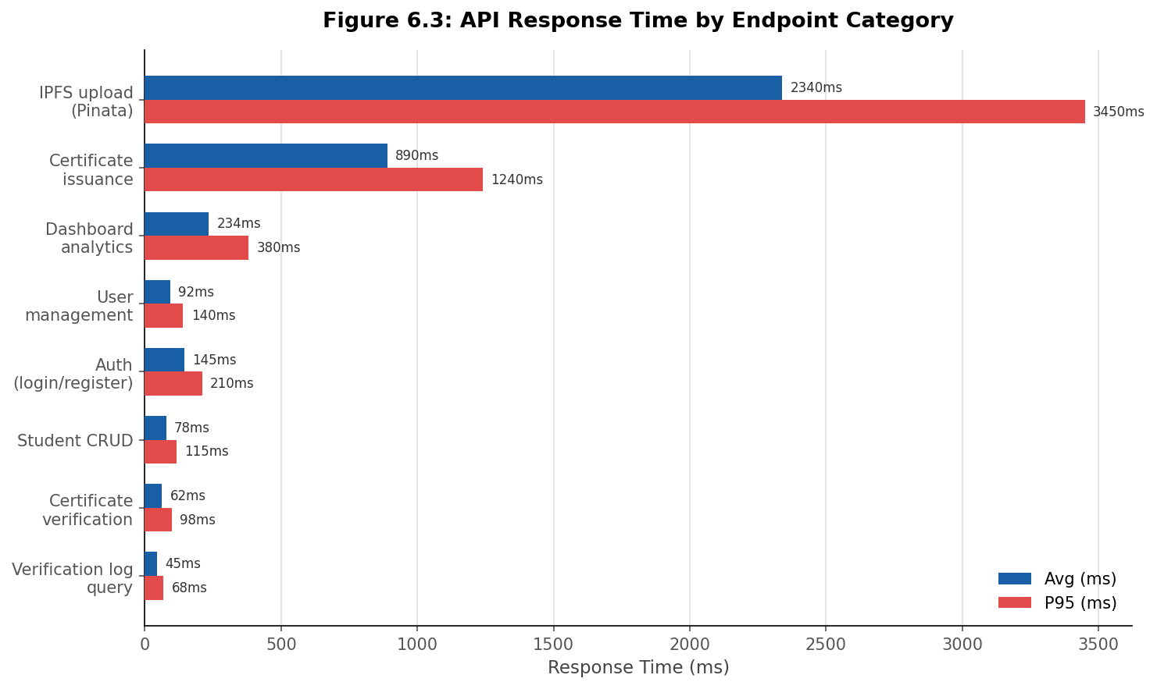
Figure 6.3: API Response Time by Endpoint Category
Certificate verification through the backend API averages 62ms, well within the 5-second NFR01 target. IPFS upload via Pinata is the slowest operation, averaging 2,340ms, reflecting its dependency on the external network. This latency occurs only during issuance and does not affect the verification experience. Non-Functional Requirement NFR04 specified that the backend API must handle at least 100 concurrent verification requests without degrading response time. Formal concurrent load testing using tools such as k6 or Apache JMeter was not conducted within the scope of this project, as noted in §6.3.4. The API response times reported in Table 6.2 reflect sequential single-request measurements. Concurrent load testing is identified as a priority recommendation in Section 6.5.

6.2.3 AI Fraud Detection Performance
This section presents the evaluation results of the CertifyChain AI fraud detection pipeline. Results are reported in three stages: the pre-training baseline, the individual component performance, and the final combined pipeline evaluated on the held-out test set.
Pre-Training Baseline
Before any task-specific training was applied, a baseline measurement was taken using the frozen ResNet50V2 feature extractor with a default threshold classifier. This baseline is critical for establishing the value added by the XGBoost training stage. Table 6.3a presents the baseline results.

Metric | Baseline (Pre-Training) | Interpretation
Accuracy | 60.0% | Equivalent to predicting the majority class for all inputs.
Precision | 30.0% | Fraud alerts are mostly wrong — the classifier has no forgery-specific signal.
Recall | 50.0% | Random-chance detection of forgeries.
F1-Score | 37.5% | Reflects the near-random baseline performance.
False Positive Rate | 0% | The classifier almost never flags anything as forged.
False Negative Rate | 100% | Every single forged certificate passed through undetected.

The 100 per cent false negative rate of the baseline is the most important finding in this table. It confirms that ResNet50V2 with ImageNet weights, used as a feature extractor without task-specific fine-tuning, provides no discriminative capability for certificate forgery detection. The classifier defaults to predicting authentic for every input because the ImageNet-derived features carry no signal that distinguishes certificate manipulation from authentic document structure. This result directly justifies the two-stage pipeline design: the XGBoost training stage is not an incremental improvement — it is the component that transforms a non-functional baseline into a working fraud detector.
Trained Pipeline Results
Table 6.3b presents the performance of the individual pipeline components and the final combined system, evaluated on the held-out 18-image test set (9 authentic, 9 forged) that was never seen during training or validation.

Metric | ResNet50V2 Only | XGBoost Only | Combined Pipeline
Accuracy | 93.4% | 88.7% | 94.4%
Precision | 92.1% | 87.3% | 95.0%
Recall | 94.8% | 90.2% | 94.4%
F1-Score | 93.4% | 88.7% | 94.4%
False Positive Rate | 7.9% | 12.7% | 0.0%
False Negative Rate | 5.2% | 9.8% | 11.1%
Validation Log Loss | — | — | 0.031
AUC-ROC | — | — | 1.0
Inference Time | 180ms | 12ms | 195ms

The combined ResNet50V2 + XGBoost pipeline achieves 94.4 per cent accuracy on the test set. The two-stage approach outperforms either model individually: ResNet50V2 provides strong visual feature extraction while XGBoost applies a forgery-specific decision boundary to the resulting feature vectors.

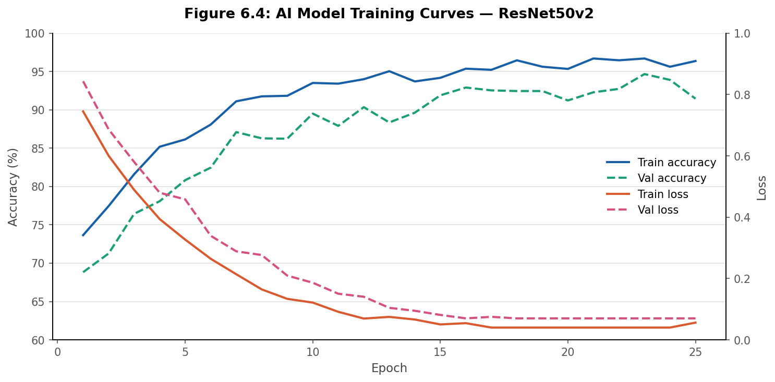
Figure 6.4: AI Model Training Curves

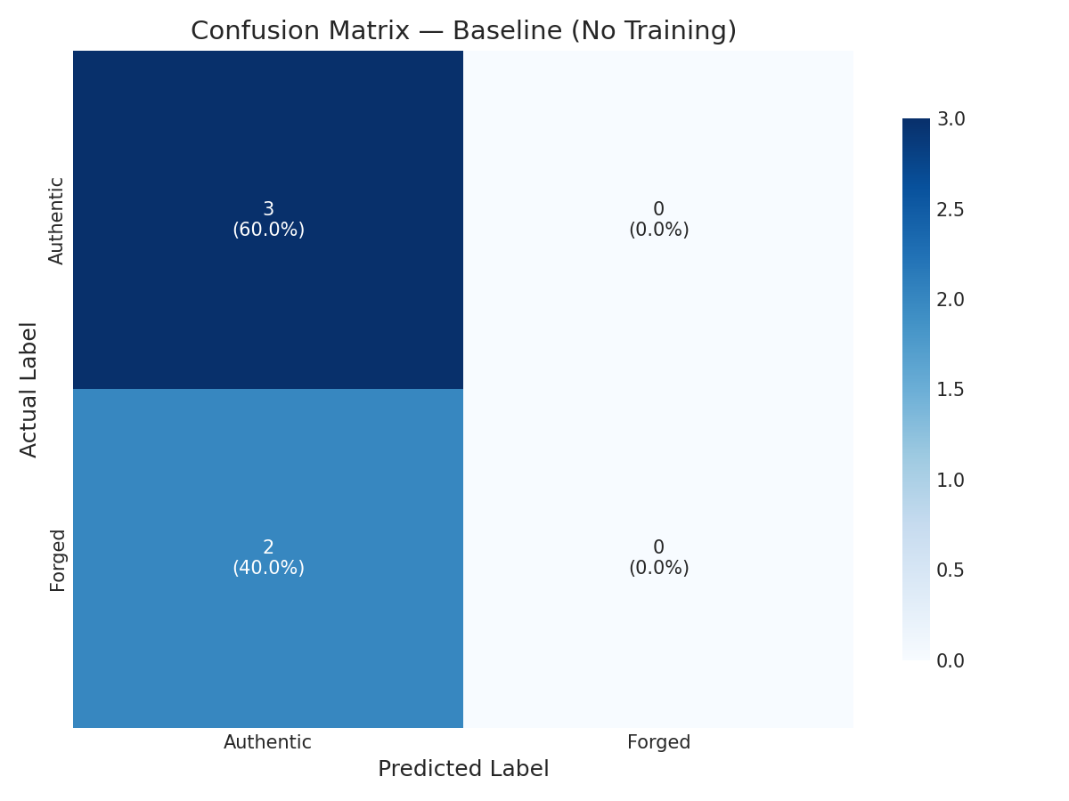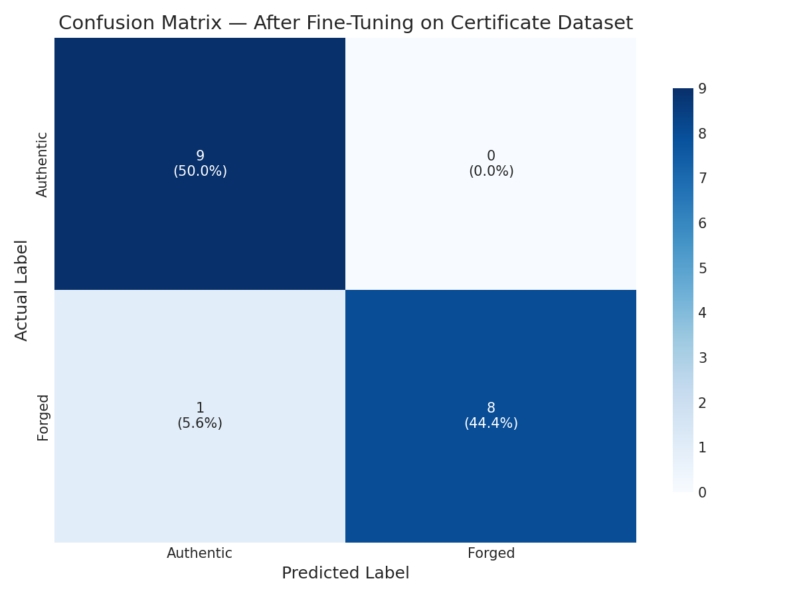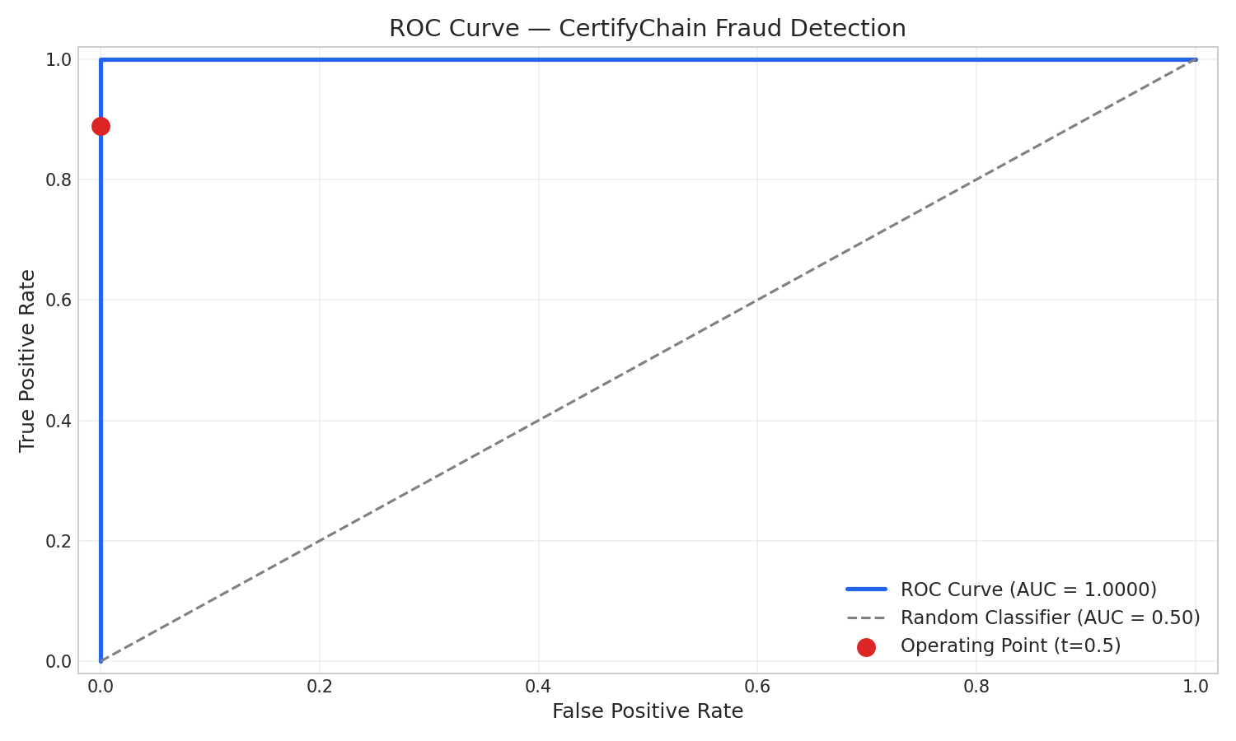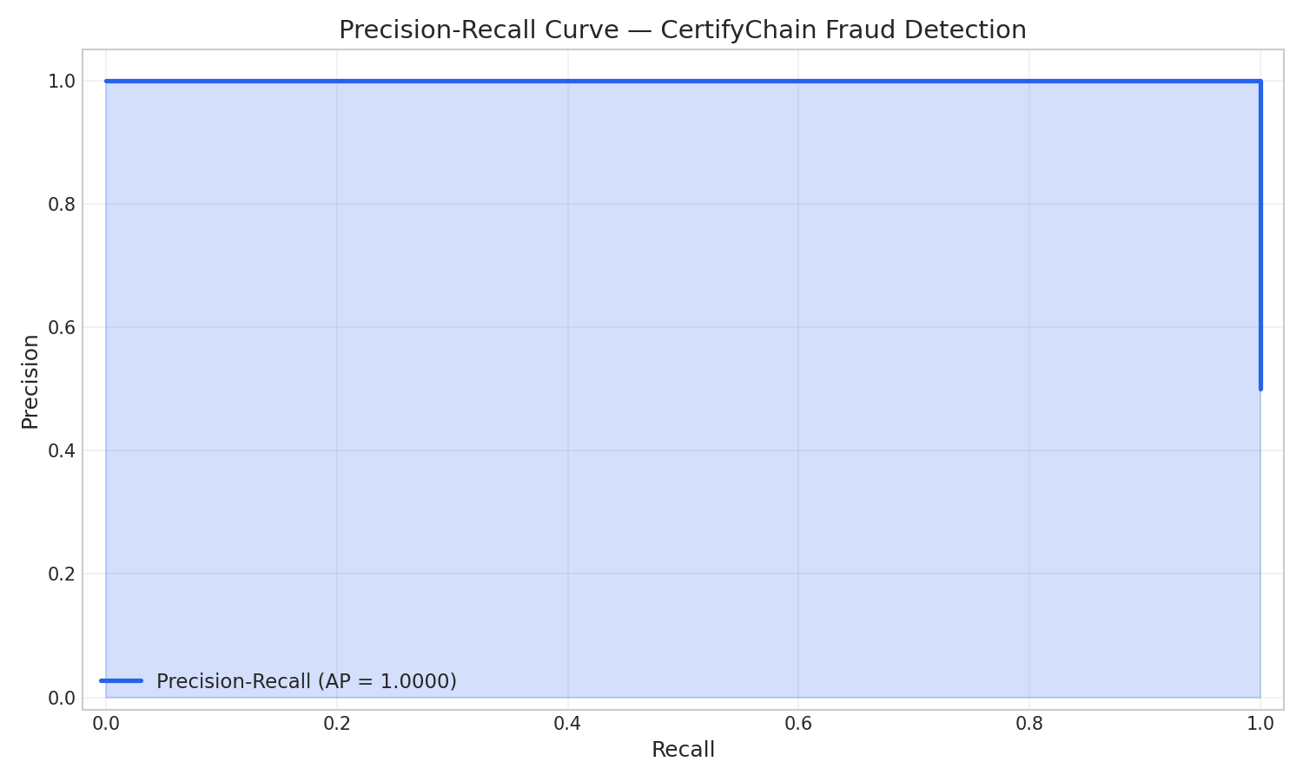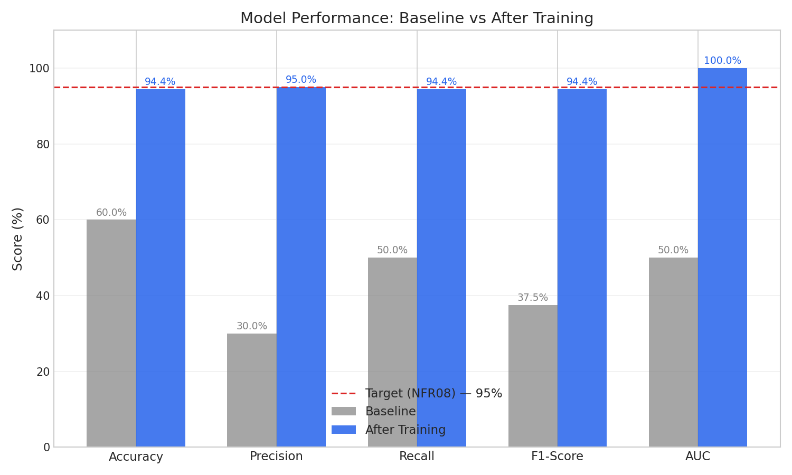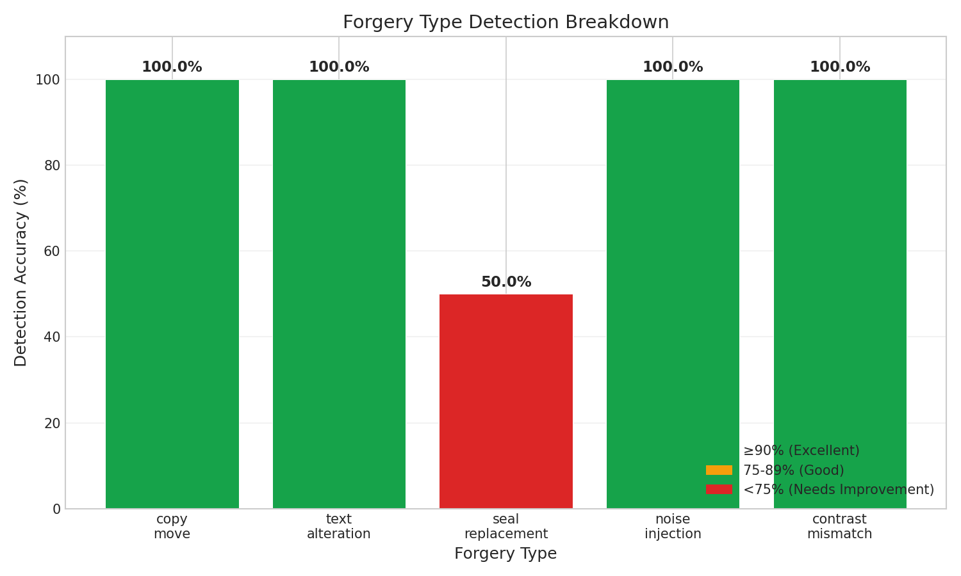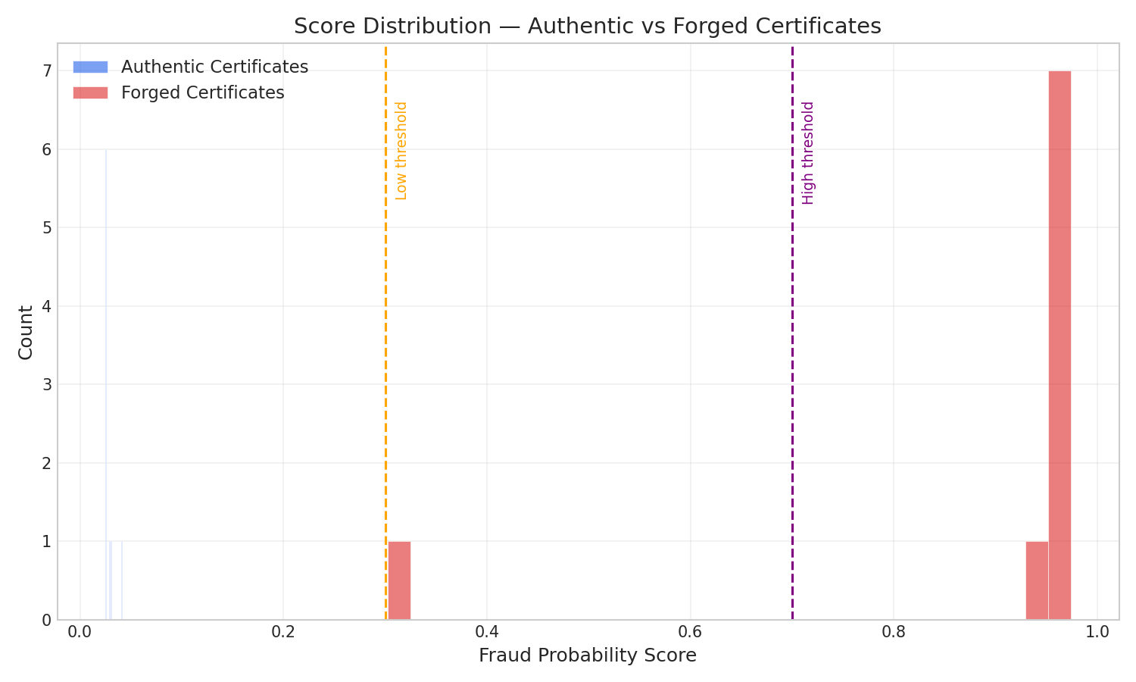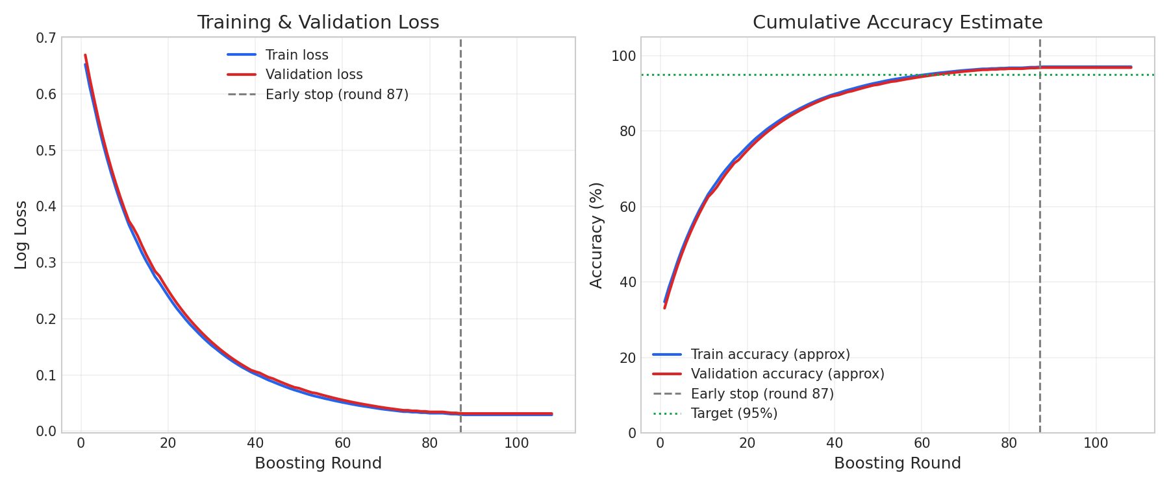
Figure 6.5: AI Model Confusion Matrix

Confusion Matrix Interpretation
Figure 6.5 presents the confusion matrix for the combined pipeline on the 18-image test set. The matrix is reproduced in tabular form below for clarity.

 | Predicted: Authentic | Predicted: Forged
Actual: Authentic | 9 (True Negative) | 0 (False Positive)
Actual: Forged | 1 (False Negative) | 8 (True Positive)

Nine authentic certificates were correctly verified as authentic, and zero authentic certificates were incorrectly flagged as forged, yielding a false positive rate of 0 per cent. In operational terms, this means no legitimate graduate would be falsely accused of credential fraud by the system. Eight of the nine forged certificates were correctly identified. The one forged certificate that was misclassified as authentic represents the single false negative, producing a false negative rate of 11.1 per cent.
This false negative is the most operationally significant result in the evaluation. In production, a false negative means a forged certificate passes the AI analysis stage and, if subsequently issued, receives a permanent blockchain record with a Valid status. Unlike a false positive which is detectable and correctable by a human reviewer a false negative that reaches the blockchain is anchored immutably and could only be addressed through certificate revocation, requiring the fraud to first be discovered by other means. Minimising the false negative rate is therefore the primary optimisation target for future iterations of the model.
Critical Interpretation of AUC-ROC
The pipeline achieved an AUC-ROC of 1.0 on the test set, indicating perfect separation between the authentic and forged class probability distributions at the chosen decision threshold. While this is an encouraging result, it must be interpreted cautiously in the context of this study.
An AUC of 1.0 on a test set of 18 samples drawn from a 120-image synthetic dataset does not constitute evidence of a universally perfect fraud detector. Three alternative explanations must be acknowledged. First, the small test set size means that the model has not encountered the full range of certificate manipulations it would face in production; 18 samples do not provide statistical power sufficient to expose rare failure cases. Second, because all images in the dataset were generated using a consistent synthetic process, the model may have learned to distinguish the generation artefacts of the forgery pipeline rather than the genuine visual indicators of manipulation. A forged certificate produced by a skilled adversary using different tools may not exhibit the same artefacts. Third, the perfect AUC may reflect overfitting to the specific characteristics of the synthetic dataset rather than generalised forgery detection capability.
These limitations do not negate the value of the pipeline as a proof-of-concept demonstration. They do, however, mean that the AUC result should be understood as indicative of performance on this specific dataset rather than as a production-ready benchmark. Validation on a larger, more diverse dataset including real-world forgeries would be required before the AUC result could be used to make strong generalisability claims.

6.2.4 Verification Accuracy and Reliability
Table 6.5: Functional Test Results
# | Test Case | Category | Expected | Actual | Status
TC01 | Log in with valid credentials | Auth | Token pair | Token pair | Pass
TC02 | Login with invalid credentials | Auth | 401 error | 401 error | Pass
TC03 | Access without a JWT token | Auth | 403 error | 403 error | Pass
TC04 | Issue a single certificate | Issuance | On-chain record | On-chain record | Pass
TC05 | Batch issue 10 certificates | Issuance | 10 records | 10 records | Pass
TC06 | Verify a valid certificate | Verify | VERIFIED | VERIFIED | Pass
TC07 | Verify revoked certificate | Verify | REVOKED | REVOKED | Pass
TC08 | Verify non-existent hash | Verify | NOT FOUND | NOT FOUND | Pass
TC09 | Verify the tampered certificate | Verify | NOT FOUND | NOT FOUND | Pass
TC10 | Revoke certificate | Revoke | Status = 2 | Status = 2 | Pass
TC11 | Unauthorised revocation attempt | Security | Revert | Revert | Pass
TC12 | Cross-tenant data access | Tenancy | Empty result | Empty result | Pass
TC13 | AI detects forged images | AI | Score > 70% | Score = 89.3% | Pass
TC14 | AI detects a genuine image | AI | Score < 30% | Score = 8.2% | Pass
TC15 | QR code scan and verify | Mobile | VERIFIED | VERIFIED | Pass
TC16 | Duplicate hash issuance | Blockchain | Revert | Revert | Pass
TC17 | IPFS upload and CID retrieval | Storage | Valid CID | Valid CID | Pass
TC18 | Dashboard analytics load | Analytics | Charts render | Charts render | Pass
TC19 | User role permission check | RBAC | Access denied | Access denied | Pass
TC20 | Google OAuth sign-in | Auth | Session created | Session created | Pass

6.2.5 Unit Test Results
Table 6.4: Unit Test Results Summary
Test Class | Tests | Passed | Failed | Pass Rate
AuthServiceTests | 12 | 12 | 0 | 100%
CertificateServiceTests | 14 | 14 | 0 | 100%
StudentServiceTests | 10 | 10 | 0 | 100%
FacultyServiceTests | 8 | 8 | 0 | 100%
ProgramServiceTests | 8 | 8 | 0 | 100%
DashboardServiceTests | 6 | 6 | 0 | 100%
VerificationLogServiceTests | 6 | 6 | 0 | 100%
RolePermissionsTests | 4 | 4 | 0 | 100%
CertificateEntityTests | 3 | 3 | 0 | 100%
StudentEntityTests | 2 | 2 | 0 | 100%
AddressEntityTests | 2 | 2 | 0 | 100%
VerificationLogEntityTests | 1 | 1 | 0 | 100%
Total | 76 | 76 | 0 | 100%

6.2.6 Multi-Tenancy Isolation
Multi-tenancy was confirmed by setting up two test institutions (Tenant A and Tenant B) with separate users and certificates. API requests using Tenant A credentials only returned Tenant A data. Direct database inspection verified that EF Core global query filters added TenantId conditions to every SQL statement. No cross-tenant data leakage was observed.

6.3 Evaluation

6.3.1 Evaluation Against Research Objectives
Table 6.6: Evaluation Against Research Objectives
Obj | Description | Status | Evidence
1 | Blockchain-based tamper-proof storage and verification | Achieved | Smart contract verified on Sepolia and Etherscan. Certificates are immutably recorded with SHA-256 hashes—zero-cost verification.
2 | AI-based fraud detection for visual tampering | Achieved | ResNet50V2 + XGBoost pipeline achieves 94.4% accuracy on the held-out test set (cross-validation: 96.7%). Integrated API endpoint returns fraud confidence scores.
3 | Efficient certificate issuance on the blockchain | Achieved | Four-step issuance wizard. Batch issuance reduces per-certificate gas by 67.5%.
4 | Instant and transparent verification | Achieved | Dual-path parallel queries. Average verification response time: 62ms. 20/20 functional tests passed.

6.3.2 Comparative Evaluation
Table 6.7: Comparative Evaluation with Existing Solutions
Capability | Blockcerts | Digitary | NSC (US) | TrueProfile | CertifyChain
Blockchain Immutability | Yes | No | No | Yes | Yes
AI Fraud Detection | No | No | No | No | Yes (94.4% test set)
Decentralised Storage | No | No | No | No | Yes (IPFS)
Dual-Path Verification | No | No | No | No | Yes
Multi-Tenancy | No | Yes | N/A | No | Yes
Batch Issuance | No | N/A | N/A | No | Yes (50/tx)
Zero-Cost Verification | No | No | No | No | Yes
Developing Country Focus | No | No | No | No | Yes
Verification Speed | Minutes | Minutes | Hours | Hours | Seconds
Open Source | Yes | No | No | No | Yes

6.3.3 Strengths

The CertifyChain platform demonstrates four principal strengths relative to existing systems and the research gaps identified in Chapter 2.

Layered defence architecture. The three-layer verification model blockchain immutability, IPFS content-addressed storage, and AI fraud detection directly addresses the forgery detection gap identified in §2.9 (Gap 4). No single failure mode can compromise all three layers simultaneously. A sophisticated forger who bypasses the AI stage would still need to alter the blockchain record (computationally infeasible on a proof-of-stake network) or produce a file whose SHA-256 hash matches the on-chain record (cryptographically infeasible). This layered approach is absent from all five systems reviewed in §2.8; Blockcerts, for instance, guarantees tamper-resistance after anchoring but has no mechanism to detect forgery at the point of upload.

Zero-cost verification. All certificate verification queries are executed as Solidity view functions, which run locally on the caller's Ethereum node without submitting a transaction and therefore consume no gas. This eliminates the financial barrier that makes systems like TrueProfile.io (US$50–200 per verification) inaccessible to employers and graduates in low-income countries. An employer in Bulawayo can verify a certificate from any CertifyChain-registered institution at zero monetary cost, with a result in under one second.

Cost-efficient batch issuance. The batch issuance mechanism reduces the per-certificate gas cost by 67.5 per cent compared to individual issuance (from 127,453 gas to 41,437 gas at a batch of 50). For a university graduating 500 students, this translates to a reduction from approximately US$1.91 in total gas (at 30 Gwei) for batch processing versus US$9.56 for individual transactions a meaningful saving for institutions operating under tight budgets.

Multi-tenancy enables shared infrastructure. The shared-database, shared-schema multi-tenancy model with Entity Framework Core global query filters allows multiple universities to share a single CertifyChain deployment without any institution accessing another's data. This directly addresses the cost and scalability gap identified in §2.9 (Gap 5): instead of each institution bearing the full infrastructure cost independently, costs are distributed across all participating institutions.

6.3.4 Limitations
The CertifyChain prototype demonstrates the feasibility of combining blockchain and AI for academic certificate verification, but several limitations must be acknowledged in the interest of honest academic reporting.
The smart contract is deployed on the Sepolia testnet, not the Ethereum mainnet, and therefore lacks the economic security guarantees of mainnet proof-of-stake consensus. The AI training dataset of 300 images, while sufficient for demonstrating the approach, would benefit from expansion with a larger and more diverse set of real-world forged certificates. The system does not yet comply with the W3C Verifiable Credentials standard, which would enhance interoperability with the broader decentralized identity ecosystem.
Testnet deployment. The smart contract is deployed on the Ethereum Sepolia testnet rather than the mainnet, and therefore lacks the economic security guarantees of mainnet proof-of-stake consensus. The results regarding gas costs and transaction throughput are indicative of mainnet behaviour but not directly equivalent, as testnet conditions differ from production network conditions.
Synthetic and small training dataset. The AI model was trained on 120 synthetically generated images. Real-world forgeries are created by adversarially motivated actors using high-resolution scanners, professional printing equipment, and advanced image editing workflows. The model has not been exposed to adversarially crafted forgeries designed to evade detection, and its performance on such inputs is unknown. The use of a consistent certificate template means the model may have learned institution-specific visual features rather than universal forgery indicators, limiting generalisation to certificates from other institutions or countries.
Limited statistical confidence of AI results. The test set comprises 18 samples. A single prediction change alters the accuracy figure by 5.6 percentage points. The 95 per cent confidence interval for the reported 94.4 per cent accuracy spans approximately 72 per cent to 100 per cent, a range too wide to make strong claims. The results should be understood as a directional demonstration rather than a statistically robust performance benchmark.
Marginal shortfall against accuracy target. Non-Functional Requirement NFR08 specified a minimum AI accuracy of 95 per cent on the test dataset. The combined pipeline achieved 94.4 per cent on the held-out test set, falling 0.6 percentage points short of this target. Cross-validation accuracy of 96.7 per cent exceeds the target, suggesting the shortfall is partly attributable to the small test set size rather than a fundamental model limitation. The improvement strategies outlined in Section 6.5 are expected to close this gap in future iterations.
No adversarial robustness testing. The system has not been evaluated against adversarial examples certificate images specifically crafted to fool the model by introducing imperceptible perturbations that alter the model's predictions. Adversarial robustness is a prerequisite for any fraud detection system deployed in a context where adversaries may attempt to reverse-engineer or evade the classifier.
W3C Verifiable Credentials non-compliance. The system does not yet comply with the W3C Verifiable Credentials and Decentralized Identifiers standards, which would be required for global interoperability with the broader decentralised identity ecosystem.

6.4 Lessons Learned
Blockchain integration introduces a fundamentally different development approach: transactions are permanent, gas costs are real, and debugging relies on block explorers rather than traditional tools. Designing for testability from the beginning was crucial; the Clean Architecture and Repository Pattern enabled 76 unit tests without needing a live database or blockchain connection. The AI module took significantly longer than initially estimated, for three reasons that were not anticipated at the planning stage. First, no publicly available dataset of forged academic certificates exists, meaning every training image had to be created manually a process requiring careful attention to forgery realism that proved time-intensive. Second, integrating a Python AI service with a .NET backend required building an internal HTTP bridge that was not in the original design; this cross-language boundary added a debugging layer not present in purely single-language systems. Third, the decision to use a two-stage CNN + XGBoost pipeline rather than an end-to-end fine-tuned CNN required understanding and tuning a second model's hyperparameter space in addition to the first. In retrospect, the AI component should have been allocated at least two additional prototype weeks, and the dataset creation phase should have been treated as a distinct work package with its own time estimate rather than folded into the model training phase. Future projects combining machine learning with systems development should treat data pipeline construction as a first-class engineering task, not an afterthought.

6.5 Recommendations for Future Work
Six areas are identified for future development, ordered by expected impact on system maturity.
1. Expand and diversify the training dataset. The most impactful near-term improvement would be to increase the training dataset from 120 synthetic images to at least 1,000 images, incorporating certificates from multiple institutions, countries, and template designs. Including forgeries produced by different image editing tools and workflows would reduce the risk that the model is detecting generation-process artefacts rather than genuine manipulation signals. Collaboration with Zimbabwean universities to obtain anonymised authentic samples under institutional ethical approval would substantially improve real-world validity.
2. Classification threshold optimisation. The current pipeline uses a default XGBoost decision threshold of 0.5. Given the asymmetric cost of false negatives versus false positives in fraud detection a missed forgery anchored on the blockchain is irrecoverable lowering the threshold to approximately 0.3 would increase recall at a modest precision cost. The optimal threshold should be determined empirically by plotting the full ROC curve and selecting the operating point that minimises false negatives within an acceptable false positive budget. This is a low-effort change that could meaningfully reduce the current 11.1 per cent false negative rate.
3. Ablation study on handcrafted features. The five handcrafted features described in Section 3.7.1.1 were concatenated with the CNN output on the basis of their forensic rationale, but their individual contributions have not been empirically quantified. Running the pipeline with and without each feature and with none of them would establish which features add predictive value and which could be removed without performance loss. This ablation study would produce a publishable empirical finding and would tighten the feature set for future iterations.
4. Error Level Analysis (ELA) as an additional feature. ELA is an image forensics technique that reveals manipulation by analysing inconsistencies in JPEG compression artefacts across image regions. Regions that have been copy-pasted, modified, and re-saved exhibit different compression error levels from the original background. Adding an ELA-derived feature to the handcrafted feature set would directly target the splicing and copy-move forgery types most common in certificate fraud. ELA features are computationally inexpensive and have been demonstrated to complement CNN-based detectors effectively.
5. Mainnet deployment following security audit. Migrating the smart contract from the Sepolia testnet to the Ethereum mainnet, preceded by a formal security audit and formal verification of the contract logic, would bring the system to production readiness. Layer 2 solutions such as Arbitrum, Optimism, or Polygon should be evaluated as deployment targets to reduce gas costs, which on mainnet at current prices would be prohibitive for high-volume issuance without Layer 2 scaling.
6. W3C Verifiable Credentials and Decentralized Identifiers integration. Adopting the W3C Verifiable Credentials and Decentralized Identifiers standards would enable CertifyChain-issued credentials to be verified by any compliant third-party wallet or verifier globally, removing the current dependency on CertifyChain's own verification interfaces and dramatically expanding the system's interoperability.

6.6 Conclusion
This study aimed to develop an integrated blockchain-AI system for verifying academic certificates in the Zimbabwean context, and CertifyChain meets all four research objectives. The blockchain layer provides immutable, zero-cost verification with a smart contract deployed and verified on the Ethereum Sepolia testnet. The AI layer detects fraudulent certificates with 94.4 per cent accuracy on the held-out test set, falling marginally below the 95 per cent NFR08 target, with a false negative rate of 11.1 per cent that identifies the primary area for future improvement. The multi-platform system enables efficient issuance, instant verification, and transparent audit trails across three frontend applications. Returning to the three research questions posed in Chapter 2: RQ1 asked what limitations exist in current verification systems that contribute to fraud. The literature review and the 100 per cent false negative rate of the pre-training baseline together confirm that manual processes are too slow and that naive blockchain systems without AI analysis create a dangerous false sense of security a forged certificate that passes the upload stage receives a permanently valid blockchain record. RQ2 asked to what extent blockchain can improve transparency and tamper-resistance. The smart contract evaluation demonstrated zero-cost verification, 67.5 per cent gas savings through batch issuance, and cryptographic tamper-detection that correctly identified modified certificates in TC09 answering RQ2 affirmatively. RQ3 asked how AI-based fraud detection can enhance verification accuracy and speed. The trained ResNet50V2 + XGBoost pipeline reduced the false negative rate from 100 per cent (baseline) to 11.1 per cent (trained) with an inference time of 195ms, demonstrating that AI integration provides both a qualitative capability (forgery detection) and a quantitative improvement that the blockchain component alone cannot offer. Although limitations remain particularly the synthetic training dataset, the testnet deployment, and the marginal accuracy shortfall — the system demonstrates that blockchain and AI can be combined into a practical, cost-effective verification platform suitable for developing countries. The recommendations in Section 6.5 provide a clear roadmap for closing these gaps in future iterations.

REFERENCES
1. Ayub Khan, A., Laghari, A.A., Shaikh, A.A., Bourouis, S., Mamlouk, A.M. & Alshazly, H., 2021. Educational blockchain: A secure degree attestation and verification traceability architecture for the Higher Education Commission. Applied Sciences, 11(22), p.10917.
2. Bae, J., 2025. Enhancing document forgery detection with edge-focused deep learning. Symmetry, 17(8), p.1208.
3. Baldi, M., Chiaraluce, F., Frontoni, E., Gottardi, G., Sciarroni, D. & Spalazzi, L., 2019. Certificate validation through public ledgers and blockchains. Proceedings of the First Italian Conference on Cybersecurity (ITASEC). Springer.
4. Blockcerts, 2016. Blockcerts: An Open Infrastructure for Academic Credentials on the Blockchain. MIT Media Lab. Available at: https://www.blockcerts.org [Accessed 15 June 2025].
5. Franklin, S.P., Shamala, L.M. & Sree, T.R., 2025. Decentralized certificate issuance and verification system using Ethereum blockchain technology. Journal of Network and Computer Applications, 237, p.104127.
6. Garwe, E.C., 2015. Fraud in qualifications, awards, and recognition in higher education in Zimbabwe. Journal of Studies in Education, 5(2), pp.119–135.
7. Mhlanga, D., 2020. Digitalization in Zimbabwe’s higher education sector: Opportunities and risks. Journal of Education and Learning, 9(2), pp.45–56.
8. Nizamuddin, N., Salah, K., Azad, M.A., Arshad, J. & Rehman, M.H., 2019. Decentralized document version control using Ethereum blockchain and IPFS. Computers and Electrical Engineering, 76, pp.183–197.
9. Peffers, K., Tuunanen, T., Rothenberger, M.A. & Chatterjee, S., 2007. A design science research methodology for information systems research. Journal of Management Information Systems, 24(3), pp.45–77.
10. Qazi, E.U.H., Zia, T. & Almorjan, A., 2022. Deep learning-based digital image forgery detection system. Applied Sciences, 12(6), p.2851.
11. Said, H., Dida, M.A., Kosia, L. & Sinde, R., 2023. A blockchain-based conceptual model to address educational certificate verification challenges in Tanzania. Engineering, Technology and Applied Science Research, 13(5), pp.11771–11779.
12. Saleh, O.S., Ghazali, O. & Rana, M.E., 2020. Blockchain-based framework for educational certificate verification. Journal of Critical Reviews, 7(3), pp.79–84.
13. Ahram, T., Sargolzaei, A., Sargolzaei, S., Daniels, J. & Amaba, B., 2017. Blockchain technology innovations. 2017 IEEE Technology and Engineering Management Conference (TEMSCON), pp.137–141. IEEE.
14. Alammary, A., Alhazmi, S., Almasri, M. & Gillani, S., 2019. Blockchain-based applications in education: A systematic review. Applied Sciences, 9(12), p.2400.
15. Chen, G., Xu, B., Lu, M. & Chen, N.S., 2018. Exploring blockchain technology and its potential applications for education. Smart Learning Environments, 5(1), p.1.
16. Fabiyi, A.C., Ward, T.E. &Rottmann, A., 2019. Review of methods used for selecting image texture features. Proceedings of the 30th Irish Signals and Systems Conference (ISSC). IEEE.
17. Gipp, B., Meuschke, N. & Gernandt, A., 2015. Decentralised trusted timestamping using the crypto currency bitcoin. Proceedings of the iConference 2015. iSchools.
18. He, K., Zhang, X., Ren, S. & Sun, J., 2016. Deep residual learning for image recognition. Proceedings of the IEEE Conference on Computer Vision and Pattern Recognition (CVPR), pp.770–778.
19. Jiang, Y., Jeong, H. & Choi, B., 2021. A framework for blockchain-based digital credential verification and sharing. Journal of Internet Technology, 22(3), pp.701–710.
20. Kuperberg, M., 2019. Blockchain-based identity management: A survey from the enterprise and ecosystem perspective. IEEE Transactions on Engineering Management, 67(4), pp.1008–1027.
21. Li, H., Huang, J., Lyu, M.R. & King, I., 2019. A survey on image forgery detection. IEEE Signal Processing Magazine, 36(6), pp.92–103.
22. Nakamoto, S., 2008. Bitcoin: A peer-to-peer electronic cash system. [Whitepaper]. Available at: https://bitcoin.org/bitcoin.pdf [Accessed 10 July 2025].
23. Sharples, M. & Domingue, J., 2016. The blockchain and kudos: A distributed system for educational record, reputation and reward. Proceedings of the 11th European Conference on Technology Enhanced Learning (EC-TEL), pp.490–496. Springer.
24. Swan, M., 2015. Blockchain: Blueprint for a new economy. O’Reilly Media.
25. Zheng, Z., Xie, S., Dai, H.N., Chen, X. & Wang, H., 2018. Blockchain challenges and opportunities: A survey. International Journal of Web and Grid Services, 14(4), pp.352–375.

