**Artificial Intelligence (Internship at DEP)**

**Submitted by:**

**Munaza Arshad**

**TASK#4**

Build a natural language processing (NLP) model to perform sentiment analysis on social media posts or product reviews...

**Introduction**

To build an NLP model for sentiment analysis on social media posts or product reviews, we'll use a well-known dataset. For this example, we'll use the "IMDB Movie Reviews" dataset, which is available from the tensorflow_datasets library. This dataset contains 50,000 movie reviews labeled as positive or negative.

**Step 1: Import Required Libraries**

First, install the required libraries if you haven't already:

**Code Snip:**

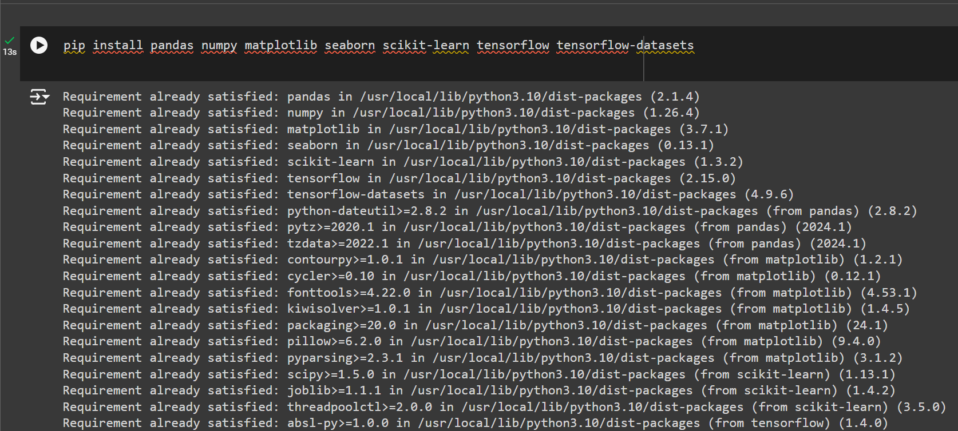

Now, import the libraries:

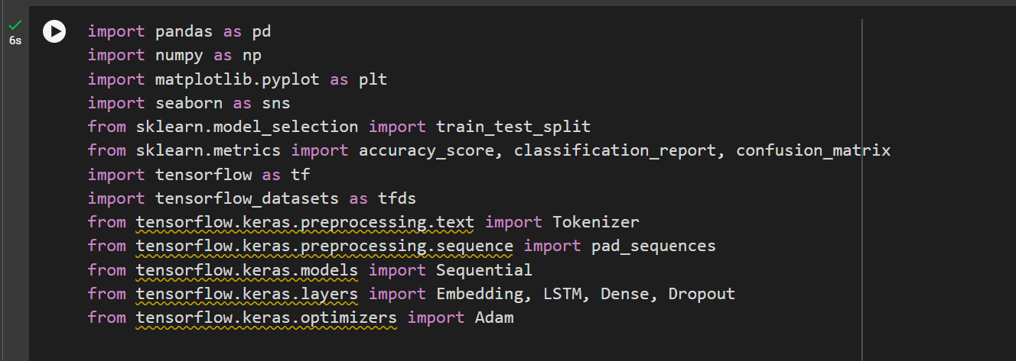

**Step 2: Load and Preprocess Data**

Load the IMDB Movie Reviews dataset:

**Code Snip:**

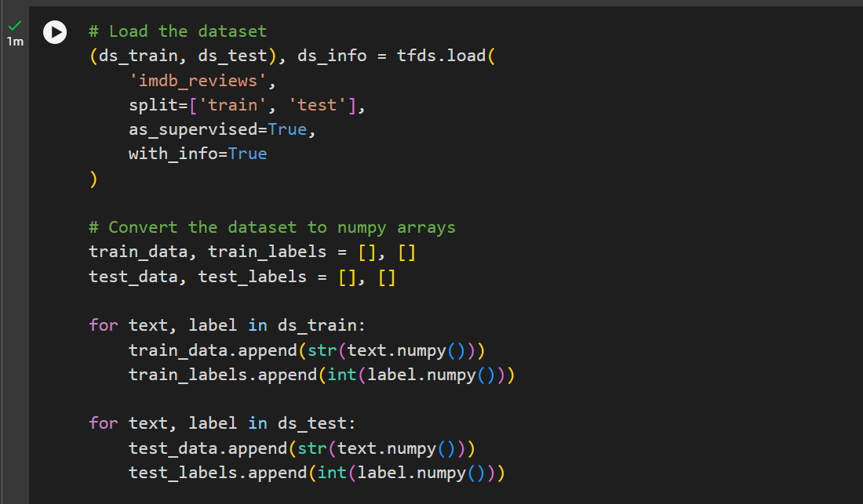

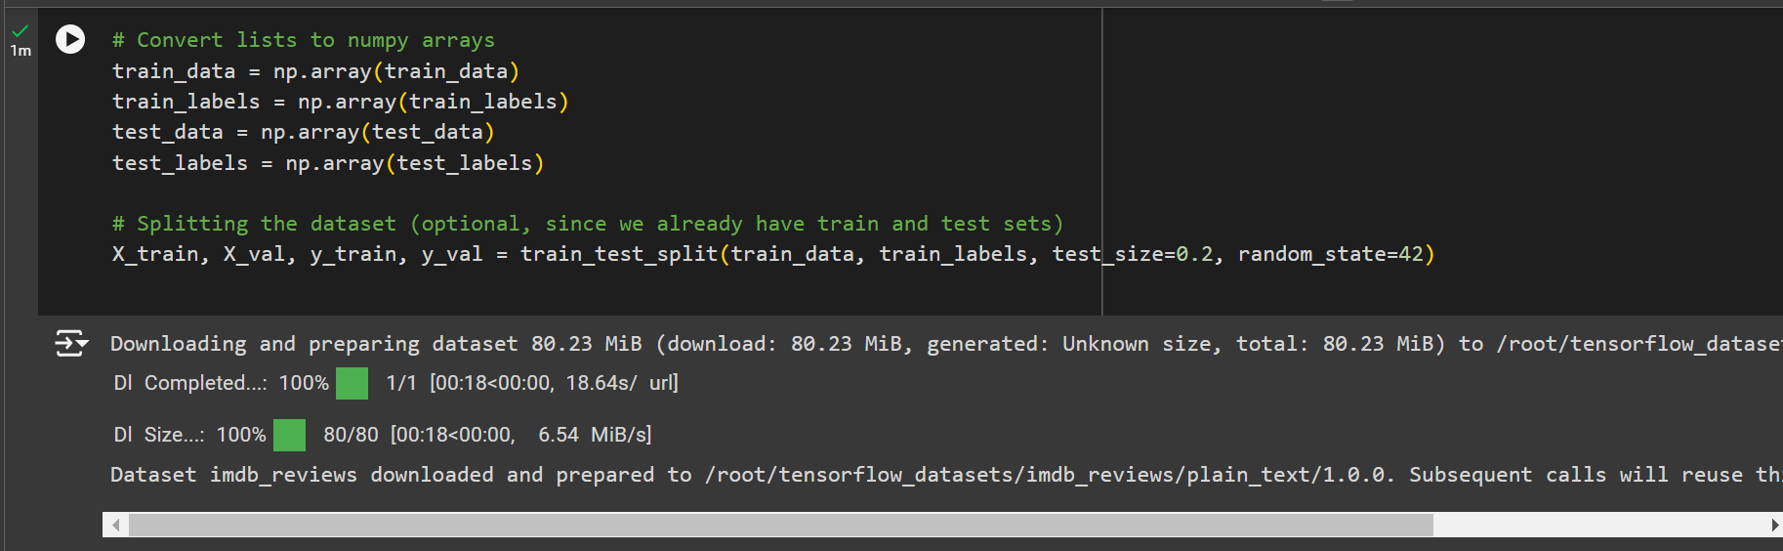

**Step 3: Text Vectorization and Tokenization**

We will use the Tokenizer and pad_sequences from Keras for text vectorization and tokenization:

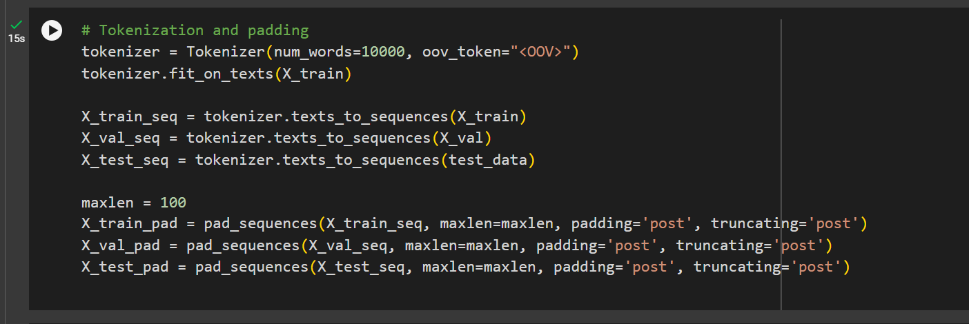

**Step 4: Building the LSTM Model**

We will use an LSTM model for sentiment analysis:

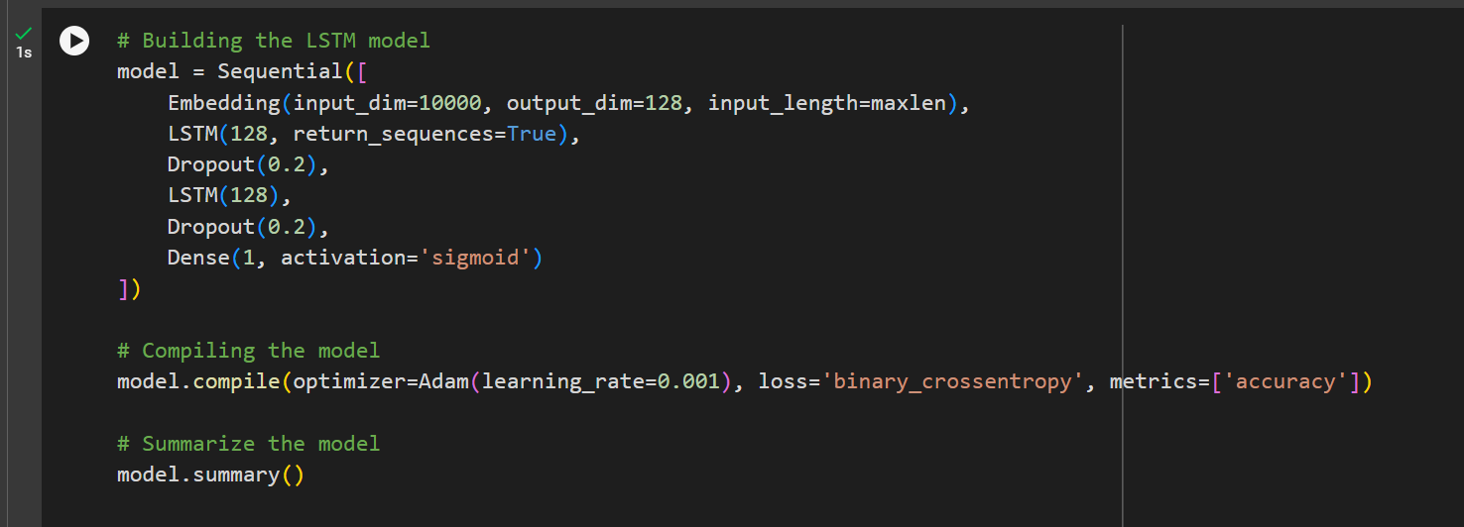

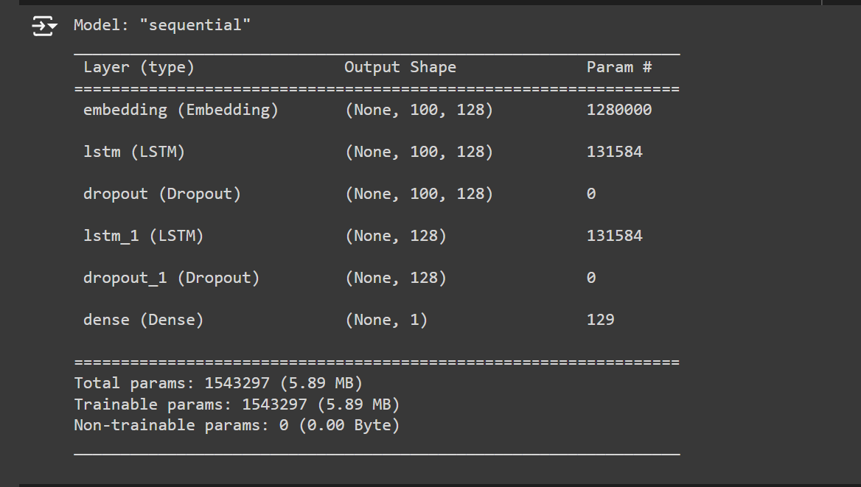

**Step 5: Training the Model**

Train the model with the training data:

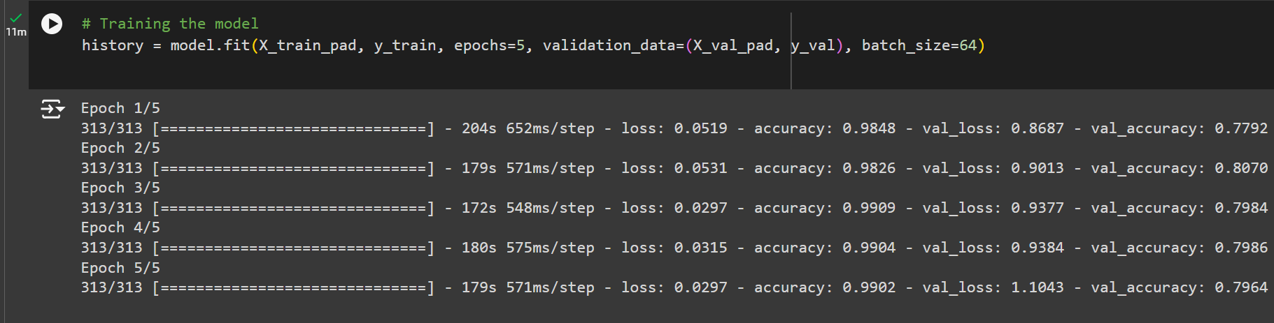

**Step 6: Evaluating the Model**

Evaluate the model's performance on the test data:

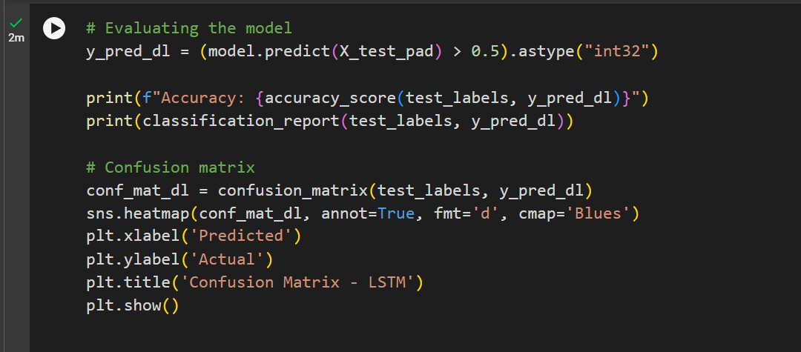

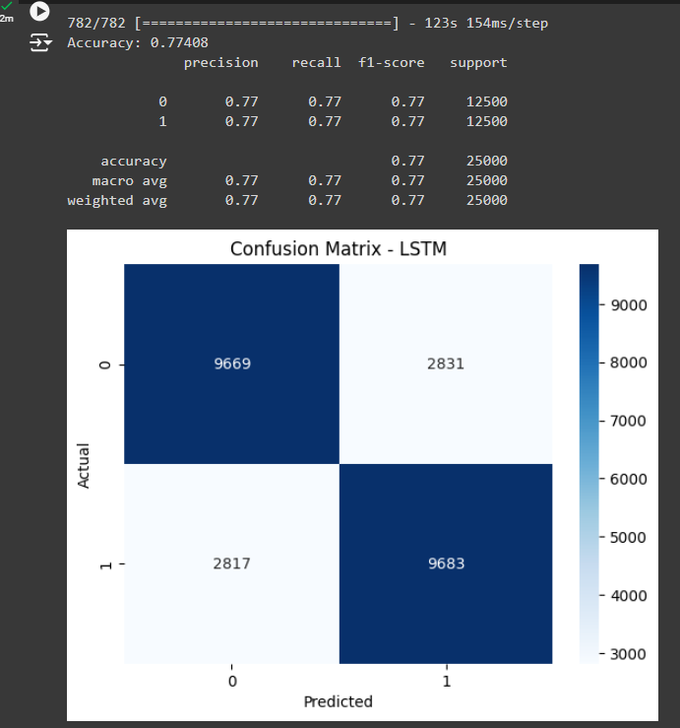.

**Step 7: Visualization**

Visualize the training process:

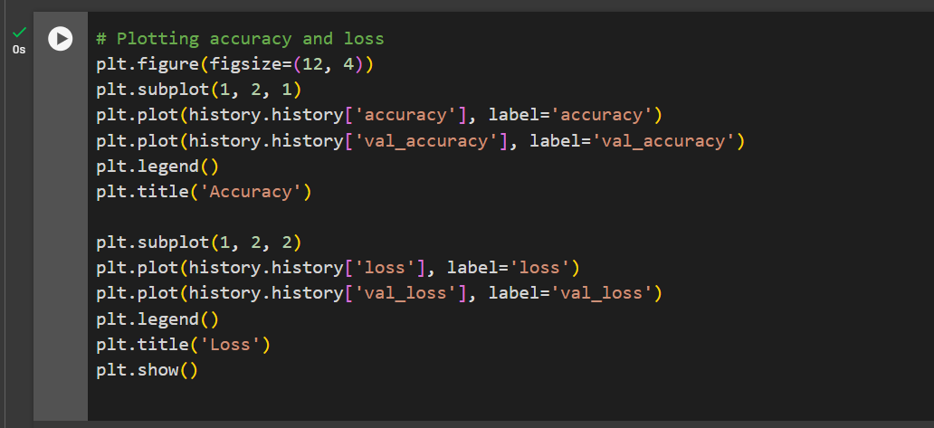

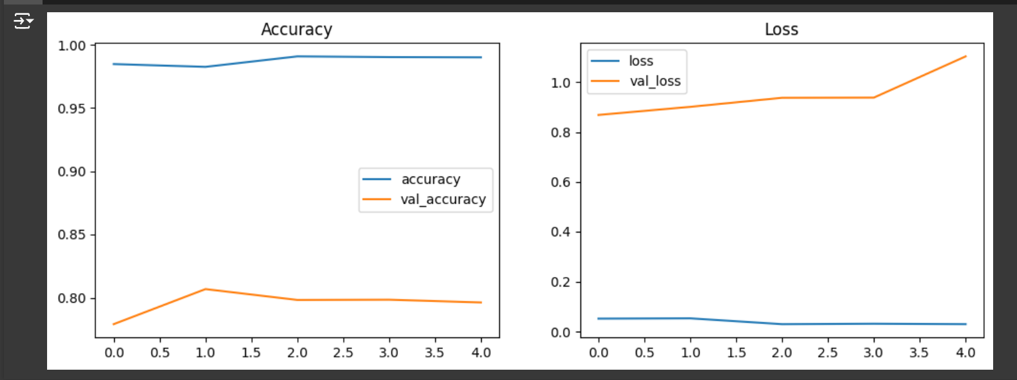

**Conclusion:**

This provides a complete pipeline for building an NLP model to perform sentiment analysis on social media posts or product reviews using the IMDB Movie Reviews dataset. You can experiment with different preprocessing techniques, model architectures, and hyperparameters to improve performance.

**GIT-HUB Repository Link:**