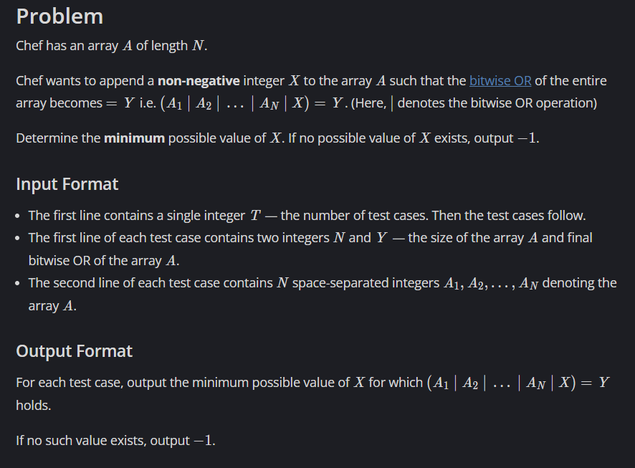

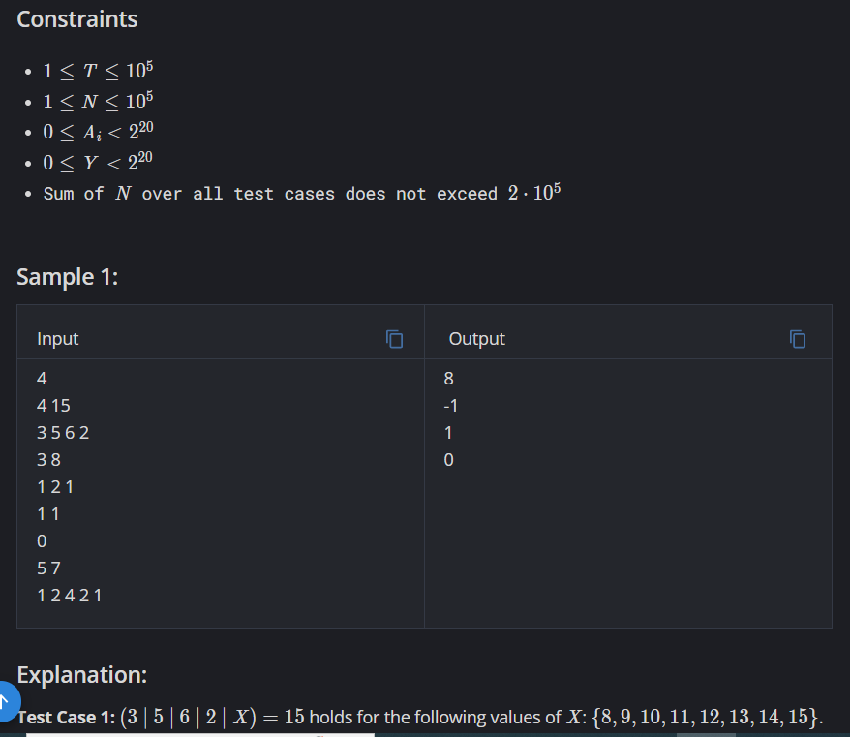

Link: <https://www.codechef.com/problems/APPENDOR>

Code:

#include <iostream>

using namespace std;

int main()

{

int t;

cin >> t;

while(t--)

{

int n, y;

cin >> n >> y;

int\* a=new int[n];

int x,ans=0;

for(int i=0;i<n;i++)

{

cin >> a[i];

ans = ans | a[i];

}

x = ans ^ y;

if(y == (ans | x))

cout << x << "\n";

else

cout << "-1\n";

}

return 0;

}