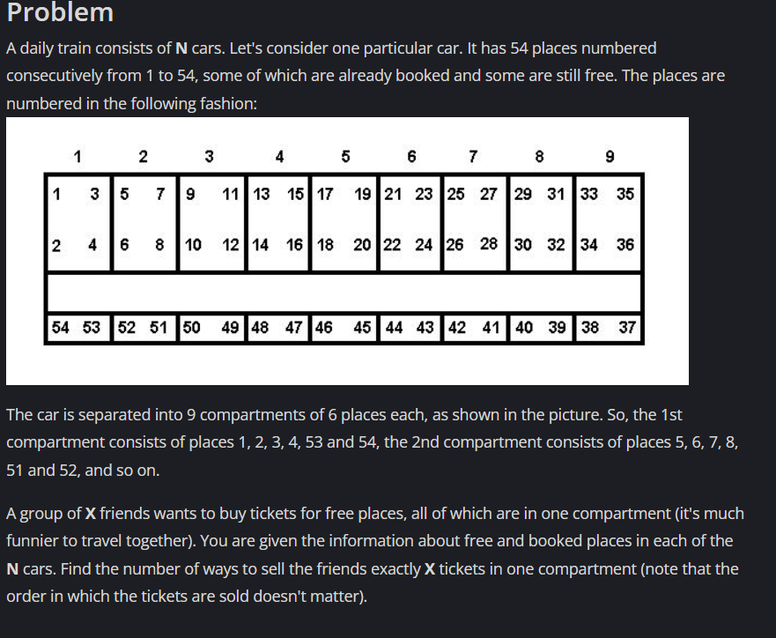

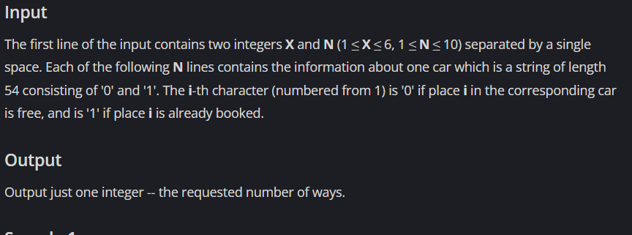

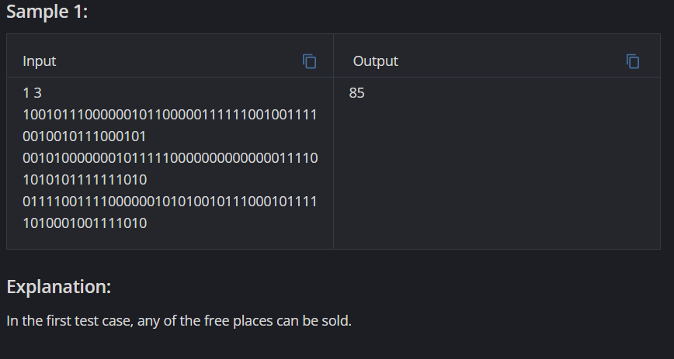

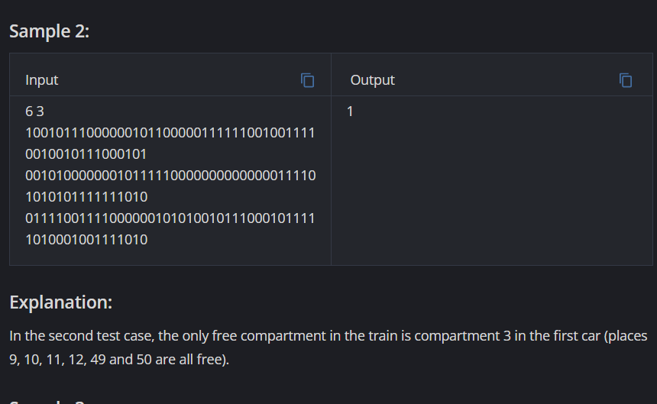

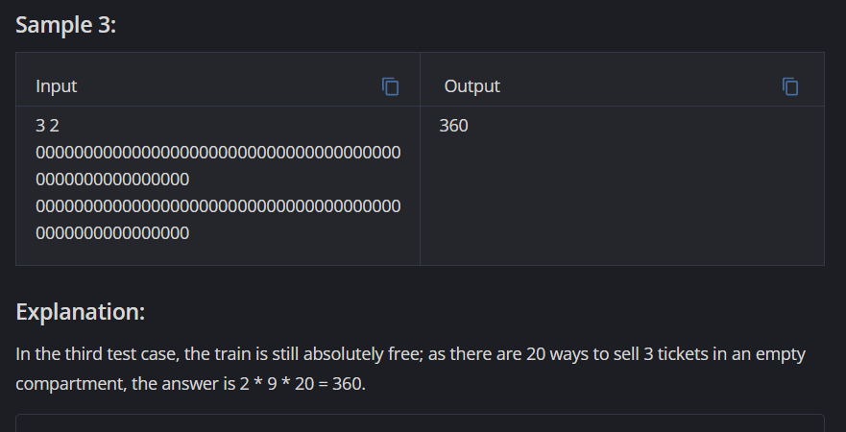

Link: <https://www.codechef.com/problems/DAILY>

Code:

#include <iostream>

#include <bits/stdc++.h>

using namespace std;

long long int comb(int n, int r)

{

long long p = 1, k = 1;

// C(n, r) == C(n, n-r),

// choosing the smaller value

if (n - r < r)

r = n - r;

if (r != 0)

{

while (r)

{

p *= n;

k *= r;

// gcd of p, k

long long m = __gcd(p, k);

p /= m;

k /= m;

n--;

r--;

}

}

else

p = 1;

return p;

}

int main()

{

int x,n;

cin >> x >> n;

int sum = 0;

while(n--)

{

string car;

cin >> car;

int s = 0, e=53;

for(int i=0;i<9;i++)

{

int f = (car[s]=='0'?1:0)+(car[s+1]=='0'?1:0)+(car[s+2]=='0'?1:0)+(car[s+3]=='0'?1:0) + (car[e]=='0'?1:0)+(car[e-1]=='0'?1:0);

if(f==x)

sum++;

else if (f>x)

sum += comb(f,x);

s+=4;

e-=2;

}

}

cout << sum;

return 0;

}