<https://codeforces.com/problemset/problem/1810/B>

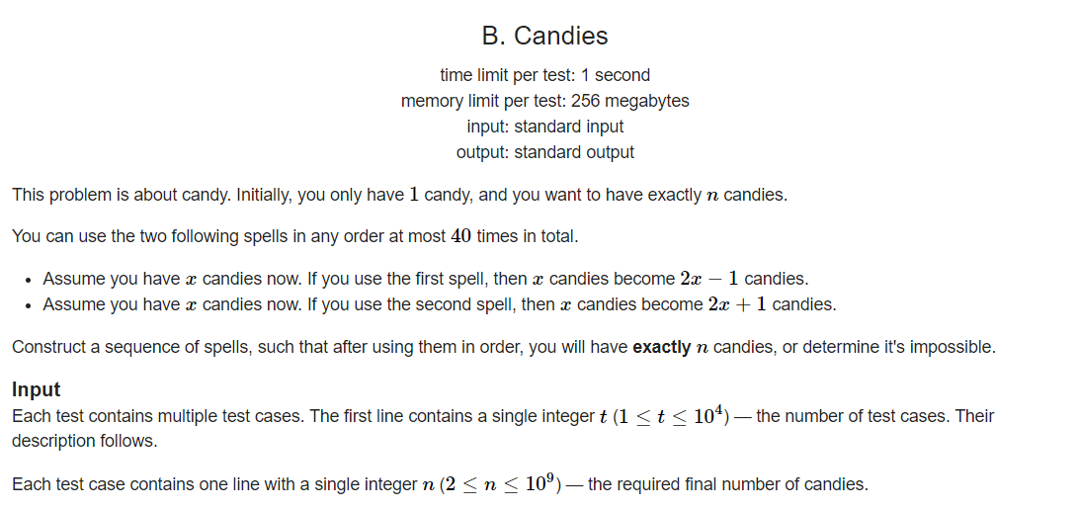

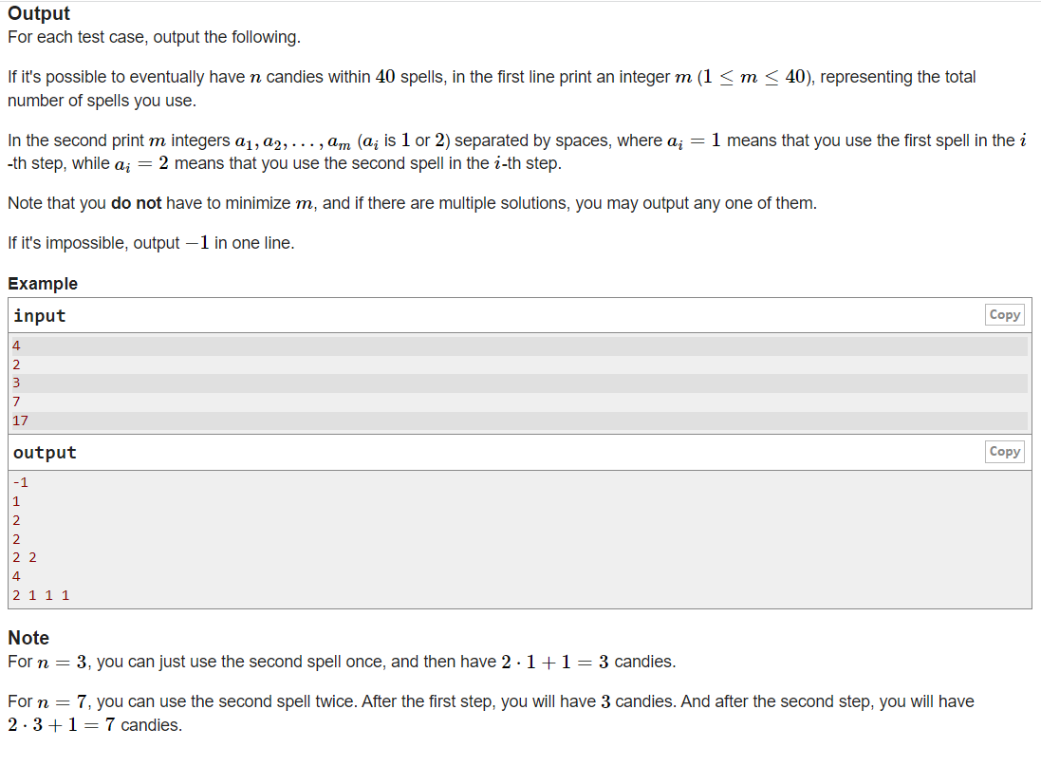

Code:

#include <vector>

#include <iostream>

using namespace std;

int main()

{

int t;

cin >> t;

while(t--)

{

int n;

cin >> n;

if(n%2==0)

{

cout << "-1\n";

}

else

{

int m = 0;

vector<int> v;

while(n!=1)

{

int n1 = (n+1)/2;

int n2 = (n-1)/2;

if(n1%2 != 0)

{

v.push_back(1);

n = n1;

}

else

{

v.push_back(2);

n = n2;

}

m++;

}

cout << m << "\n";

int n = v.size();

cout << v[n-1];

for(int i=n-2; i>=0;i--)

{

cout << " " << v[i];

}

cout << "\n";

}

}

return 0;

}