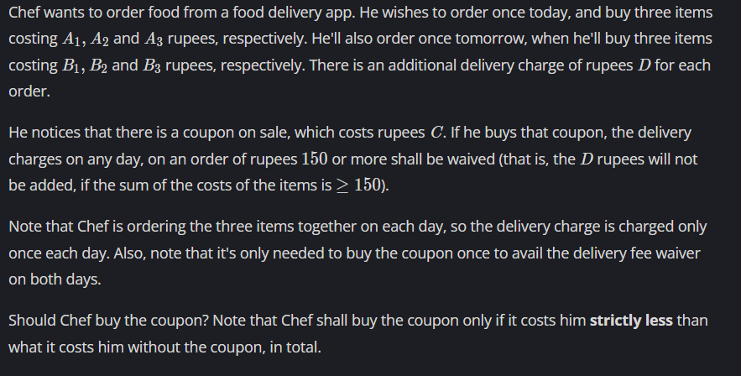

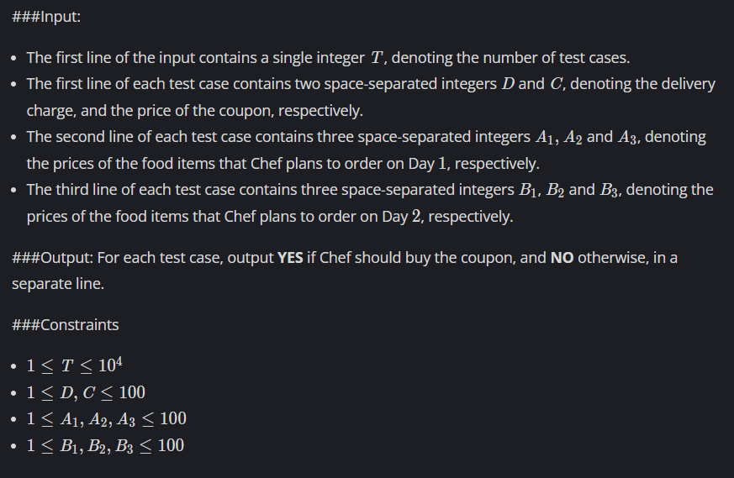

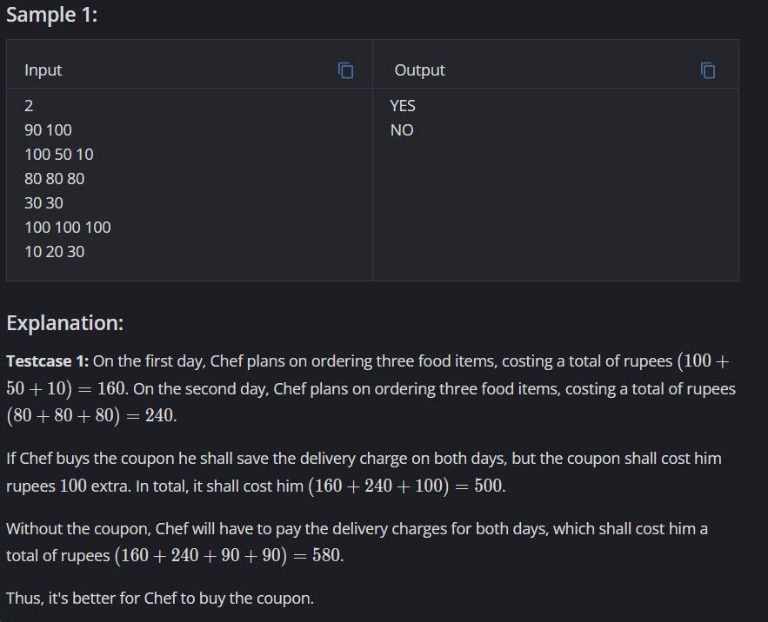

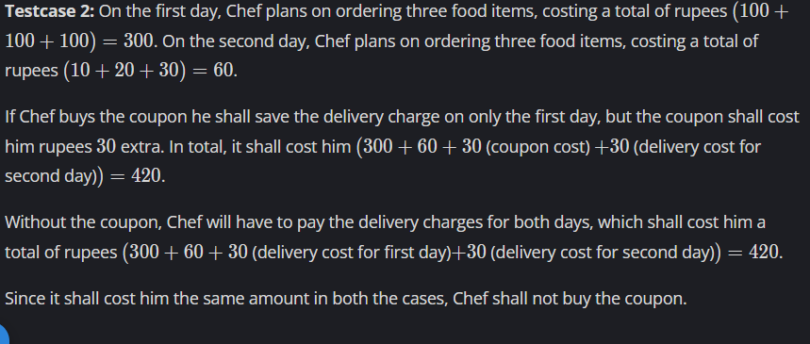

Link: <https://www.codechef.com/problems/COUPON2>

WORKING:

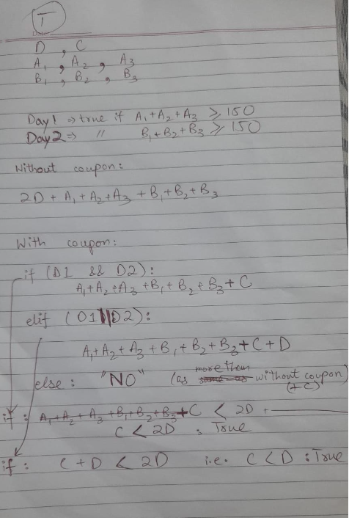

Code:

#include <iostream>

using namespace std;

int main()

{

int t;

cin >> t;

while(t--)

{

int d,c;

cin >> d >> c;

int a[3],b[3];

bool d1=false,d2=false;

cin >> a[0] >> a[1] >> a[2];

cin >> b[0] >> b[1] >> b[2];

if(a[0]+a[1]+a[2]>=150) d1= true;

if(b[0]+b[1]+b[2]>=150) d2=true;

if(d1 && d2)

{

if(c < 2\*d)

cout << "YES\n";

else

cout << "NO\n";

}

else if (d1 || d2)

{

if(c < d)

cout << "YES\n";

else

cout << "NO\n";

}

else

cout << "NO\n";

}

return 0;

}