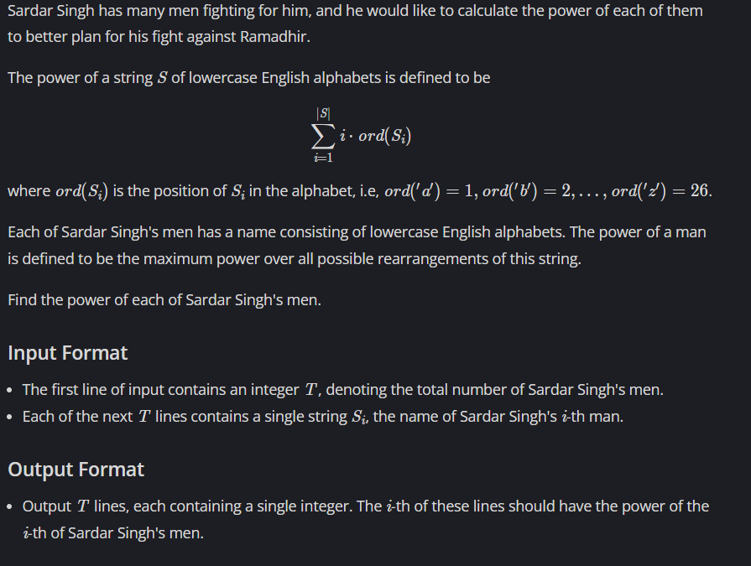

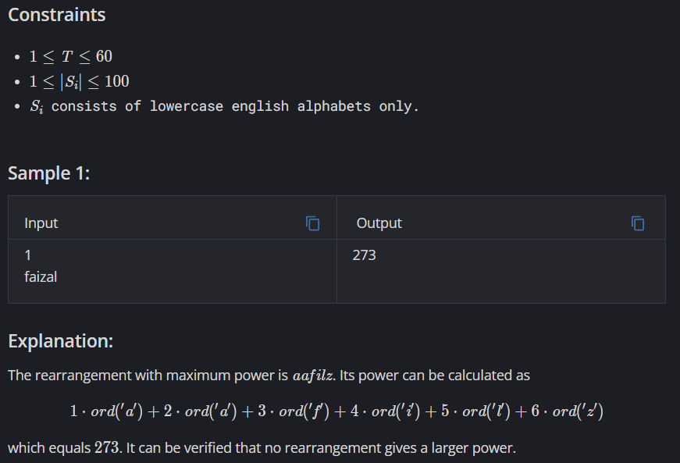

Link: <https://www.codechef.com/problems/CALPOWER>

Code:

#include <iostream>

#include <bits/stdc++.h>

using namespace std;

int main()

{

int t;

cin >> t;

while(t--)

{

string s;

cin >> s;

int n = s.length();

int\* arr= new int[n];

for(int i=0;i<n;i++)

arr[i] = int(s[i]-'a'+ 1);

sort(arr,arr+n);

int sum = 0;

for(int i=0;i<n;i++)

{

sum += (arr[i]\*(i+1));

}

cout << sum << "\n";

}

return 0;

}