<https://codeforces.com/problemset/problem/1807/C>

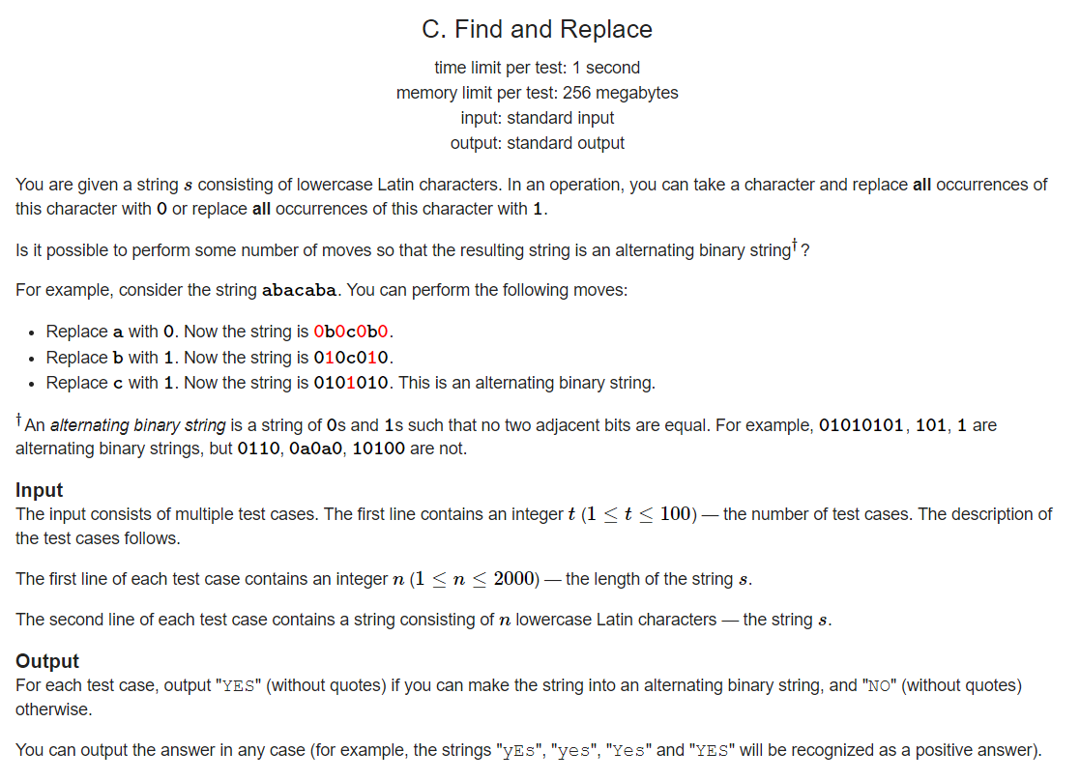

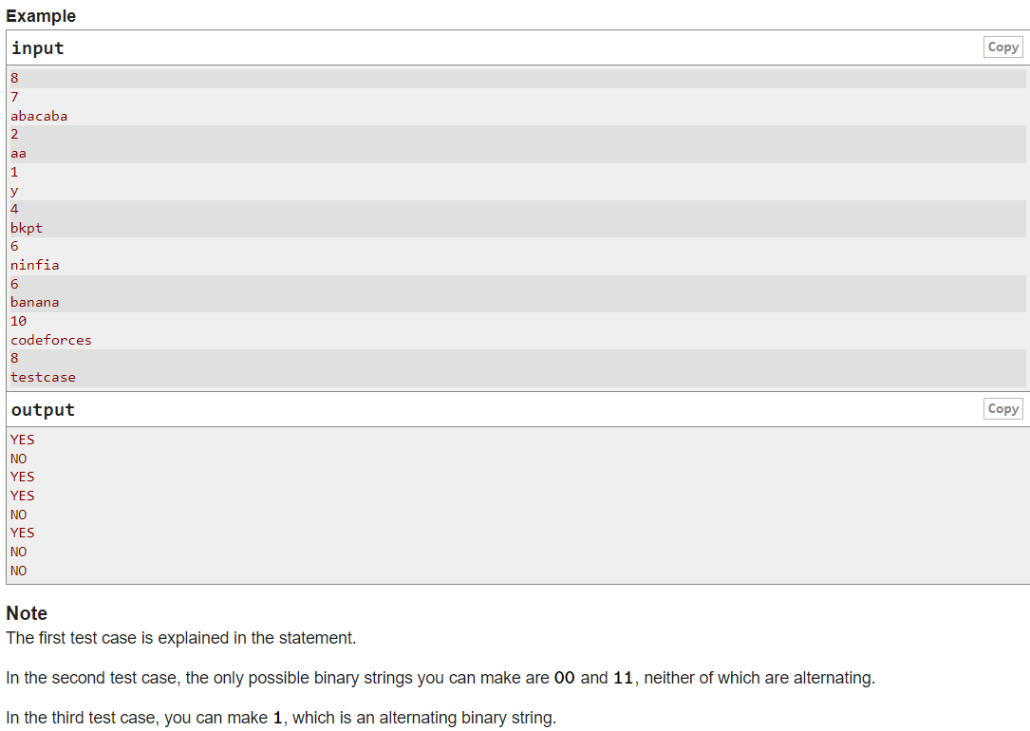

Code:

#include <iostream>

using namespace std;

int main()

{

int t;

cin >> t;

while(t--)

{

int n;

cin >> n;

string s;

cin >> s;

bool\* arr = new bool[n]{0};

bool ans = true;

for(int i=0;i<n && ans; i++)

{

if(!arr[i])

{

arr[i]=true;

bool even = (i%2 == 0);

for(int j=i+1;j<n;j++)

{

if(s[i]==s[j])

{

arr[j]=true;

if( even != (j%2==0))

{

ans = false;

break;

}

}

}

}

}

if(ans)

cout << "YES\n";

else

cout << "NO\n";

}

}