<https://codeforces.com/problemset/problem/1809/A>

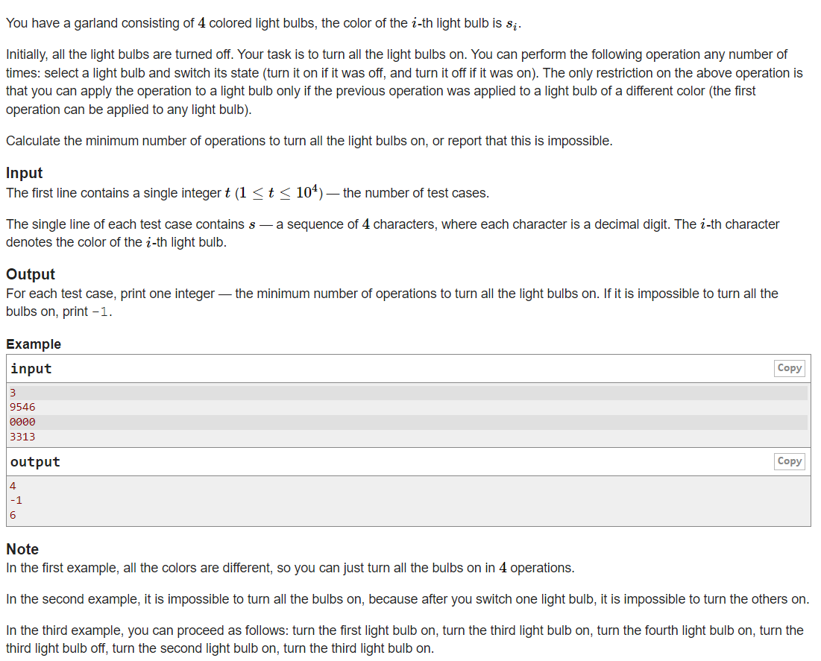

Code:

#include <iostream>

using namespace std;

int main()

{

int t;

cin >> t;

while(t--)

{

char a[4];

for(int i=0;i<4;i++)

cin >> a[i];

if(a[0]==a[1] && a[1]==a[2] && a[2]==a[3])

cout << "-1\n";

else if(a[0]==a[1] && (a[1]==a[2] || a[1]==a[3]))

cout << "6\n";

else if(a[0]==a[2] && a[2]==a[3])

cout << "6\n";

else if (a[1]==a[2] && a[2]==a[3])

cout << "6\n";

else

cout << "4\n";

}

}