<https://codeforces.com/problemset/problem/1811/A>

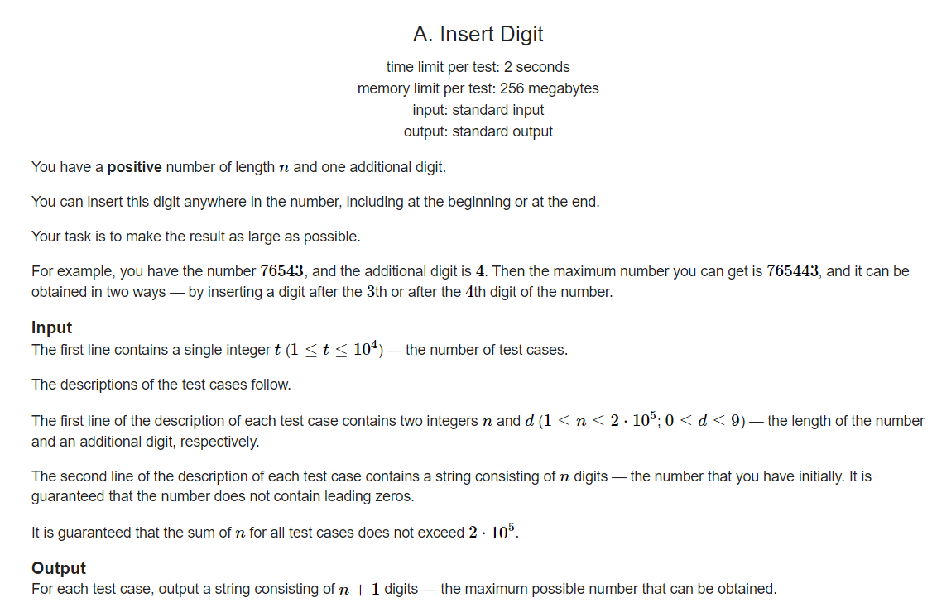

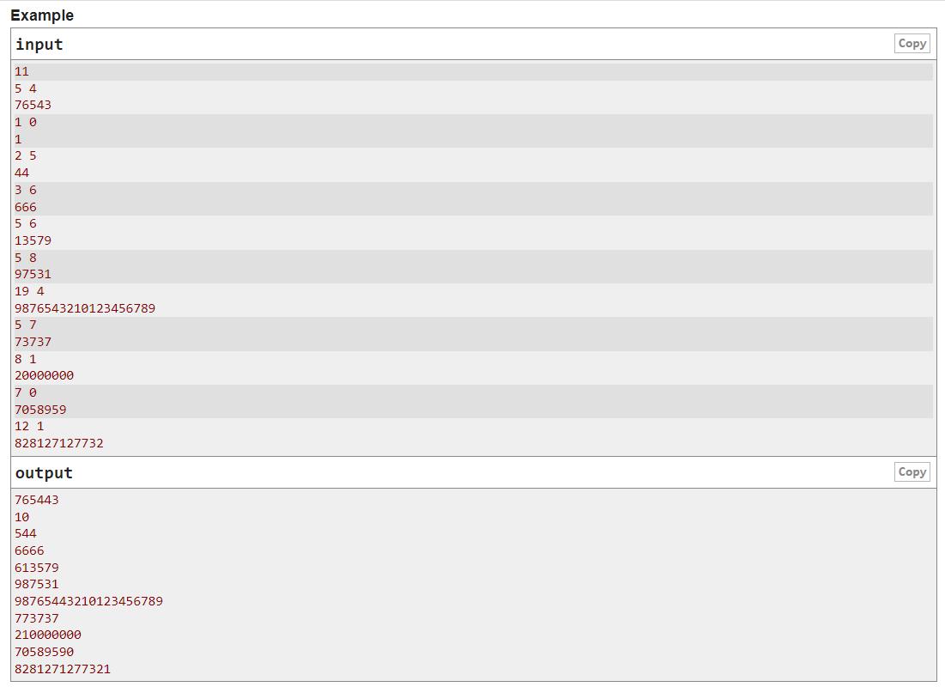

Code:

#include <iostream>

using namespace std;

int main()

{

int t;

cin >> t;

while(t--)

{

int n,d;

cin >> n >> d;

int\* arr = new int[n];

for(int i=0;i<n;i++)

{

char c;

cin >> c;

arr[i] = c - '0';

}

int ind;

for(ind = 0;ind<n;ind++)

{

if(arr[ind] < d)

break;

}

for(int i=0;i<n;i++)

{

if(ind == i)

cout << d;

cout << arr[i];

}

if(ind == n)

cout << d;

cout << "\n";

}

}