<https://codeforces.com/problemset/problem/1806/A>

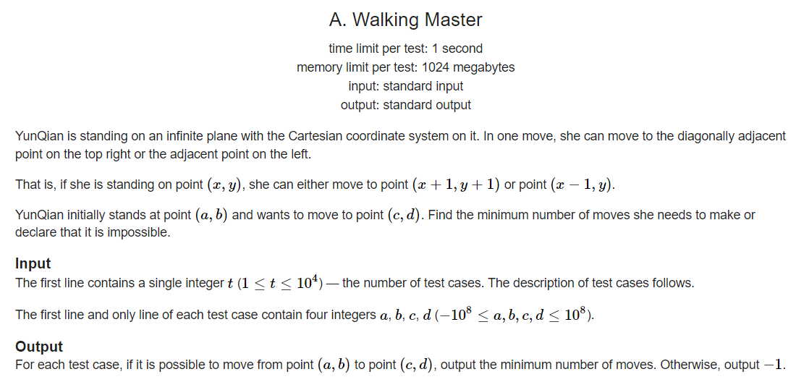

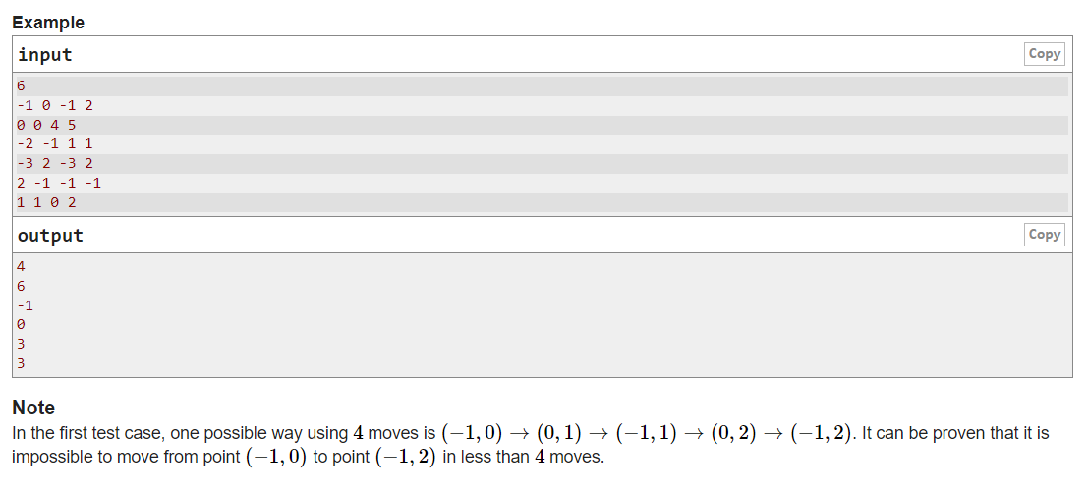

Code:

// Online C++ compiler to run C++ program online

#include <iostream>

#include <bits/stdc++.h>

using namespace std;

int main()

{

int t;

cin >> t;

while(t--)

{

int a,b,c,d;

cin >> a >> b >> c >> d;

int ans;

if(d < b)

{

ans = -1;

}

else if (d == b)

{

if(a == c)

ans = 0;

else if( a > c)

ans = a - c;

else

ans = -1;

}

else

{

int m1 = d - b;

int x = a + m1;

if(x == c)

ans = m1;

else if (x > c)

ans = m1 + (x - c);

else

ans = -1;

}

cout << ans << "\n";

}

return 0;

}