<https://codeforces.com/problemset/problem/1810/A>

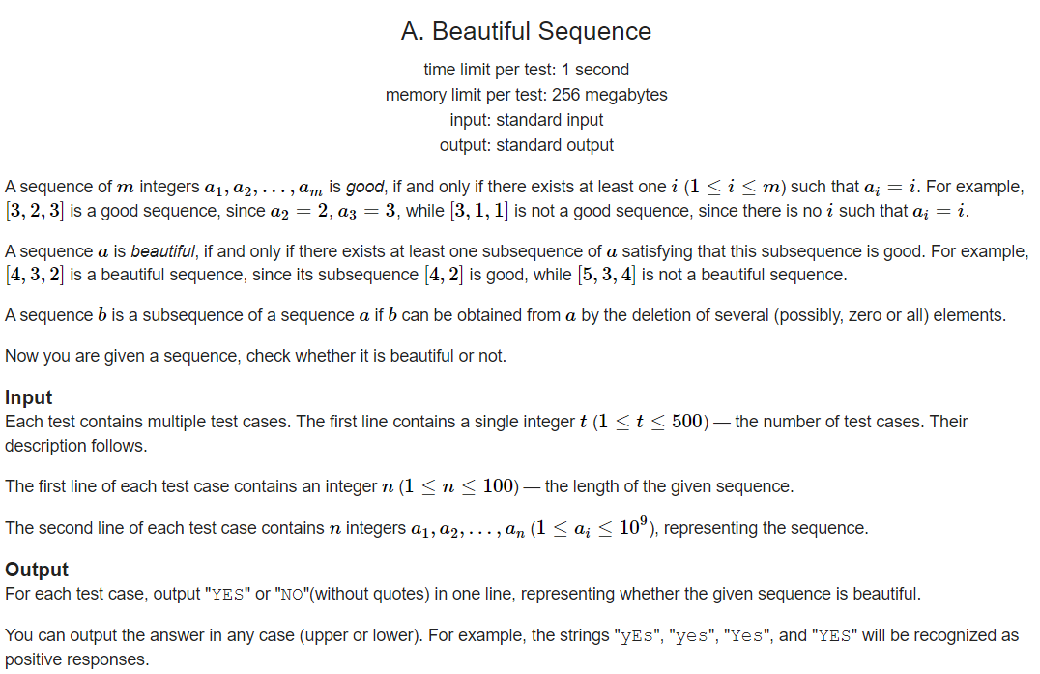

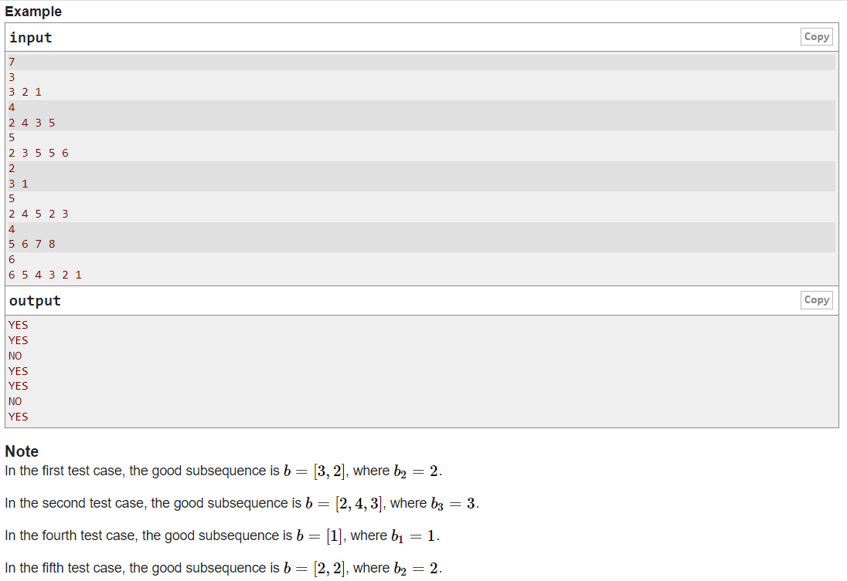

Code:

#include <iostream>

using namespace std;

int main()

{

int t;

cin >> t;

while(t--)

{

int n;

cin >> n;

int\* arr = new int[n];

for(int i=1;i<=n;i++)

{

cin >> arr[i-1];

}

bool v = false;

for(int i=1;i<=n;i++)

{

if(arr[i-1] <= i)

{

v = true;

break;

}

}

if(v)

cout << "YES\n";

else

cout << "NO\n";

}

}