***Baume& Mercier***

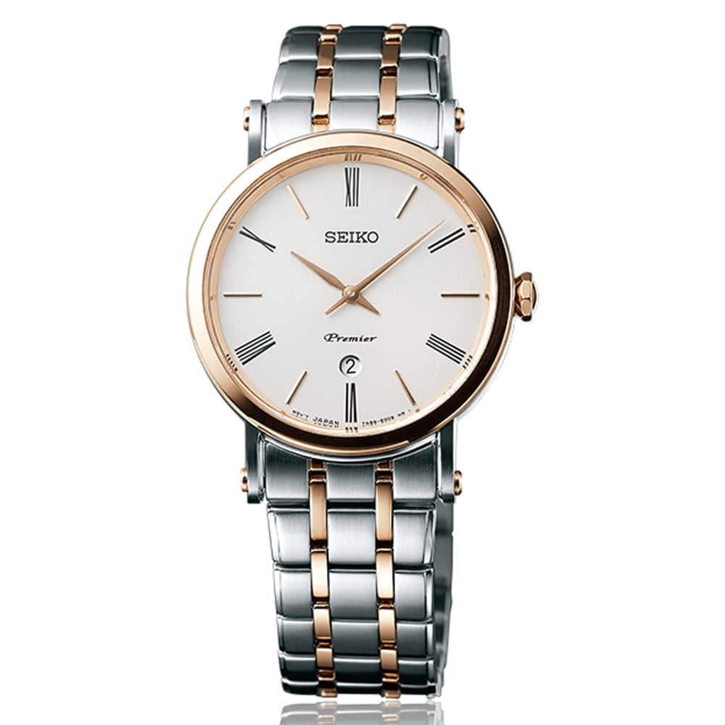

***Price:***

***Rs:6,900***