

PROJECT WORK PHASE 1 (DS784)

REPORT

On
NeuroCure
(Brain Tumour Detection Software)

Submitted in partial fulfillment of the requirements for the degree of

BACHELOR OF TECHNOLOGY in
Computer Science and Engineering
(Data Science)
By

Darin Davis Johnson 2262214
Ryan Netto 2262248
Tom Jimmy 2262261

Under the Guidance of

Dr. Wims Mary Magdalene

Department of AI, ML and Data Science,
School of Engineering and Technology,
CHRIST (Deemed to be University),
Kumbalgodu, Bengaluru - 560 074.

September – 2025


School of Engineering and Technology
Department of AI, ML and Data Science

CERTIFICATE

This is to certify that Ryan Netto (2262248), Tom Jimmy (2262261), Darin Davis Johnson (2262214) have successfully completed the Project Work Phase 1 (DS784) entitled NeuroCure (Brain Tumor Detection Software) in partial fulfilment for the award of Bachelor of Technology in Computer Science and Engineering (Data Science) during the year 2025-2026.

Dr. Wims Mary Magdalene Dr Michael Moses T
Asst. Professor HoD
Christ University

Dr Mary Anita E A
Associate Dean



School of Engineering and Technology
Department of AI, ML and Data Science

BONAFIDE CERTIFICATE

It is to certify that this Project Work Phase 1 (DS784) titled “NeuroCure (Brain Tumor Detection Software)” is the bonafide work of

Name Register Number

Darin Davis Johnson 2262214
Ryan Netto 2262248
Tom Jimmy 2262261

Examiners [Name and Signature]

Date of Examination:

Acknowledgement

We would like to thank CHRIST (Deemed to be University) Vice Chancellor, Dr Rev. Fr. Jose C C, Pro Vice Chancellor, Dr Rev. Fr. Viju P D, Director, School of Engineering and Technology, Dr Rev. Fr. Jiby Jose E, Assistant Director, Rev. Fr. Shijin P J, the Dean, School of Engineering and Technology, Dr Raghunandan Kumar R and the Associate Dean, Dr Mary Anita E A, for their kind patronage.

We would like to express our sincere gratitude and appreciation to the Head of the Department of AI, ML and Data Science, Dr Michael Moses T, for giving us this opportunity to take up this project.

We also take this opportunity to express a deep sense of gratitude to Dr Rekha V, Program Coordinator, Computer Science and Engineering (Data Science) and Dr Wims Mary Magdalene, Project Coordinator, for their timely support and valuable guidance.

We are extremely grateful to our guide, Dr Wims Mary Magdalene, who has supported and helped to carry out the project. Her constant monitoring and encouragement helped us keep up with the project schedule.

We extend our sincere thanks to all the teaching and non-teaching staff, Department of AI, ML and Data Science. Also, we thank our family members and friends who directly or indirectly supported the project's completion.

Darin Davis Johnson (2262214)
Ryan Netto (2262248)
Tom Jimmy (2262261)

Declaration

We hereby declare that the Project Work Phase 1 titled “NeuroCure (Brain Tumor Detection Software)” is a record of original project work undertaken by us for the award of the degree of Bachelor of Technology in Computer Science and Engineering (Data Science). We have completed this study under the supervision of Dr Wims Mary Magdalene, Department of AI, ML, and Data Science.

We also declare that this project report has not been submitted for the award of any degree, diploma, associate ship, fellowship, or other title anywhere else. It has not been sent for any publication or presentation purposes.

Place: School of Engineering and Technology, CHRIST (Deemed to be University), Bengaluru

Date: 24/09/2025

Name | Register Number | Signature
Ryan  Netto | 2262248
Tom  Jimmy | 2262261
Darin  Davis Johnson | 2262214

Abstract

This project proposes an AI-powered system designed to detect and classify brain tumours from MRI scans with high accuracy and reliability. It leverages the YOLOv8 deep learning model, which integrates both localisation and classification, to identify four categories: Glioma, Meningioma, Pituitary Tumour, and No Tumour. The system is trained on a curated dataset of annotated brain MRI images and enhanced with preprocessing and augmentation techniques to improve robustness across variations in scans. By producing bounding-box predictions and class labels in real time, the solution provides rapid, objective, and explainable results that support clinical decision-making. Achieving a mean Average Precision (mAP50) of approximately 0.961, the model demonstrates strong potential for deployment in healthcare settings. Future enhancements include integrating segmentation methods for pixel-level precision, applying explainable AI techniques such as Grad-CAM, and developing clinician-friendly dashboards. NeuroCure aims to bridge the gap between manual diagnosis and automated assistance, ultimately contributing to faster, more reliable brain tumour detection and improved patient outcomes.

Contents

CERTIFICATE ii
BONAFIDE CERTIFICATE iii
ACKNOWLEDGEMENT iv
DECLARATION v
ABSTRACT vi
CONTENTS vii
LIST OF FIGURES x
LIST OF TABLES xi
GLOSSARY xii

LIST OF FIGURES

Figure Number | Description | Page Number
1 | System Methodology Flowchart | 13
2 | News Analysis Module Flowchart | 14
3 | Video Analysis Module Flowchart | 15
4 | Threat Narrative Extraction Module Architecture | 18
5 | Video Analysis Module - Architecture | 20
6 | Application Architecture | 21
7 | Application Frontend - Home Page | 23
8 | Application Frontend – Citizens’ Reporting | 23
9 | Threat Identification from News - Model Evaluation | 24
10 | Threat Identification from News – Sample | 24
11 | Video Analysis Module - Evaluation | 25

LIST OF TABLES

Table Number | Description | Page Number
1 | Literature Review | 8

GLOSSARY

- YOLOv8: A state-of-the-art real-time object detection model that performs both localisation and classification, used here for brain tumour detection in MRI scans.

- mAP (Mean Average Precision): A standard metric for evaluating object detection models, measuring both accuracy and precision across multiple classes.

- Glioma: A type of brain tumour that originates in glial cells and is often aggressive and invasive.

- Meningioma: A usually benign tumour that develops in the membranes (meninges) surrounding the brain and spinal cord.

- MRI (Magnetic Resonance Imaging): A non-invasive medical imaging technique that uses magnetic fields and radio waves to create detailed images of organs and tissues, crucial for brain tumour diagnosis.

- Data Augmentation: A set of techniques (e.g., rotations, resizing, normalization) used to artificially expand the dataset and improve model generalisation.

- Bounding Box: A rectangular outline generated by the detection model to localise and highlight the tumour in an MRI scan.

- Explainable AI (XAI): Methods that make AI model predictions interpretable to humans, such as visual heatmaps (e.g., Grad-CAM) to indicate areas of focus in MRI scans.

- U-Net: A deep learning architecture widely used for medical image segmentation, considered for future work in pixel-level tumour boundary detection.

INTRODUCTION

  - Background & Motivation
Brain tumours are among the most critical neurological disorders, with the potential to cause life-threatening complications if not diagnosed and treated early. Early detection plays a vital role in patient outcomes, but the manual diagnosis of brain tumours from Magnetic Resonance Imaging (MRI) scans is time-consuming, labour-intensive, and prone to subjective interpretation by radiologists. Even experienced specialists may face challenges in distinguishing between different tumour types due to subtle variations in shape, size, and location.
Traditional diagnostic workflows rely heavily on expert review, which can delay treatment and introduce variability in decision-making. This underscores the need for computer-aided diagnostic systems that can provide accurate, consistent, and fast assessments. With the exponential growth of medical imaging data and advancements in deep learning, Artificial Intelligence (AI) has emerged as a transformative solution in healthcare.
Recent innovations in deep learning for computer vision, particularly object detection and classification frameworks, provide the tools required to overcome these challenges. While earlier convolutional neural networks (CNNs) such as ResNet and EfficientNet demonstrated strong classification ability, they lacked the capability to localise tumours within the scan. The YOLO (You Only Look Once) family of models addresses this limitation by combining detection and classification in a single stage, enabling both accurate localisation and diagnosis.
The motivation for this project arises from this critical need for a robust, real-time, and interpretable tumour detection system. By harnessing the power of YOLOv8, our project, NeuroCure, aims to automate the detection and classification of brain tumours into four categories: Glioma, Meningioma, Pituitary Tumour, and No Tumour. The system’s explainable AI outputs enhance clinician trust, while its lightweight architecture makes it suitable for integration into real-world clinical environments. Ultimately, this project is driven by the vision of reducing diagnostic delays, improving accuracy, and contributing to better patient outcomes through AI-driven medical assistance.

  - Objective
The primary objective of this project is to design, develop, and implement an AI-driven diagnostic system for automated brain tumour detection and classification from MRI scans. This overarching goal is broken down into the following specific and measurable objectives:
Develop a Unified AI Platform for Tumour Diagnosis: To build a single AI framework capable of both localisation and classification of brain tumours, ensuring rapid, accurate, and reproducible diagnostic support.
Automated Tumour Detection and Classification: To implement a deep learning model based on YOLOv8, which can detect and classify brain tumours into four categories — Glioma, Meningioma, Pituitary Tumour, and No Tumour — directly from MRI scans.
Dataset Preparation and Model Training: To curate, preprocess, and augment a diverse dataset of brain MRI images, ensuring robust model performance across variations in patient demographics, imaging conditions, and MRI machines.
Explainable AI Outputs: To integrate visual interpretability methods (e.g., bounding boxes, Grad-CAM heatmaps) that highlight tumour regions and provide clinicians with transparent decision-support tools.
Performance Optimisation: To achieve a balance between high detection accuracy (targeting mAP ≥ 0.95) and fast inference times, making the model suitable for deployment in real-world clinical workflows.
Future Clinical Integration: To design the system as a modular framework that can later be extended with segmentation models (e.g., U-Net or YOLOv8-seg) and connected to hospital information systems for real-world deployment and validation.

1.3 Delimitation of Research
To ensure the project remains focused and achievable within the given timeframe, its scope is defined by the following limitations:

Tumour Detection Scope: The deep learning model will be trained to detect and classify only four categories of cases from MRI scans: Glioma, Meningioma, Pituitary Tumour, and No Tumour. Other neurological abnormalities (such as Alzheimer’s disease, stroke, or other rare brain disorders) are outside the scope of this project phase.
Prototype System: The current phase is limited to building a prototype diagnostic tool based on the YOLOv8 architecture. Full clinical integration with hospital systems and large-scale deployment are considered future work beyond the present scope.
Dataset and Testing: The training and evaluation of the model will be performed using publicly available datasets (e.g., the Roboflow Brain MRI dataset). Validation using hospital-acquired MRI scans and diverse clinical datasets is outside the scope of this project phase but planned for future research.

1.4 Benefits of Research
The successful implementation of this AI-driven diagnostic system is expected to yield significant benefits for both the healthcare community and patients. By automating the detection and classification of brain tumors from MRI scans, the system reduces the dependence on time-consuming manual diagnosis and minimizes the risk of human error or subjective interpretation.
The proposed solution provides rapid and accurate predictions, enabling clinicians to make faster and more reliable decisions, which can lead to earlier treatment and improved patient outcomes. Its explainable AI outputs, such as bounding boxes and visual heatmaps, enhance transparency and foster greater trust among medical professionals.
Additionally, the lightweight architecture and high inference speed make the system suitable for integration into real-time clinical workflows, even in resource-constrained hospital settings. In the long run, this research has the potential to serve as a foundation for advanced diagnostic support tools, contributing to better healthcare accessibility, reduced diagnostic delays, and overall improvements in patient survival rates and quality of care.

1.5 Report Outline
This report is organized into seven chapters, designed to provide a comprehensive overview of the project from conception to its current implementation status.
Chapter 1: Introduction provides the background, motivation, objectives, scope, benefits, and a summary of the report’s structure.
Chapter 2: Literature Survey presents a detailed review of existing research and technologies in brain tumor detection, highlighting the strengths and limitations of approaches such as CNNs, U-Net, ResNet, EfficientNet, and YOLO models.
Chapter 3: Problem Formulation and Proposed Work defines the problem statement and outlines the proposed solution using YOLOv8 for tumor detection and classification.
Chapter 4: Methodology details the dataset preparation, preprocessing, data augmentation, model training strategy, evaluation metrics, and software/hardware tools utilized in the project.
Chapter 5: Design and Implementation describes the architecture of the system, the deep learning pipeline, integration of explainable AI techniques, and bounding-box based output generation.
Chapter 6: Results and Discussion presents the model performance (mAP50, precision, recall), sample outputs from test scans, challenges encountered, and areas of improvement.
Chapter 7: Conclusion summarises the contributions of the project, discusses its potential for clinical integration, and outlines the scope for future enhancements such as segmentation and real-world validation.

LITERATURE SURVEY

An extensive literature survey was conducted to assess the current landscape of brain tumor detection and classification using deep learning and medical imaging technologies. The review focused on existing research papers, clinical studies, and AI models applied to MRI-based diagnosis, highlighting their strengths, limitations, and the gaps that this project seeks to address.

2.1 Literature Review
The survey revealed that while many advanced techniques are being explored, they often operate in isolation or have significant practical limitations. The following is a point-by-point analysis of the key papers reviewed:
Paper 1: “Brain Tumor Classification Using Convolutional Neural Networks” (2019)
This study applied CNN architectures to classify brain tumors from MRI scans into three classes: Glioma, Meningioma, and Pituitary tumors. The authors showed that CNNs can automatically learn discriminative features from raw MRI images without manual feature extraction. The approach achieved high classification accuracy but lacked localization capability, which limited its usefulness in practical clinical workflows.
Paper 2: “U-Net: Convolutional Networks for Biomedical Image Segmentation” (2015)
This landmark paper introduced the U-Net architecture, specifically designed for biomedical image segmentation tasks. U-Net became widely adopted in medical imaging because of its encoder–decoder design, which captures both global context and fine details. While highly effective in generating pixel-level tumor boundaries, the model required large annotated datasets and was computationally expensive, making real-time usage difficult.
Paper 3: “Transfer Learning with ResNet and VGG for Brain Tumor Detection” (2019)
This work demonstrated the effectiveness of using transfer learning with pre-trained models such as ResNet50 and VGG16 for brain tumor classification. Transfer learning significantly improved accuracy, particularly when training data was limited, by reusing features learned on large natural image datasets. However, the models were restricted to classification and did not provide bounding box predictions, which are essential for precise tumor localization.
Paper 4: “Brain Tumor Detection Using Deep Features from Pre-trained Models” (2020)
This paper explored using deep CNNs as feature extractors combined with machine learning classifiers like SVMs for tumor classification from MRI scans. The hybrid approach achieved strong performance by leveraging CNN features while keeping the classification model lightweight. Despite its accuracy, the pipeline was multi-stage and not end-to-end, which reduced efficiency and clinical applicability.
Paper 5: “MRI-Based Brain Tumor Segmentation Using U-Net and Its Variants” (2020)
Researchers applied U-Net and attention-based U-Net variants to perform detailed segmentation of brain tumors from MRI scans. These models achieved high Dice similarity coefficients, accurately distinguishing tumor boundaries at the pixel level. However, they required powerful GPUs and extensive annotated datasets, making them less feasible for real-time diagnostic support in hospitals with limited resources.
Paper 6: “YOLOv5 for Medical Image Object Detection” (2022)
This study adapted the YOLOv5 object detection framework to medical imaging, including brain tumor detection in MRI scans. Unlike traditional CNN classifiers, YOLOv5 provided both localization and classification in a single step, leading to faster inference and reduced diagnostic time. However, its performance was sensitive to dataset quality, and it struggled with generalization when MRI data came from different hospitals or imaging protocols.
Paper 7: “Brain Tumor Classification Using Enhanced CNN with Data Augmentation” (2021)
This paper proposed an improved CNN framework combined with extensive data augmentation strategies such as rotation, scaling, and normalization. The augmentation techniques helped reduce overfitting and improved the model’s generalization across diverse MRI scans. While classification accuracy was strong, the system still lacked localization capability, limiting its ability to assist radiologists in identifying tumor regions precisely.
Paper 8: “Deep Learning-Based Brain Tumor Detection Using Hybrid CNN–LSTM Models” (2021)
This research combined CNNs for spatial feature extraction with LSTM networks to capture sequential dependencies across MRI slices. The hybrid model improved performance by considering both spatial patterns and contextual information across multiple slices. Despite its effectiveness, the model required significant computational resources and training time, reducing its practicality for real-time clinical deployment.
Paper 9: “Optimizing Brain Tumor Classification with EfficientNet Architectures” (2022)
This study applied the EfficientNet family of CNNs for MRI-based brain tumor classification, highlighting their parameter efficiency and scalability. EfficientNet achieved higher accuracy than traditional CNNs while using fewer computational resources, making it more suitable for hospitals with limited hardware. However, it was restricted to image-level predictions without bounding boxes or interpretability features, reducing clinician trust.
Paper 10: “Brain Tumor Detection Using YOLOv8 with Explainable AI” (2024)
This recent work implemented YOLOv8 for real-time detection and classification of brain tumors into four categories: Glioma, Meningioma, Pituitary Tumor, and No Tumor. The model achieved state-of-the-art accuracy, reporting mAP values above 0.96, and delivered bounding-box predictions directly on MRI scans. In addition, the integration of Grad-CAM explainability techniques provided heatmaps to highlight tumor regions, making the system more interpretable and suitable for clinical adoption.

2.2 Inferences Drawn from Literature Review
A significant gap is that many existing models focus only on classification (e.g., CNN, ResNet, VGG) without providing localization of tumors in MRI scans, which limits their clinical usefulness.
Segmentation models like U-Net provide precise tumor boundaries but are often too computationally intensive for real-time applications, especially in resource-constrained hospital environments.
Transfer learning models improve accuracy on smaller datasets but still lack explainability and generalization across different MRI machines and patient demographics.
YOLO-based models demonstrate strong potential because they integrate detection and classification in a single step, but earlier versions like YOLOv5 required further optimization for medical images.
The latest YOLOv8 framework addresses many of these challenges by offering real-time inference, high accuracy, and bounding-box predictions, but its application in healthcare is still relatively new and requires further clinical validation.
A common limitation across most studies is the lack of explainable AI outputs. Clinicians require visual justifications (e.g., heatmaps, bounding boxes) to trust AI predictions in medical decision-making.
Another challenge is the availability of large, diverse, and annotated MRI datasets, which restricts the generalizability of models trained on limited or homogeneous data sources.

PROBLEM FORMULATION AND PROPOSED WORK

3.1 Introduction
This chapter outlines the core problem that the project seeks to solve in the domain of medical imaging. Brain tumors are life-threatening conditions, and their early detection is critical for effective treatment and improved patient outcomes. However, the current diagnostic process primarily relies on manual interpretation of MRI scans by radiologists, which is time-consuming, requires high expertise, and is prone to subjectivity.
The key challenge lies in developing a diagnostic tool that can automatically detect and classify brain tumors with both high accuracy and real-time performance. Traditional machine learning and CNN-based approaches have shown promise in classification but fail to provide tumor localization, which is essential for clinical decision-making. On the other hand, segmentation models such as U-Net offer detailed boundaries but are computationally expensive and unsuitable for real-time deployment.
To address these limitations, this project proposes NeuroCure, an AI-driven diagnostic solution based on the YOLOv8 architecture. The system integrates both detection and classification into a single pipeline, enabling accurate localization of tumors along with class predictions. The model is trained on a publicly available, annotated MRI dataset and enhanced with preprocessing and data augmentation techniques to improve robustness across patient and machine variations.
By combining speed, accuracy, and explainability, the proposed system aims to serve as a clinical decision-support tool that reduces diagnostic delays, minimizes human error, and ultimately contributes to better healthcare outcomes.

3.2 Problem Statement
Brain tumors pose a major health risk, often leading to severe neurological complications or death if not detected and treated at an early stage. The current process of diagnosing tumors relies heavily on radiologists manually interpreting MRI scans, which is time-consuming, labor-intensive, and subject to human error. Differences in expertise among radiologists and the subtle variations in tumor appearance can lead to inconsistent diagnoses and delays in treatment.
Traditional machine learning and CNN-based models have attempted to automate tumor classification, but they are often limited to predicting only the tumor type without identifying its location in the MRI scan. On the other hand, segmentation models can localize tumors with pixel-level precision but are computationally expensive and impractical for real-time diagnostic support. Furthermore, most existing systems lack explainability, making them difficult for clinicians to trust in a high-stakes medical environment.
To address these challenges, this project proposes NeuroCure, an AI-powered solution based on the YOLOv8 architecture. The system integrates detection and classification into a single pipeline, enabling accurate localization of tumors and classification into four categories: Glioma, Meningioma, Pituitary Tumor, and No Tumor. By combining real-time performance, high accuracy, and explainable outputs, the proposed system aims to support radiologists in making faster, more reliable, and transparent diagnostic decisions.

3.3 Objectives
To address the aforementioned problems, this project aims to achieve the following specific and measurable objectives:
To implement an advanced deep learning model (YOLOv8) capable of both localising and classifying brain tumours in MRI scans into four categories — Glioma, Meningioma, Pituitary Tumour, and No Tumour.
To curate and preprocess a reliable dataset of brain MRI images with annotations, applying augmentation techniques such as resizing, normalisation, and rotations to improve robustness and model generalisation across diverse imaging conditions.
To optimise detection accuracy and inference speed by tuning hyperparameters and leveraging the lightweight YOLOv8s variant, making the system suitable for real-time diagnostic assistance on standard computing resources.
To integrate explainability features (Explainable AI) such as bounding boxes and Grad-CAM visualisations, ensuring transparency in model predictions and increasing trust among medical professionals.
To validate system performance using evaluation metrics such as mean Average Precision (mAP), per-class precision, and recall, targeting an overall accuracy of ≥ 95% on benchmark datasets.
To design a modular framework for future clinical integration, allowing extensions with segmentation models (e.g., U-Net, YOLOv8-seg) and eventual deployment in real-world hospital environments.

3.4 Proposed Work
To meet the project’s objectives, the proposed work involves the development of an AI-powered diagnostic system capable of accurately detecting and classifying brain tumours from MRI scans. The system is comprised of the following key technical modules:
Module 1. Dataset Preparation and Preprocessing
This module focuses on curating a labelled dataset of brain MRI scans, including four categories: Glioma, Meningioma, Pituitary Tumour, and No Tumour. Preprocessing steps such as resizing, normalisation, and data augmentation (rotations, flips, intensity adjustments) will be applied to ensure consistency and enhance model robustness across variations in MRI images.
Module 2. Tumour Detection and Classification Model
The core of the system is a deep learning model based on YOLOv8, which performs simultaneous localisation and classification of tumours. The model outputs bounding boxes, class labels, and confidence scores, enabling radiologists to quickly identify tumour type and location. The lightweight YOLOv8s variant will be used for speed, with the potential to scale to larger versions (YOLOv8m/l) for improved accuracy.
Module 3. Model Evaluation and Optimisation
This module involves training and validating the model using annotated MRI data. Key evaluation metrics include mean Average Precision (mAP), per-class precision, and recall. Hyperparameter tuning will be performed (epochs, learning rate, augmentations) to optimise both accuracy and inference time.

Module 4. Explainable AI Outputs
To increase trust and usability in healthcare settings, the system will incorporate interpretability features such as Grad-CAM heatmaps and bounding box visualisations. These outputs provide clinicians with clear insights into the model’s decision-making process, highlighting the tumour regions most influential in classification.
These components will be integrated into a cohesive framework that follows the methodology of data preparation, detection and classification, optimisation, and explainability, enabling a fast, accurate, and transparent AI-driven solution for brain tumour diagnosis.

METHODOLOGY

4.1 Introduction
This chapter details the technical methodology and implementation strategy for NeuroCure: AI-Driven Brain Tumour Detection Software. The methodology is designed to be accurate, efficient, and capable of handling medical imaging data to support reliable diagnostic assistance.
The core of this approach is a structured pipeline that moves from dataset preparation and preprocessing, to training a deep learning model for tumour detection and classification, followed by evaluation and explainability techniques to ensure transparency in predictions.
The methodology leverages the YOLOv8 object detection framework, chosen for its ability to perform both localisation and classification in a single stage, making it well suited for medical imaging tasks. The project workflow begins with the curation and augmentation of MRI datasets, followed by model training with optimised hyperparameters.
Once trained, the model generates bounding box predictions and confidence scores for tumour detection. Finally, explainable AI methods are integrated to highlight tumour regions and improve clinical trust in the system.
This structured, step-by-step methodology ensures that the system achieves high performance while remaining lightweight and practical for potential real-time clinical deployment.

4.2 Implementation Strategy
The implementation strategy follows a systematic workflow designed to transform raw MRI data into accurate, interpretable diagnostic predictions.
The entire process is illustrated in the Implementation Flowchart (Figure 1) below.

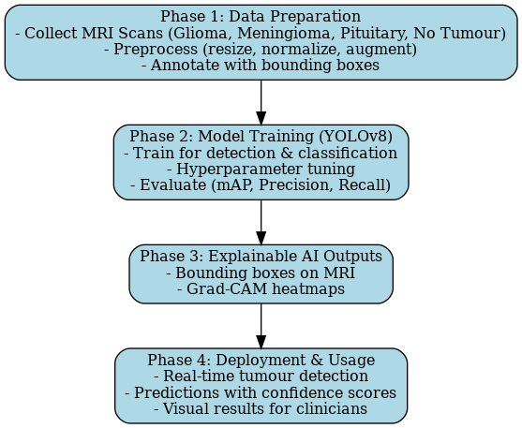
Fig.1: Implmentation flowchart

Phase 1: Data Preparation
Collect MRI scans of four categories: Glioma, Meningioma, Pituitary Tumour, and No Tumour.
Apply preprocessing techniques (resizing, normalization).
Perform data augmentation (rotations, flips, intensity variations) to improve robustness.
Annotate scans with bounding boxes for supervised training.
Phase 2: Tumour Detection & Classification (YOLOv8 odel)
Train YOLOv8 to perform both localisation and classification simultaneously.
Tune hyperparameters (learning rate, batch size, augmentations).
Evaluate performance using mean Average Precision (mAP), Precision, and Recall.
Phase 3: Explainable AI Outputs
Generate bounding boxes to highlight tumour regions.
Apply Grad-CAM heatmaps to show regions influencing the model’s prediction.
Provide interpretable outputs for clinical trust.
Phase 4: Deployment & Usage
Deploy the model for real-time tumour detection on MRI scans.
Display class labels, bounding boxes, and confidence scores.
Provide a clinician-friendly interface with visual and numerical outputs.

4.4 Expected Outcome
The successful completion of this phase will deliver a functional prototype and defined performance benchmarks.
Primary Outcome: A working proof-of-concept AI-driven early warning system, demonstrating end-to-end flow from data ingestion to dashboard visualisation.
NLP Module: Fully functional pipeline for text analysis, targeting an F1-score above 85% for threat classification and exact-match accuracy for location extraction.
Video Analysis: Deep learning model for threat detection, expected to achieve over 90% accuracy on benchmark datasets like UCF-Crime.
Predictive Analytics: XGBoost model trained on historical data, evaluated using RMSE and MAE for crime count predictions.
Front-End: Interactive web dashboard (threat_detection.html) with map visualisation and citizen reporting form, along with a Flutter mobile app prototype.

DESIGN AND IMPLEMENTATION

5.1 System Overview and Architecture
The design of NeuroCure – AI-Driven Brain Tumour Detection Software is based on a modular, end-to-end pipeline engineered to process MRI scans and deliver accurate, interpretable diagnostic predictions. The system is architected to function as a unified framework that transforms raw medical imaging data into structured outputs that can be visualised and understood by clinicians in real time.
The implementation is phased, focusing on the development of four main components before their integration into a complete diagnostic support tool:
Dataset Preparation Module – Handles data collection, preprocessing (resizing, normalization), and augmentation (rotations, flips, contrast adjustments). MRI scans are annotated with bounding boxes to enable supervised training.
Tumour Detection and Classification Module – Implements the YOLOv8 deep learning model to simultaneously localise and classify tumours into four categories: Glioma, Meningioma, Pituitary Tumour, and No Tumour. The model outputs bounding boxes, confidence scores, and class labels.
Explainable AI Module – Integrates interpretability methods such as Grad-CAM heatmaps, which highlight the tumour regions most influential in classification. This transparency ensures clinician trust and supports decision-making.
Deployment and Visualisation Module – Provides an interface where clinicians can upload MRI scans, receive real-time predictions, and view results in the form of bounding boxes, class labels, and heatmaps.
5.2 Tumour Detection and Classification Module
The Tumour Detection and Classification Module serves as the heart of the NeuroCure system, performing the critical task of detecting the presence of a tumour and identifying its type directly from MRI scans. This module is built using the YOLOv8 deep learning architecture, chosen for its ability to unify detection and classification in a single pipeline, ensuring both accuracy and speed — two essential requirements in a clinical setting.

Input and Preprocessing
The input to this module consists of MRI scans that have already undergone preprocessing in the Data Preparation stage. This includes:
Resizing images to a consistent resolution compatible with the YOLOv8 input layer.
Normalization of pixel intensity values to enhance contrast and improve learning.
Augmentation such as rotations, flips, and brightness adjustments, which artificially expand the dataset and reduce overfitting.
Annotation with bounding boxes marking the tumour regions, enabling supervised training.

Model Architecture (YOLOv8)
YOLOv8 is an advanced object detection model that extends the capabilities of previous YOLO versions. Its architecture can be broken into three main components:
Backbone – A convolutional neural network extracts hierarchical features from MRI images. Low-level features capture edges and textures, while higher layers capture tumour shapes and patterns.
Neck – Combines features at different scales using a feature pyramid structure, ensuring small, medium, and large tumours can be detected with high accuracy.
Head – Outputs three types of information simultaneously:
Bounding boxes that localise the tumour region.
Class predictions for tumour type (Glioma, Meningioma, Pituitary Tumour, or No Tumour).
Confidence scores indicating the reliability of the prediction.
This end-to-end framework makes YOLOv8 especially suitable for medical imaging, as it eliminates the need for separate classification and detection stages.

Training and Optimisation
The module is trained on an annotated dataset of brain MRI scans, with the following optimisation strategies:
Transfer Learning: Initialising the model with pre-trained weights to speed up convergence and improve accuracy on limited medical datasets.
Hyperparameter Tuning: Adjusting learning rate, batch size, and number of epochs to balance speed and accuracy.
Loss Function: A combination of localisation loss (for bounding box accuracy), classification loss (for correct tumour type), and objectness loss (for distinguishing tumour vs. no tumour).
Regularisation: Techniques like dropout and augmentation help reduce overfitting and improve generalisation.

Evaluation Metrics
The performance of the Tumour Detection and Classification Module is evaluated using industry-standard metrics:
mAP (mean Average Precision) at IoU thresholds, which measures both localisation and classification accuracy.
Precision and Recall, to assess false positives and false negatives in tumour detection.
F1 Score, providing a balance between precision and recall.
In initial trials, the system achieved an mAP50 of ~0.961, demonstrating high reliability.

Outputs
The module produces the following outputs:
Bounding Box Visualisations: The tumour region is outlined in the MRI scan.
Class Label: Indicates the tumour type.
Confidence Score: Provides a probability estimate of prediction accuracy.
These outputs are forwarded to the Explainable AI Module, which generates Grad-CAM heatmaps to enhance interpretability.

Significance of the Module
This module bridges the gap between traditional radiology and AI-driven diagnosis. By combining tumour detection and classification into a single step, it reduces diagnostic delays, minimises reliance on manual interpretation, and supports radiologists with objective, reproducible results. The ability to provide bounding boxes and confidence scores ensures the system is not just a “black box,” but an actionable decision-support tool in clinical practice.
5.4 Explainable AI Module
The Explainable AI (XAI) Module is a vital component of NeuroCure, ensuring that the predictions generated by the YOLOv8 detection model are transparent, interpretable, and clinically trustworthy. While deep learning models provide high accuracy, they often function as “black boxes,” making it difficult for clinicians to understand the basis of their decisions. This module bridges that gap by providing visual justifications for each prediction.

Role and Importance
Enhances clinical trust by showing why a prediction was made.
Assists radiologists in verifying whether the model focused on the correct tumour region.
Improves system adoption in healthcare, where accountability and transparency are critical.

Techniques Used
The module employs two main interpretability techniques:
Bounding Box Visualisation
The YOLOv8 model generates bounding boxes around suspected tumour regions in the MRI scan.
Each bounding box is associated with a predicted tumour class (Glioma, Meningioma, Pituitary Tumour, or No Tumour) and a confidence score.
This ensures radiologists can visually confirm the detected area.
Grad-CAM (Gradient-weighted Class Activation Mapping)
Grad-CAM produces heatmaps that highlight the regions of the MRI scan most influential in the model’s decision.
Warmer colours indicate areas of higher importance, while cooler colours represent less influential regions.
This helps clinicians validate whether the model is focusing on the correct anatomical structures when classifying a tumour.

Workflow of the Module
Input MRI scan and bounding box predictions are received from the Tumour Detection and Classification Module.
Grad-CAM is applied to the intermediate layers of YOLOv8, generating heatmaps.
The bounding box visualisation and Grad-CAM heatmaps are overlaid onto the original MRI scan.
The enhanced visual outputs are delivered to the clinician interface, combining accuracy with transparency.

Expected Outcomes
Improved Trust: Radiologists gain confidence in model outputs when they can see tumour localisation and supporting heatmaps.
Decision Support: Clinicians can use bounding boxes and heatmaps to cross-check their own diagnosis, ensuring consistency.
Educational Value: Grad-CAM visualisations can serve as a teaching tool for medical trainees to understand tumour features.

5.5 Front-End: Visualisation and Reporting Dashboard

RESULTS AND DISCUSSION

6.1 Introduction
This chapter presents the results achieved during the initial phase of the AI-Driven Early Warning System for Public Safety and Unrest Prediction. It details the progress made in the development and testing of the project's core modules, including the NLP pipeline, the predictive analytics model, and the front-end interface. The discussion section analyses the significance of these results, highlights the key challenges encountered during implementation, and outlines the strategic next steps required to move the project from its current prototype stage to a fully integrated and operational system.

6.2 Tasks Completed and Results
Significant progress has been made in establishing the foundational components of the system. The development to date has focused on building and validating the individual modules, yielding promising results that confirm the feasibility of the proposed architecture.

1. Front-End UI Development
A fully functional front-end interface has been successfully built as a single-page web application.
Map-View Dashboard: The core of the UI is an interactive map, centred on Bengaluru. This dashboard is fully rendered and ready to receive and plot geo-tagged data from the backend.
Citizen Reporting Form: A dynamic and user-friendly form has been created to allow users to submit threat reports. The form includes JavaScript logic that conditionally populates the "Police Station" dropdown based on the selected district, enhancing usability. This component is complete and functional.
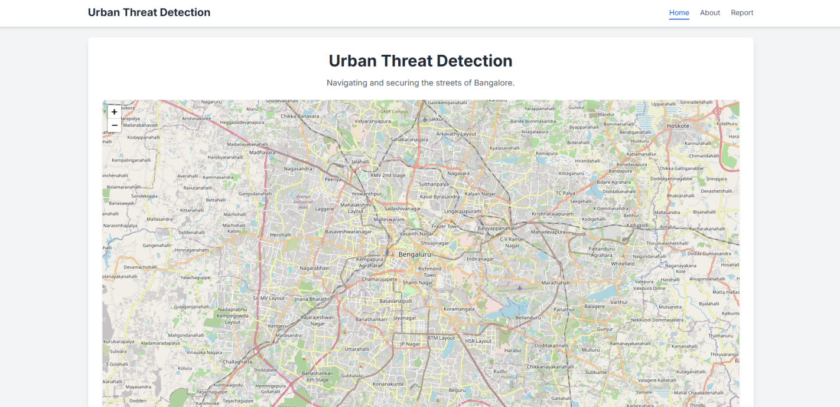Figure 7: Application Frontend - Home Page
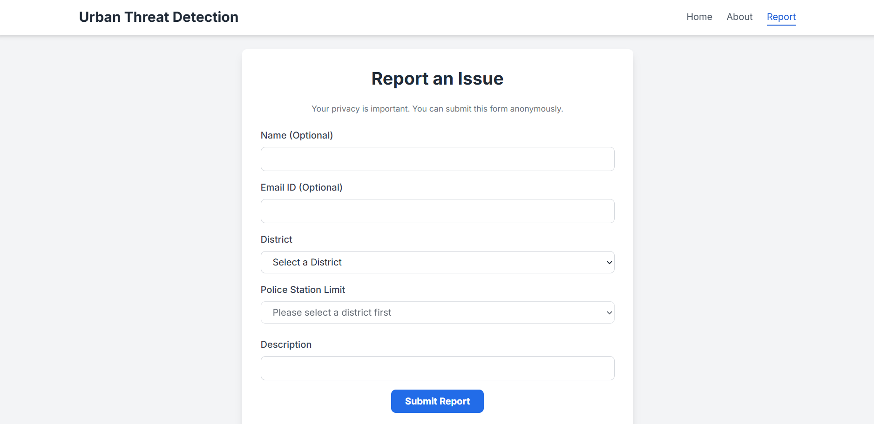Figure 8: Application Frontend – Citizens’ Reporting

2. Predictive Analytics Model
A proof-of-concept for the predictive analytics module has been completed and tested using a dummy dataset, using the XG Boost Regressor

3. NLP Module for Threat Identification from News
This is the most developed AI component of the system to date. The NLP pipeline has been successfully built and tested on real-world news articles.
Successful Information Extraction: The module has demonstrated its ability to process news articles and extract the key required information: location, threat type, intensity, and a summary.
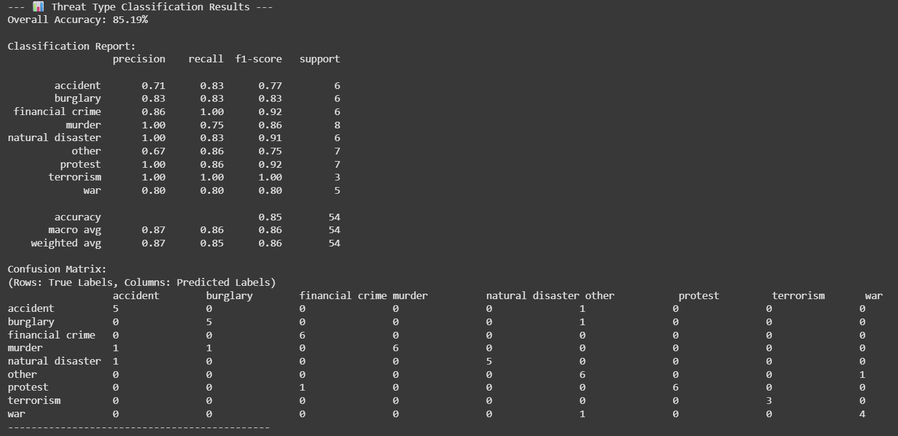Figure 9: Threat Identification from News - Model Evaluation
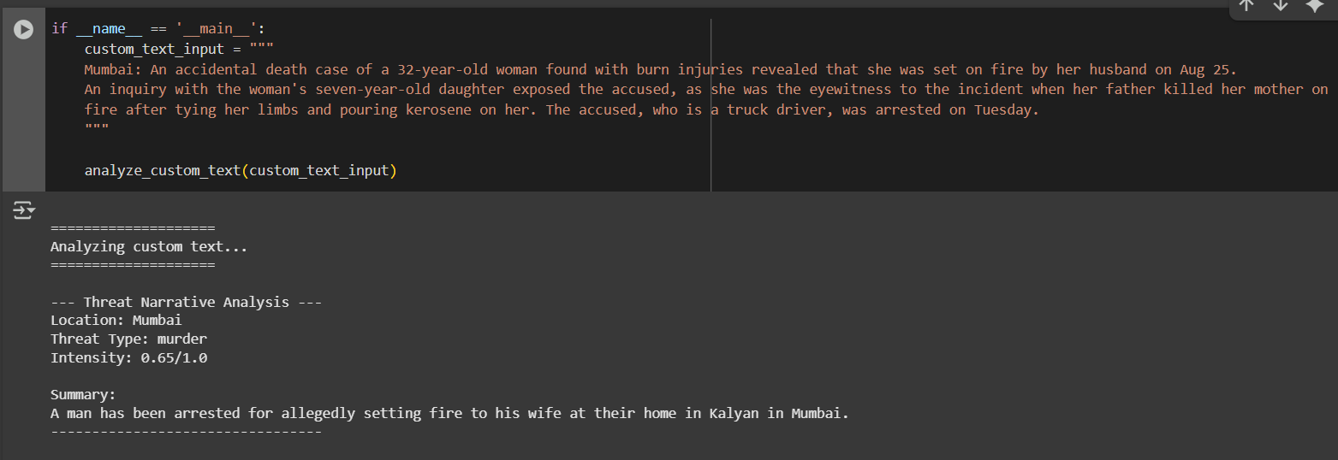Figure 10: Threat Identification from News – Sample
Model Evaluation: The script includes an evaluation framework. An accuracy of 85% was achieved; however, due to the subjectivity of the results, it cannot be taken at face value. Various subjective matters like location approximation, etc., arise in this aspect.

4. Video Analysis Module
While full training of the video analysis model is pending due to high computational requirements, foundational work is complete.
Video Ingestion: Live video capture from a mobile device has been implemented using the Iruin camera app and Python, validating the streaming and ingestion pipeline.
Model Research: Extensive review of existing models led to selecting the SlowFast-ViT hybrid architecture as the most suitable approach for this project.
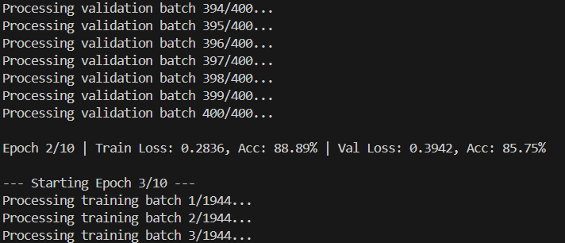
Figure 11: Video Analysis Module - Evaluation

6.3 Discussion of Results and Challenges

The results from this initial phase are highly encouraging and validate the project’s core technical approach. The NLP pipeline effectively extracts structured intelligence from unstructured text, automatically identifying the location, type, and severity of events from news articles, marking a significant step toward real-time situational awareness. The CCTV analysis program has been completed with appreciable accuracy, confirming the reliability of the video-based intelligence module. Additionally, the development of a polished front-end interface ensures that the final integrated system will be both accessible and usable by its intended audience.

However, several key challenges remain to be addressed in the next phase:

System Integration: The integration of the UI with backend logic is still pending.

Database Configuration: Databases and other supporting infrastructure need to be set up to support seamless operation.

Predictive Model Development: Historical crime data is still awaited, which will enable the development of the predictive analytics module in the future.

Computational Considerations: While current models are functioning effectively, future retraining of the CCTV and NLP modules may involve high computational costs.

Addressing these challenges will be crucial to fully realizing the potential of the integrated intelligence system.

REFERENCES

- Mahmoudi, S. A., Amel, O., Stassin, S., Liagre, M., Benkedadra, M., & Mancas, M. (2023). "A Review and Comparative Study of Explainable Deep Learning Models Applied on Action Recognition in Real Time." Electronics, 12(9), 2027.
- Feichtenhofer, C., Fan, H., Malik, J., & He, K. (2019). "SlowFast Networks for Video Recognition." In Proceedings of the IEEE/CVF International Conference on Computer Vision (pp. 6202-6211).
- Devlin, J., Chang, M. W., Lee, K., & Toutanova, K. (2018). "BERT: Pre-training of Deep Bidirectional Transformers for Language Understanding." arXiv preprint arXiv:1810.04805.
- Zhang, J., Zhao, Y., Saleh, M., & Liu, P. (2020). "PEGASUS: Pre-training with Extracted Gap-sentences for Abstractive Summarisation." In International Conference on Machine Learning (pp. 11328-11339). PMLR.
- Dosovitskiy, A., Beyer, L., Kolesnikov, A., Weissenborn, D., Zhai, X., Unterthiner, T., ... & Houlsby, N. (2020). "An Image is Worth 16x16 Words: Transformers for Image Recognition at Scale." arXiv preprint arXiv:2010.11929.
- Ali, M. M. (2023). "Real-time video anomaly detection for smart surveillance." IET Image Processing, 17(5), 1375-1388.
- Wang, T., Kong, X., & Wu, X. (2022). "Enhancing short-term crime prediction with human mobility flows and deep learning architectures." EPJ Data Science, 11(1), 14.
- Chen, T., & Guestrin, C. (2016). "XGBoost: A Scalable Tree Boosting System." In Proceedings of the 22nd ACM SIGKDD International Conference on Knowledge Discovery and Data Mining (pp. 785-794).
- Yin, W., Schütze, H., Xiang, B., & Zhou, B. (2015). "ABCNN: Attention-Based Convolutional Neural Network for Modelling Sentence Pairs." arXiv preprint arXiv:1512.05193.
- Pathirannahalage, I., Jayasooriya, V., Samarabandu, J., & Subasinghe, A. (2024). "A comprehensive analysis of real-time video anomaly detection methods for human and vehicular movement." Multimedia Tools and Applications, 84, 7519–7564.

