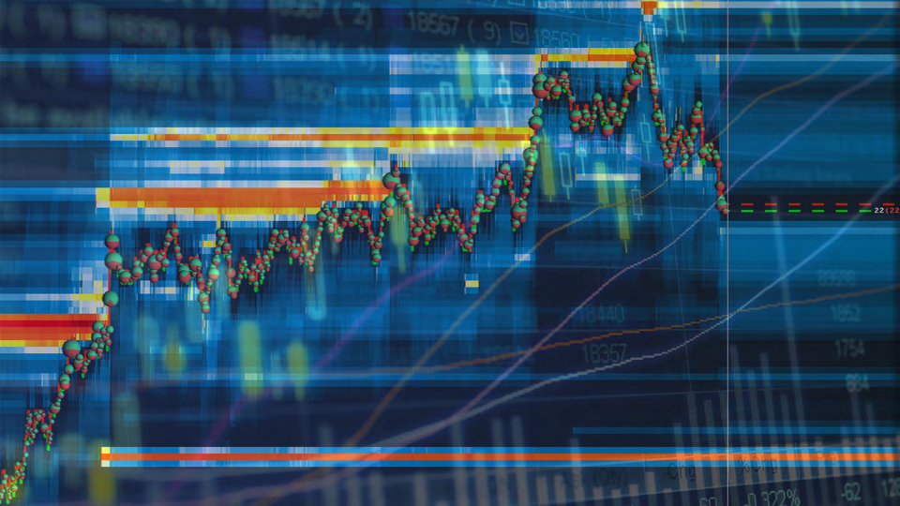
Bookmap™ Masterclass
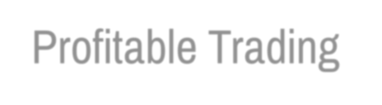


Profitable Trading with
LOB and Bookmap™
© Copyright 2019 by TTW Trading Services Ltd.
All rights reserved.
This presentation and video material is protected by International copyright laws.
No part of this publication and video material may be reproduced, distributed, or transmitted in any form or by any means, including photocopying, recording, or other electronic or mechanical methods, without the prior written permission of the publisher, except in the case of brief quotations embodied in critical reviews and certain other noncommercial uses permitted by copyright law. For permission requests, write to the publisher, addressed “Attention: Permissions Coordinator,” at the address below.
TTW Trading Services Ltd.
Doulton Trading Estate
Doulton Road
Unit 10 -11
Rowley Regis
West Midlands
B65 8JG
England
https://ttwtrader.com
education@ttwtrader.com
12 December 2019 © 2019, TTW Trading Services Ltd. based on Bookmap™ 7.1.0 2
General Trading Risk Disclaimer
Futures, stocks and options trading involves substantial risk of loss and is not suitable for every investor. The valuation of futures, stocks and options may fluctuate, and, as a result, clients may lose more than their original investment. The impact of seasonal and geopolitical events is already factored into market prices. The highly leveraged nature of futures trading means that small market movements will have a great impact on your trading account and this can work against you, leading to large losses or can work for you, leading to large gains. If the market moves against you, you may sustain a total loss greater than the amount you deposited into your account. You are responsible for all the risks and financial resources you use and for the chosen trading system. You should not engage in trading unless you fully understand the nature of the transactions you are entering into and the extent of your exposure to loss. If you do not fully understand these risks you must seek independent advice from your financial advisor.
All trading strategies are used at your own risk.
Any content on “TTW Trading Services Ltd.” should not be relied upon as advice or construed as providing recommendations of any kind. It is your responsibility to confirm and decide which trades to make. Trade only with risk capital; that is, trade with money that, if lost, will not adversely impact your lifestyle and your ability to meet your financial obligations. Past results are no indication of future performance. In no event should the content of this correspondence be construed as an express or implied promise or guarantee. “TTW Trading Services Ltd.” is not responsible for any losses incurred as a result of using any of our trading strategies. Loss-limiting strategies such as stop loss orders may not be effective because market conditions or technological issues may make it impossible to execute such orders. Likewise, strategies using combinations of options and/or futures positions such as “spread” or “straddle” trades may be just as risky as simple long and short positions. Information provided in this correspondence is intended solely for informational purposes and is obtained from sources believed to be reliable. Information is in no way guaranteed. No guarantee of any kind is implied or possible where projections of future conditions are attempted.
12 December 2019 © 2019, TTW Trading Services Ltd. based on Bookmap™ 7.1.0 3
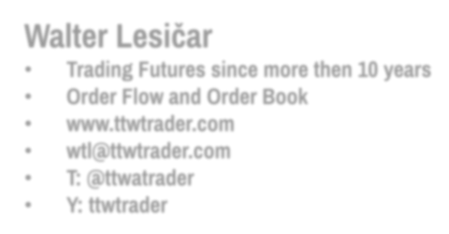
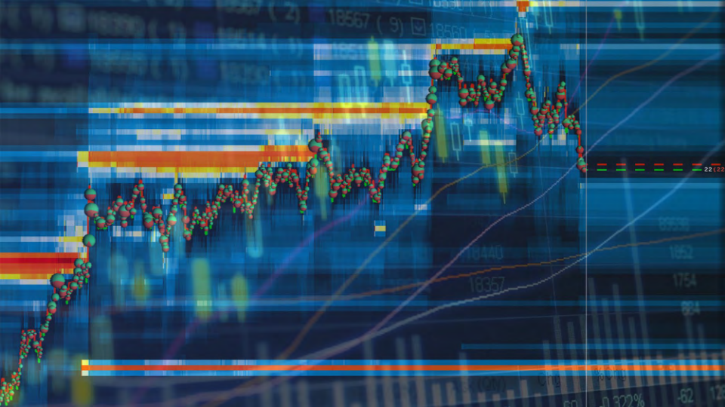
Few Words About me
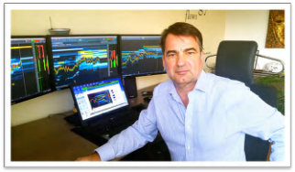
Walter Lesičar
• Trading Futures since more then 10 years
• Order Flow and Order Book
• www.ttwtrader.com
• wtl@ttwtrader.com
• T: @ttwatrader
• Y: ttwtrader
12 December 2019 © 2019, TTW Trading Services Ltd. based on Bookmap™ 7.1.0 4
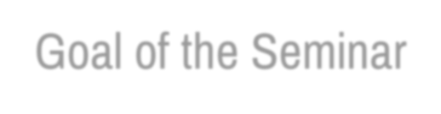

Goal of the Seminar
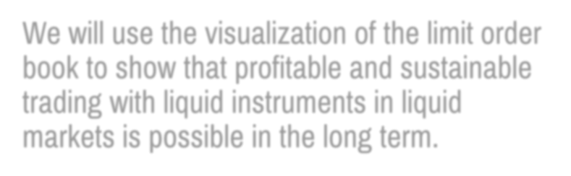
We will use the visualization of the limit order book to show that profitable and sustainable trading with liquid instruments in liquid markets is possible in the long term.
12 December 2019 © 2019, TTW Trading Services Ltd. based on Bookmap™ 7.1.0 5

Goal of the Seminar
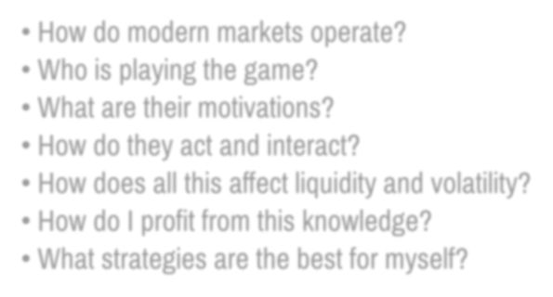
• How do modern markets operate?
• Who is playing the game?
• What are their motivations?
• How do they act and interact?
• How does all this affect liquidity and volatility?
• How do I profit from this knowledge?
• What strategies are the best for myself?
12 December 2019 © 2019, TTW Trading Services Ltd. based on Bookmap™ 7.1.0 6
Syllabus
Bookmap™
Oganization and Data Presentation
Data Feed
Auction LOB
Liquidity Absorption
Exhaustion Sweep
Strategies Correlations
Adv. Analysis Tools
Practice
Practice Practice Practice
Book Flipping
Spoofing /Layering Quote Stuffing
Stop Runs
CVD
Large Lot Tracker Ice berg Detector Volume Imbalance POC
12 December 2019 © 2019, TTW Trading Services Ltd. based on Bookmap™ 7.1.0 7
1. Test 1
2. Part 1 – Auction
3. Limit Order Book (LOB)
4. Part 2 - Market Mechanic
1. Basic Terminology
5. Part 3 – Market Mechanic
1. Liquidity
6. Part 4 - Market Mechanic
1. Market Terminology
7. Part 5 – Order Book
1. Visualization
8. Part 6 – Strategies
1. Strategies Part 1
Liquidity, Sweep Trades, Pullback 9. Strategies Part 2
1. Correlations
10.Part 7: Trading Preparation
11.Strategies Pattern
1. Execution Summary
12.Strategies
13.Strategies Indicators Part 3 1. VWAP
14.Strategies Part 4
1. Advanced Analysis Tools 15.Part 8 - Data Feed
16.Part 9 – Option Expiration 17.Part 10 - Trading Advice 18.Test 2
12 December 2019 © 2019, TTW Trading Services Ltd. based on Bookmap™ 7.1.0 8
Documentation
• All documentation, presentation, replay files and any additional material can be downloaded from our Dropbox file. • DropBox
• ttwtrader.echofin.co
• Video recordings via VIMEO
• Live Education Room via Zoom.us
• Announcement in ttwtrader.echofin.co „Signal Room“ • Skype for direct contact
12 December 2019 © 2019, TTW Trading Services Ltd. based on Bookmap™ 7.1.0 9
This Seminar is designed for
• Short Term Trader : Retail -, discretionary Trader • Professional Trader
• Prop. Trader
• Institutional Trader
12 December 2019 © 2019, TTW Trading Services Ltd. based on Bookmap™ 7.1.0 10
Respect
We all are from different countries. We all have different background and knowledge in trading.
For most of us English is not our native language. Let‘s help each other with respect to grow and to become profitable trader.
12 December 2019 © 2019, TTW Trading Services Ltd. based on Bookmap™ 7.1.0 11
Bookmap™ Test 1
Test
• Please answer fast and intuitively • Where will the price move next? • Price rises (up)
• Price declines (down)
• Price goes sideways
12 December 2019 © 2019, TTW Trading Services Ltd. based on Bookmap™ 7.1.0 13
12 December 2019 © 2019, TTW Trading Services Ltd. based on Bookmap™ 7.1.0 14
12 December 2019 © 2019, TTW Trading Services Ltd. based on Bookmap™ 7.1.0 15
12 December 2019 © 2019, TTW Trading Services Ltd. based on Bookmap™ 7.1.0 16
12 December 2019 © 2019, TTW Trading Services Ltd. based on Bookmap™ 7.1.0 17
12 December 2019 © 2019, TTW Trading Services Ltd. based on Bookmap™ 7.1.0 18
12 December 2019 © 2019, TTW Trading Services Ltd. based on Bookmap™ 7.1.0 19
12 December 2019 © 2019, TTW Trading Services Ltd. based on Bookmap™ 7.1.0 20
12 December 2019 © 2019, TTW Trading Services Ltd. based on Bookmap™ 7.1.0 21
12 December 2019 © 2019, TTW Trading Services Ltd. based on Bookmap™ 7.1.0 22
12 December 2019 © 2019, TTW Trading Services Ltd. based on Bookmap™ 7.1.0 23
Bookmap™
Part 1 - Auction
Limit Order Book (LOB)
Syllabus
Bookmap™
Oganization and Data Presentation
Data Feed
Auction LOB
Liquidity Absorption
Exhaustion Sweep
Strategies Correlations
Adv. Analysis Tools
Practice
Practice Practice Practice
Book Flipping
Spoofing /Layering Quote Stuffing
Stop Runs
CVD
Large Lot Tracker Ice berg Detector Volume Imbalance POC
12 December 2019 © 2019, TTW Trading Services Ltd. based on Bookmap™ 7.1.0 25
„Limit Order Book“ or LOB is the standardised „Bookkeeping“ for every traded transaction
12 December 2019 © 2019, TTW Trading Services Ltd. based on Bookmap™ 7.1.0 26
LOB Characteristics
• LOB (Limit Order Book) is standardised (!) for all traded instruments worldwide • LOB Answers Questions:
• How much was traded?
• When was it traded?
• At which price was it traded?
• Was the price accepted by the traders?
• Which side wants to buy?
• Which side wants to sell?
• Are there aggressive buyers or sellers?
•„Thin“ Liquidity (illiquid markets)
•„Thick“ Liquidity (liquid markets)
12 December 2019 © 2019, TTW Trading Services Ltd. based on Bookmap™ 7.1.0 27
Structure of a LOB
• Price
• Bid, Ask
• Best Bid and Offer (BBO)
• Traded Volume
• Aka Current Trades against inside bids and offers
• Refresh time to be defined
• Snapshot or Delta Volume
• Pulling and Stacking of limit orders
• Statistics
• Volume Profile shows total number of contracts traded at each level. It shows also Session VWAP and POC.
• Acts as Volume Profile tool
• Quotes Center shows the number of contracts refreshed for each specific price level.
12 December 2019 © 2019, TTW Trading Services Ltd. based on Bookmap™ 7.1.0 28
12 December 2019 © 2019, TTW Trading Services Ltd. based on Bookmap™ 7.1.0 29
Compare Bookmap to a DOM
Price
12 December 2019 © 2019, TTW Trading Services Ltd. based on Bookmap™ 7.1.0 30
Compare Bookmap
to a DOM
Depth of Bid
Depth of Bid
12 December 2019 © 2019, TTW Trading Services Ltd. based on Bookmap™ 7.1.0 31
Compare Bookmap to a DOM
Depth of Ask Depth of Ask
12 December 2019 © 2019, TTW Trading Services Ltd. based on Bookmap™ 7.1.0 32
Compare Bookmap to a DOM
Best Bid & Offer
Best Bid & Offer
12 December 2019 © 2019, TTW Trading Services Ltd. based on Bookmap™ 7.1.0 33
Compare Bookmap
to a DOM
Traded Market
Volume
Traded Market
Volume
12 December 2019 © 2019, TTW Trading Services Ltd. based on Bookmap™ 7.1.0 34
Compare Bookmap
to a DOM
Snapshot /Delta
Column
12 December 2019 © 2019, TTW Trading Services Ltd. based on Bookmap™ 7.1.0 35
Group Excercise: Auction
Goals
• Understanding the Auction
• Understanding the Organisation of the LOB • Understanding LOB terminology
• Understanding Your role as Trader • Understanding what moves the Price • Why is price going up?
• Why is price going down?
12 December 2019 © 2019, TTW Trading Services Ltd. based on Bookmap™ 7.1.0 36
Auction Rules
• Open Outcry (Pit Trading)
• Auctioneer aka. Matching Machine
• Auctioneer is the Market Maker
• Bank, Broker sells and buys back Future-Contracts (not in a Webinar) • We will practise a simple auktion
• Everyone get $2000 to start ($100, $20, $10)
• Participants trade only Market Order
• No short selling at the beginning
• Duration about 10 – 15 min.
• At the end of the auction you have be flat
• Bank, Broker, Auctioneer must be paid $10 for each auction
12 December 2019 © 2019, TTW Trading Services Ltd. based on Bookmap™ 7.1.0 37
12 December 2019 © 2019, TTW Trading Services Ltd. based on Bookmap™ 7.1.0 38
Discussion
• Your Feeling
• Did you get what you want?
• Why are we allowed to trade?
• What are you trading?
• Trading is a Zero-Sum-Game!
• > 98% Retail Trader are losing
YOU WILL BE A WINNER!
12 December 2019 © 2019, TTW Trading Services Ltd. based on Bookmap™ 7.1.0 39
LOB Terms – Limit Order
A limit order sits in the order book until it is:
• either executed against a matching market order or it is canceled
• A limit order may be executed very quickly if it corresponds to the Best- Bid-Offer (BBO) price • A limit order may take a long time if the market price moves away from the requested price • the requested price is too far from the bid/ask.
• can be canceled at any time
• Typically, a limit order waits for a match
• transaction cost is known
• execution time is uncertain
12 December 2019 © 2019, TTW Trading Services Ltd. based on Bookmap™ 7.1.0 40
LOB Terms – Market Order
• A market order is an order to buy/sell a certain quantity of the asset at the best available price in the book.
• Traders can put a market order that, for a buy (resp. sell) order,
• The first share(s) will be traded at the ask (resp. bid) price
• The remaining one(s) will be traded some ticks upper (resp. lower) in order to fill the order size.
• The ask (resp. bid) price is then modified accordingly.
• When either the bid or ask queue is depleted by market orders or cancelations the price is updated up or down to the next level of the order book.
• Typically a market order consumes the cheapest limit orders immediate
execution (if the book is filled enough)
12 December 2019 © 2019, TTW Trading Services Ltd. based on Bookmap™ 7.1.0 41
LOB Terms – Cancellation
• Traders can put a cancellation of x orders in a given queue reduces the queue size by x
• When either the bid or ask queue is depleted by market orders and cancelations, the price moves up or down to the next level of the order book.
12 December 2019 © 2019, TTW Trading Services Ltd. based on Bookmap™ 7.1.0 42
LOB Dynamics
Actual trades come in two forms
• Trader can put a limit order and wait that this order matches another one
• transaction cost is known
• execution time is uncertain
• Trader can put a market order that consumes the cheapest limit orders in the book
• immediate execution (if the book is filled enough)
• price per instrument instead depends on the order size
• For a buy (resp. sell) order, the first instrument will be traded at the ask (resp. bid) price while the last one will be traded some ticks upper (resp. lower) in order to fill the order size. The ask (resp. bid) price is then modified accordingly. • Trader can put a cancellation of x orders in a given queue reduces the queue size by x
• When either the bid or ask queue is depleted by market orders and cancel^{ations, the price moves} up or down to the next level of the order book 12 December 2019 © 2019, TTW Trading Services Ltd. based on Bookmap™ 7.1.0 43
Trading Advice
• You never trade alone!
• If no one wants to trade with you, you won‘t be trading anything.
• Trading always needs two parties.
• Cui Bono! (To Whom is it a benefit?)
12 December 2019 © 2019, TTW Trading Services Ltd. based on Bookmap™ 7.1.0 44
Price Volume
Time regulates each
opportunity
Price is simply the auction‘s mean of advertising opportunity
^{e}i
Time
Volume measures the degree of success of each auction.
James Dalton, Markets Profile,
Profiting from the Auction Process
12 December 2019 © 2019, TTW Trading Services Ltd. based on Bookmap™ 7.1.0 45
Bookmap™
Part 2 - Market Mechanic Basic Terminology
Market Maker
• Provides Liquidity
• Without Liquidity no Trading
• Quoting:
• MM provides a bid-price with corresponding bid-volume
• MM provides a ask-price with corresponding ask-volume
• Clearing:
• MM decides on a price (p) to keep unsatisfied orders as small as possible • Satisfied orders are cleared
• Facilitating Trading at any time and price
• Most instruments trade 24h/day (except. Crypto)
• „Thin“ and „Thick“ Markets
12 December 2019 © 2019, TTW Trading Services Ltd. based on Bookmap™ 7.1.0 47
Market Maker & Other Traders
• Market Maker are called: Liquidity Providers • Other traders are called : Liquidity Takers
12 December 2019 © 2019, TTW Trading Services Ltd. based on Bookmap™ 7.1.0 48
Aggressors & Passive Trader
• Aggressors are active traders who consume liquidity from the market
• Aggressors buys always at market!
• Algorithmic Trading Programs too (Sweeping!) • Market Order are „active“ Order
• Passive Traders provide Liquidity
• Limit Order are „passive“ Order
• Transaktions matches always at Best-Bid-Offer! • Matching aggressor and passive trader
12 December 2019 © 2019, TTW Trading Services Ltd. based on Bookmap™ 7.1.0 49
Informed vs. Uninformed Trader
• Informed traders posses information about the future price of an asset
• News, company numbers, better market access, etc • Uninformed traders has no access to information • Lack of news, lack of knowledge about traded asset, random trading, market ignorance
• Information is hard to measure
12 December 2019 © 2019, TTW Trading Services Ltd. based on Bookmap™ 7.1.0 50
Matching Engine - Auktioneer
• Enables electronic trading based on defined, fixed rules • Matches two parties, which want to trade
• Matching Engine is always (!) fair
• Following matching algorithms are used by the CME Group: • First In First Out (FIFO)
• FIFO with Lead Market Maker
• Pro Rata
• Configurable
• Threshold pro Rata
• Threshold pro Rata with LMM
• Allocation and Ending
• Quelle: https://www.cmegroup.com/education/matching-algorithm-overview.html
12 December 2019 © 2019, TTW Trading Services Ltd. based on Bookmap™ 7.1.0 51
Current Price trading on Best Offer
Last trade is current price
12 December 2019 © 2019, TTW Trading Services Ltd. based on Bookmap™ 7.1.0 52
Price Moves – Transacts on Best Bid
Aggressor hits the bid with a sell market order
Liquidity on Best Bid is consumed
12 December 2019 © 2019, TTW Trading Services Ltd. based on Bookmap™ 7.1.0 53
BEST
OFFER
BEST
BID
12 December 2019 © 2019, TTW Trading Services Ltd. based on Bookmap™ 7.1.0 54
BEST
OFFER
BEST
BID
12 December 2019 © 2019, TTW Trading Services Ltd. based on Bookmap™ 7.1.0 55
Bookmap™
Part 3 – Market Mechanic Liquidity
Syllabus
Bookmap™
Oganization and Data Presentation
Data Feed
Auction LOB
Liquidity Absorption
Exhaustion Sweep
Strategies Correlations
Adv. Analysis Tools
Practice
Practice Practice Practice
Book Flipping
Spoofing /Layering Quote Stuffing
Stop Runs
CVD
Large Lot Tracker Ice berg Detector Volume Imbalance POC
12 December 2019 © 2019, TTW Trading Services Ltd. based on Bookmap™ 7.1.0 57
Liquidity Provides
• Liquidity is the „blood“ of all markets!
•Without liquidity no trading!
•Markets need sufficient liquidity to attract active and passive buyers • Market support buyers on the offer by providing liquidity
• Market seeks buyers or sellers for distribution in price zones • Market uses liquidity to pressure the price down
• Liquidity aka Volume attracts the price (magnet)
• Liquidity is easy to manipulate – see Order Book Pulling, Stacking • Liquidity quickly vanishes from the market
12 December 2019 © 2019, TTW Trading Services Ltd. based on Bookmap™ 7.1.0 58
Conclusions
• Market always seeks liquidity – liquidity acts like magnet! • Liquidity is reliable if it is firm and stays firm
• Long Term Liquidity
• Stacking in LOB
• Liquidity is weak
• Short Term Liquidity – might appear only seconds in the LOB
• Pulling in LOB
• Liquidity need to be taken by an equal amount of volume = absorption • Liquidity act like a Catapult (Support)
• Book flipping, Spoofing, Long- , Short Term Liquidity
• Liquidity is „thin“ and „thick“ – depends on market type • „Thin“ markets: FDAX, Forex, CL, 6E, NQ, YM etc
• „Thick“ markets: Bonds, Treasuries, Indices
• When Liquidity disappears (lack of liquidity) – Sit on Hands! (SOH)
12 December 2019 © 2019, TTW Trading Services Ltd. based on Bookmap™ 7.1.0 59
Liquidity Absorps Market Volume
Absorption
Liquidity Volume
Limit Order Market Order
• Whenever market volume and limit volume collide, volume or “energy” is taken out of the market – “Energy” is absorbed • Less (!) “Energy” aka Volume remains in the market
12 December 2019 © 2019, TTW Trading Services Ltd. based on Bookmap™ 7.1.0 60
Liquidity Absorps Market Volume
Volume
Market Order
Absorption
Liquidity
Limit Order
• Whenever market volume and limit volume collide, volume or “energy” is taken out of the market – “Energy” is absorbed • Less (!) “Energy” aka Volume remains in the market 12 December 2019 © 2019, TTW Trading Services Ltd. based on Bookmap™ 7.1.0 61
Not enough
energy to trade
Large Volume Cluster
Long Term Liq.
Seeking new
buyers!
12 December 2019 © 2019, TTW Trading Services Ltd. based on Bookmap™ 7.1.0 62
_{Oil Inventories} Keine Liquidität! No Liquidity!
12 December 2019 © 2019, TTW Trading Services Ltd. based on Bookmap™ 7.1.0 63
12 December 2019 © 2019, TTW Trading Services Ltd. based on Bookmap™ 7.1.0 64
12 December 2019 © 2019, TTW Trading Services Ltd. based on Bookmap™ 7.1.0 65
12 December 2019 © 2019, TTW Trading Services Ltd. based on Bookmap™ 7.1.0 66
Liquidity: Group Discussion
•What is liquidity?
•Who provides liquidity?
•How does liquidity manipulate the price? •How is liquidity manipulating traders?
•When is Liquidity reliable?
12 December 2019 © 2019, TTW Trading Services Ltd. based on Bookmap™ 7.1.0 67
Long Term High Liquidity
• High liquidity remains in the book
• Defines the auction
• Digested by the auction participants
• Channeling between longer term liquidity
• Act as magnet
• Market can trade there – seeking high liquidity!
• Understand context of the area
• More or less liquidity around the area?
• Tendencies to pull the liquidity?
12 December 2019 © 2019, TTW Trading Services Ltd. based on Bookmap™ 7.1.0
68
12 December 2019 © 2019, TTW Trading Services Ltd. based on Bookmap™ 7.1.0 69
Long Term High LiquidityLong Term High Liquidity
12 December 2019 © 2019, TTW Trading Services Ltd. based on Bookmap™ 7.1.0 70
Long Term High Liquidity
12 December 2019 © 2019, TTW Trading Services Ltd. based on Bookmap™ 7.1.0 71
Long Term High Liquidity
12 December 2019 © 2019, TTW Trading Services Ltd. based on Bookmap™ 7.1.0 72
12 December 2019 © 2019, TTW Trading Services Ltd. based on Bookmap™ 7.1.0 73
Short Term High Liquidity
• Short Term High liquidity briefly in the book • Creates large auction imbalances
• New info for auction participants
• Skews the auction – Repels price
• Price reacts to supply and demand imbalance • Understand context of the area
• Near areas of longer term liquidity
• Relationships to swings in microstructure • Relationship with volume
12 December 2019 © 2019, TTW Trading Services Ltd. based on Bookmap™ 7.1.0 74
Long Term High Liquidity
Short Term
High Liq.
Short Term High Liq.
12 December 2019 © 2019, TTW Trading Services Ltd. based on Bookmap™ 7.1.0 75
Long Term High Liquidity
Short Term
High Liq.
Short Term
High Liq.
Long Term High Liquidity
Short Term High Liq.
12 December 2019 © 2019, TTW Trading Services Ltd. based on Bookmap™ 7.1.0
76
Liquidity - Path of Least Resistance
• Clearly visible in Bookmap
• BID or ASK side support the price move in one direction • Real time evidence which way the market will go • Valid until resistance or support shows up
12 December 2019 © 2019, TTW Trading Services Ltd. based on Bookmap™ 7.1.0 77
12 December 2019 © 2019, TTW Trading Services Ltd. based on Bookmap™ 7.1.0 78
12 December 2019 © 2019, TTW Trading Services Ltd. based on Bookmap™ 7.1.0 79
Bookmap™
Part 4 - Market Mechanic Market Terminology

