I want to thank ICT (Inner Circle Trader) Michael Huddleston for sharing his mentorship with everyone for free.
This is my concise breakdown of his teachings from Episode 1 & 2 which totals roughly 1.5 hours of instructions.
Here is my concise ( cut to the chase ) translation of it.
Episode 1:
If you are new to trading then you need to do everything on a demo account. If you are unfamiliar with what a demo account is at this point – it is trading account using play money.
You can open one with any broker using MT4/MT5 (I use this one; www.octafx.com/signup/) or you can sign up with an account using the platform called Trading View (and choose a broker from their availability.
The point is do not use real money when learning to trade.
All of the teachings will be completed in trading view using futures and in an intraday timeframe but can be scaled to any timeframe along with usage for forex and/or CFDs.
I am located in Japan and I use two brokers Oanda Japan (Trading View) and MT4/MT5 with OctaFx which has higher leverage.
Episode 2:
Looking for set-ups:
Weekly (top down approach)
Try to predict the next candle in the weekly chart. Using the example of a nasdaq e-mini 100 future. Use a collection of biases: seasonal tendecies and fed plans to raise interest rates.
Price will magnetize to certain price levels.
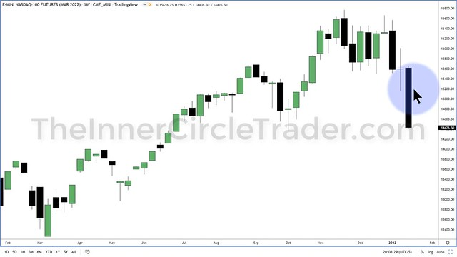
Daily (where most of your set-ups will be found)
Price will be drawn to Liquidity Pools such as stop-losses. Such as traders who are putting stop losses on intraday short term lows or highs. Above old highs and lows.
Price are moved by Imbalances. Large Candles moving in one direction without any checks and balances on those prices. Essentially presented the least contention between buyers and sellers.
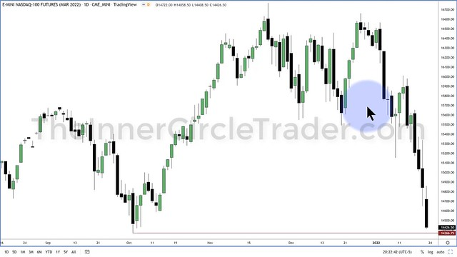
Hourly
If we anticipate a move lower after our study of the weekly and daily analysis and we notice a consolidation of price from the high and low formed from the consolidaton; expect the hunting of sell stops and buys tops before the initial move lower. The same is true for the opposite direction.
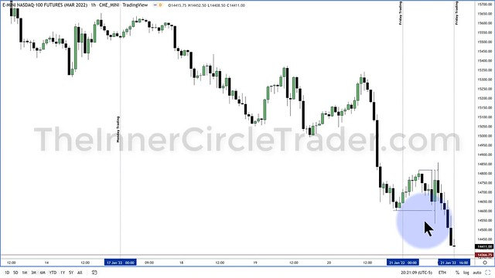
15 Min.
Using the analysis of the hourly chart and adding lines for the intra day highs and lows draw a line.
Side Note to Readers: I actually have a lot of experience drawing and viewing these intra day lines for the highs and lows when I learned this method called the New York Breakout Strategy. (which doesn’t work that well but it was interesting to observe how price moved. At that point a became a believer that price is manipulated to take out stops.)
Essentially you could say the ICT method would be an anti-breakout trader who is anticipating the stop hunts.
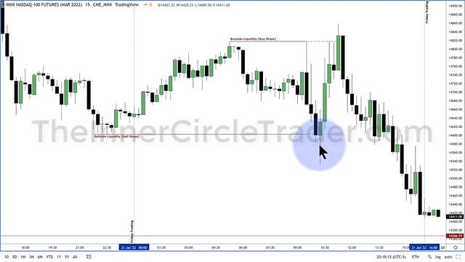
2 Min.
Using all of the above higher timeframe bias we are now looking for an entry. Just because the there was a run on stops ( a stop hunt ) we are still waiting for a specific market signal before entry which will repeat on any type of trading instrument.
This breakdown after the stop hunt as price heads down we look to the next 2min. candles to find an entry to go short inside what is coined as the Fair Market Value location which essentially is the next set of 2min. candles just below the breakdown of the high that was stop hunted.
The stop loss will be added above the previous 2min candles high.
To maximize your short entry price you want to make sure that you are entering the trade on the 2min. candles that are heading up into that Fair Market Value location.
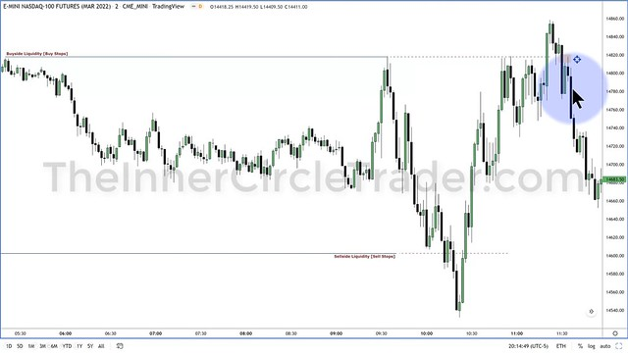
Where to Close your trade (get out at)
The stop hunt highs and lows are now the new markers for creating your exit point. You will mark those highs and lows and use the half way point (50%) level as a marker for exiting and locate the next closest level to exit based on a previous recent low.
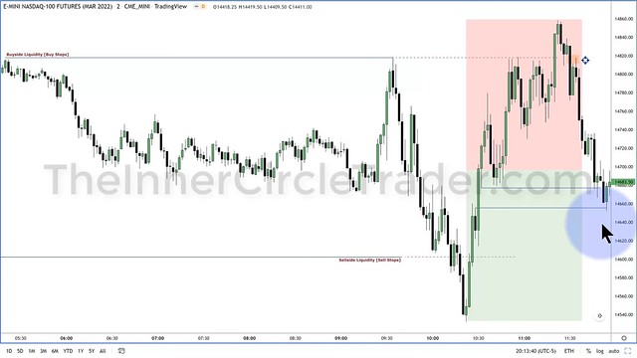
Back Test the ICT Method in MT4 using Soft4Fx
www.soft4fx.com
Replicate the Order Blocks, Fair Value Gaps and Liquidity Pools.
https://soft4fx.com/software/forex-simulator.php
Congratulations to ICT (Inner Circle Trader) for 30 years of trading now lets recap mentorship videos 3 & 4, lets get started.
Episode 3
A range has formed and we can anticipate price to stop hunt those
liquidity pools on the 15min chart.
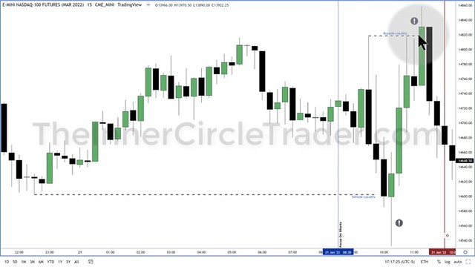
We move to a 2min chart to take a closer look without any annotations.
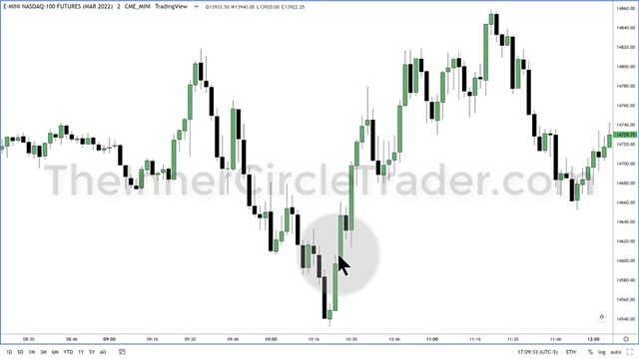
The entry point is in the same position as Lesson 2 and our exit point
looks to be the same area as before which was 50% level of the new high and low formed from the stop hunts.
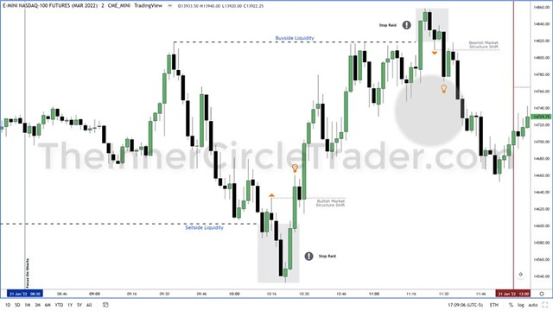
Additional exit points are taught. On the rally up the higher lows can
be used as exit points to exit your short position.
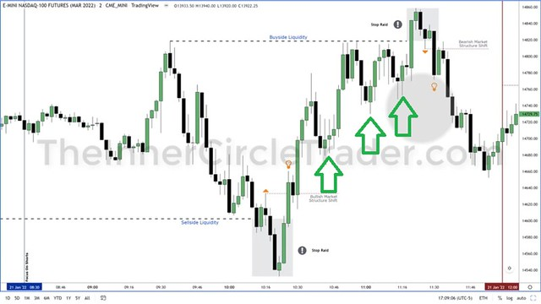
How do we know if there is a market structure shift changing the state of delivery?
Essentially the u-turn that price does on each side of the stop hunts
is where market structure shifts and the price is now delivering in
the opposite direction.
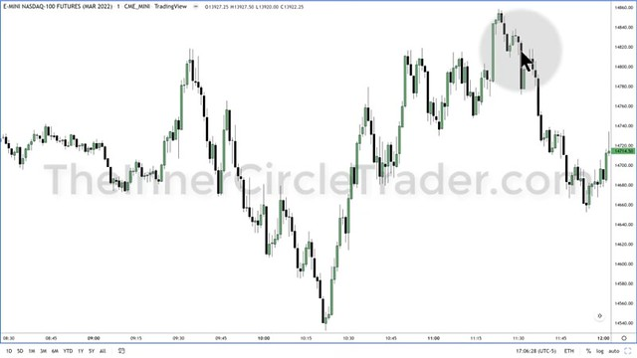
These small signatures as the price breaks through signal price is
now delivering in the opposite direction attacking the sell stops
on the previous run up.
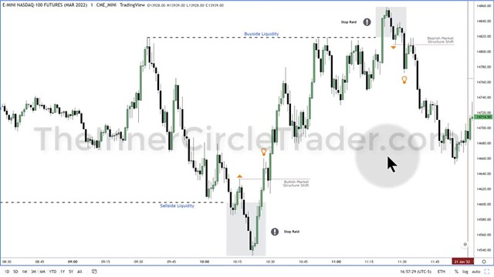
When are the Session Highs and Lows Formed?
London Session 2am-5am (E.T.)
New York Session 7am-10am (E.T.)
Asian Session 7pm-9pm (E.T.)
The hours to trade: 8:30am-11:00 (E.T.)
Episode 4
Here is a similar range bound price set-up and examples defining what a Fair Value Gap is with some examples.
On a 2min Chart a fair value gap is a space that seems to contain unfilled liquidity as price has breaks down through it quickly we can anticipate price to go back into this area.
This is the area in which we want to enter short letting us enter at the best price.
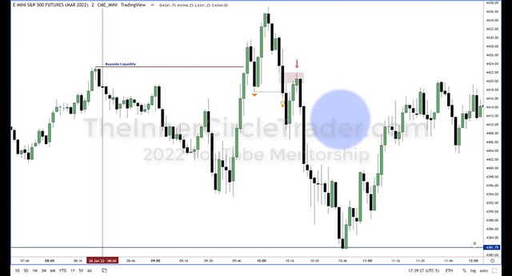
Here was another example of a trade with price moving a little less defined as previous examples and with a exit point that is less defined but exiting on a higher low as the price runs up looks like a defined exit point.
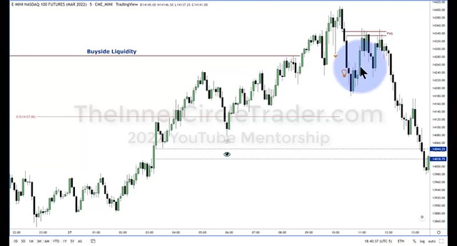
Back Test the ICT Method in MT4 using Soft4Fx
www.soft4fx.com
Replicate the Order Blocks, Fair Value Gaps and Liquidity Pools.
https://soft4fx.com/software/forex-simulator.php

Episode 5
On the 15min chart to determine your high and lows that will be stop hunted look to the previous session and mark off the swing highs and swing lows.
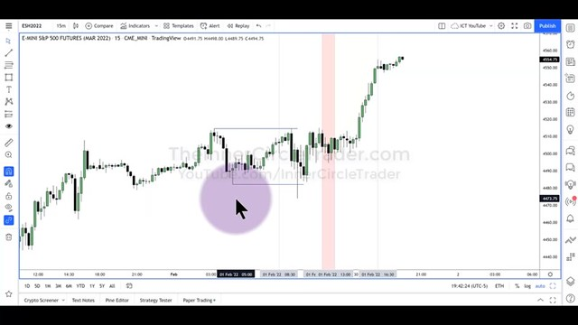
Move down to the 5min chart and when market structure breaks down with a sizable candle anticipate price to move into the fair market value zone.
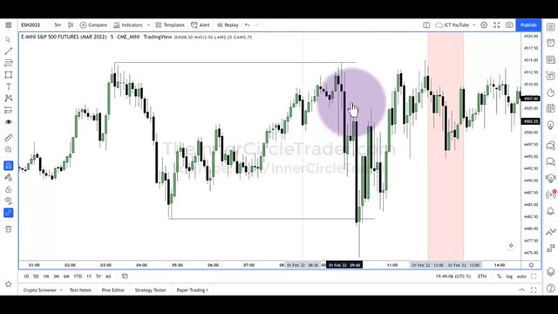
Episode 6
Defining the fair value gap;
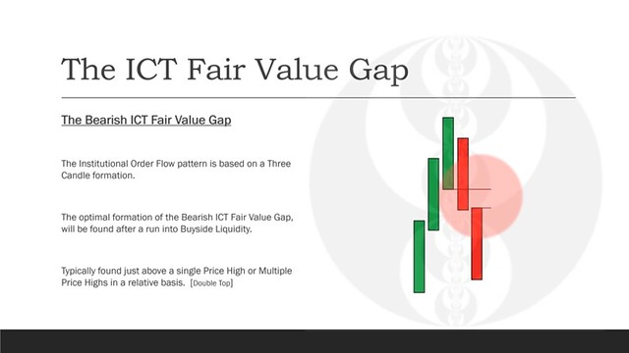
Defining a Market Structure Shift;
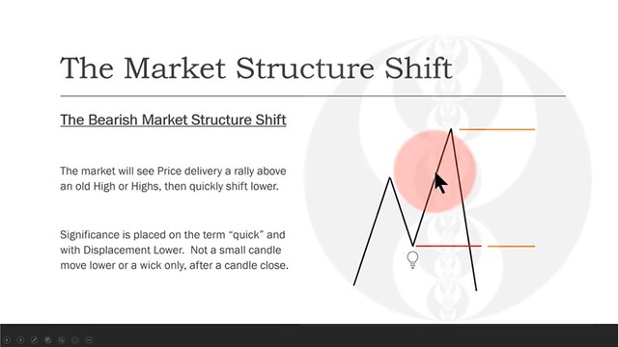
Defining a Bullish Fair Value Gap
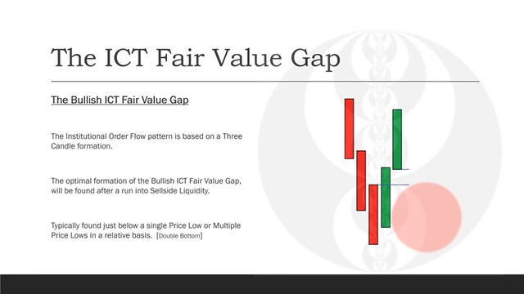
Defining a Bullish Market Structure Shift
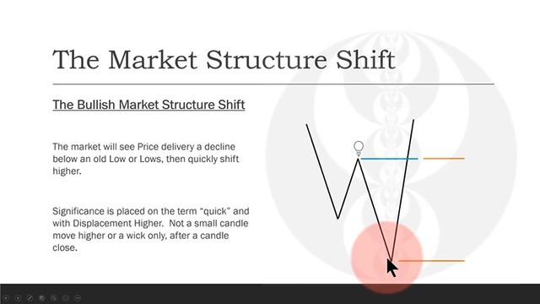
The Trading View platform requires a minimum of 15USD monthly subscription for replay, I am using a forex/CFD/crypto software simulator that works with MT4 called: www.soft4fx.com
Here is the link to download the fair value gap indicator.
Back Test the ICT Method in MT4 using Soft4Fx
www.soft4fx.com
Replicate the Order Blocks, Fair Value Gaps and Liquidity Pools.
https://soft4fx.com/software/forex-simulator.php
Episode 7
A high/low range is defined on the Nasdaq 15min chart with the anticipation of price taking out the stops on the lower end of the range.
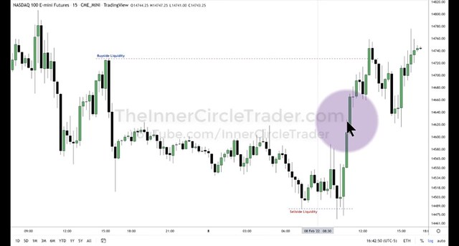
The same range forms on a correlated 15min chart on the S&P500.
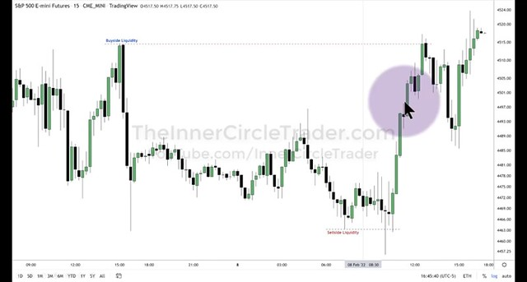
A fair value gap forms on the 2min S&P 500 chart after taking out the lows.
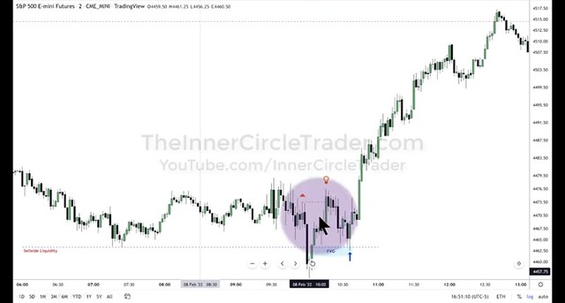
On the same Nasdaq 2min chart the price action looks very similar but there is no Fair Value Gap.
Although since the markets are correlated you can replicate and the on the NASDAQ as if you were trading the S&P.
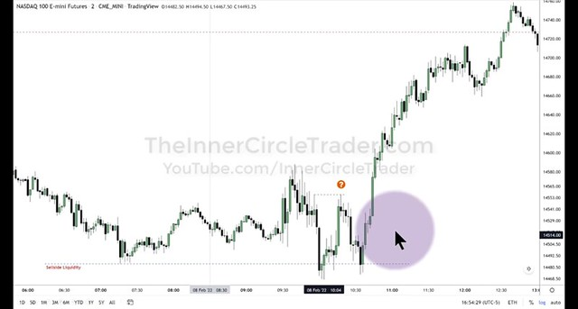
Episode 8
To determine the trading bias of a trading pair that you would like to trade you can view the daily chart of the EURJPY.
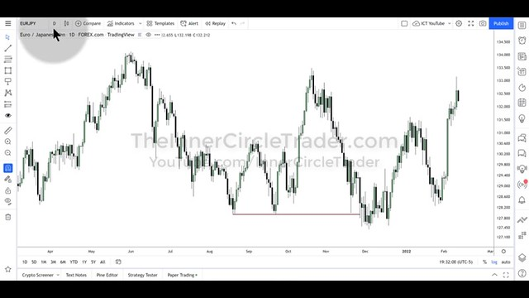
You can also further identify the trend by observing the individual futures contracts of the pair. Here is an example of the Euro Contracts looking strong and bullish.
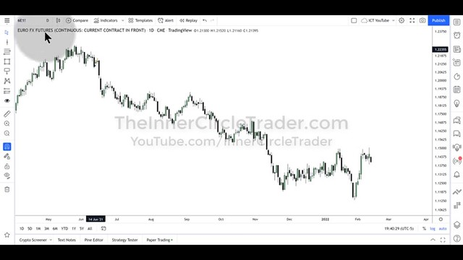
Here is an example of the Japanese Yen futures contracts looking weak and bearish.
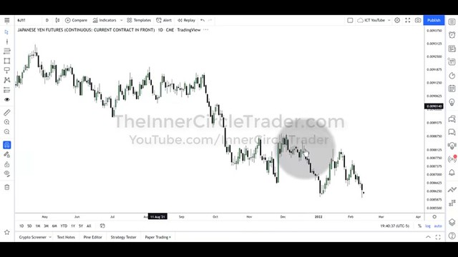
This gives us an additional confirmation we can anticipate prices of the EUR to move higher against the YEN.
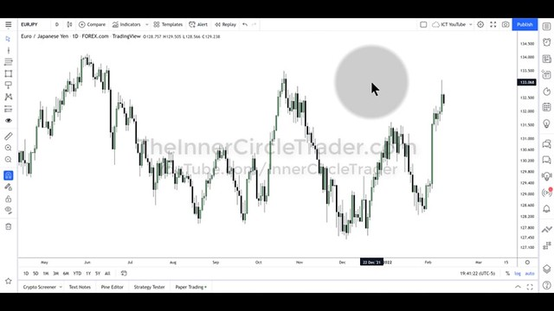
Episode 9
Power of 3 – Accumulation, Distribution and Manipulation
If we anticipate the larger timeframe such as the daily candle to move bullish, price will fake a move lower from the opening, rally, and finish the day near the high of the day.
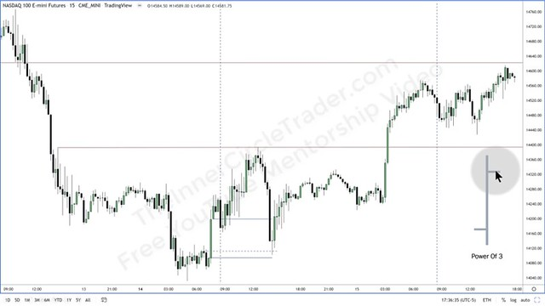
Do not chase price. If price has run up extremely fast in a previous session do not jump into the trade along with it. Let price show you some more characteristics and let it trade into a more ideal entry point such as a fair value gap that is taking out liquidity before moving onwards.
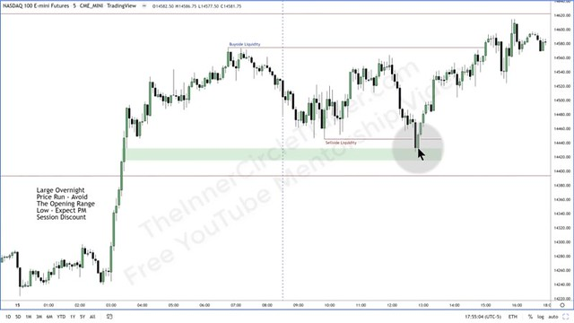
Back Test the ICT Method in MT4 using Soft4Fx
www.soft4fx.com
Replicate the Order Blocks, Fair Value Gaps and Liquidity Pools.
https://soft4fx.com/software/forex-simulator.php
Episode 10
Bearish Power of 3
If we are bearish on the daily bais then we can expect the next trading days candle to open, rally higher, and close at the near the low of the day.
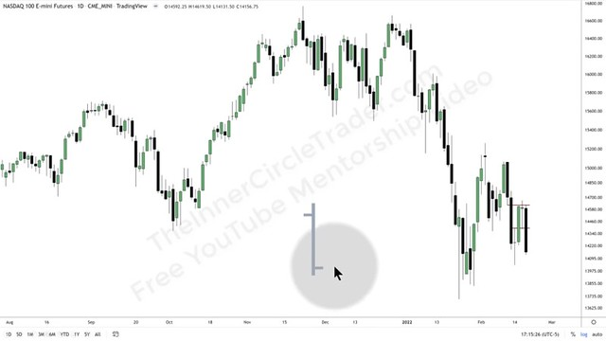
Here is a closer look at the phenomenon from New York Open. The daily bais is bearish. Price rallies higher from the open, and heads lower before closing near the low of the day.
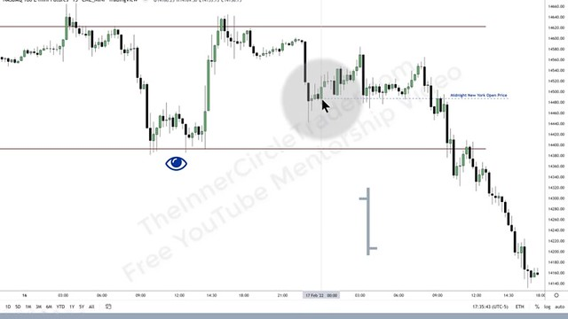
On the lower timeframe 4min chart – the same fair value set up appears for taking the short trade.
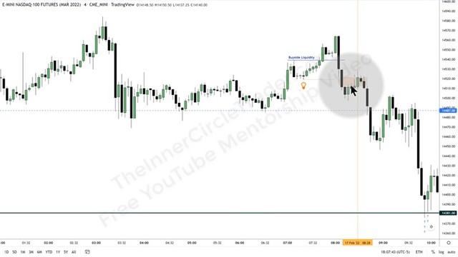
Episode 11
Here is an example of a trade on a bearish 3 min chart where price moves into a fair value gap where you can enter the trade and exit at a key low where market liquidity is located.
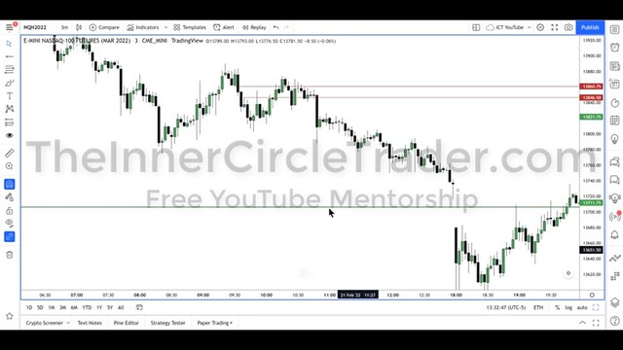
Episode 12
Where is price headed? Price is headed in the direction of Buyside/Sellside Liquidity or to fill an Imbalance. So there are Long Term Highs/Lows, Intermediate Highs/Lows, Short-Term Highs/Lows.
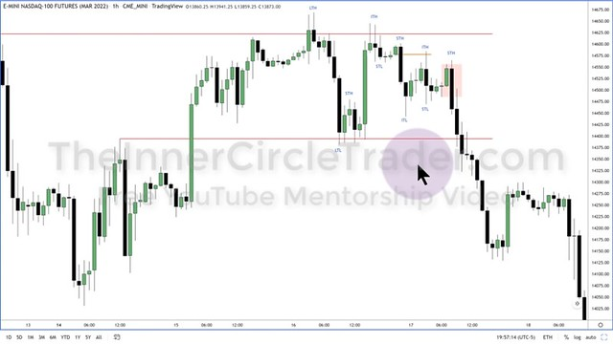
Here is an example of a fair value gap trade entry area located in a Short Term High identified on the hourly chart but can also be seen on this 15min. chart.
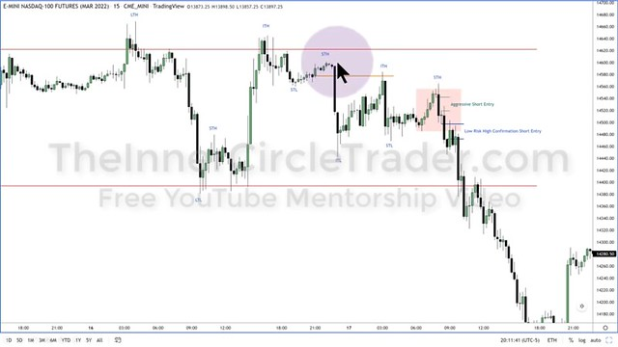
Here is an even closer look at how precise your entry can be in the fair value gap for this short example.
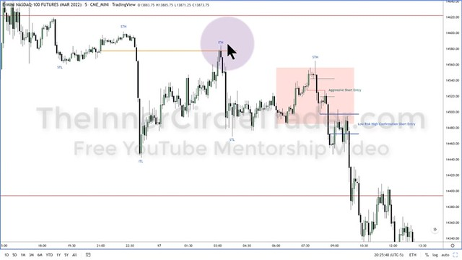
Your imbalances that are filled should create higher lows to confirm your bias is correct on trading short and being bearish.
Always trade in the direction of your daily bias study and if you do not know what direction price is being drawn to stay neutral and out of the markets until you can confirm a bias.
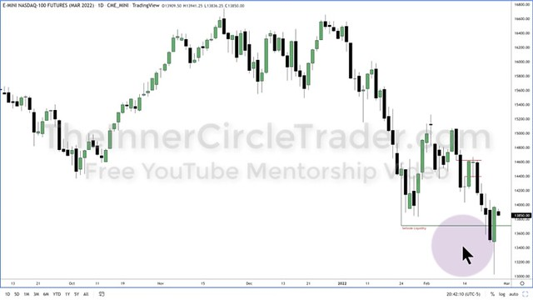
Back Test the ICT Method in MT4 using Soft4Fx
www.soft4fx.com
Replicate the Order Blocks, Fair Value Gaps and Liquidity Pools.
https://soft4fx.com/software/forex-simulator.php
Episode 13
Using a top down approach on the daily charts determines that the applicable trading direction is long.
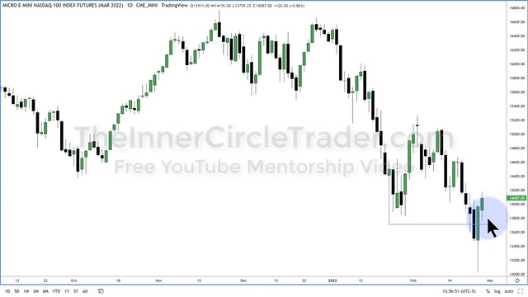
On the hourly chart an area of buyside liquidity is identified.
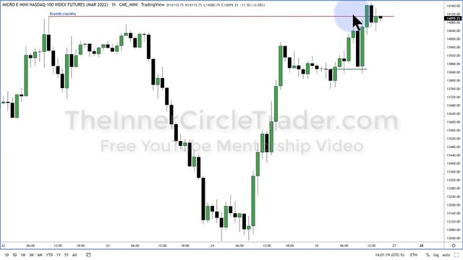
A reversal is created by an order block and a fair value gap appears on the 5min chart. This is where we begin to take our long position.
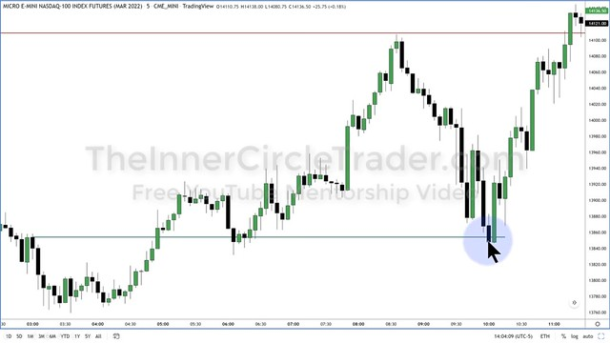
On the 1 min. chart fair value gaps and entry opportunities appear all the way up to the exit location at the high where the buyside liquidity is resting.
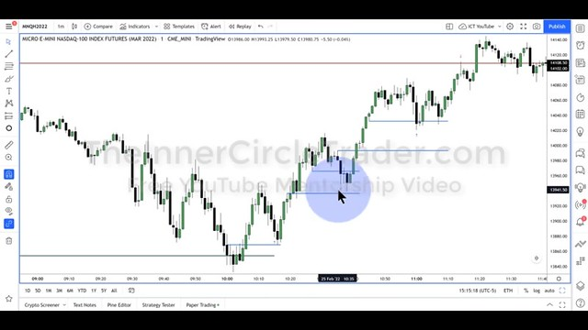
Episode 14
A entry is made on the 1min chart inside a fair value gap.
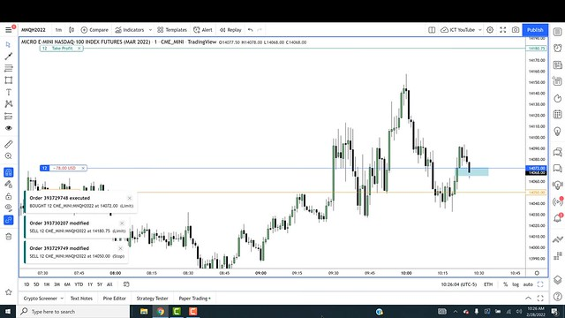
An exit location for partial or entire profits is located at an area of buyside liquidity. It is also an area to move your stop loss to break even.
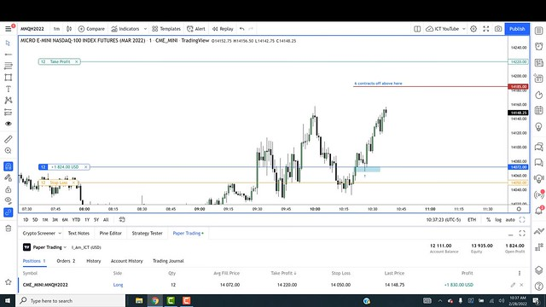
Episode 15
A fair value gap appears on the 1min. chart after the swing low and it is an ideal area to enter the trade.
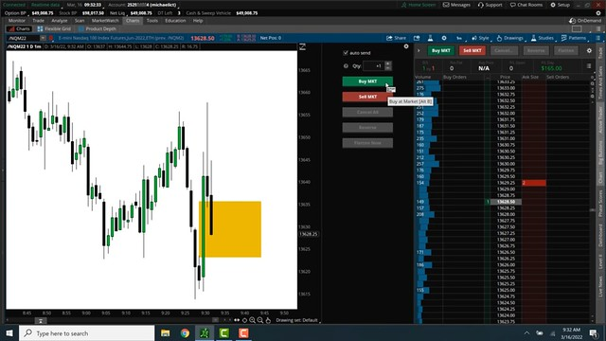
An exit is placed above an old high where liquidity is located and price is drawn towards.
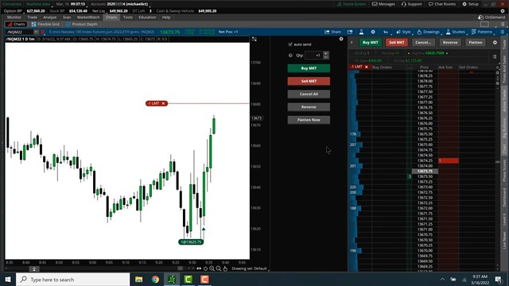
Episode 16
If we anticipate price to go lower we can expect price to rally higher before going lower to a key low where liquidity is located.
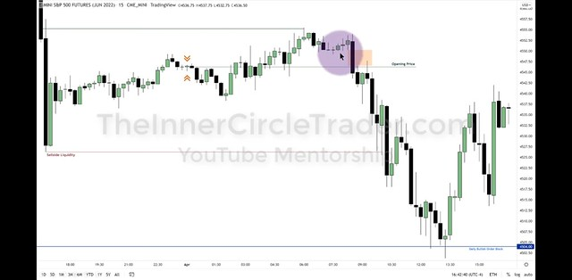
The set-ups can appear perfectly sometimes but not always and sometimes an imbalance is not completely filled in a fair value gap.
There are always additional entries points to enter that will appear perfectly if you missed the first short entry.
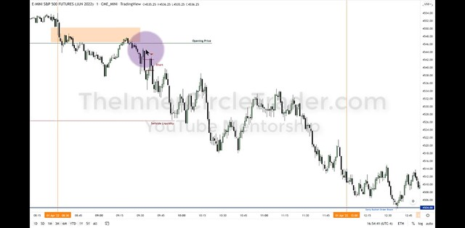
Once price has taken out the sellside liquidity and moved into a bullish order block we can expect price to reverse and we can take the trade long.
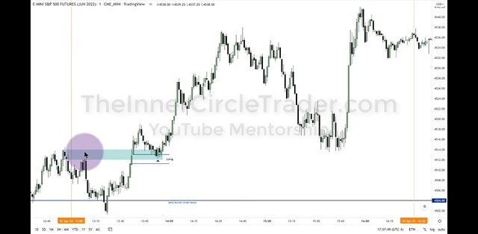
On the short run down stops were placed above old highs and now that price has reversed you can expect price to revisit those areas as it climbs highers and this is an ideal place to exit our long positions.
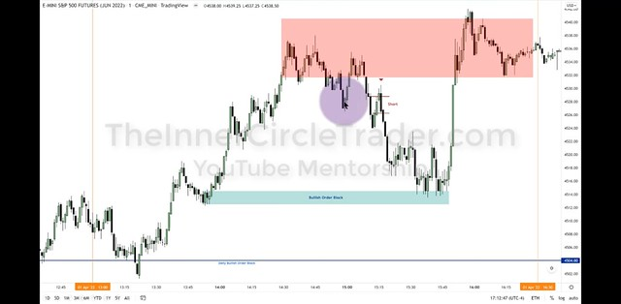
Back Test the ICT Method in MT4 using Soft4Fx
www.soft4fx.com
Replicate the Order Blocks, Fair Value Gaps and Liquidity Pools.
https://soft4fx.com/software/forex-simulator.php
Published August 12, 2022
Categorized as Inner Circle Tr
Episode 17
On the daily chart price will be drawn to previous swing lows where liquidity is located and to round numbers where you can target exits.
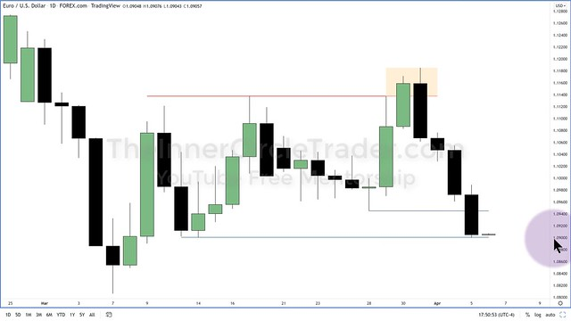
The New York Kill Zone is from 7am to 10am on forex. This timeframe is where you can hunt your entries for the anticipated short set-up and target your exits near the round number.
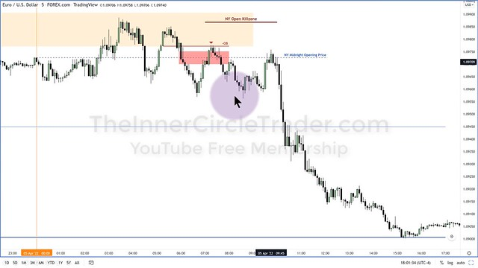
Episode 18
Our daily analysis of price gives us a daily bias based off the fair value gap that price will run above the previous daily candle before heading lower.
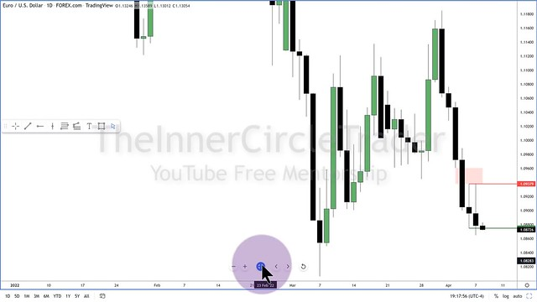
We are anticipating a run higher above yesterday’s high to stop hunt but then initial move lower. The entry can be identified on the 15min. chart and preciously entered on the 5min. chart.
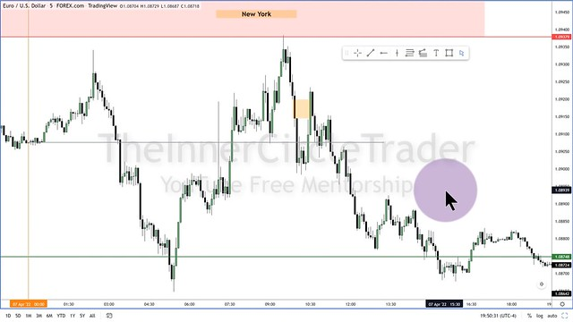
Episode 19
Although your daily bias could be long in nature there are still opportunities to go short or contrarian to the daily bais.
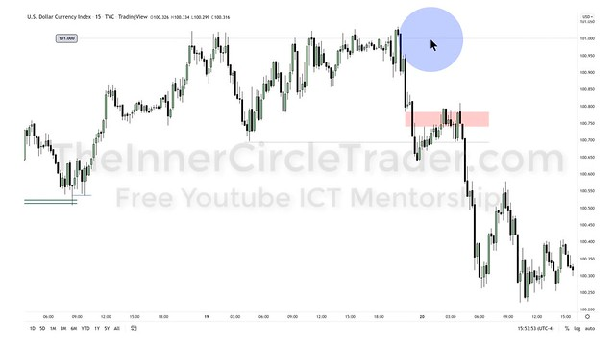
Your daily bias can be tested by candles not exactly performing how you anticipated but that should not change your decision of your analysis as it sometimes just takes patience.
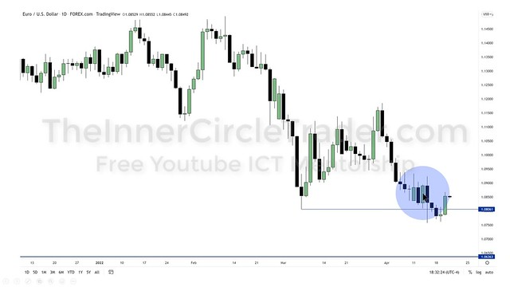
On the analysis of the daily charts a fair value gap was filled and swing low is formed our daily bais would be bullish for the next trading session.
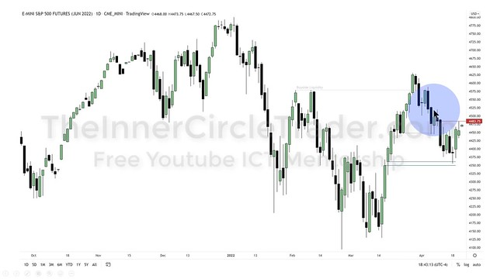
A bullish set up appears after the market has absorbed all the sellside liquidity it pivots higher reaching for the buyside liquidity.
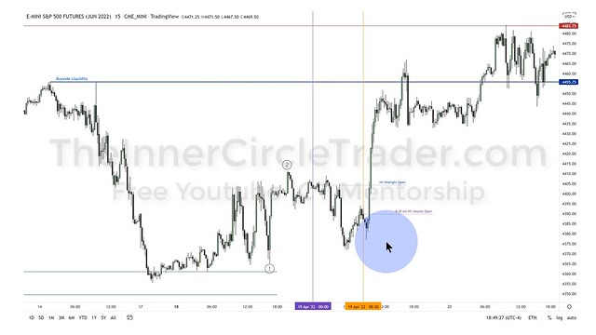
The execution of the entry can be done on the 1min. chart in a fair value gap.
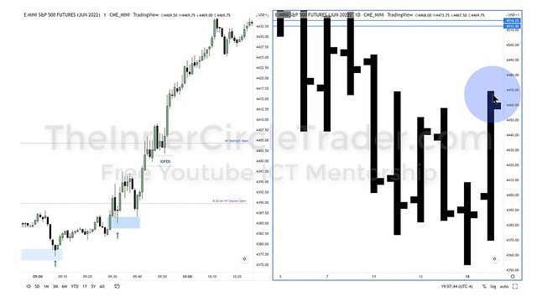
Episode 20
On the 2min chart a high is created on the London Open and a shorting opportunity is present by creating a fair market value gap for an entry and an imbalance exit point if held past the 50% level between the high and the low.
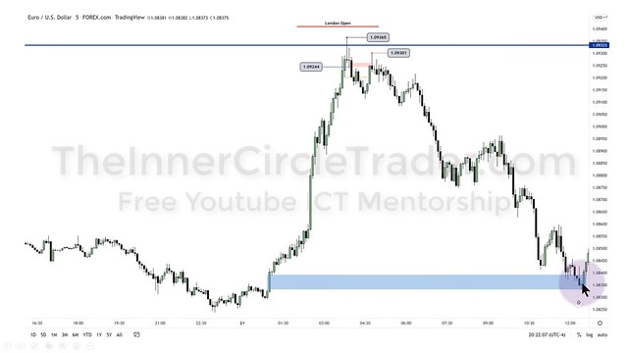
Back Test the ICT Method in MT4 using Soft4Fx
www.soft4fx.com
Replicate the Order Blocks, Fair Value Gaps and Liquidity Pools.
https://soft4fx.com/software/forex-simulator.php

