ST10378057
Masimba Mundembe
CLDV7111
Github Repo:
ERD: 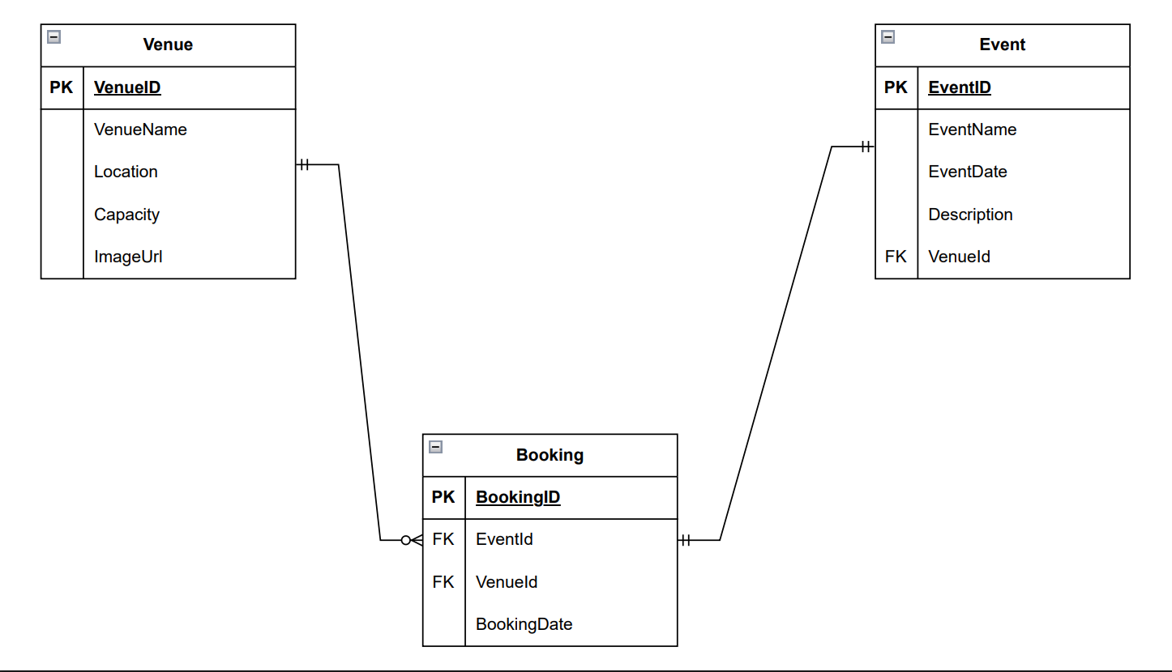
Database Creation Script:
