**Mini-Project Final Report**

# DEPARTMENT OF COMPUTER SCIENCE & ENGINEERING



**CMR COLLEGE OF ENGINEERING AND TECHNOLOGY**

##### (An Autonomous Institution under UGC, Approved by AICTE,Accredited by NAAC with ‘A’ Grade)

**A  Project report on**

**ONLINE VOTING SYSTEM**

A Dissertation submitted to JNTU Hyderabad in partial fulfillment of the academic requirements for the award of the degree.

## Bachelor of Technology

**in**

**Computer Science & Engineering**

Submitted by

**(VISHAL MAAN , GEDELA BANGARU NAIDU , N.SUNIL )**

(12H51A05H8, 12H51A05D9,13H55A0519)

Under the esteemed guidance of

(Mr.Basha Shaikh Kaimullah)

(Assistant Professor)



**Department of Computer Science & Engineering**

**CMR COLLEGE OF ENGINEERING AND TECHNOLOGY**

(An Autonomous Institution under UGC & JNTUH, Approved by AICTE, Permanently Affiliated to JNTUH, Accredited by NAAC with ’A’ Grade.)

**2012- 2016**

**CMR COLLEGE OF ENGINEERING & TECHNOLOGY**

KANDLAKOYA, MEDCHAL ROAD, HYDERABAD – 501401

** DEPARTMENT OF COMPUTER SCIENCE AND ENGINEERING**

**CERTIFICATE**

This is to certify that the Project report entitled **" Online Voting System "** being submitted by **Vishal maan , Gedela Bangaru Naidu , N.Sunil *Roll-no’s – 12H51A05H8 , 12H51A05D9 , 13H55A0519*** in partial fulfillment for the award of **Bachelor of Technology in Computer Science and Engineering** is a record of bonafide work carried out his/her under my guidance and supervision.

The results embodies in this project report have not been submitted to any other University or Institute for the award of any Degree.

**Mr.Basha Shaikh Kaimullah Dr. K.Srinivas Rao Assistant Professor Professor and HOD**

**Dept. of CSE Dept. of CSE**

Submitted for viva voice Examination held on

**External Examiner**

**Acknowledgment**

With great pleasure I want to take this opportunity to express my heartfelt gratitude to all the people who helped in making this project work a grand success.

I am grateful to **Basha Shaikh Kaimullah** Assistant Professor, Dept of Computer Science and Engineering for his valuable suggestions and guidance during the execution of this project work.

I would like to thank **Dr. K. Srinivas Rao**, Head of the Department of Computer Science and Engineering, for his moral support throughout the period of my study in CMRCET.

I am highly indebted to **Dr. M. RamaLinga Reddy**, Principal CMRCET for giving permission to carry out this project in a successful and fruitful way.

I would like to thank the Teaching & Non- teaching staff of Department of Computer Science and Engineering for their co-operation

Finally I express my sincere thanks to **Mr. Ch. Gopal Reddy**, Secretary, CMR Group of Institutions, for his continuous care. I sincerely acknowledge and thank all those who gave support directly and indirectly in completion of this project work.

**Vishal Maan – 12H51A05H8**

**Gedela Bangaru Naidu – 12H51A05D9**

**N.Sunil – 13H55A0519**

**TABLE OF CONTENTS**

|  |  |  |  |
| --- | --- | --- | --- |
| **CHAPTER NO.** | **TITLE** | | **PAGE NO.** |
|  | **LIST OF FIGURES**  **LIST OF TABLES** | | 6  7 |
|  | **ABSTRACT** | | 8 |
| **1** | **INTRODUCTION** | | 10 |
|  | 1.1 | Purpose | 10 |
|  | 1.2  1.3  1.4 | Scope  Technologies used  Overview | 10  10  11 |
| **2** | **BACKGROUND AND WORK OF EXISTING SYSTEM** | | 12 |
|  | 2.1  2.2 | Background  Drawbacks | 12  12 |
|  |  |
| **3** | **BACKGROUND WORK** | | 13 |
|  | 3.1  3.2  3.3  3.4  3.5  3.6 | Goal of the proposed system  Background  Project Requirement  User Characteristics  Constraints  Definition of problem | 13  14  14  14  15  15 |
| **4** | **DESIGNING** | | 16 |
|  | 4.1 | Software Requirement Specification  4.1.1 Objective  4.1.2 Scope  4.1.3 Advantages  4.1.4 Technologies  4.1.5 Overview | 16  16  16  17  17  17 |
|  | 4.2 | Diagrams | 20 |
| **5** | **COMMUNICATION** | | 22 |
| **6** | **DISCUSSION**  6.1 Technical Feasibility  6.2 Economical Feasibility  6.3 Operational Feasibility  6.4 Schedule Feasibility | | 38  39  40  41  41 |
| **7**  **8**  **9** | **CONCLUSION**  **BIBLIOGRAPHY**  **APPENDIX - A** | | 42  43  44 |

**List of Figures**

|  |  |  |
| --- | --- | --- |
| **FIGURE NO.** | **TITLE** | **PAGE NO.** |
| 4.2 | Class Diagram. | 20 |
| 3.2 | Activity Diagram | 21 |
| 3.3 | Data Flow Diagram | 22 |

**List of Tables**

|  |  |  |
| --- | --- | --- |
| **FIGURE NO.** | **TITLE** | **PAGE NO.** |
| 3.1 | User Table | 36 |
| 3.3 | Party Detail Table | 37 |

**Abstract**

This project deals with voting for your party from touch of your mobile .

This project aims for the betterment of public service and manages India’s

most complicates system of voting . The project is time efficient and allows

People of India to vote from their home . Basic idea of online voting is

Reducing the rush on voting days , reducing wastage of time . This project is new phase of controlling votes .

***Existing System***

Existing system of voting requires to be present at the voting

site and wait in long queue for providing votes . This system is very slow ,

time consuming and creates too much of rush , traffic jam , which directly

or indirectly effects the working of a state . Present system of voting system

requires lots of security . Each and every voting site is taken care by local

police , management of things becomes tough and time taking .

***Disadvantages Of Existing System***

• Very Slow

• Direct or indirect impact on city traffic , schools , colleges etc.

• Requires lots of man power for management .

***Proposed System***

Proposed system makes use of technology to maintain

time management of voting system of India . As a democratic country ,

voting system is most important part of country . This Project makes use of

android for making a user interface in their mobiles . Through their android

mobiles users can vote online to their favorite party . Proposed system

takes care of authentication problem , by validating a user by storing its

aadhar id and voter id . This system takes input of a user as its aadhar

number and voter id . It allows voting only once for entered aadhar number

and voter id .

***Technology Used***

***FRONT END*** – Android

***BACK END*** – php

***DATA BASE*** - MySql

***CHAPTER-1***

**INTRODUCTION**

* 1. **Purpose**

In “Online voting system “ a user whoever wants to vote for a party will can vote to it using an android application . No voter will have to stand in line for their turn to vote .A voter can easily vote from this app and his information will be stored in the database . An android app connected to the server will allow the user to directly vote for the interested party . Main purpose of this project is to reduce the wastage of time and money spent on elections . No more worry about standing in queues . Voters can vote to any party which they like without any external pressure of parties . This way votes will not be partial and reduces lot of resources used during elections .

* 1. **Scope**

The scope of the project is that hosted on the server. There is a DATABASE which is maintained in which all the names of voter with party selected and party list is stored

* 1. **Technologies to be used**
* The project will be a android application based on php and mysql.
* Front end – Android
* Back end – php
* Data base – MySql

**1.4 Overview**

* Project is related to Online Voting System.
* The project maintains database of parties list and users
* Main facilities available in this project are:-
  + - Maintaining voter’s Identification.
    - Providing online voting management.
    - Providing Updation of voter’s information.
  + Voter can give his\her vote from any part of India.

***CHAPTER-2***

**BACKGROUND WORK OF EXISTING SYSTEM**

**2.1 Background**

PRESENT VOTING SYSTEM is a voting system by which any Voter can use his\her at specified voting centers only.IT contains-:

* Voter’s information in boxes of voting pages .
* Voter’s Names with ID.
* Calculation of total number of votes is done by machines and humans.
* Use Electronic Voting Machine

**2.2 Drawbacks**

PRESENT VOTING SYSTEM in Inida is not efficient , because of following reasons

* Use of electronic machines , which contains list of parties is not reliable .
* It takes long amount of time to vote for a use .
* Very slow , because there is a particular voting center defined in the place , and everyone will have to go their to vote .
* Direct or indirect Impact on city traffic and schools and colleges .
* Requires a lot of man power to handle all the process .

***CHAPTER-3***

**BACKGROUND WORK**

**3.1 Goals of proposed system**

1. **Planned approach towards working: -** The working in the organization will be well planned and organized. The data will be stored properly in data stores, which will help in retrieval of information as well as its storage.

2. **Accuracy: -** The level of accuracy in the proposed system will be higher. All operation would be done correctly and it ensures that whatever information is coming from the user is accurate.

3. **Reliability:** - The reliability of the proposed system will be high due to the above stated reasons. The reason for the increased reliability of the system is that now there would be proper storage of information.

4. **No Redundancy: -** In the proposed system utmost care would be that no information is repeated anywhere, in storage or otherwise. This would assure economic use of storage space and consistency in the data stored.

5. **Immediate retrieval of information: -** The main objective of proposed system is to provide for a quick and efficient retrieval of information.

6. **Immediate storage of information: -** In manual system there are many problems to store the largest amount of information.

7. **Easy to Operate: -** The system should be easy to operate and should be such that it can be developed within a short period of time and fit in the limited budget of the user.

And can be accessed by anyone with a android mobile .

**3.2 Background**

ONLINE VOTING SYSTEM is a voting system by which any Voter can use his\her voting rights from any where in India. ONLINE VOTING SYSTEM contains-:

* Voter’s information in database.
* Voter’s Names with ID.
* Voter’s vote in a database.
* Calculation of total number of votes.

Various operational works that are done in the system are:-

* Recording information of the Voter in Voter database.
* Checking of information filled by voter.
* Discard the false information.

**3.3 Project Requirements**

**Hardware Requirements**

**(Android Mobile *)-*** Min Android version – 4.0 “Ice Cream Sandwich”

**Software Requirements**

**(E-Voting Application –On Android *)***

**(Windows with Wamp Server*)***

**3.4 User Characteristics**

Every user should be:

* Comfortable with Internet Browser.
* He must have brief knowledge of voting system.
* He must also have basic knowledge of English too.

**3.5 Constraints**

* GUI is only in English.
* Login and password is used for identification of Voter.

**3.6 Definitions of problems**

• ***Not User Friendly*:** The existing system is not user friendly because the retrieval of data is very slow and data is not maintained efficiently.

• ***Difficulty in report generating*:** We require more calculations to generate the final result so it is generated at the end of the session. And the voter not get a single chance to change his\her vote.

• ***Time consuming***: Every work is done manually so we cannot generate report in the middle of the session or as per the requirement because it is very time consuming.

***CHAPTER-4***

**DESIGNING**

**4.1 Software Requirement Specification**

***4.1.1 Objective:***

The main objectives of system for ***Online voting system*** are:

* The objective of **Online voting system** is to help the organization in automating the whole manual processing of the existing system.
* The main objective to develop the system is to make the accurate & efficient decisions in different tasks at different time at different situations. The existing system is manual so members of the unit generally face a lot of embarrassing situations many times. Now they need to automate the whole process so as to make it more easy and accurate.
* System should support multi-user environment.
* System should be fully automated.
* System should provide concrete security features like creating users and assigning privileges to users .
* System should be capable to keep track of all the detailed descriptions of the client and the whole details of services offered by the client organization.
* Various outputs (reports) should be available online any time.
* System should be able to handle extremely large volumes of data (i.e. Large database support)

***4.1.2 Scope:-***

1. **Advanced technology**- It is an advanced technology used now a days. It increases the E knowledge of the users which is very necessary for current generation.
2. **Internet:** It is an online facility and hence very useful for the users.

Voters can vote from any where at any time in India.

1. **Authentication:** Using php at server we can send the error report to a particular user if he\she entered false information.

***4.1.3 Advantages:***

* Fast and easy service.
* The online voting system provides a less time consuming .
* It reduces the paper work and makes the work less tedious for Voting System
* It is a better way for voting.
* By this voting percentage will increase drastically.
* Voter has no need to go to any polling booth ,so it is easy to use
* Voting will become unbiased

.

***4.1.4 Technologies to be used:-***

This project will be a Android application to be developed in Android Studio having

* Database Design (My SQL)
* Frontend Design (Android)
* Coding (PHP)
* Testing (WAMP SERVER)

***4.1.5 Overview:-***

***1. Requirements:***

***FUNCTIONAL REQUIREMENTS:***

* Registration of the voter is done by Database Running on Wamp Server.
* Administrator can change the information any time if required.
* Registration of the Voter depends upon the information filled by the user.
* Voter is given a unique session for voting
* In the DATABASE information of every voter is stored.
* Database shows the information of every user.

**• NON-FUNCTIONAL REQUIREMENTS:**

1. Secure access of confidential data .
2. 24 X 7 availability.
3. Better component design to get better performance at peak time.
4. Flexible service based architecture will be highly desirable for future extension

***2. Project Requirements***

**Hardware Requirements**

**(Android Mobile – min v 4.0 (Ice Cream Sandwich*)***

**Software Requirements**

**(E-voting android application – Android Phone*)***

**(Wamp Server Running on your server – System *)***

***3. Software interface:***

• Client on Internet: Android App, Operating System (Android)

• Client on interaction: php , Operating System (Windows).

• Web Server: WAMP Server, Operating System (Windows)

• Data Base server: MYSQL, Operating System (Windows).

**DIAGRAMS**

1. ***Class Diagaram:***

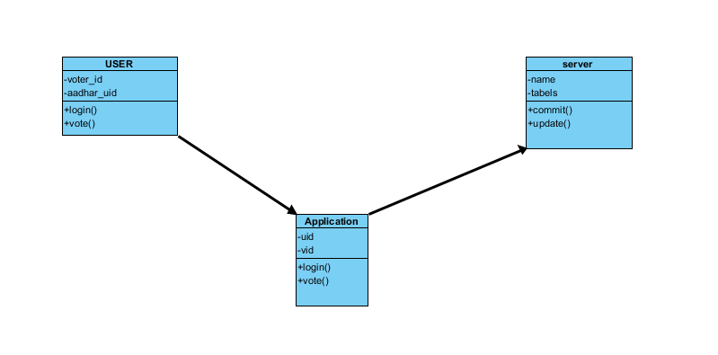

1. ***Activity Diagram:***

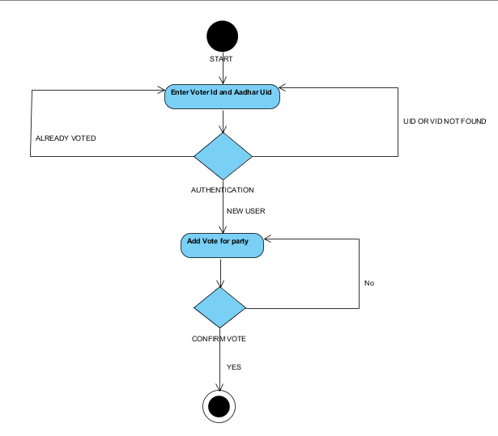

1. ***Data Flow Diagram***

Administrator

Voter

Final

Result

Voting process

Voter Registration

Information checking

administrators

Login Process

Login

voter data stored data voting data final result

SERVER

***CHAPTER-5***

**COMMUNICATION**

1. ***CONNECTION BETWEEN APP AND DATABSE :***

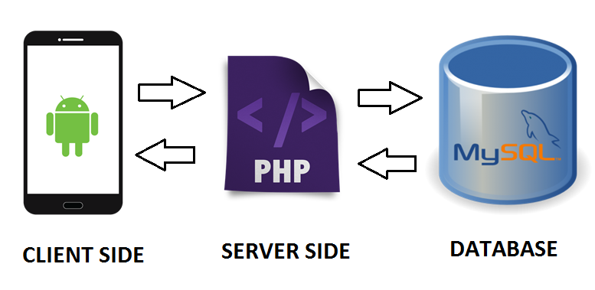

The above diagram shows how the actual connection is taking place between your android mobile and database . The mobile will allow to send data to the server using php script , which is server side scripting language . Now again after fetching the request from database , php will allow the user to receive and send data from or to the server .

This is how connection takes place . And data is transferred between user and server .

1. ***FRONTEND :***

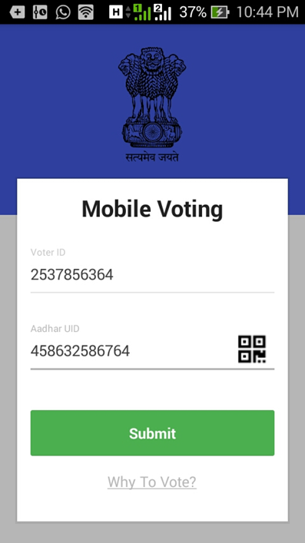

This is how our app looks . This is the front end part from where user will interact and data will be transferred according to the use selection .

This contains 2 Fields to be filled , which are Voterid and Aadhar uid . User will enter these details and then he will proceed to submit button .

We have a php running at the server side , which will take care of all the authentications and will provide a user with next page . This is how this 1st page of app works , by allowing or discarding the permissions to the users and taking care of authentication .

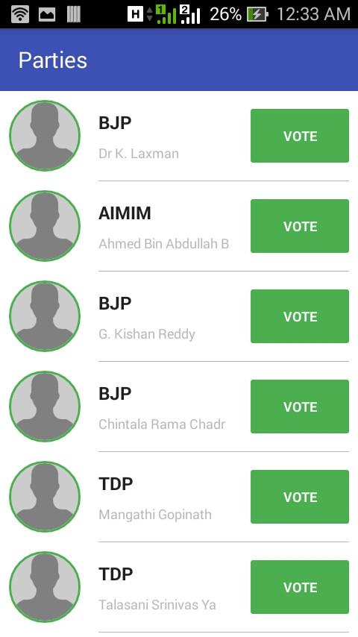

If a user is authenticated and allowed by the php script checking for no duplication and security of app , then the user will land on this activity screen . It is list of the parties , provided to a user to vote , whenever a user pushes that vote button , user will get a confirmation of whether you want to vote or not for the party . As soon as you click to vote for a party , It will automatically take you out to the 1st signing page . To maintain the consistency and accuracy to maintain the security .

***FRONTEND [CODE (Android) ] :***

* Party List

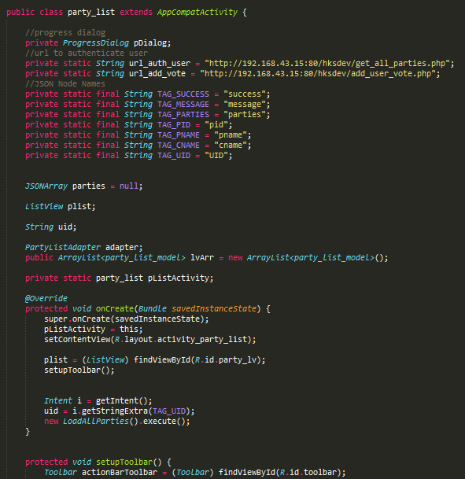

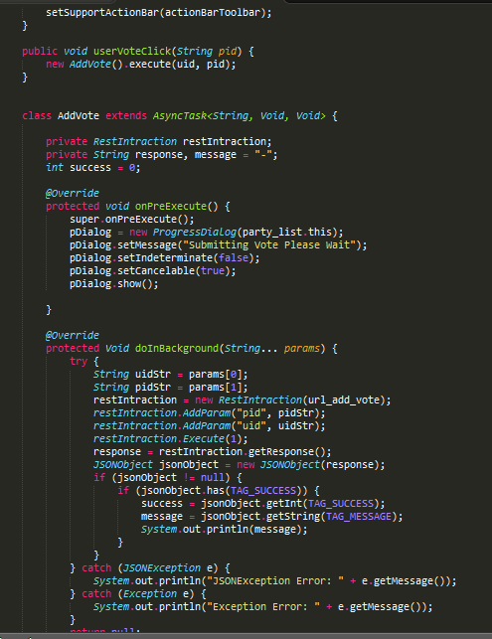

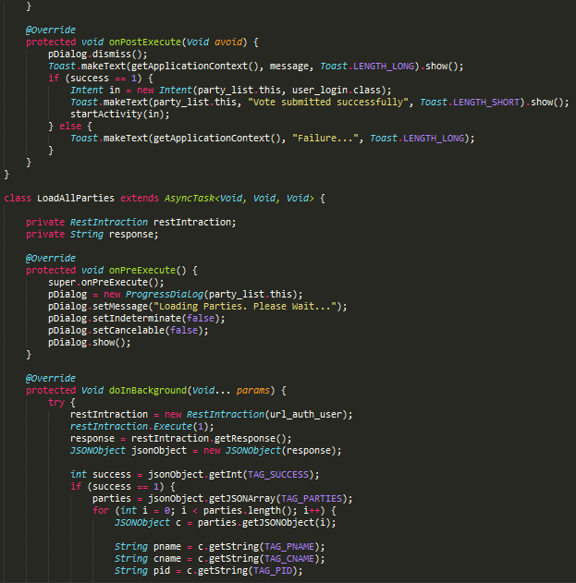

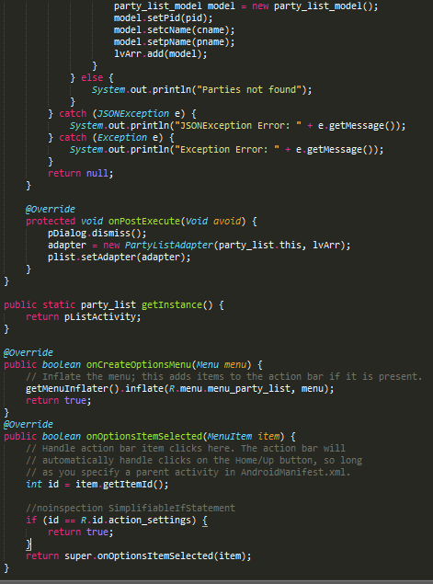

***FRONTEND [CODE (Android) ] :***

* User Login

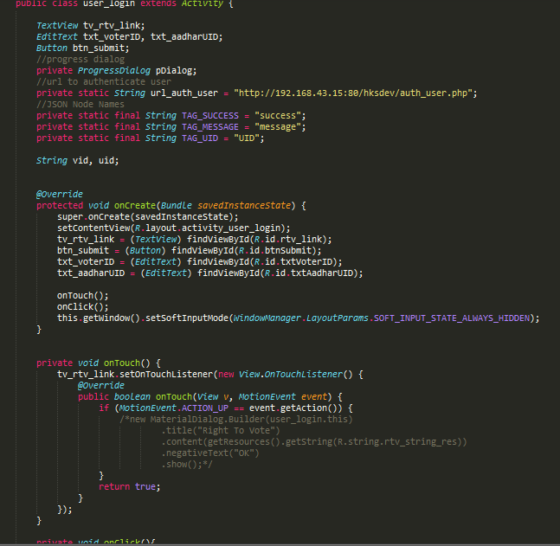

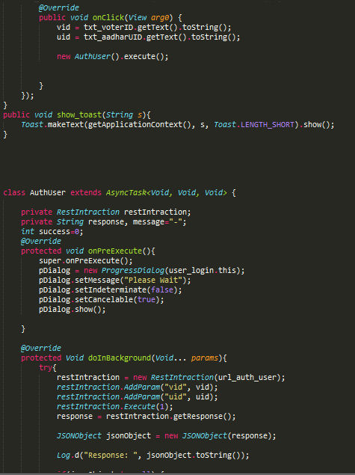

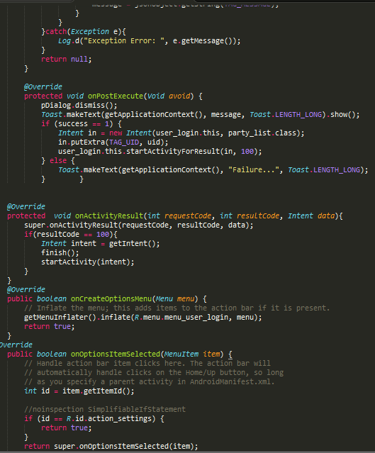

1. ***BACKTEND :***

We use php as our server side script .

We have following tables for interaction

• auth_user (For authenticating user )

• get_all_parties (to get all the parties for voting )

• add_vote (For adding vote to a particular party )

* Auuth_user

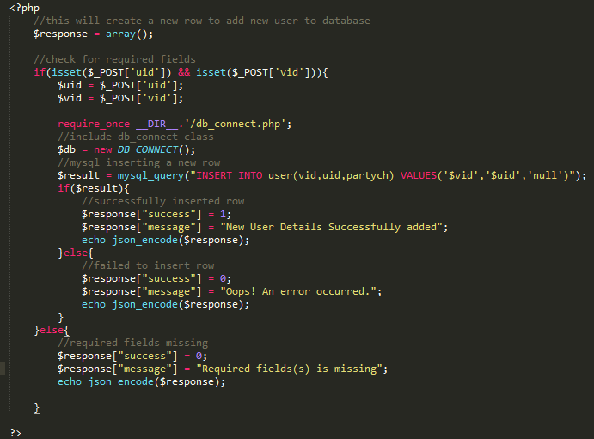

* get_all_parties

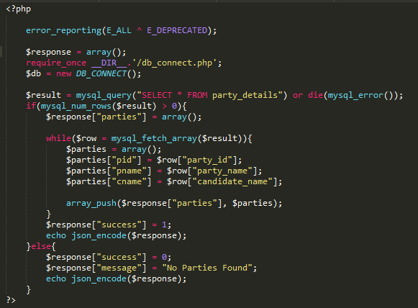

* add_vote

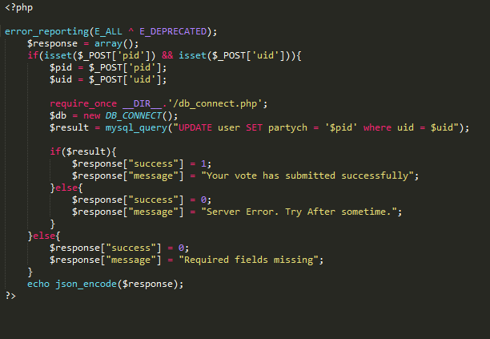

1. ***BACKEND***

In backend part , we are using mysql for managing databse . We are using wamp server for providing storing for database values and retrieving values when needed . We user mysql for storing data into tables , and for query purpose .

Wamp server can be accessed from web browser by typing localhost . In that if we go to phpmyadmin we can see the whole structure of database .

We have two tables stored at our database named “voting”

• user

• party_details

* User Table

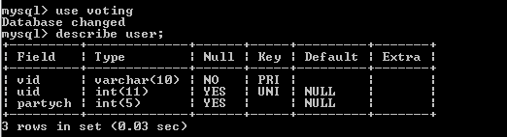

* Party Details Table

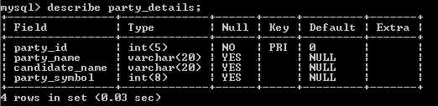

***CHAPTER-6***

**DISCUSSION**

Depending on the results of the initial investigation the survey is now expanded to a more detailed feasibility study. Feasibility is a test of system proposal according to its workability, impact of the organization, ability to meet needs and effective use of the resources. It focuses on these major questions:

1. What are the user’s demonstrable needs and how does a candidate system meet them?

2. What resources are available for given candidate system?

3. What are the likely impacts of the candidate system on the organization?

4. Whether it is worth to solve the problem?

During feasibility analysis for this project, following primary areas of interest are to be considered. Investigation and generating ideas about a new system does this.

Steps in feasibility analysis

Eight steps involved in the feasibility analysis are:

* Form a project team and appoint a project leader.
* Prepare system flowcharts.
* Enumerate potential proposed system.
* Define and identify characteristics of proposed system.
* Determine and evaluate performance and cost effective of each proposed system.
* Weight system performance and cost data.
* Select the best-proposed system.
* Prepare and report final project directive to management.
  1. ***Technical feasibility***

A study of resource availability that may affect the ability to achieve an acceptable system. This evaluation determines whether the technology needed for the proposed system is available or not.

* Can the work for the project be done with current equipment existing software technology & available personal?
* Can the system be upgraded if developed?
* If new technology is needed then what can be developed?
* This is concerned with specifying equipment and software that will successfully satisfy the user requirement. The technical needs of the system may include:

**Front-end and back-end selection**

An important issue for the development of a project is the selection of suitable front-end and back-end. When we decided to develop the project we went through an extensive study to determine the most suitable platform that suits the needs of the organization as well as helps in development of the project.

The aspects of our study included the following factors.

**Front-end selection:**

1. It must have a GUI that assists employees that are not from IT background.

2. Scalability and extensibility.

3. Flexibility.

4. Robustness.

5. According to the organization requirement and the culture.

6. Must provide excellent reporting features with good printing support.

7. Platform independent.

8. Easy to debug and maintain.

9. Event driven programming facility.

10. Front end must support some popular back end .

According to the above stated features we selected ANDROID as the front-end for

developing our project.

**Back-end Selection:**

1. Multiple user support.

2. Efficient data handling.

3. Provide inherent features for security.

4. Efficient data retrieval and maintenance.

5. Stored procedures.

6. Popularity.

7. Operating System compatible.

8. Easy to install.

9. Various drivers must be available.

10. Easy to implant with the Front-end.

According to above stated features we selected MY SQL as the backend.

The technical feasibility is frequently the most difficult area encountered at this stage. It is essential that the process of analysis and definition be conducted in parallel with an assessment to technical feasibility. It centers on the existing computer system and to what extent it can support the proposed system.

***6.2 Economical feasibility***

Economic justification is generally the “Bottom Line” consideration for most systems. Economic justification includes a broad range of concerns that includes cost benefit analysis. In this we weight the cost and the benefits associated with the candidate system and if it suits the basic purpose of the organization i.e. profit making, the project is making to the analysis and design phase.

The financial and the economic questions during the preliminary investigation are

verified to estimate the following:

* The cost to conduct a full system investigation.
* The cost of hardware and software for the class of application being considered.

. The benefits in the form of reduced cost.

* The proposed system will give the minute information, as a result the

performance is improved

* This feasibility checks whether the system can be developed with the available funds. The **Online voting system** does not require enormous amount of money to be developed. This can be done economically if planned judicially, so it is economically feasible. The cost of project depends upon the number of man-hours required.

***6.3 Operational Feasibility***

It is mainly related to human organizations and political aspects. The points to be

considered are:

* What changes will be brought with the system?
* What organization structures are disturbed?
* What new skills will be required? Do the existing staff members have these

skills? If not, can they be trained in due course of time?

The system is operationally feasible as it very easy for the End users to operate it. It only needs basic information about Android Mobile platform.

***6.4 Schedule feasibility***

Time evaluation is the most important consideration in the development of project. The time schedule required for the developed of this project is very important since more development time effect machine time, cost and cause delay in the development of other systems.

A reliable **Online voting system** can be developed in the considerable amount of time

**CONCLUSION**

This Online Voting system will manage the Voter’s information by which voter can login and use his voting rights. The system will incorporate all features of Voting system. Its provide the tools for maintaining voter’s vote to every party and it count total no. of votes of every party. There is a DATABASE which is maintained in which all the names of voter with complete information is stored.

In this user who is stored in database and when he/she want to vote he/she has to login by his Voter id and AAdhar uid and can vote to any party only single time. Voting detail store in database and the result is displayed by calculation. By online voting system percentage of voting is increases. It decreases the cost and time of voting process. It is very easy to use and It is vary less time consuming. It is very easy to debug.

***BIBLIOGRAPHY***

[1] I have studied about Android , PHP , MySQL these were the main source in working of Application .I have also used Apache Server and MySQL to store the data in database.

In the making of report i got a lot of help from websites

The sources are:-

* [*www.php.net*](http://www.php.net)
* [*www.w3schools.com*](http://www.w3schools.com)
* [*www.google.com*](http://www.google.com)
* [*www.developer.android.com*](http://www.developer.android.com)

[2] I have also used some software:-

* WAMP Server
* Android Studio

***APPENDIX – A***

***USER MANUAL***

* ***Requirement of Tools:***

This application is mounted on the Localhost, to user has to make sure that the Mobile, which he is using the application , is connected to Server through hotspot Wi-Fi .

* ***How to use the application*:**

To use the application the user has open the Android app in android mobile . Then, user gets the Login Page of the Application . And after entering correct details user will be forwarded to party list to vote for .