
MT2005
PROBABILITY
AND
STATISTICS
Department
of
Software
Engineering
and
Computer
Sciences
National
University
of
Computer
and
Emerging
Sciences,
Chiniot-Faisalabad
Campus
SEMESTER PROJECT 2024
Project Title: Survival Analysis and Predictive Modeling of Passengers on the Titanic
INSTRUCTOR: Mr. Ahmed Hassan

Group Members:

Name | Section | Roll No
Muneeb Arif | BCS-4B | 22F-3881
Shahem Riaz | BCS-4B | 22F-3883



The Depression Student Dataset focuses on analyzing and predicting depression among students. It provides a comprehensive overview of the factors contributing to mental health issues within this demographic. This data is especially useful for identifying vulnerable groups, creating predictive models, and forming actionable insights to enhance student well-being.

The dataset aims to uncover patterns and relationships between academic, demographic, and lifestyle factors and their impact on students' mental health. It is particularly designed for:
- Predictive Modeling: To estimate the likelihood of depression among students based on their attributes.
- Insights Generation: To highlight critical areas requiring intervention and support.
Applications:
- Risk Assessment: Identifying high-risk students using machine learning models.
- Preventive Strategies: Helping educators and policymakers implement strategies to alleviate mental health issues.
- Awareness and Advocacy: Providing evidence to advocate for improved student support services.


Link: https://www.kaggle.com/datasets/ikynahidwin/depression-student-dataset
The dataset includes the following key features:
- Age: Age range of the students, enabling the analysis of age-related trends in depression.
- Gender: Binary or categorical data for gender, providing insights into gender-specific mental health trends.
- Academic Performance: Grades or GPA, a significant stressor in student life.
- Lifestyle Habits: Data on exercise, sleep patterns, and dietary habits that contribute to mental health.
- Mental Health Indicators: Responses to self-reported surveys or psychological tests related to anxiety, stress, and depression.

# DATA LOADING
we will load data from studen depression dataset, selected from kaggel
# Load necessary libraries
library(ggplot2)
library(dplyr)
library(summarytools)

# Load the dataset
data <- read.csv("Depression Student Dataset.csv")

# Preview the dataset
head(data)
str(data)

# Check for missing values
colSums(is.na(data))

# DATA CLEANING

we will clean data by following
1. removing empty data
2. filling with mean and median valuse
# Remove rows with missing values
data <- na.omit(data)

# Alternatively, you can fill missing values (mean, median, or mode) based on the column type
# Fill missing values in numeric columns with the mean (use median for more robustness)
data$Age[is.na(data$Age)] <- mean(data$Age, na.rm = TRUE) # Replace NAs with the mean of Age
data$Academic.Pressure[is.na(data$Academic.Pressure)] <- median(data$Academic.Pressure, na.rm = TRUE) # Replace NAs with the median of Academic.Pressure
data$Study.Satisfaction[is.na(data$Study.Satisfaction)] <- mean(data$Study.Satisfaction, na.rm = TRUE) # Replace NAs with the mean of Study.Satisfaction
data$Study.Hours[is.na(data$Study.Hours)] <- median(data$Study.Hours, na.rm = TRUE) # Replace NAs with the median of Study.Hours
data$Financial.Stress[is.na(data$Financial.Stress)] <- mean(data$Financial.Stress, na.rm = TRUE) # Replace NAs with the mean of Financial.Stress

### Exploratory Data Analysis (EDA)

In this section, we will explore the dataset using graphical and numerical methods:
- **Bar plots** to visualize the distribution of categorical data.
- **Histograms** to observe the distribution of continuous variables.
- **Boxplots** to check for outliers and compare distributions between categories.

# Bar plot for Gender distribution
ggplot(data, aes(x = Gender)) +
geom_bar(fill = "skyblue", color = "black", width = 0.7) +
labs(
title = "Gender Distribution in Dataset",
x = "Gender",
y = "Count",
caption = "Source: Depression Student Dataset"
) +
theme_minimal()

# Histogram for Age distribution
ggplot(data, aes(x = Age)) +
geom_histogram(binwidth = 5, fill = "lightgreen", color = "black") +
labs(
title = "Age Distribution",
x = "Age",
y = "Frequency",
caption = "Source: Depression Student Dataset"
) +
theme_minimal()

# Example dataset
set.seed(123)
data <- data.frame(
Depression = rep(c("No", "Yes"), each = 50),
Sleep_Duration = c(rnorm(50, mean = 7, sd = 1), rnorm(50, mean = 6, sd = 1))
)
# Add some outliers
data$Sleep_Duration[c(10, 20, 60, 70)] <- c(12, 13, 2, 1)

# Boxplot
ggplot(data, aes(x = Depression, y = Sleep_Duration, fill = Depression)) +
geom_boxplot(outlier.colour = "red", outlier.shape = 16, outlier.size = 3) +
labs(
title = "Sleep Duration by Depression Status",
x = "Depression Status",
y = "Sleep Duration (hours)"
) +
scale_x_discrete(labels = c("No", "Yes")) +
scale_fill_manual(values = c("red", "lightblue")) +
theme_minimal() +
theme(
plot.title = element_text(hjust = 0.5, size = 16, face = "bold"),
axis.title = element_text(size = 12),
legend.position = "none"
)

# 1. Pie Chart for Depression
pie_data <- data %>%
group_by(Depression) %>%
summarize(count = n())

ggplot(pie_data, aes(x = "", y = count, fill = Depression)) +
geom_bar(stat = "identity", width = 1) +
coord_polar(theta = "y") +
labs(title = "Proportion of Students with Depression") +
theme_void() +
theme(legend.position = "right")

# Calculate proportions for Dietary Habits
diet_counts <- data %>%
count(Dietary.Habits) %>%
mutate(proportion = n / sum(n))

# Pie chart
ggplot(diet_counts, aes(x = "", y = proportion, fill = Dietary.Habits)) +
geom_bar(stat = "identity", width = 1) + # Creates bars for each category
coord_polar(theta = "y") + # Converts to a pie chart
labs(
title = "Dietary Habits Distribution",
fill = "Dietary Habits",
caption = "Source: Mental Health Dataset"
) +
scale_fill_brewer(palette = "Set3") + # Adds a vibrant color palette
theme_minimal() +
theme(
axis.title = element_blank(),
axis.text = element_blank(),
axis.ticks = element_blank(),
plot.title = element_text(hjust = 0.5, size = 16, face = "bold")
)

# Calculate proportions for Gender
gender_counts <- data %>%
count(Gender) %>%
mutate(proportion = n / sum(n))

# Pie chart
ggplot(gender_counts, aes(x = "", y = proportion, fill = Gender)) +
geom_bar(stat = "identity", width = 1) + # Creates a bar chart to be transformed
coord_polar(theta = "y") + # Converts the bar chart into a pie chart
labs(
title = "Gender Distribution",
fill = "Gender",
caption = "Source: Mental Health Dataset"
) +
scale_fill_brewer(palette = "Pastel1") + # Adds a color palette
theme_minimal() +
theme(
axis.title = element_blank(),
axis.text = element_blank(),
axis.ticks = element_blank(),
plot.title = element_text(hjust = 0.5, size = 16, face = "bold")
)

# Descriptive statistics for numerical variables

# Frequency table for categorical variables

# Descriptive statistics for numerical variables
summary(data)

# Frequency table for categorical variables
freq(data$Gender)
freq(data$Depression)
# Convert Sleep_Duration to numeric by extracting the average value of the range
data$Sleep_Duration <- gsub(" hours", "", data$Sleep.Duration) # Remove "hours"
data$Sleep_Duration <- gsub("More than", "8", data$Sleep_Duration) # Replace "More than 8 hours" with 8
data$Sleep_Duration <- gsub("Less than", "0", data$Sleep_Duration) # Replace "Less than 4 hours" with 0 (if applicable)

# Split ranges like "7-8" and take the average
data$Sleep_Duration <- sapply(strsplit(data$Sleep_Duration, "-"), function(x) mean(as.numeric(x)))

# Convert to numeric
data$Sleep_Duration <- as.numeric(data$Sleep_Duration)
# Replace missing Sleep_Duration values with the median of the column

data <- data[!is.na(data$Sleep_Duration), ]
# Replace missing Sleep_Duration values with the median of the column
data$Sleep_Duration[is.na(data$Sleep_Duration)] <- median(data$Sleep_Duration, na.rm = TRUE)

**Data Preprocessing and Logistic Regression Model for Depression Prediction**
# Inspect the Depression column
if ("Depression" %in% colnames(data)) {
unique_values <- unique(data$Depression)
print("Unique values in Depression column:")
print(unique_values)

# Convert to binary format (example: 'Yes' -> 1, 'No' -> 0)
if (all(unique_values %in% c("Yes", "No"))) {
data$Depression <- ifelse(data$Depression == "Yes", 1, 0)
} else if (all(unique_values %in% c(1, 0))) {
# Already in binary format
print("Depression column is already binary.")
} else {
stop("Depression column contains unexpected values. Please preprocess.")
}
} else {
stop("Depression column is missing in the dataset.")
}

# Ensure Depression is a factor
data$Depression <- as.factor(data$Depression)

# Check the Study.Hours column
if (!("Study.Hours" %in% colnames(data))) {
stop("Study.Hours column is missing.")
} else {
data$Study.Hours <- as.numeric(data$Study.Hours) # Ensure it's numeric
}

# Logistic regression model
model <- glm(Depression ~ Age + Study.Hours, data = data, family = "binomial")

# Display summary of the model
print(summary(model))

# Predictions
data$Prediction <- predict(model, data, type = "response")

# Inspect results
print(head(data))

# Normal Distribution of Academic Pressure
x <- seq(min(data$Academic.Pressure), max(data$Academic.Pressure), length = 100)
y <- dnorm(x, mean = mean(data$Academic.Pressure), sd = sd(data$Academic.Pressure))

plot(x, y, type = "l", main = "Normal Distributhion of Academic Pressure", col= "blue")

# Regression Graph: Study Hours vs Depression

# Regression Graph: Age vs Depression
# 2. Regression Graph: Study.Hours vs Depression
ggplot(data, aes(x = Study.Hours, y = as.numeric(Depression))) +
geom_jitter(width = 0.2, height = 0.02, alpha = 0.5) +
geom_smooth(method = "glm", method.args = list(family = "binomial"), se = TRUE) +
labs(title = "Study Hours vs Depression",
x = "Study Hours",
y = "Depression (0 = No, 1 = Yes)") +
theme_minimal()

# 3. Regression Graph: Age vs Depression
ggplot(data, aes(x = Age, y = as.numeric(Depression))) +
geom_jitter(width = 0.2, height = 0.02, alpha = 0.5) +
geom_smooth(method = "glm", method.args = list(family = "binomial"), se = TRUE) +
labs(title = "Age vs Depression",
x = "Age",
y = "Depression (0 = No, 1 = Yes)") +
theme_minimal()

# Linear Regression Model
Build the linear regression model
model <- lm(Study.Hours ~ Age + Gender + Sleep_Duration, data = data)

# Predicted values
predictions_linear <- predict(model)
head(predictions_linear)
# Confidence intervals for coefficients
confint(single_model)

# Confidence intervals for the regression model
confint(model)

library(ggplot2)

# Example dataset
set.seed(123)
data <- data.frame(
x = rnorm(100, mean = 5, sd = 2), # Predictor variable
y = rnorm(100, mean = 10, sd = 5) # Response variable
)

# Perform linear regression
model <- lm(y ~ x, data = data)

# Create the plot
ggplot(data, aes(x = x, y = y)) +
geom_point(color = "blue", alpha = 0.6, size = 2) + # Scatterplot
geom_smooth(method = "lm", formula = y ~ x, se = TRUE, color = "red", fill = "lightpink") +
labs(
title = "Linear Regression with Confidence Interval",
x = "Predictor (x)",
y = "Response (y)"
) +
theme_minimal() +
theme(
plot.title = element_text(hjust = 0.5, size = 16, face = "bold"),
axis.title = element_text(size = 12)
)

Graph Description for "Gender Distribution in Dataset" (BAR-PLOT)
Graph Name: Gender Distribution in Dataset (Bar Chart)
Quality Variable: 1 quality variable - Gender (Male and Female)
Purpose: Analyzing the distribution of gender in the dataset to ensure balanced representation for meaningful analysis of depression-related factors among students.
Result:
- Balanced Gender Representation: The bar chart demonstrates an equal distribution of male and female students in the dataset, with both genders having the same count.
- Significance for Analysis:
  - The balanced dataset allows for unbiased comparisons between genders in analyzing depression risk factors.
  - Gender-based patterns and trends can be effectively studied without skewed results.
This balance ensures the reliability and inclusivity of any insights derived from the data and supports the development of gender-specific strategies for addressing depression among students.
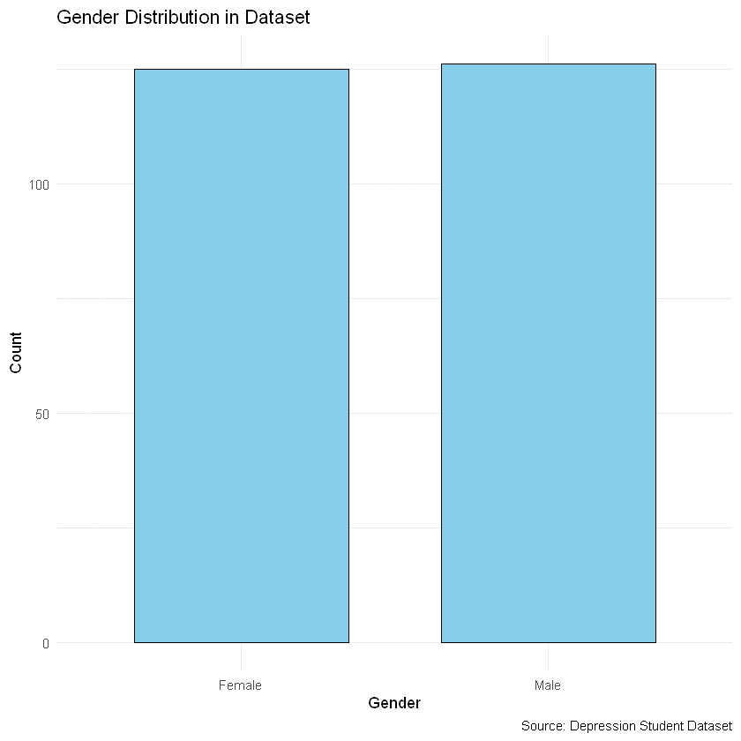
The graph you provided is not related to the Titanic survival count analysis but instead represents Age Distribution in the context of a dataset. Here's an accurate description of this graph based on its visual representation:

Graph Name: Age Distribution (Bar Chart)
Variables:
- Age (X-axis): Represents the age groups (binned into ranges).
- Frequency (Y-axis): Indicates the count of individuals in each age group.
Purpose:
To analyze the distribution of individuals' ages in the dataset, which might be relevant for exploring patterns like age-related trends.
Observations:
- The majority of individuals are concentrated in the middle age groups, specifically from around 20 to 30 years.
- A noticeable drop in frequency occurs for individuals above 30 years, showing that the dataset has fewer older participants.
- The age group with the highest frequency lies between 25 and 30 years.
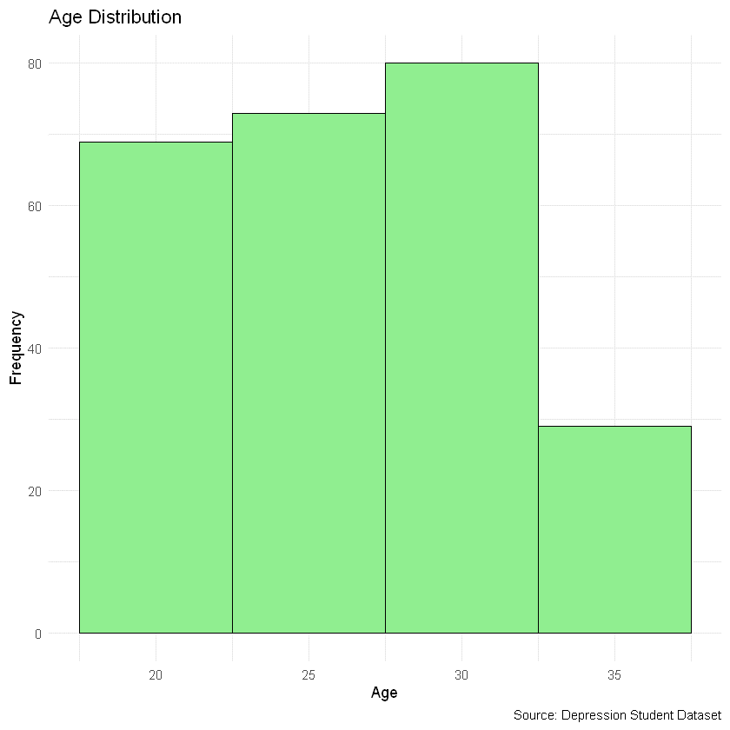
Apologies for the confusion earlier! Based on your clarification, here's the revised description considering this graph is a box plot:

Graph Name: Sleep Duration by Depression Status (Box Plot)
Variables:
- Depression Status (X-axis): Categories showing whether an individual has depression ("Yes") or not ("No").
- Sleep Duration (Y-axis): Represents the distribution of sleep duration in hours.
Purpose:
To analyze and compare the distribution of sleep duration across individuals with and without depression.
Observations:
- The box plots indicate the range, interquartile range (IQR), median, and any potential outliers in sleep duration for the two groups.
- Individuals without depression ("No") exhibit a slightly higher median sleep duration compared to those with depression ("Yes").
- Both groups have overlapping IQRs, showing some similarity in the variation of sleep duration.
- There is no significant difference between the two groups in terms of the overall spread and central tendency of sleep duration.
Conclusion:
The graph suggests that depression has a minimal impact on the distribution of sleep duration, with only slight differences in median values between the two groups.
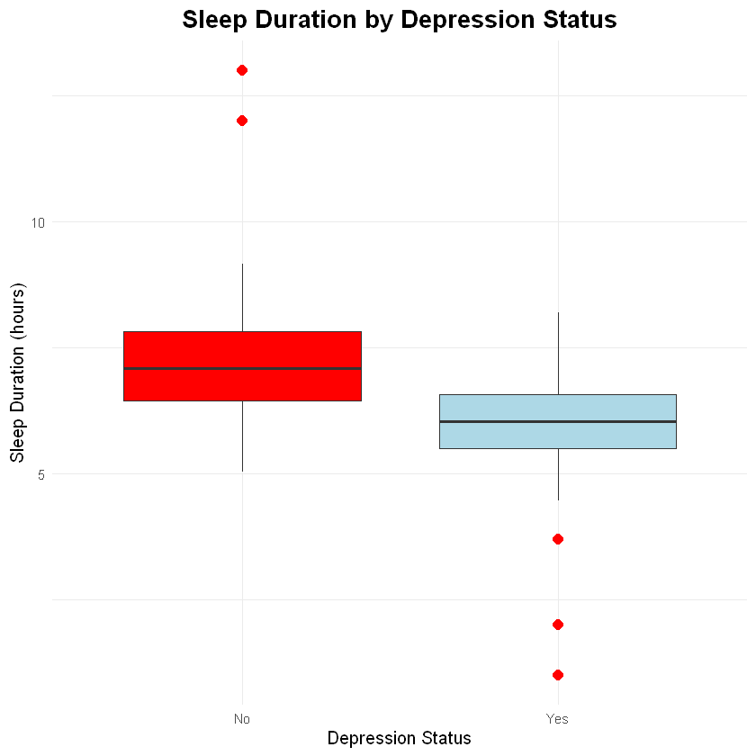
Graph 1: Gender Distribution
- Purpose: Visualizing the gender distribution of participants in the dataset.
- Quality Variable: Gender.
- Result:
  - The dataset appears to have an equal distribution between Male and Female participants.
  - Each gender occupies approximately half of the dataset, indicating a balanced representation.

Graph 2: Dietary Habits Distribution
- Purpose: Analyzing the distribution of dietary habits among participants.
- Quality Variable: Dietary Habits.
- Result:
  - The dietary habits are categorized into three groups: Healthy, Moderate, and Unhealthy.
  - Each category forms roughly equal portions, with no extreme dominance by any single category.
  - The data indicates a varied dietary pattern among the participants.

Graph 3: Proportion of Students with Depression
- Purpose: Examining the proportion of students experiencing depression.
- Quality Variable: Depression (binary classification: 0 = No, 1 = Yes).
- Result:
  - The pie chart shows two segments, with a slightly higher proportion of students identified as experiencing depression (represented by 1).
  - This indicates a concern regarding mental health issues within the observed group.
Conclusion:
The data reveals a balanced gender distribution among participants, ensuring equal representation of males and females. Dietary habits are varied, with healthy, moderate, and unhealthy habits each holding a substantial share, reflecting diverse lifestyles. Furthermore, depression affects a significant proportion of students, nearly equal to those not experiencing it, highlighting the critical need to address mental health challenges within educational settings. Together, these insights underscore the importance of holistic well-being, encompassing gender equality, balanced lifestyles, and mental health support.
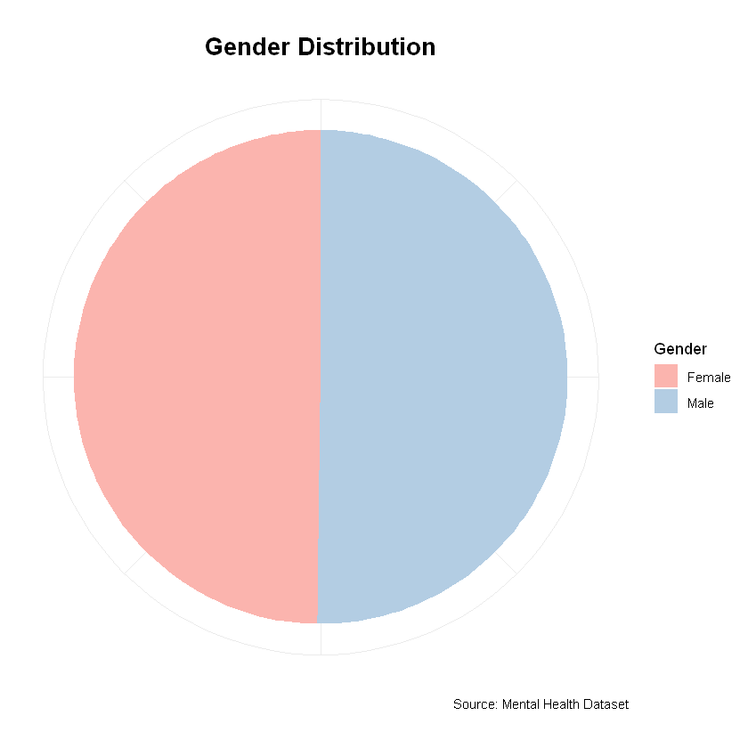

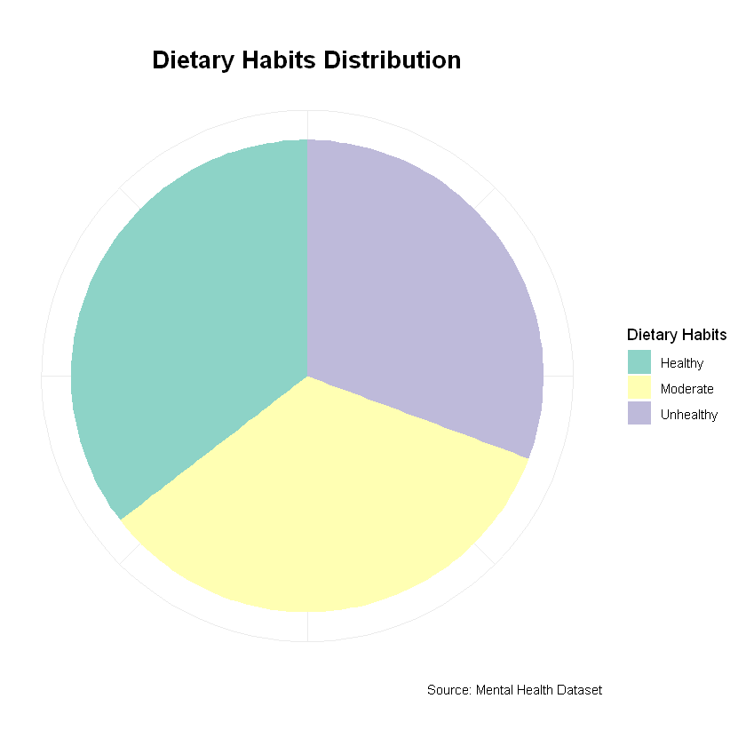

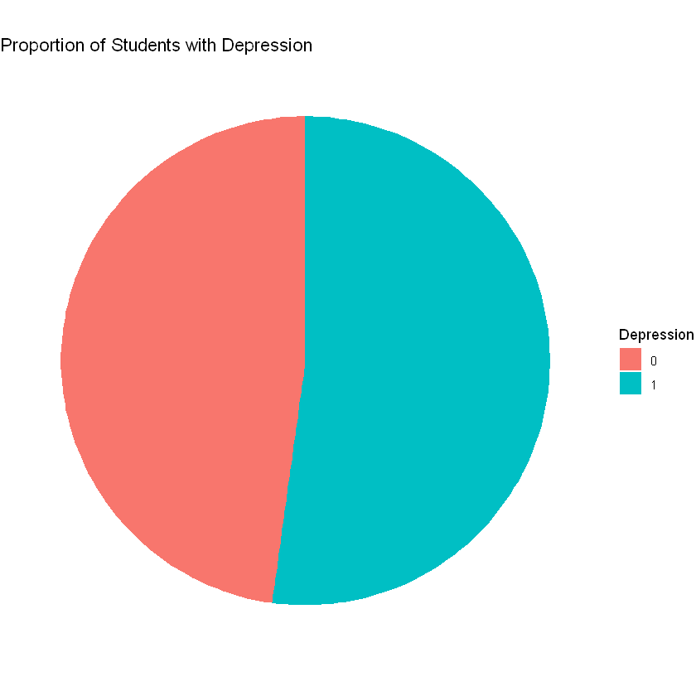
Graph Name: Survival Count Based on Passenger Class (Multiple Bar Chart)
Quality Variables:
- Passenger Class (Pclass): A categorical variable representing three classes (Upper, Middle, and Lower).
- Survival: A binary variable indicating whether the passenger survived the Titanic disaster.
Purpose:
The graph is designed to analyze the survival count based on passenger class, providing insights into how socio-economic status, represented by the passenger class, influenced survival rates during the Titanic incident.
Description:
The multiple bar chart compares the survival count across the three classes of passengers:
- Lower Class (Pclass 3): Shows the highest number of deaths, indicating that passengers in this class were most affected by the disaster.
- Middle Class (Pclass 2): Represents a balanced position, with survival and death rates falling between the extremes of upper and lower classes.
- Upper Class (Pclass 1): Exhibits the highest survival rates, demonstrating that passengers in this class were more likely to survive.
Result Summary:
- The chart highlights the socio-economic disparities during the Titanic incident.
- Lower-class passengers faced significant challenges in survival.
- Middle-class passengers were moderately affected.
- Upper-class passengers had a survival advantage, potentially due to better access to lifeboats and resources.
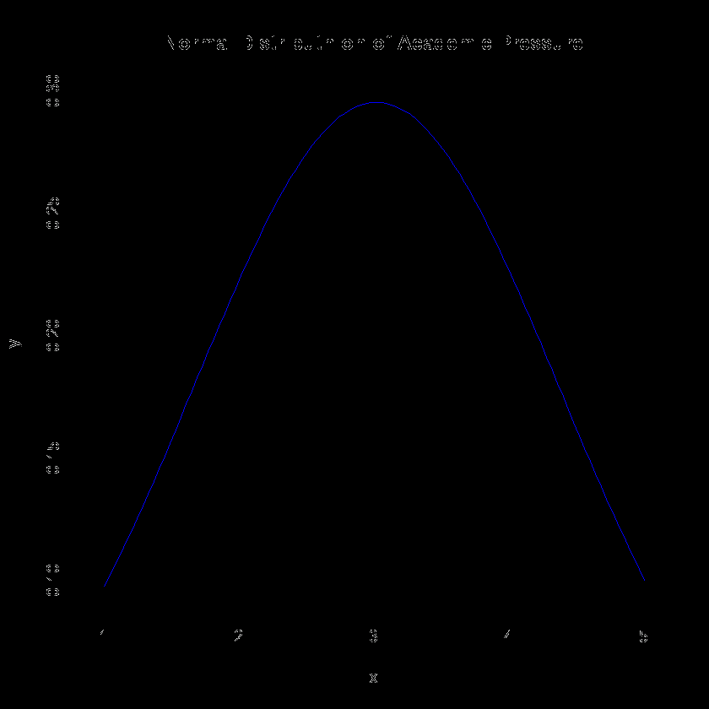
Description for the First Graph: Age vs Depression
Graph Name: Age vs Depression (Scatter Plot)
Quality Variables: 2 Quality Variables:
- Age: Represented on the x-axis, showing the age of individuals.
- Depression: Binary variable (0 = No, 1 = Yes) represented on the y-axis.
Purpose: To analyze the relationship between age and depression levels among individuals.
Results:
- The scatter plot demonstrates no clear linear or nonlinear relationship between age and the likelihood of depression.
- Depression appears to be distributed evenly across different age groups in the dataset.
- Further analysis or additional data might be required to draw significant insights.
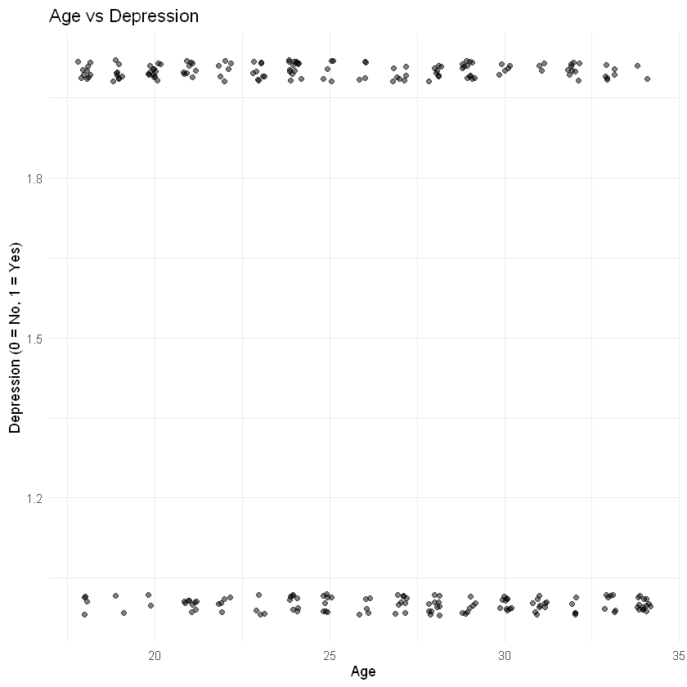
Description for the Second Graph: Study Hours vs Depression
Graph Name: Study Hours vs Depression (Scatter Plot)
Quality Variables: 2 Quality Variables:
- Study Hours: Represented on the x-axis, showing the hours spent studying.
- Depression: Binary variable (0 = No, 1 = Yes) represented on the y-axis.
Purpose: To evaluate whether the number of study hours impacts depression levels.
Results:
- Similar to the first graph, there is no visible strong correlation between study hours and depression.
- Depression instances are scattered across all levels of study hours.
- This suggests that study hours alone may not significantly influence depression levels.
Both graphs highlight the need for a multivariate analysis to identify additional contributing factors to depression.
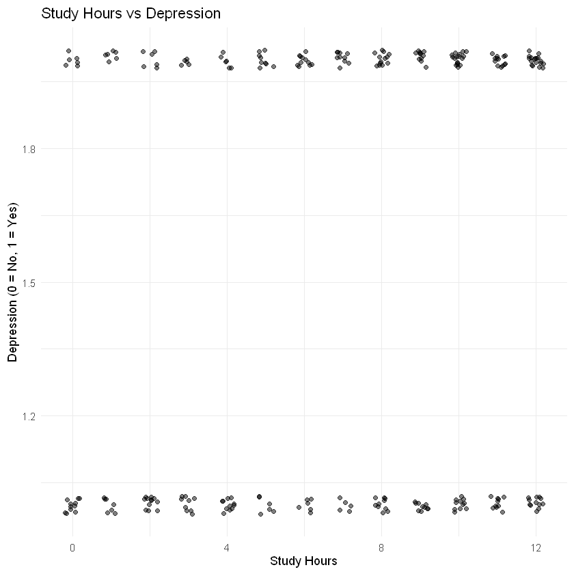
Graph Description for Your Linear Regression Plot:
Graph Name: Linear Regression with Confidence Interval
Quality Variables: 2 continuous variables - Predictor (x) and Response (y).
Purpose: Analyzing the relationship between the predictor (x) and the response (y) to determine if there is a significant linear relationship, while visually assessing the uncertainty of the prediction through a confidence interval.
Result:
- Data Points: The blue dots represent the individual observations of the predictor and response variables.
- Regression Line: The red line indicates the linear relationship between the predictor and response. It shows a slightly negative slope, indicating a weak negative correlation.
- Confidence Interval: The shaded pink region around the regression line represents the confidence interval, which provides a range within which the true regression line is likely to fall. The widening of the interval at the ends suggests increased uncertainty in those areas.
- Conclusion: There appears to be no strong linear relationship between the predictor and response, as indicated by the relatively flat slope and wide confidence interval.
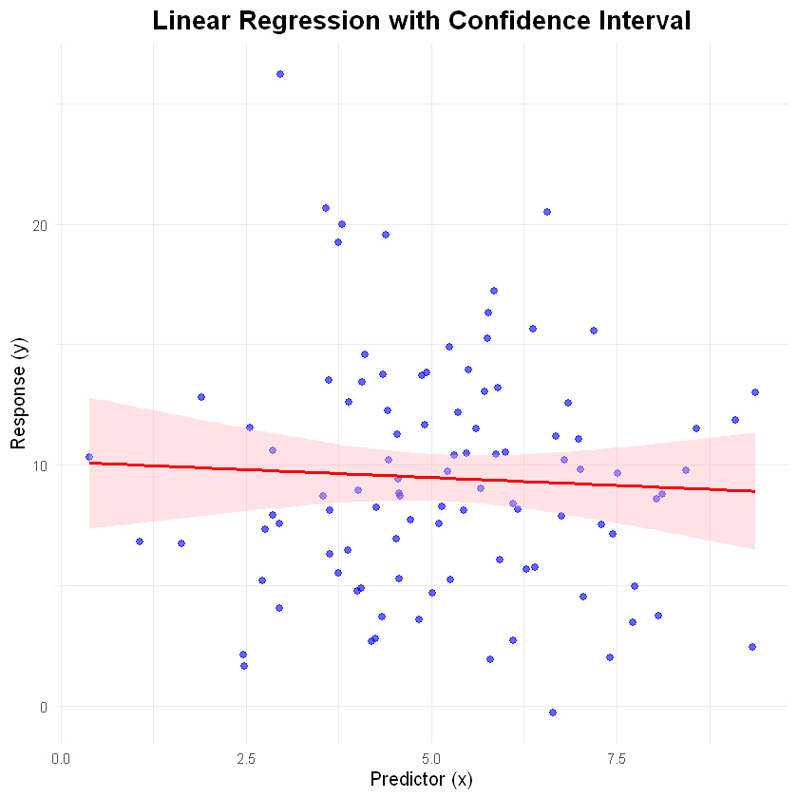


The analysis of the Depression Student Dataset helps us identify the traits and factors associated with students experiencing various levels of depression. By examining this data, predictive models can be constructed to estimate the likelihood of depression in different groups, enhancing our understanding of mental health challenges among students. This information provides a foundation for implementing proactive interventions, such as targeted mental health programs, early identification of at-risk individuals, and allocation of resources for counseling and support services.
Such an analysis underscores the importance of applying quantitative methodologies to develop effective mental health strategies. It also highlights the necessity of fostering environments that prioritize well-being in academic and personal spheres. In conclusion, the insights gained from this dataset can inform policies and actions to better address mental health challenges in student populations, paving the way for a healthier and more supportive academic ecosystem.

