Convergent and Descriptive Transcriptional Signatures of Regenerative Wound Healing Across Mouse Skin and Digit Tip Injury Models
A computational framework identifying candidate regeneration-associated genes and pathways using public transcriptomic datasets, with explicit separation of data-driven and pathway-derived evidence
Revision note: this is a revised version of the original write-up. Changes: (1) skin dataset statistics are now explicitly labeled descriptive/ranked rather than statistically significant, given the small replicate count; (2) an ion channel / gap junction screen was added, covering both the core convergent gene set and a larger ECM/signaling candidate set; (3) a figure bug in the skin volcano plot was found and fixed; (4) findings are now organized into two explicitly separate branches rather than presented as one list; (5) manual literature tiering, originally limited to 4 genes while every other analysis step covered 111, was extended to the top 20 network/model-ranked genes (23 genes total), and a bias caveat was added next to the automated PubMed count table.

Abstract
Mammalian tissue regeneration is tissue-dependent: adult mouse digit tips regenerate after amputation, while adult mouse skin generally scars. This project asks whether independent published transcriptomic datasets covering these two regenerative contexts share a common signature. Using public single-cell and bulk RNA-seq data (GSE186527, GSE130438, GSE279540), fibroblast-specific expression differences were computed for skin wounds (Verteporfin-treated, regenerative vs PBS-treated, scarring) and digit tip amputation (P3, regenerating vs P2, non-regenerating). Because the public skin dataset provides only three pooled libraries per treatment group, skin-side statistics are reported as descriptive rankings, not as FDR-significant findings, throughout this document. Within that constraint, four genes (Dusp4, Nfatc1, Saa3, Sfrp4) rank highly in the skin data and are also specifically associated with successful digit regeneration (Branch A). Separately, pathway enrichment identified a substantially larger set of 108 genes underlying 12 shared biological processes, dominated by extracellular matrix organization and PI3K-Akt signaling (Branch B). A gap junction gene, Gja1 (connexin 43), was identified within Branch B on explicit ion channel/gap junction screening. Two of the four Branch A genes (Nfatc1, Sfrp4) have independently published, direct roles in mammalian wound regeneration versus fibrosis, which supports the validity of the analysis approach despite the skin dataset's statistical limitations.

Introduction
Regeneration in mammals is unevenly distributed across tissues. Digit tips in mice regenerate after distal amputation, while dorsal skin wounds in the same animal heal by scarring under normal conditions, and regenerate only under specific pharmacological intervention (YAP pathway inhibition). This project treats these two systems as independent natural experiments and asks whether the transcriptional programs distinguishing regeneration from scarring/non-regeneration overlap, at the gene level and at the pathway level.
This is a hypothesis-generating, correlational analysis. It does not establish causality. Genes and pathways identified here are candidates for future functional validation, not proven regulators of regeneration.

A note on statistical framing (read before Results)
This section applies to every skin-dataset statistic in this document.
The public GSE186527 deposit contains only 3 pooled sequencing libraries per treatment group (PBS vs Verteporfin), each library itself a hashed pool of multiple mice (GEO's own overall_design field states the original study profiled 90 mice across 5 timepoints and 2 groups, but only 9 pooled libraries were made public). This was confirmed directly from GEO metadata and cross-checked against the original publication (PMID 35077667), which also confirmed the treatment-to-outcome mapping used throughout this project: Verteporfin (YAP inhibitor) drives regeneration, PBS is the scarring control.
A search for additional public replicates from the same study found none — GSE186527 is the only scRNA-seq deposit tied to this publication, and no companion series with more mouse-level replicates exists. This is a hard ceiling on statistical power for the skin comparison, not something further analysis can fix.
As a result, every skin-side padj value in this document is reported for ranking purposes only and is explicitly not treated as a validated significance test. Any language elsewhere implying otherwise should be read as this descriptive framing.

Datasets
Dataset | Tissue | Design | Used as
GSE186527 | Mouse dorsal skin wound | PBS (scarring) vs Verteporfin (regenerative), POD 7/14/30, plus unwounded baseline; single-cell RNA-seq, 3 pooled libraries per group | Skin regenerative vs scarring, descriptive ranking only
GSE130438 | Mouse digit tip (P3) | Amputation time course, 0h-21d, 9 timepoints, ~30 samples; bulk RNA-seq | Regenerating injury response
GSE279540 | Mouse digit tip (P2) + macrophages | Non-regenerating (NR) amputation time course, same timepoints, ~29 samples; separate macrophage M1/M2/baseline data | Non-regenerating injury response; independent immune-context validation

Methods

Skin single-cell processing
- 9 GEO samples (10x Genomics mtx format) loaded via Scanpy
- QC: 200 < genes/cell < 6000, mitochondrial fraction < 10%; doublet removal via Scrublet
- Normalization, 2000 highly variable genes (Seurat v3, computed on raw counts)
- PCA(30) → Leiden clustering (resolution 1.0) → 28 clusters; 13 clusters (4046 cells) annotated as fibroblasts by marker genes (Col1a1, Col1a2, Col3a1, Dcn, Lum)
- Pseudobulk: summed raw fibroblast counts per gene per sample

Differential expression
- Skin: DESeq2, Verteporfin vs PBS, baseline excluded, apeglm shrinkage. n=3 pooled libraries/group — results reported descriptively (see framing section above)
- Digit P3 / P2: DESeq2 LRT across all 9 timepoints, followed by Wald tests of each timepoint vs 0h. Regeneration-specific set (D3_specific, 170 genes) = time-responsive AND upregulated in P3, minus the equivalent set in P2 (D2, 1909 genes)

Two-branch candidate definition
This analysis produces two explicitly separate, differently-derived gene sets, kept apart throughout rather than merged into one undifferentiated list:
- Branch A (data-driven convergent set): intersection of the top 200 skin genes by |DESeq2 test statistic| with the 170 digit regeneration-specific genes. 4 genes: Dusp4, Nfatc1, Saa3, Sfrp4. Alias-corrected via org.Mm.eg.db (Gja1/Cx43-style synonym check) — no additional matches.
- Branch B (pathway-derived descriptive set): all genes underlying the 12 GO/KEGG/Reactome terms found significantly enriched (padj<0.05) in both the skin gene set and the digit regeneration-specific set independently. 108 genes, dominated by extracellular matrix organization, collagen biosynthesis, and PI3K-Akt signaling terms.
Branch A and Branch B together comprise 111 unique genes (1 gene, none, overlapped between branches at time of construction). All downstream network, ion channel, and literature screening in this revision covers the full 111-gene merged list, with each result tagged by branch of origin.

Ion channel / gap junction / pump screening
All 111 genes (both branches) were screened against four GO terms covering ion channel activity, gap junction channel activity, gap junction structure, and ATPase-coupled ion transport (GO:0005216, GO:0005243, GO:0005921, GO:0042625), using automated GO lookup (mygene.info) followed by a manual name-prefix check (Kcn*, Scn*, Cacn*, Gj*, Atp1a*/Atp2*) across the full list.

Network and machine learning
- STRING protein-protein interaction network (Mus musculus), run on the full 111-gene merged list at medium confidence (score≥400)
- ML: feature matrix built from Branch A (4 genes) only, per the original pre-registered plan, z-scored per dataset, 65 total samples. Three classifiers (logistic regression, random forest, MLP) evaluated by leave-one-out cross-validation, best model tested against a permutation null (50 permutations)
- An additional, exploratory feature matrix using the full 155-gene set present across all 3 datasets (a superset closely related to Branch B) was also tested, clearly labeled as a secondary, non-pre-registered analysis

Results

Branch A: data-driven convergent genes (descriptive skin statistics)
The skin dataset's descriptive ranking (n=3 pooled libraries/group; not a significance test — see framing note) placed Plp1 as the top-ranked gene (log2FC = -3.21, descriptive padj = 0.0004), shown in Figure 1 below. Because of the small, pooled sample size, this is reported as a ranking artifact worth noting rather than a validated finding, and the volcano plot below is presented with that framing in its own title.
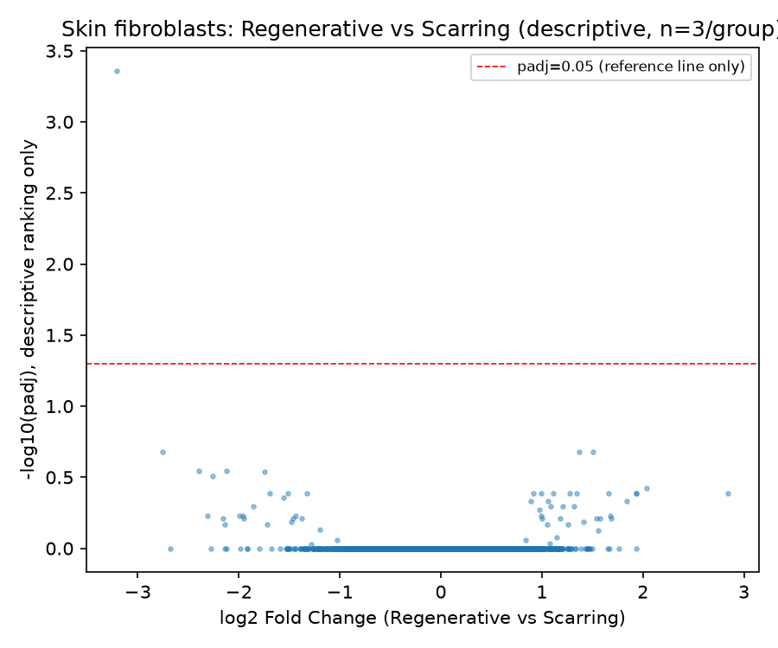
Figure 1. Skin fibroblast expression ranking, Verteporfin vs PBS. Y-axis is -log10(descriptive padj); the horizontal line marks padj=0.05 as a visual reference only, not a significance threshold, given n=3 pooled libraries per group.
Intersecting the top 200 skin genes by ranking with the 170 digit regeneration-specific genes yielded 4 overlapping genes: Dusp4, Nfatc1, Saa3, Sfrp4 (Figure 2). This 4-gene overlap is the full extent of gene-level convergence found between the two tissue systems; it is a small set and is presented as such, alongside the larger, separately-derived Branch B set below.
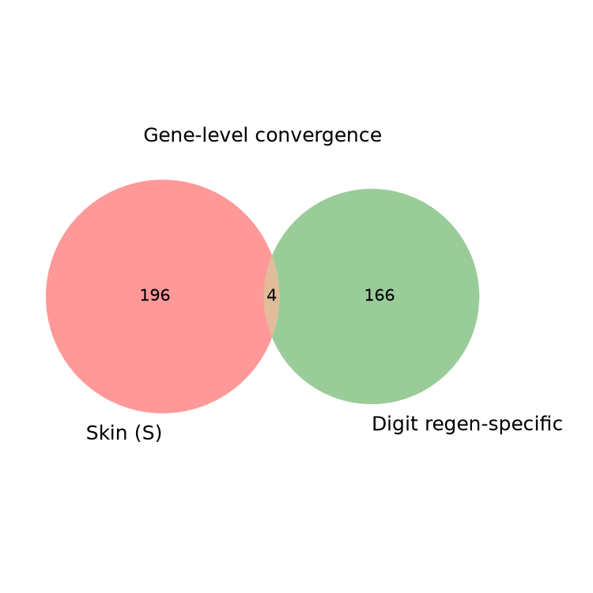
Figure 2. Gene-level overlap between top-200 skin-ranked genes and digit regeneration-specific genes (170 genes). 4 genes overlap.
Gene set sizes at each stage of the Branch A derivation are shown in Figure 3.
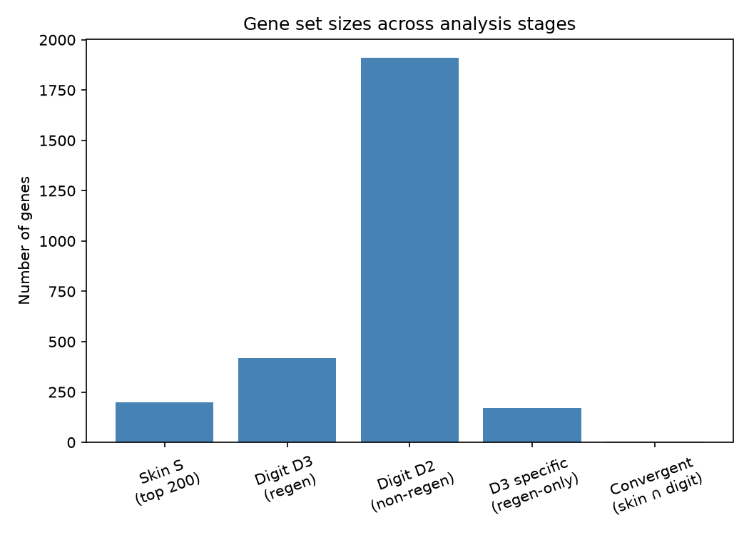
Figure 3. Gene set sizes across Branch A derivation stages.

Branch B: pathway-derived descriptive gene set
Independent Enrichr pathway analysis of the skin ranking (top 200 genes) and the digit regeneration-specific set (170 genes) found 97 and 130 significantly enriched terms respectively, with 12 terms shared between them: extracellular matrix organization, collagen biosynthesis and modifying enzymes, collagen chain trimerization, external encapsulating structure organization, granulocyte chemotaxis, inflammatory response, PI3K-Akt signaling, positive regulation of multicellular organismal process, regulation of cell migration, and bone development.
The 108 genes underlying these 12 shared terms (Branch B) form a substantially larger, biologically coherent candidate set than Branch A. This branch is presented as descriptive/pathway-derived evidence, not as an independently statistically-validated gene list — its members were selected by enrichment membership, not by a per-gene significance cutoff in either dataset.

Ion channel / gap junction / pump screen
Screening all 111 genes (both branches) against ion channel, gap junction, and pump GO terms identified one match: Gja1 (connexin 43), a member of Branch B, flagged for both gap junction channel activity (GO:0005243) and gap junction structure (GO:0005921). No other genes in either branch matched, by automated GO lookup or manual name-prefix check (Kcn*, Scn*, Cacn*, Atp1a*/Atp2* — no matches beyond Gja1 in either branch).
This is a single hit out of 111 genes screened, and should be read as a modest but real result: Gja1/Cx43 is well established in the broader literature as a wound healing and bioelectric signaling-relevant gap junction protein, and its presence here — found through pathway enrichment membership rather than being searched for directly — is a small piece of convergent, independent support for that connection, not a confirmed regeneration mechanism specific to this dataset.

Network structure (111-gene merged list)
STRING analysis of the full merged list found 457 medium-confidence interactions, a substantially denser network than Branch A alone supported (Branch A alone: 0 edges at medium confidence, 1 weak edge at low confidence in the original analysis). The most connected genes were Fn1 (fibronectin, degree 46), Ptprc (CD45, degree 36), Cxcr4 (degree 30), Icam1 (degree 27), and Spp1 (osteopontin, degree 26). Fn1's high connectivity is consistent with the extracellular matrix organization theme identified independently by pathway enrichment.

Literature counts (111-gene merged list)
Automated PubMed counts (Mus musculus, regeneration/wound healing/digit tip context) were computed for all 111 genes. The most-cited genes in this context were Bcl2 (499), Myc (469), Cxcr4 (327), Bmp4 (161), and Icam1 (105).
Caveat on raw PubMed counts: this automated count method is biased toward generically famous, heavily-studied genes (e.g. Bcl2, Myc) regardless of their actual relevance to regeneration specifically, in the same way the skin dataset's padj values are a ranking artifact rather than a validated statistic. A high count does not imply a regeneration-specific role, and a low count does not imply unimportance — both the count table above and the manual tiering below should be read with that limitation in mind, and the manual tier column (not the raw count) is the more informative signal.

Extended literature validation (top 20 network/model-ranked genes + Branch A)
The original write-up manually tiered only the 4 Branch A genes; this was a real scope gap given that every other analysis step (STRING, ion channel screen, PubMed counts) was extended to the full 111-gene merged list. To close that gap without manually reading literature for all 111 genes, the top 20 genes by combined STRING degree and SHAP importance rank were selected and manually tiered, alongside the original 4 Branch A genes (union: 23 genes, since Nfatc1 appears in both lists).
Gene | Tier | Basis
Nfatc1 | Known regulator | NFAT signaling in wound healing; hair follicle stem cell regeneration
Fn1 | Known regulator | Central provisional matrix protein; multiple mouse wound healing studies
Cxcr4 | Known regulator | Documented blastema marker gene in mouse digit tip regeneration
Spp1 | Known regulator | Osteopontin; mouse KO shows altered wound healing and matrix organization
Bmp4 | Known regulator | Essential, well-established pathway for digit tip regeneration (Msx1-BMP4)
Col2a1 | Known regulator | Major cartilage collagen; matches digit tip bone/cartilage regeneration
Col9a2 | Known regulator | Cartilage collagen family; digit-relevant bone/cartilage regeneration
Sfrp4 | Known regulator | Wnt inhibitor; macrophage clearance controls fibrotic vs regenerative fate (Gay et al., Sci Adv 2020)
Ptprc | Studied elsewhere | Pan-leukocyte marker (CD45); general immunology literature
Icam1 | Studied elsewhere | Leukocyte adhesion/inflammation; broad literature outside regeneration
Bcl2 | Studied elsewhere | Apoptosis regulator; predominantly cancer biology
Itgb3 | Studied elsewhere | Integrin; mainly platelet biology and general adhesion
Fbn1 | Studied elsewhere | Structural ECM protein; primarily Marfan syndrome literature
Agt | Studied elsewhere | Angiotensinogen; predominantly cardiovascular literature
Cdh5 | Studied elsewhere | VE-cadherin; angiogenesis/vascular biology, not regeneration-specific
Itgb2 | Studied elsewhere | Integrin; predominantly leukocyte adhesion/immune literature
Ncam1 | Studied elsewhere | Neural cell adhesion; mainly neural development and cancer
Ccr5 | Studied elsewhere | Chemokine receptor; predominantly immunology/HIV literature
Syk | Studied elsewhere | Immune signaling kinase; broad literature outside regeneration
Myc | Studied elsewhere | General proliferation/oncogene; extremely broad literature
Ccnd1 | Studied elsewhere | Cyclin D1, general cell cycle regulator; not regeneration-specific
Saa3 | Studied elsewhere | Innate immune/inflammation literature; no direct regeneration role found
Dusp4 | Studied elsewhere | MAPK/ERK phosphatase; cancer and cardiac literature

8 of 23 manually-reviewed genes (35%) are known regulators of wound healing or limb/digit regeneration specifically, including three genes (Bmp4, Col2a1, Col9a2) pointing directly to the bone/cartilage regeneration process central to digit tip healing — a pattern not visible from the raw PubMed count table alone, since these genes did not top that table by count. This is read as reasonable, if partial, external validation of the Branch B pathway-derived gene set, alongside the two Branch A genes (Nfatc1, Sfrp4) already validated in the original analysis. The remaining 15 genes are established in other biological contexts (immunology, cancer, cardiovascular, neural biology) without a direct regeneration-specific literature basis found, and are treated as descriptive network/pathway members rather than validated regeneration candidates. Manual tiering for the remaining ~88 genes in the 111-gene merged list was not performed and remains a scope limitation of this project, noted explicitly rather than left implicit.

Independent macrophage validation (Branch A)
As an additional check, all 4 Branch A genes were tested for differential expression between M1 (inflammatory) and M2 (regenerative-associated) macrophage polarization states, a separate cell type and separate GEO subset (GSE279540 macrophage data). All four were significant: Dusp4 and Sfrp4 upregulated in M2, Nfatc1 and Saa3 downregulated in M2. This is an independent line of evidence, in a different cell type from the fibroblast-focused main analysis, that these genes are transcriptionally responsive to regenerative versus inflammatory states.

SHAP feature importance (Branch A random forest model)
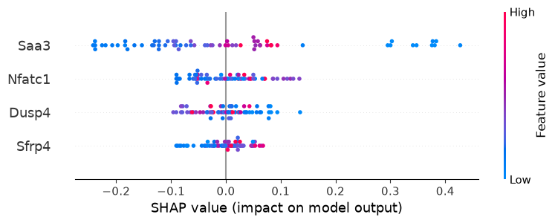
Figure 4. SHAP value distribution for the 4-gene random forest classifier. Saa3 contributes most to model output, followed by Nfatc1, Dusp4, Sfrp4.

Machine learning classification
Model / feature set | Pre-registered? | Accuracy | ROC-AUC | Permutation p-value
Logistic regression, Branch A (4 genes) | Yes | 0.26 | 0.15 | —
Random forest, Branch A (4 genes) | Yes | 0.65 | 0.66 | 0.078 (not significant)
MLP, Branch A (4 genes) | Yes | 0.52 | 0.51 | —
Random forest, 155-gene expanded set | No — exploratory | 0.85 | 0.91 | 0.020

The pre-registered Branch A classifier did not reach statistical significance (random forest best at 65% accuracy, permutation p=0.078). This is reported as a valid negative result. The exploratory 155-gene classifier reached significance (p=0.020) but was not part of the original plan, was not validated on a held-out cohort, and carries meaningful overfitting risk given 155 features against 65 samples; it is reported as a secondary, hypothesis-generating result only, not a confirmed finding, and should not be given equal weight to the pre-registered negative result above it.

Discussion
This revision separates what the data can and cannot support more carefully than the original version. Two findings stand out as the most defensible: first, Sfrp4's presence in Branch A directly matches an independently published mechanism (macrophage-mediated SFRP4 clearance controlling fibrotic vs regenerative wound fate) in the exact framework this project investigates — this is real, if narrow, external validation. Second, the pathway-level Branch B result (108 genes, ECM/PI3K-Akt convergence, 457 STRING interactions, one gap junction hit in Gja1) is a substantially larger and more networked body of evidence than Branch A alone, and should be read as the stronger overall signal from this project, even though it is descriptive rather than significance-tested.
The skin dataset's statistical limitations are structural, not a processing error: only 3 pooled libraries per group exist publicly, each pooling multiple mice, and no additional replicates exist anywhere in the public record for this study. Every skin-side statistic in this document, including the ranking that produced Branch A, should be read with that in mind.
The 4-gene Branch A classifier's non-significant result and the 155-gene exploratory classifier's significant result are not in conflict — they answer different questions. The pre-registered test asked whether specifically the 4 most strictly convergent genes predict regenerative state; it could not. The exploratory test asked whether a much larger, pathway-informed gene set carries predictive signal; it suggested yes, but without independent validation this remains a direction for follow-up work, not a conclusion.

Limitations
- Skin dataset: 3 pooled libraries per group, each a multi-mouse pool, is a hard structural ceiling on statistical power that this project could not resolve; all skin-side padj values are descriptive rankings, not significance tests, throughout this document.
- Branch A (4 genes) and Branch B (108 genes) were derived by different methods (direct gene intersection vs pathway-enrichment membership) and are not statistically comparable to each other; they are presented side by side, not combined into one ranked list.
- The ion channel/gap junction screen found one hit (Gja1) out of 111 genes; this is too small a number to draw a general conclusion about bioelectric signaling in this system, and is reported as a single data point, not a pattern.
- The 155-gene exploratory ML result is not independently validated, was not pre-registered, and has meaningful overfitting risk (155 features, 65 samples); it should not be treated with the same confidence as the pre-registered 4-gene negative result.
- STRING, SHAP, and PubMed-count results are correlational and descriptive; none establish that any gene causally drives regeneration. Raw PubMed counts specifically are biased toward generically well-studied genes (Bcl2, Myc) regardless of regeneration relevance.
- Manual literature tiering covers 23 of 111 merged-list genes (Branch A plus the top 20 by network/model importance); the remaining ~88 genes have automated PubMed counts only, not manually reviewed tiers.
- All comparisons used already-processed, publicly deposited count matrices, not raw sequencing reads; upstream processing choices made by original authors could not be independently re-verified.
- This project does not claim a cross-species or cross-tissue 'regeneration code', does not claim proof of causation, does not introduce a novel AI method, and does not combine its evidence into a single composite score.

Conclusion
Given a structural limitation in the public skin dataset's replicate count, this project reports its skin-side findings descriptively rather than as validated statistics, and separates its results into two explicitly distinct branches: a small (4-gene), data-driven convergent set with meaningful literature and independent macrophage-context support, and a larger (108-gene), pathway-derived descriptive set with denser network structure and one gap junction gene (Gja1) identified on explicit screening. The pre-registered machine learning test of the 4-gene set was a valid negative result; an exploratory extension to a larger gene set showed a significant but unvalidated positive signal. Together, these results support extracellular matrix remodeling and PI3K-Akt signaling, plus a small set of individual genes led by Sfrp4 and Nfatc1, as the most credible candidate directions for future, properly replicated follow-up work.

Data and Code Availability
All scripts, intermediate data tables, and figures are available in the project repository: https://github.com/muneeb-dotcom/regen-convergence-v2

