AI-based Network Attack Forecasting from Network Traffic Data
Problem Statement 26153 · National Technical Research Organisation (NTRO) · Smart India Hackathon 2026 · Architecture Document

1. Overview
Classifiers that score one flow at a time discard exactly the structure that gives an infiltration away: the order in which ports get probed, the SYN-before-ACK-flood pattern, the timing between reconnaissance packets. We treat the network as a dynamical system instead of a bag of independent flows. A world model learns P(S_{t+1} | S_{≤t}) — the distribution over the next network state given the recent past — and rolls that forward K steps to answer the question a defender actually has:
“Given what I’m seeing right now, how likely is compromise in the next minute, at what stage, and why?”

2. System Architecture
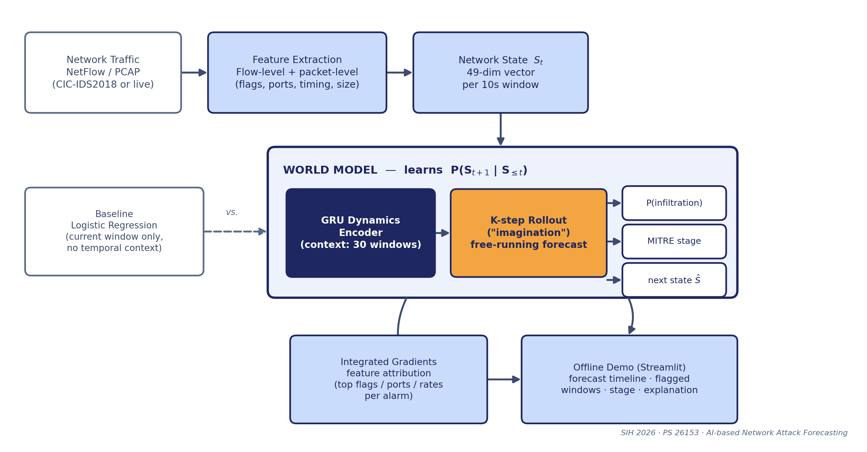
Flow-level and packet-level features are aggregated into a 49-dimensional network-state vector every 10 seconds (flag ratios, destination-port entropy, packet-timing and size statistics, TCP window behaviour). A GRU encodes 30 windows (5 minutes) of history; a rollout head then runs free-running for K=6 windows (1 minute) — feeding its own predicted state back in, not the ground truth — to produce a genuine forecast rather than a one-step-ahead fit. Three heads read out of every rollout step: infiltration probability, predicted MITRE ATT&CK stage, and the predicted state itself.

3. Methodology
- Multi-task training loss: Gaussian negative-log-likelihood on the predicted next state (not plain MSE — the model learns a distribution, so its confidence is calibrated), binary cross-entropy on infiltration with a class-balanced
  - pos_weight, and cross-entropy on ATT&CK stage. Scheduled sampling decays teacher forcing from 1→0 over training so the model is never evaluated in an easier regime than it is trained in.
- Stage mapping: dataset labels map to Initial Access, Lateral Movement, Command & Control and Impact/DDoS by rule.
  - CIC-IDS2018 carries no Reconnaissance- or Exfiltration-labelled flows — the architecture supports both stages, but this dataset alone gives them no training signal (noted here rather than glossed over).
- Explainability: Integrated Gradients through the full un-truncated rollout attributes every alarm back to the specific flags, ports and rate features that drove it — chosen over SHAP because it needs only autograd and is well-defined for a recurrent, free-running forecast, where KernelSHAP’s black-box sampling is not.
- Evaluation design: metrics are reported per rollout step (how quality degrades the further ahead we forecast) and aggregated (“attack anywhere in the next 60s”); a logistic-regression baseline is trained on the identical standardised
  - single-window features — isolating exactly what temporal modelling buys over a memoryless classifier, which is the comparison the problem statement asks for. A lead-time metric further reports, for attacks with a clean run-up, how many seconds before completion the alarm fired.

4. Technology Stack
Layer | Choice | Why
Features | pandas (chunked), NumPy | Streams the 3.8 GB day without loading it whole
Model | PyTorch (GRU dynamics + rollout head) | Small enough to train on a 6 GB laptop GPU in minutes
Baseline | scikit-learn LogisticRegression | Required benchmark, same standardised features
Explainability | Integrated Gradients (custom, autograd-only) | No extra dependency; well-defined through a free-running rollout
Interface | Streamlit | Local web UI, zero cloud calls, matches PS requirement

5. Deployment & Applicability
The reference implementation (a few hundred thousand parameters) trains in minutes on a 6 GB laptop GPU and infers in real time on a CPU, and the Streamlit interface runs fully offline with no cloud dependency — a deliberate fit for air-gapped enterprise SOCs and Critical Information Infrastructure deployments where telemetry cannot leave the perimeter. The same pipeline accepts flow CSVs from any CICFlowMeter-compatible exporter, not only CIC-IDS2018.

6. Limitations & Next Steps
- No Reconnaissance/Exfiltration ground truth in this dataset (see §3) — fusing in CIC-IDS2017 (which labels PortScan) is the planned fix.
- Validated end-to-end on schema-matched synthetic traffic during development; full-scale benchmark numbers on the real 16M-flow dataset are the next run.
- Planned: GNN variant over a live flow graph (rather than aggregate statistics) for lateral-movement patterns that a single-node state vector under-represents.

7. Preliminary Validation (Synthetic, Schema-Matched Traffic)
The pipeline below was exercised end-to-end — download → feature extraction → training → evaluation → explainability — on traffic generated with the identical CICFlowMeter schema and injected attack episodes, ahead of the full run on the real 16M-flow dataset. On this validation run: F1 0.72, AUROC 0.87, AUPRC 0.61, false-positive rate 0.8% for “attack somewhere in the next 60s”, versus F1 0.00 for the logistic-regression baseline at the same operating point — i.e. the temporal signal is where the detections are coming from. Left: forecast probability against ground truth over one held-out segment. Right: Integrated-Gradients feature attribution, correctly surfacing packet-rate, flow-count and SYN-without-ACK signatures for the injected flood-style attack.
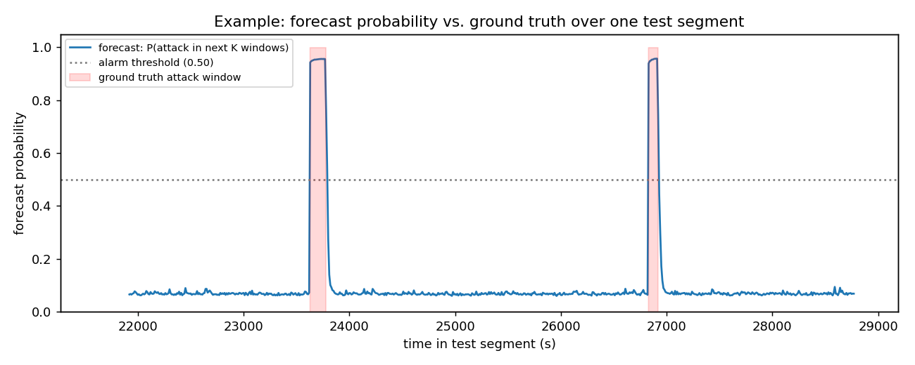 | 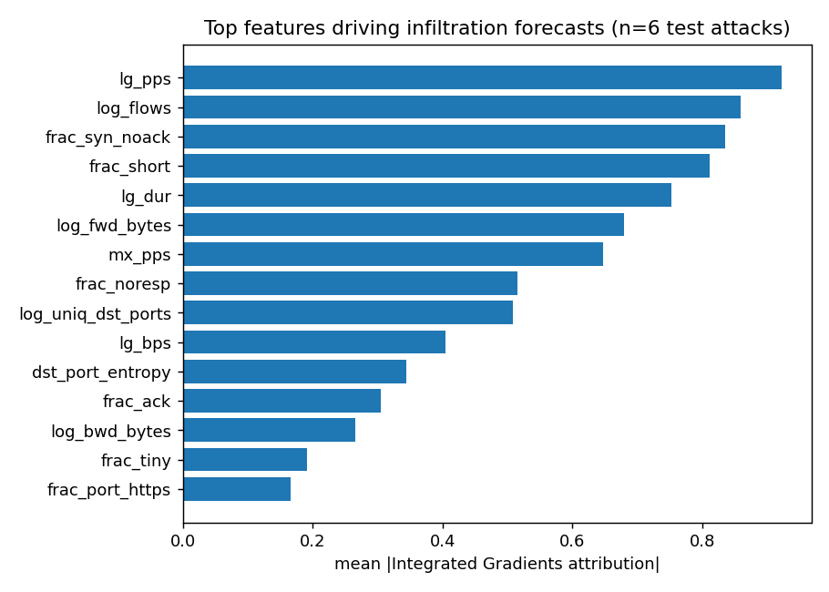
Real-dataset numbers will supersede these once training completes on the target machine; the architecture, losses and evaluation code do not change between the two.

