LAB # 3
Introduction to Concurrency
OBJECTIVE:
Understanding and implementing the concept of concurrency through different mechanisms of multithreading
Lab Task:
- Implement the following program on eclipse IDE and answer the following questions:
- How many threads are running?
- How many tasks are running?
- If more tasks are added than what will be the impact on number of threads?
- Explain the flow of program.
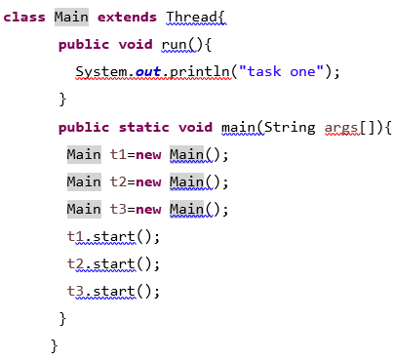
ANSWER
QUESTION-1
3 threads are running.
Each time you call .start(), a new thread is created.
t1.start() → starts Thread 1
t2.start() → starts Thread 2
t3.start() → starts Thread 3
QUESTION-2
3 tasks are running.
Each thread executes the same task defined in the run() method
If you create more task objects (like t4, t5, etc.) and call .start() on them, then more threads will be created.
Each .start() call → creates one new thread.
So if you add more tasks → the number of threads increases linearly.
Main thread starts the execution.

QUESTION-3
In main():
Three thread objects are created: t1, t2, t3.
t1.start() is called → it internally calls the run() method of t1 in a new thread
Similarly, t2.start() and t3.start() each start their own new threads.
Now, 3 threads run concurrently, each printing "task one".
The order of output may change each time you run the program because threads execute asynchronously
- With the help of threading print two tables concurrently, print one table number of student roll number e.g. 2019-SE-092 and second number should be date of birth e.g. 05-April.
CODE:
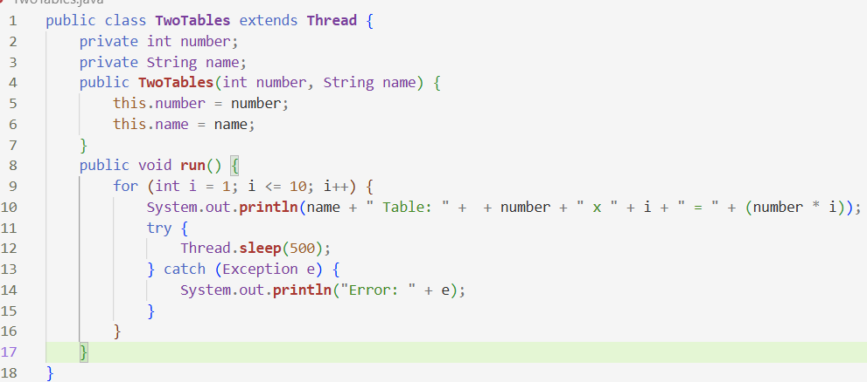
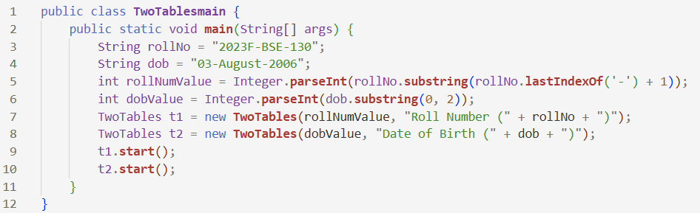
OUTPUT:
