LAB # 11
INTRODUCTION TO TEST SUITE
OBJECTIVES:
Grouping the multiple JUnit test cases and constructing a Test Suite program. Test suite: Test suite is used to bundle a few unit test cases and run them together. In JUnit, both @RunWith and @Suite annotations are used to run the suite tests.
Lab-Task:
Make a class having four functions for determining,
• Whether the input integer is odd.
• Whether the input integer is even.
• Whether the input integer is prime.
• For calculating the factorial of that input integer.
Write their test cases and execute them in a single test suite class. Follow all the steps mentioned above in the manual.
CODE
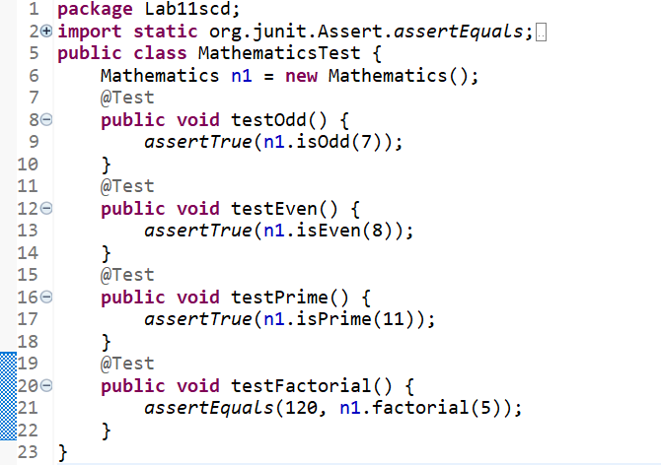
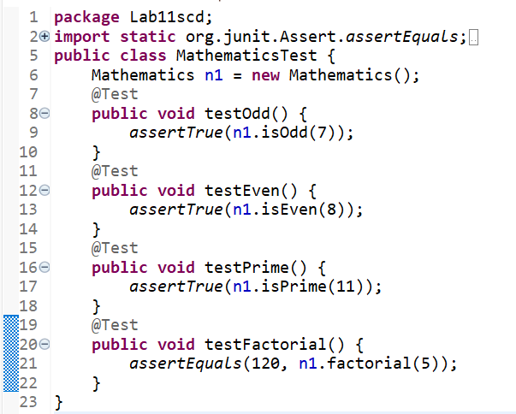
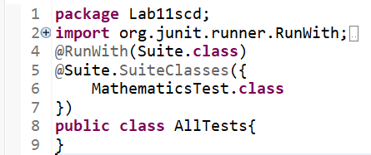

OUTPUT:
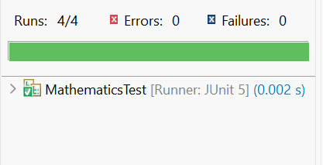
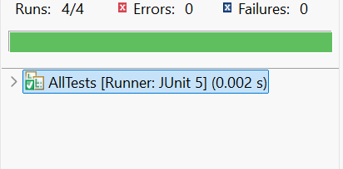
GITHUB-SCREENSHORT:

