**Following is the summary of experimental results, describing the existences of Latin squares for each n = 4, ..., 9; if they exist, provide these Latin squares constructed from the output of minisat:**

Latin Square with two additional conditions (sx,x,x and -sx,y,z \/ -sy,x,w \/ sz,w,x ) for all x,y,z,w in N exists for N=4 and N=8. It looks like this Latin Square will exists for order of multiple of 4 and will not exist for any other order. Following are the results produced by the minisat.

**N = 4:**

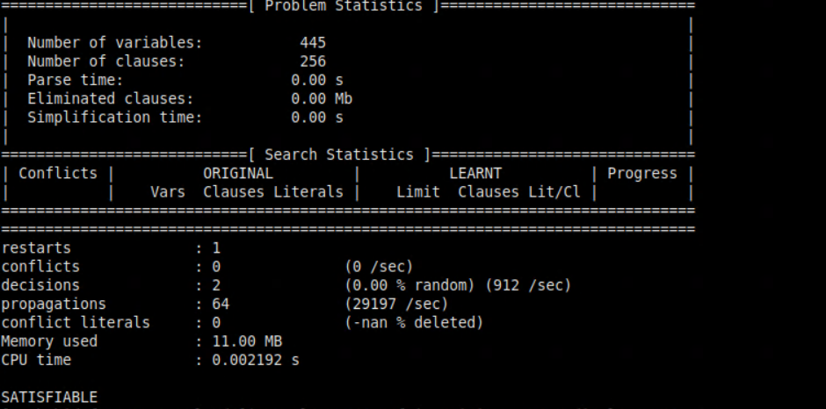

**N = 5:**

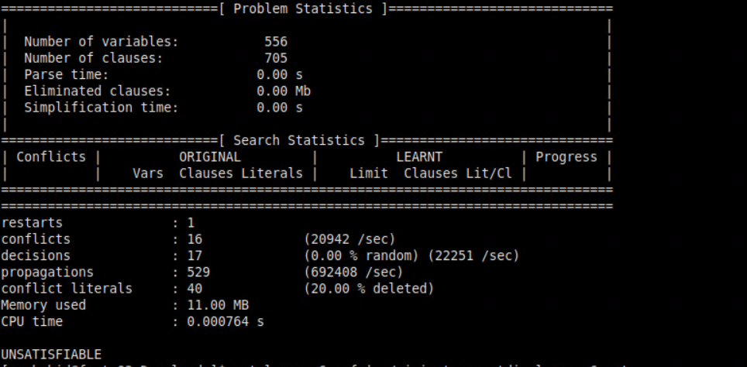

**N = 6:**

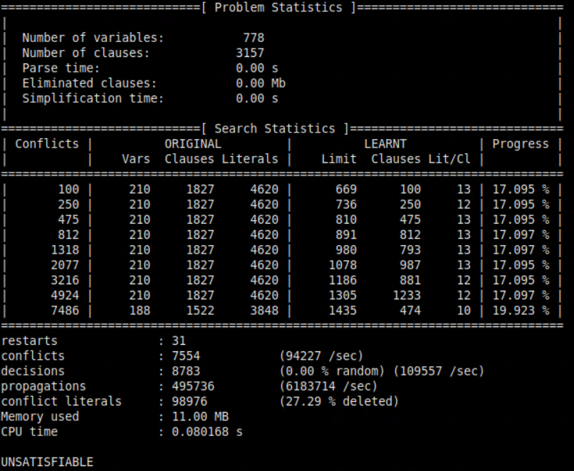

**N = 7:**



**N = 8:**

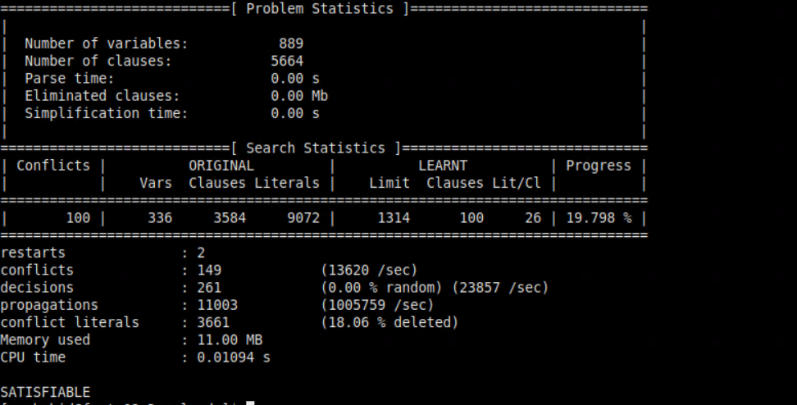

**N = 9:**

