 NABEEL GRAMMAR HIGH SCHOOL
Roll No. ____________________________Student Name__________________________
Class 10th |  |  |  | Math |  |  |  |  |  |  | Time: 3 Hour
Date: 13-Nov-2017 |  |  |  | 2nd Term Examination |  |  |  |  |  |  | Total Marks: 75
Question No | Q. 1 | Q. 2 | Q. 3 |  | Q. 4 | Q. 5 | Q. 6 | Q. 7 | Q. 8 | Q. 9 |  | Q. 10 | Q. 11 | Total Mark
Total Marks | 15 | 12 | 12 |  | 12 | 24
Obtained Marks
Object Type
Q. 01: CIRCLE THE CORRECT ANSWER 15
- 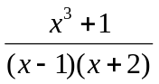is…..:
(a) Proper (b) Improper (c) Constant tern (d) None
- A function of the form f(x)= 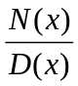, with D(x)=0:
(a) Fraction (b) Proper (c) Rational (d) None
- The identity (5x+4)²=25x²+40x+16 is true for:
(a) One values of x (b) Two values of x (c) Three values of x (d) None
- Pastial fractions of 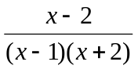are of the form:
(a) 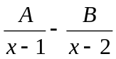 (b) 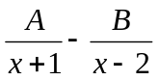 (c) 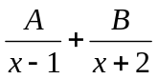 (d) None
- If U & V², then…….:
(a) V²=KU (b) 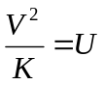 (c) U=KV² (d) None
- In a ratio a:b, a is called____________:
(a) Relation (b) Antecedent (c) Consequent (d) None
- If a:b = x : y, then atternando property is_______:
(a) 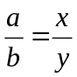 (b) 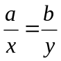 (c) 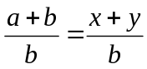 (d) None
- A third proportional of 15,6,5 is _______________:
(a) 2 (b) 3 (c) 4 (d) None
- Cube roots of -1 are:
(a) -1, w, w² (b) 1,w,w² (c) -1,-w,-w² (d) None
- W²⁵⁶⁷⁸⁹=:
- 1 (b) w (c) w² (d) None

Q. 02: GIVE ANSWER IN SIX QUESTIONS: 12
- Define fraction.
- Define improper fraction.
- Resolve into partial fraction 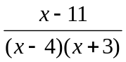.
- Convert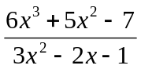into proper fraction.
- Check 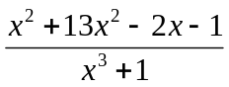 is proper fraction or improper fraction. Explain your answer.
- Define proper fraction
- How we can make the partial fraction of 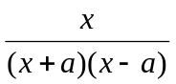.
- Define circle.
- Define sector.
Q. 03: GIVE ANSWER IN SIX QUESTIONS: 12
- If 3(4x-5y)=2x-7y, find the ratio x:y.
- Find x; 3x-2 :: 2x+3:.
- If 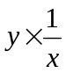 when x=3, find x when y=24.
- Find a mean proportional between: 20x³y⁵,5x⁷y.
- Define direct variation.
- Define continued proportion.
- If 24/7= 6/x, then 4x will be.
- Find the cost of 8kg of mangoes, if 5kg of mangoes cost Rs. 250.
- If R × T² and R=8 when T=3, find R when T=6
Q. 04: GIVE ANSWER IN SIX QUESTIONS: 12
- Define the properties of discriminant.
- Find discriminant 4x²-7x-2=0.
- Find the nature of roots, 3x²+7x-13=0.
- Evaluate (1-w-w²)⁷.
- Evaluate w⁻¹³+w⁻¹⁷.
- Prove that x³+y³=(x + y)( x + wy)(x+w²y).
- Prove that the produce fo three cube root of unit y is 1.
- Find cube root of -1.
Q. 05: GIVE ANSWER IN 2 QUESTIONS: 10
5. (a) Resolve into partial fraction 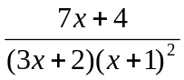. 04
- 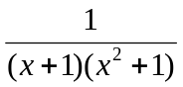Resolve into partial fraction. 04
- (a) If a:b = c: d then show that 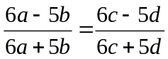. 04
(b) Use theorem of componendo- dividend find the value 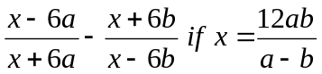. 04
7. (a) If the roots of the equation (c²-2ab)x²-2(a²-bc)(c²-ab)x²2(a²-bc)x+(b²-ac)=0 are equal then
Show at a=0 or a³+ b³+ c³. 04
(b) find the cube of 64
8. One and only one circle can pass through three non-collinear points.. 08

