 NABEEL GRAMMAR HIGH SCHOOL
Roll No. ____________________________Student Name__________________________
Class 9th |  |  |  | Math |  |  |  |  |  |  | Time: 3 Hour
Date: 13-Nov-2017 |  |  |  | 2nd Term Examination |  |  |  |  |  |  | Total Marks: 50
Question No | Q. 1 | Q. 2 | Q. 3 |  | Q. 4 | Q. 5 | Q. 6 | Q. 7 | Q. 8 | Q. 9 |  | Q. 10 | Q. 11 | Total Mark
Total Marks | 15 | 12 | 12 |  | 12 | 24 |  |  |  |  |  |  |  | 75
Obtained Marks
Object Type
Q. 01: CIRCLE THE CORRECT ANSWER 10
- log_{b}ª ×log _{c}^{b} can be written as:
(a) log_{a}^{c} (b) log_{c}ª (c) log_{a}^{b} (d) log _{b}^{c}
- For common logarithm, the bas is :
- e (b) 10 (c) rational (d) None
- If x=logy, then y is called the …..of x:
(a) Multiple (b) Mantisa (c) Antilogy (d) None
- Characteristic of the logarithm 0.00345 is:
(a) +3 (b) -3 (c) –3 (d) None
- Lowest form of 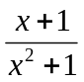 is:
(a) 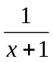 (b) x+1 (c) x²+1 (d) None
- (a³+3ab(a+ b)-b³ is equal to….:
(a) (a + b)³ (b) (a- b)³ (c) a³+b³ (d) None
- |x|=0 has only______ solution….:
(a) One (b) Two (c) a & b (d) None
- The inequality symbols <and> were introduced by:
(a) John Napier (b) Henry Briggs (c) Thomas Harriot (d) None
- If x is no larger than 10, then…….:
(a) x < 10 (b) x > 10 (c) x<10 (d) None
- The equation 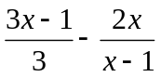=x become true statement if we put x=…….:
- 1/5 (b) 1/7 (c) 2 (d) None

Q. 02: GIVE ANSWER IN Any Six QUESTIONS: 12
- Solve 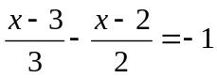.
- Solve and check 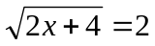.
- Solve for x= |2x+5|=11
- Solve for x: |3+2x|=|6x-7|
- Solve 3x+1 < 5x-4
- 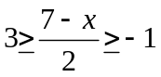
- Define the absolute value of a real number
- Define linear equation.
Q. 03: GIVE ANSWER IN Any Six QUESTIONS: 12
- Express 0.00643 in scientific notation.
- Find the value of unknown log₃⁸¹=L.
- Evaluate log₂1/128.
- Prove that log_{a}(mn)=log _{a} m + log_{a}n.
- Write log5 + 3log6-log2 in single logarithm.
- Calculate: log₅³×log₃25
- Find the value of (789.5)^{1/8} by using log. table.
- Define scientific notation.
Q. 04: GIVE ANSWER IN Any Six QUESTIONS: 12
- Reduce 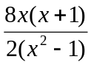into lowest form.
- Solve 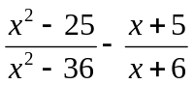.
- Solve 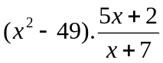.
- If x + y = 7 and xy=12, then find the value of x³+y³.
- Find the product of (x³-y³)( x⁶+x³y³+y⁶) by using formulas.
- Of x-1/x=7, then find the value of x³-1/x³
- Define polynomial.
- Define Rational Expression.
Q. 01: GIVE ANSWER IN 2 QUESTIONS: 10
- (a) Find the value of 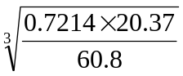by using log. Table. (04)
- Prove that log_{a}^{mn}=nlog_{a}^{m} (04)
- (a) Solve and Check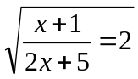. (04)
(b) Solve 3x-2<2x+1<4x+17 (04)
- (a) Solve 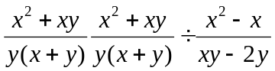. (04)
- (b) Solve 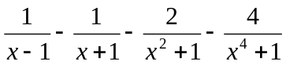 . (04)
- (a) Express x-2logx +3 log (x+1)- log (x²-1) as single 10.
(b) Solve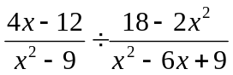. (04)
6. Prove that any point on the right bisector of a line segment is equidistant from its end points.(08)

