

**The University of Azad Jammu and Kashmir**

**Department of Software Engineering**

**Computer Vision (SE – 4104)**

**Instructor: Engr. Ahmed Khawaja**

**Semester: Fall 2024**

**Session: 2021 – 25**

**Assignment 01**

**Name: Muneeba Shafiq**

**Roll No: 2021 – SE – 28**

# IMPLEMENTATION OF HYBRID FILTER FOR IMAGE MERGING

## Objective

To implement a hybrid filter for merging two images in a way that different frequency components dominate the visual perception depending on the viewing distance. The objective is to reproduce the effect described in hybrid images, where low frequencies dominate when viewed from afar and high frequencies dominate when viewed closely.

## Introduction

Hybrid images are an innovative way of combining two images by manipulating their frequency components. The concept relies on the human visual system's varying sensitivity to different frequencies based on viewing distance.

* **Low frequencies** (blurred components) are prominent from a distance.
* **High frequencies** (sharp details) are noticeable up close.

The hybrid image is constructed by:

1. Applying a **low-pass filter** (Gaussian blur) to one image to preserve its low frequencies.
2. Applying a **high-pass filter** to the second image by subtracting its low frequencies from the original image.

These filtered images are combined to create a single image with the desired hybrid effect.

## Methodology

**Steps:**

1. **Image Alignment**: The two input images were resized to the same dimensions to ensure pixel-level alignment.
2. **Low-Pass Filtering**:
   * A Gaussian blur filter was applied to one image to extract its low-frequency components.
   * The filter size was determined by the cutoff frequency parameter (sigma).
3. **High-Pass Filtering**:
   * The second image’s low frequencies were removed by subtracting its blurred version from the original image.
4. **Combination**:
   * The low-frequency and high-frequency images were blended together using pixel-wise addition.
5. **Visualization**:
   * The resulting hybrid image was displayed alongside the input images to illustrate the frequency manipulation effects.

### Filters Used:

* **Low-Pass Filter**: Gaussian blur with a tunable sigma value.
* **High-Pass Filter**: Subtraction of the low-pass filtered image from the original.

## Code Implementation

The implementation used Python with the OpenCV library for image processing. Key steps include:

* Loading and aligning the images.
* Applying low-pass and high-pass filters to their respective inputs.
* Merging the processed images into a single hybrid image.

## Source Code

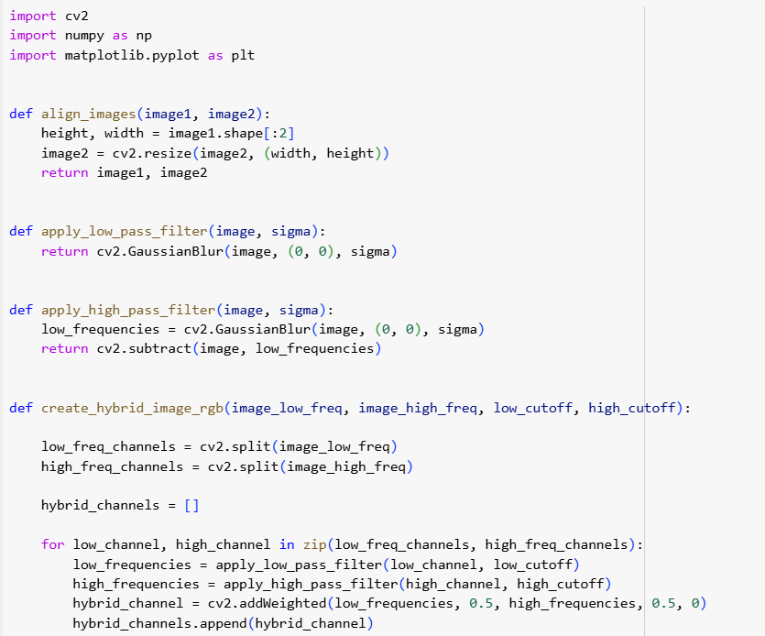

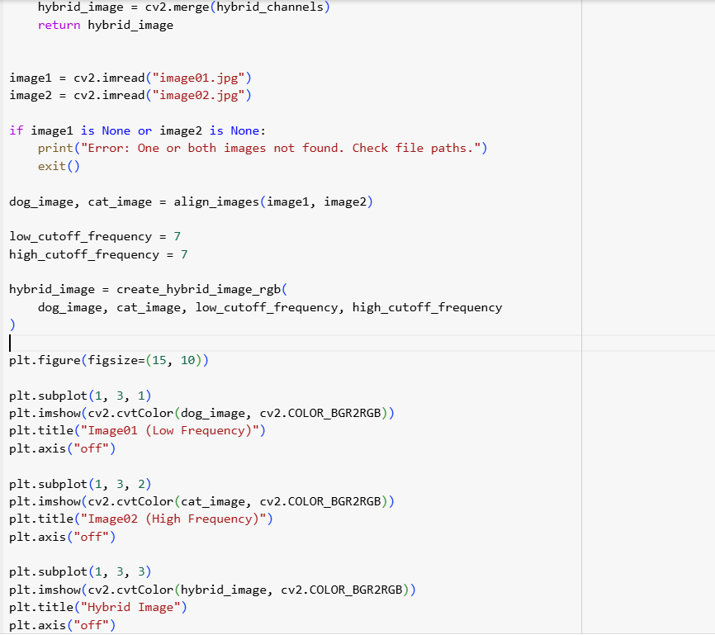

## Output

