IJSRD - International Journal for Scientific Research & Development| Vol. 8, Issue 9, 2020 | ISSN (online): 2321-0613

An Overview of Analysis of Road Accidents using Data Mining Approach
Prof. Yogita Narwadkar1 Aditya Joshi2 Saurabh Kalelkar3 Rohan Nalawade4 Himanshu Nirmal5
^{1,2,3,4,5}PES Modern College of Engineering, India

Abstract— Road traffic accidents are one of the major reasons behind loss of human life on an enormous scale and have become a glaring concern in recent years. It is necessary to reduce the number of accidents in order to save valuable human lives. Our system uses a data mining approach for analysis of available road accident data. The system aims at forming clusters of states according to their fatality rate. Apriori algorithm is used to determine strong association rules to draw conclusions based on the factors influencing the accidents. Classification technique is involved in the analysis. The system can be useful for Road Transport and Maintenance Authorities, researchers, students and trip planners.
All rights reserved by www.ijsrd.com
206
Keywords: Data Mining, Fatal Accidents, Association Rules, Apriori Algorithm, Clustering, K-Means Clustering Algorithm, Classification, Naive Bayes Classifier

- INTRODUCTION

With the advent of technological advances in the 20th century, the world is moving forward at a blistering pace. It has certainly taken its toll on human health. Human life which is an invaluable resource is being treated as if it is expendable and of little significance. Road traffic accidents are one of the major reasons behind loss of human life on an enormous scale and have become a glaring concern in recent years. In order to increase driving safety, careful analysis of road accidents data is critical to find out variables that are closely related to fatal accidents.
Liling Li, Sharad Shrestha and Gongzhu Hu [1] used association rule mining and classification algorithms and it has been observed that the environmental factors like roadway surface, weather and light condition do not strongly affect the fatal rate, while human factors like being drunk or not, and the collision type have stronger effect on the fatal rate. From the clustering result it was observed that some states have higher fatal rates, others have lower rates.
Sachin Kumar and Durga Toshniwal [2] used R- statistical software for k-mode clustering. Apriori algorithm has been applied on every cluster using WEKA to identify interesting association rules that can help in understanding the circumstances of accidents in different clusters. The result can be utilized by the concerned officers of the traffic and road safety department to put some accident prevention efforts into the areas identified for different categories of accidents in order to overcome them.
Suwarna Gothane [3] figured out the factors influencing the accidents and identified which factor is more accident prone with Info Gain Attribute Evaluator function using WEKA tool. This paper performed association rule mining using Apriori algorithm and identified the best rule for accident dataset. Reasons for accidents include overspeeding, drunkenness and defects in vehicles as well as bad road condition.
Maninder Singh and Amrit Kaur [4] built various classification models using Decision tree, Random forest, ID3, Functional Tree, J48 and Naïve Bayes in order to
predict accident severity. Classification models are generated on the basis of the training data whose independent variables and target variable are known, to be applied for the new dataset whose objective is the prediction of the target variable. It can be seen that the value of Naive Bayes and J48 techniques are approximately displaying the same accuracy. The values are nearby 84.66% and 85.18%. Using various data mining techniques for traffic accident analysis can improve the road traffic safety management level effectively.
Jayasudha and Chandrasekhar [5] applied data mining techniques in the field of accident investigation. Association rules are used to discover the patterns and the rules that cause the occurrence of accidents. But it does not determine which traffic crash excesses are due to poor roadway conditions or the necessity of stop signs or traffic lights.
Li-Yen Chang and Wen-Chieh Chen [6] proposed a non-parametric tree-based Classification and Regression Tree(CART) model to establish the empirical relationship between traffic accidents and highway geometric variables, traffic characteristics, and environmental factors. By comparing the analysis and prediction results of a negative binomial regression model, this study demonstrates that CART is a good alternative for analyzing freeway accident frequency. The results obtained here, by exploring a broad range of variables including highway geometry, traffic and environmental characteristics, provide valuable insight into the underlying relationship between risk factors and vehicle accidents.
Bahram Sadeghi Begham [7] used a UKDA dataset for the analysis. In this study, the technique of association rules with a large set of accident data to identify the reasons of road accidents is used. Analysis shows that producing the association rules makes identification of factors involved in the accident easier. So, the association rule mining gives the direction for deeper research on the causes of road accidents. In this study it is tried to choose the interesting and superior rules to provide a lot of valuable information for Road Transport Authorities to provide better safety policies.
Manuel Fogue, Piedad Garrido, Francisco J. Martinez, Juan-Carlos Cano, Carlos T. Calafate, Pietro Manzoni [8] designed and implemented a prototype for automatic accident notification and assistance based on V2V and V2I communications. Further the effectiveness of this technology can be improved with the support of intelligent systems which can automate the decision making process associated with an accident. A preliminary assessment of the severity of an accident is needed to adapt resources accordingly. This estimation can be done by using historical data from previous accidents using a Knowledge Discovery in Databases process.

- PROPOSED SYSTEM
Road Accident Data Set is in .CSV format. Data pre- processing step involves removal of records that contain missing values in the chosen attribute(s). All numerical values are converted to nominal values.
Fatality rate is calculated for each state as FATALITY RATE = FATALS/PERSONS
where FATALS is the number of fatalities and PERSONS is the number of persons involved in the accident.
Naive Bayes classification algorithm is used to classify road accidents as highly fatal or not. The cleaned dataset is divided into two parts namely Training Dataset and Testing Dataset. The training dataset is used to build a classifier model along with Naive Bayes algorithm to classify the testing dataset. The class label is “Fatality Rate : High or Low”.
In association rule mining, strong association rules are found for each state using the Apriori algorithm. Apriori
algorithm is implemented in order to find frequent factors. These association rules give an idea about the factors that affect road accidents the most.
Using the K-Means Clustering algorithm, states are grouped into clusters as having fatality rates high, medium or low. The clustering will be based on Fatality Rate value. Numerical dataset is used for this task. These clusters are subsequently mapped to geographical regions to draw useful conclusions. Based on the fatality rate for each state, State- wise safety rating is calculated. This rating reflects the degree of driving safety in the corresponding state.
Values of attributes such as bad weather conditions, fault of driver, fault of pedestrian, defective roads, etc. are represented in pictorial format for statistical analysis. Visualization of the statistical data of road accidents using pie charts, bar graphs etc. is done in order to prepare a report. Year-wise accident percentage and change in number of accidents as well as number of fatalities are shown graphically.

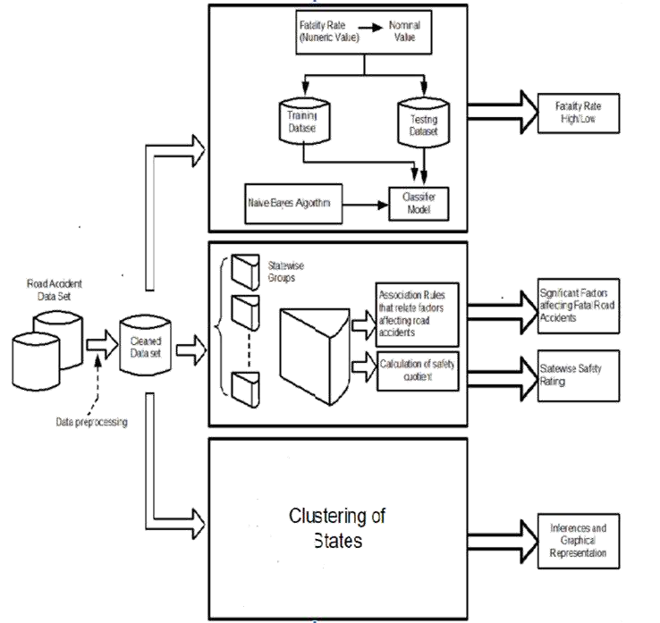

- CONCLUSION
Issue of a large ratio of fatality due to road traffic accidents needs careful and efficient analysis of road traffic accidents in order to take action. The proposed system will analyze road traffic accidents' data using various data mining techniques like Association Rule Mining, Classification and Clustering and it will provide a way to find the most affecting factors for highly fatal road accidents. Also, the
project will provide a summary-like report that will be easier to comprehend than a theoretical report. Thus, it will give users a way to understand several unknown factors that lead to highly fatal accidents and it will help action taking authorities like Government/Non-Government authorities of Road Transport and Maintenance take successful efforts to reduce the number of accidents, thus reducing the number of fatalities.

REFERENCES
- Liling Li, Sharad Shrestha, Gongzhu Hu, "Analysis of Road Traffic Fatal Accidents Using Data Mining Techniques", IEEE 15th International Conference on Software Engineering Research, Management and Applications (SERA), 2017
- Sachin Kumar and Durga Toshniwal, "Analysing road accident data using association rule mining", In Proceedings of International Conference on Computing, Communication and Security, pages 1-6, 2015
- Suwarna Gothane and Dr. M. V. Sarode, "Analysing Factors, Construction of Dataset, Estimating importance of factor and generation of association rules for Indian road accidents", IEEE 6th International Conference on Advanced Computing, pages 15–18, 2016
- Maninder Singh, Amrit Kaur, "A Review on Road Accident in Traffic System using Data Mining Techniques", International Journal of Science and Research, pages 1530-1535, 2016
- K Jayasudha and C Chandrasekar, "An overview of data mining in road traffic and accident analysis", Journal of Computer Applications, 2009
- L. Y. Chang, and W. C. Chen, “Data Mining of Tree based Models to Analyze Freeway Accident Frequency”, Journal of Safety Research, Elsevier, vol. 36, 2005.
- Bahram Sadeghi Bigham, "Road Accident Data Analysis: A Data Mining Approach", Indian Journal of Scientific Research, May 2014
- Manuel Fogue, Piedad Garrido, Francisco J. Martinez, Juan-Carlos Cano, Carlos T. Calafate and Pietro Manzoni, ”A system for Automatic Notification and Severity Estimation of Automotive Accidents”, IEEE Transactions on Mobile Computing, Vol. 13, pp. 5, May 2014

