IOP Conference Series: Materials Science and Engineering

PAPER • OPEN ACCESS

Virtual Reality and Navigation subsystems of the Interactive System for Road Safety Improving
To cite this article: M E Eliseev et al 2018 IOP Conf. Ser.: Mater. Sci. Eng. 386 012027

View the article online for updates and enhancements.

Related content
- Virtual Reality and Its Application in Military
Xinxiong Liu, Jing Zhang, Guoxiang Hou et al.

- Virtual reality for showcasing sustainable engineering design
Walter Chen, Dong-Huang Li and Yeou- Fong Li

- Most common road safety engineering deficiencies in South Eastern Europe as a part of safe system approach
D Jovanov, H J Vollpracht, H Beles et al.


This content was downloaded from IP address 139.81.164.122 on 31/07/2018 at 10:33

Virtual Reality and Navigation subsystems of the Interactive System for Road Safety Improving

M E Eliseev T N Tomchinskaya E D 2Galkina N Yu Dudakov, R A Musarsky Nizhny Novgorod State Technical University n.a. R. E. Alekseev, Russia

E-mail: eliseevmic@mail.ru

Abstract. The article considers the Interactive System for Road Safety Improving of a large city. Its virtual reality and navigation subsystems, their interaction with each other and with the main system are described in detail. The navigation subsystem informs drivers about potentially dangerous sections of the road in real time. The virtual reality subsystem allows you to visualize various mechanisms of emergency situations, connect them with the landscape, various conditions of the urban environment, and a road accident statistics map. The alpha version of the software is being tested in Nizhny Novgorod, Russia. It is planned to use the system by all subjects of the road process: drivers, pedestrians, enterprises involved in transportation, road services, road traffic organizers.

Introduction
The problem of accident rate has become especially dangerous. According to statistics, about 1,2 million people die every year in road accidents (3300 people a day). From 20 to 50 million are not fatal injuries. At the same time, over three quarters of all road accidents are related to violations of the Road Traffic Rules by drivers of vehicles. Drivers with a driving experience of up to three years make up a large percentage of participants in road accidents. Virtual Reality and Navigation subsystems of the Interactive System for Road Safety Improving of a large city (further ISIRS) are primarily aimed at reducing accidents in this category of drivers. ISIRS is a system for collecting, storing and processing information related to road accidents, as well as for feedback to road users.
Similar systems are being developed by a number of authors [1-14]. For example, Hanshin Expressway Company Limited considers the risk of an accident as one of the important concepts of its safe driving assistance and traffic management for the next generation. The company analyzes its various data on the driving conditions it has as an operator network and road accident records so as to be able to predict traffic accidents for these driving conditions. The company suggests using information about the risks of accidents for comfortable and safe driving [15].
Interesting studies offer an architecture for interactive motion-based motion modeling Environment. In order to enhance modeling realism involving actual human beings, the proposed architecture integrates multiple types of simulation, including: motion-based driving simulation, pedestrian simulation, motorcycling and bicycling simulation, and traffic flow simulation. The architecture has been designed to enable the simulation of the entire network; as a result, the actual driver, pedestrian, and bike rider can navigate anywhere in the system. In addition, the background traffic interacts with the actual human beings [16].

Content from this work may be used under the terms of the Creative Commons Attribution 3.0 licence. Any further distribution of this work must maintain attribution to the author(s) and the title of the work, journal citation and DOI.
Published under licence by IOP Publishing Ltd 1

The principal differences of the proposed system are as follows: 1) the most complete collection of information related to accidents; 2) structuring information; 3) autonomy; 4) adaptability; 5) statistical validity of the obtained results of information processing; 6) transfer of information to the participants of the road process in a form convenient for make use of [17].
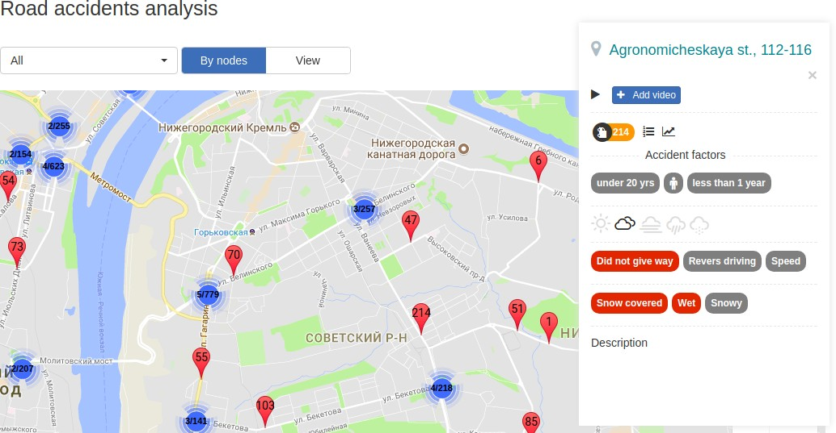
Autonomy here means that once configured for a particular city system does not require regular support and can operate in a fully automated mode. Naturally, the system is updated with new information and its work can be adjusted by specialists. By adaptability we mean that the ISIRS can be configured for any large city by changing a number of parameters. Under the form convenient we mean that it may be used for trainees in driving schools, there is information videos linked to specific sections of the road infrastructure, for drivers there is navigation application hints, for traffic experts - accident monitoring datarepresented in information banners on the map, charts, graphs and tabular forms.Figure 1 shows one example of the presentation of information about foci of road accidents.

Figure 1. Information window of the detailed information of a node The following hierarchy is assumed (Figure 2):
- the main urban information management system "Smart City";
- transport information subsystem;

ISIRS;
- subsystems of virtual reality and navigation.
Information from sensors of various types and from various city services enters the information- management system "Smart City".That part of it that is used in transport processes is delivered to the transport subsystem, if required, in a revised form.In the transport subsystem, the data are analyzed and their part that is related to road safety is transmitted to the ISIRS.
It processes the information received and transmits it in the desired form to the subjects of the road process: drivers, pedestrians, enterprises involved in transportation, road services, road traffic organizers directly, or returning to the transport subsystem, but in a different form. In its turn, the transport subsystem can either use the data internally, or return it to the global urban information management system "Smart City", which will forward the information to the necessary subjects of urban control processes. Such a delimitation of the functions of the systems will allow the most complete and accurate processing of data entering the global system.

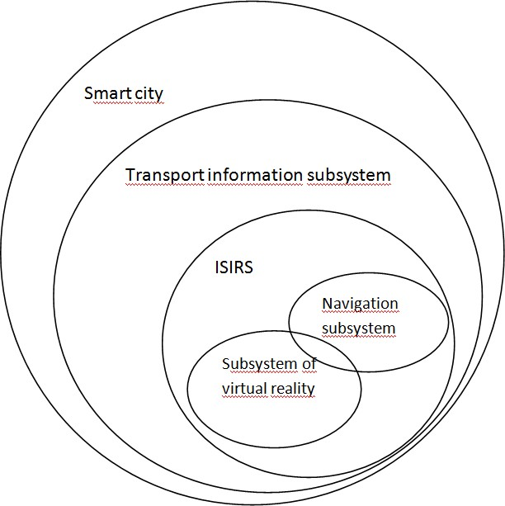
Figure 2. Hierarchy of urban information management systems

Let us confine ourselves to one small illustration, to explain the nature of the interaction of systems.Let the weather forecast for the next day come from the meteorological stations in the city.Since this information affects transport processes, it is transferred to the transport subsystem.In view of the fact that the weather data is related to road safety, they are transmitted to the ISIRS, where they loads into the subsystem of weather data analysis.If it is revealed that these data correspond toone of the criteria of a dangerous combination of weather factors, the following actions will be performed:
  - In the ISIRS annotation subsystem information messages will be created. They will be transferred to the ISIRS subsystems, which will provide feedback to the subjects of the road process, in particular, the navigation subsystem. The navigation subsystem will add this information to the information messages for drivers when passing the accident foci related to the appropriate combination of weather factors.
  - The navigation subsystem will transfer the data in a revised form to the transport subsystem that will send the information to the appropriate subsystems, for example, the passenger transport subsystem, and then send them to the "Smart City". If this information requires the connection of city services (for example, a heavy snowfall is predicted), data, in a revised form will come to the subjects of urban processes.So, in the case of forecast data, "heavy snowfall", road services associated with snow removal will be put in a ready state.A very simplified example is given, as in ISIRS, of course, it is not simply a "snowfall" being considered, but a set of forecast data (air temperature, pressure, etc.) verifies the fulfillment of one of the criteria.

General view of the criteria: k1, k2 ,.k6
– values of the variables of the weather factor

( k₁ - predicted temperature, k₂ - predictedpressureetc.). Factors are previously selected using factor

analysis,
π1, π2 ,.π6- values of correlation coefficients between the relevant weather factor and the

daily number of accidents. For a more accurate prediction, the entire temperature range was divided into several intervals. For each interval the criterion is:

k1 π₁ + k2 π₂ +.+ k6 π₆ < K0
(1)

where
range.
K 0 – is the threshold value of the criterion, which is selected experimentally for each temperature

In order to understand the internal interaction of components in ISIRS, we list its main subsystems: topographic analysis, route construction, accident monitoring, 3D modelling, weather data analysis, annotation, client-server application, navigation, virtual reality.
In this paper, the last two subsystems of this list are presented.

The navigation subsystem of ISIRS
For feedback from drivers, as one of the main participants of the road process, information on accidentally-dangerous road factors should be transmitted to them in a form convenient for perception.One of the most suitable means of transmitting these data, along with information monitors, are navigators and navigation applications.
We will discuss in detail how the interaction of various subsystems of the ISIRS takes place to form navigational hints.
  - The driver indicates the start and end points in the navigation application.
  - This data, together with information about driving experience, gender and age of the driver (if authorized) are transferred to the subsystem of the client-server application that refers to the subsystem of the construction of routes.At this stage, the path is built in the "json" format.A fragment of the encoding of this route in the"json" format is shown in Figure 4.
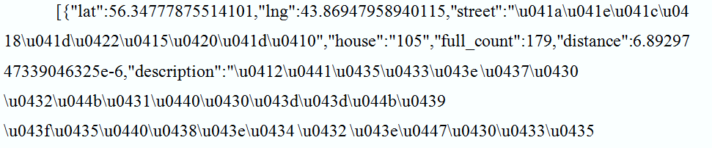
Figure 3. Fragment of "json" file, encodedthe selected path

  - Routes in the form of a set of points and polylines are transferred to the topographic analysis subsystem, in which the places of concentration of accidents (furtherthe accidents foci) on the route are determined.
  - There is an appeal to the subsystems for monitoring the accident rate and analyzing the weather data. At this stage, information is requested about accidents foci along the way.
  - Information about the foci, weather data and accident monitoring data, together with the driver's personal information (experience, gender and age), is transmitted into the annotation subsystem.

The formation of an annotated message for a specific focus is performed using the following algorithm.

  - Algorithm for generating an annotated message
    - If there is an expert comment, it will be given the highest priority, and it will be automatically added to the message.
    - The weather data are analyzed. According to the table of criteria, it is checked whether the existing combination of weather factors satisfies at least one of the criteria of the form (1), if yes, then this

criterion will be included in the processing, if not, then the weather data will not be taken into the annotation.
    - Road infrastructure data tables are checked: road works, idle traffic lights, etc., if there is a focus data in them, the corresponding information is added to the message.
    - The data of the monitoring subsystem are checked, if a sharp growth of accidents of certain categories is noticed in this center, then at the annotation this data will have the next priority level.
    - If during the last week and the month sharp increase in the number of accidents is not observed, the annotation will use data for the last 3 years: the accident factors and categories of drivers for which the average accident rate is significantly exceeded and a message will be built on them.

Table 1. Table of possible values of accident factors.
№ | Data | Value
1 | Expert's comment | text
2 | Weather criteria 1 | 0 or 1
3 | Weather criteria 2 | 0 or 1
4 | Weather criteria 3 | 0 or 1
5 | Weathercriteria 4 | 0 or 1
6 | Weathercriteria 5 | 0 or 1
7 | Roadinfrastructure | 0-4 (the digit corresponds to the factor: 0 - factors are absent, 1 - road works, 2 - not working traffic light and  etc.)
8 | Monitoringdatafactor | 0-9 (the digit corresponds to the factor: 0 - factors are absent, 1 - distance, 2 - priority and etc.)
9 | Monitoringdatadrivercategory | 0-10 (0 - not allocated categories, 1 - male, 2 - female, 3  - driving experience 0 full years and etc.)
10 | Generaldatafactor | 0-9 (the digit corresponds to the factor: 0 - factors are absent, 1 - distance, 2 - priority and etc.)
11 | Generaldatadrivercategory | 0-10 (0 - not allocated categories, 1 - male, 2 - female, 3  - driving experience 0 full years and etc.)

Let us dwell in more detail on the technique of calculations. The marker of the cause of the accident rate was calculated. This is a row matrix, the elements of which are the portions:

𝐾"
= 𝑛"% × 𝑁
𝑁% × 𝑛"
(2)

where𝑁 – total number of RA, 𝑛" – the number of RA with the i factor, 𝑁% – total number of RA in the node, 𝑛"% – the number of RA in the node with the i factor. List of factors-conditions associated with RA or types of RA, is set in advance. When annotating the largest coefficients 𝐾" in groups: driving experience, gender, driver age, concomitant factor, weather factor are taken into account. In this case, weather factors are displayed only when the conditions of clause 2 are fulfilled, other factors only if their value is not less than the specified threshold, the latter is proposed to be taken equal to 1.2, i.e. the average accident rate is exceeded by 20%.
As a result, annotations are formed for each focus along the route. The message created for the focus is shown in Figure 3.

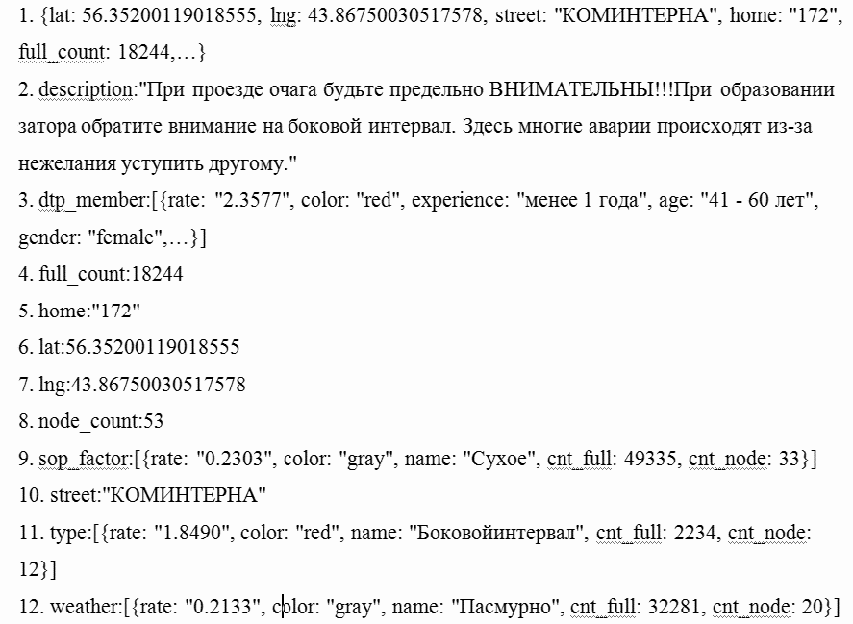
Figure 4. Server Response Example - Information about the accident focus

    - Route data including annotations for foci are sent to the navigation application.
    - When approaching a crossroad or a linear section of a route with an annotated message, the standard audio message is supplemented with the corresponding information. Intheexampleabove, itlookslikethis:

"When passing through the focus, be extremely ATTENTIVE! When forming a traffic stack, pay attention to the lateral interval. Here, many accidents occur because of reluctance to give way to another"

Note that without authorization (driving experience, gender and age), the message would look different:

When forming a traffic stack, pay attention to the lateral interval. Here, many accidents occur because of reluctance to give way to another"

This is due to the fact that in the topographic analysis subsystem it is revealed that for this category of drivers this focus has exceeded the threshold value of the ratio of focal and general data.

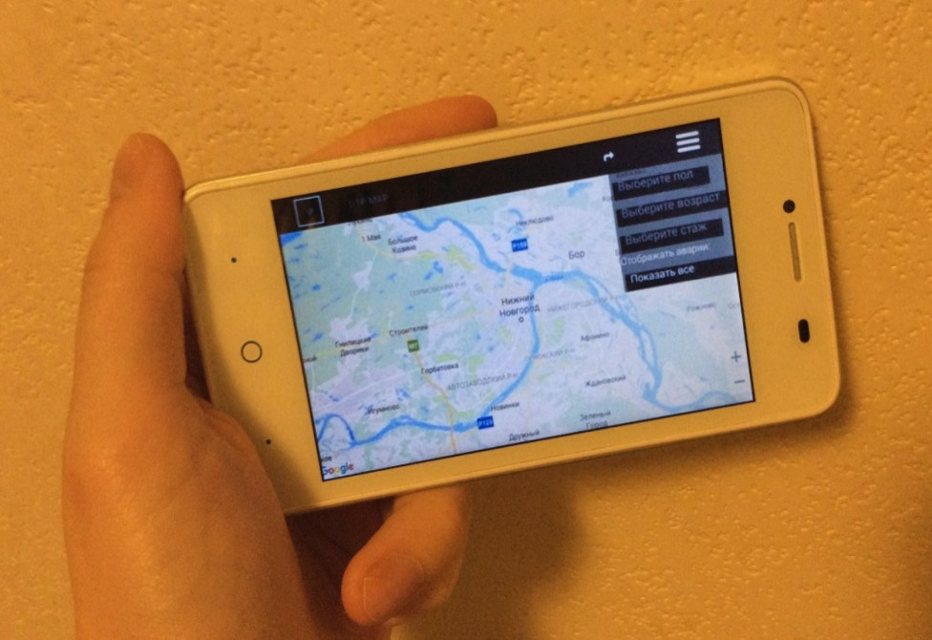
Figure 5. Abuildingroutemenu

The navigation subsystem is under development. The menu for building a route for a mobile application is shown in Figure 4.

The subsystem of virtual reality
In this subsystem, two ways of ensuring road safety are considered.
  - Preview an unfamiliar section of the path using augmented reality. Pointing the camera smartphone on a map of the city, for example, Yandex map, the driver can see a realistic model of a specific section of the road infrastructure on the smartphone screen with all the signs and markings.
  - By immersing himself in virtual reality, the driver can see an accident that occurred on a particular section of a realistically modeled part of a particular cityin the stereo mode. You can see this situation from different points of view, like the victim, the culprit or the casual witness and understand all the reasons for this accident.
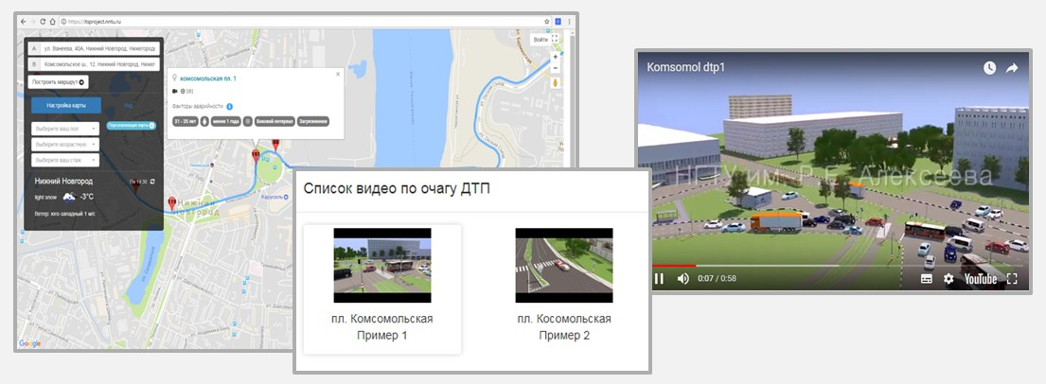Based on the information received during the work of the topographic analysis subsystem, a list of the most accident-prone sections of the road infrastructure (foci of accidents) is singled out. For each of the foci, in accordance with the formula (2), the factors that will be the parameters of the simulation are identified.
Figure 6. Operation of the ISIRS topographic analysis subsystem

1.1. The most dangerous parts of the city are identified, corresponding to each factor, and dangerous road situations are modeled on these sections. Recordedvideosshowing:
- erroneous behavior of the driver and
- how to act properly in a similar situation. A video bank has been prepared, which stores videos demonstrating traffic rules. Figure 5 shows the accident-prone areas with a factor - "Pedestrian accident".

  - Augmented Reality Block
To implement the application on the Android platform, the integrated development environment of Unity 3D is used. Scenes with traffic accidents in the most dangerous parts of the city, previously developed in the technology of low-poly modeling in the tool environment of AutodeskMaya and 3Ds Max, and then converted to a Unity 3D environment.
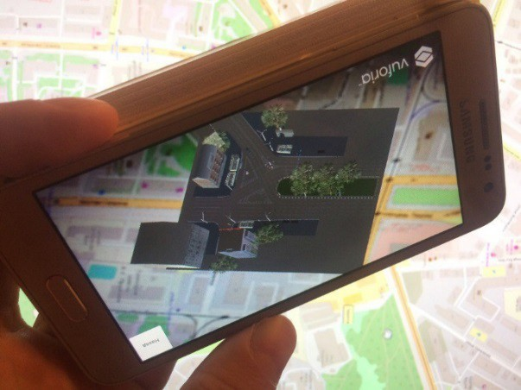
Figure 7. Uploading a scene to the smartphone by the map label

In the application, several blocks are created, each block is responsible for a specific section. An integrated method of creating a program is used, standard modules are used, and the links between them are written using the C # programming language. In the AR, augmented reality, the Vuforia plug-in launches a mechanism for tags searching, created in advance on the basis of maps and linking a model or a tooltip to it. The scene with the most dangerous areas is integrated into the map. The Vuforia plug- in recognizes the image of one of the marks on the map received from the smartphone's camera, based on information about the position of the marker in space.
Then, the calculation of the reference points with simultaneous tracking is performed, thereby the three-dimensional object is oriented in space.
The application projects the corresponding model onto the label, and the scene of the accident case is loaded on the screen. The scene is played in the third person view mode (Figure 6).

  - VirtualRealityBlock
Block VR (virtual reality) is designed to view the model in virtual reality mode without using a label. From the list of suggested scenes, the user selects the model of interest. The screen of the smartphone or tablet is loaded with a scene, with the ability to view it from different angles and from different road users with full or partial immersion.
For a full immersion, a virtual reality helmet is required. A virtual camera is added to the scene. The choice is made in favor of the product Fibrum SDK, because it has all the necessary settings, and it does not overload the system with additional plug-ins. Using the Fibrum SDK object, two cameras are installed, for each eye, respectively, the distance between the cameras, the distortion of the image and

the required cylindrical distortion. To manage the character standard internal plug-in Unity 3D – Characters Controller is used.
When you download a scene on a smartphone in the virtual reality mode, you can view the situation from various faces of road users, whether the culprit, the victim or the free movement of the scene. When the user is in the free movement mode, he can look around, explore the terrain and the road infrastructure surrounding it, or navigate around the stage using the standard control joystick (Figure 7). Buttons for selecting the view mode are at the top of the screen. Back button - to exit the scene, to the main menu (Figure 8).
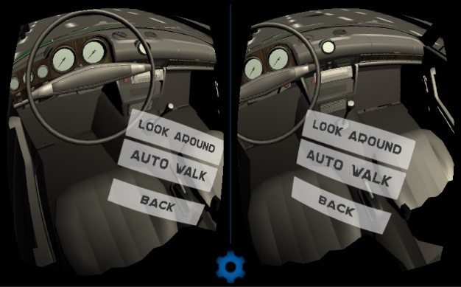
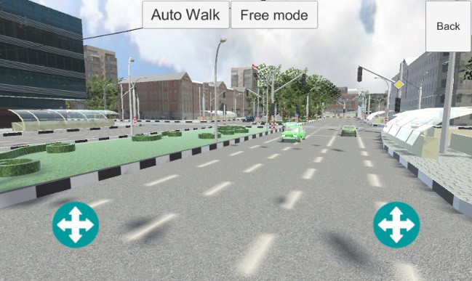

Figure 8. Navigation and orientation control buttons in the space
Figure 9. Operation of two cameras for stereo imaging

To switch to viewing a scene from another participant of the road, the user needs to "look" at the corresponding button on the screen. For a more complete immersion, objects inside the scene cast a shadow from static and dynamic light sources. To do this, a 3D object cylinder is added to the parent prefect of the Rigid Body FPS Controller. It casts a shadow from the character, but in order for the polygons of the object to fall into the camera, it is excluded from the renderer. To make the body have its volume and collide with other objects, a standard MeshCollider script is added, which makes all faces of the character physical and does not allow it to pass through the walls. The same plugin should be on objects, through which the user is forbidden to pass.

Conclusion
A pilot project of an interactive system for improving road safety, a navigation and a virtual subsystem for informing drivers, is presented. The authors propose to use information on the risks of road accidents and for the realization of safe and comfortable traffic. The ways of practical information service for drivers to choose a route and correct behavior in emergency situations are offered.
In the paper, the application of virtual and augmented reality technologies during driver training in real emergency areas of the city is investigated. To build scenarios for the creation of accident-dangerous cases, statistics and situational descriptions of accidents is used. The mode of dynamic training in the mode of virtual and augmented reality with various degrees of immersion is offered.
We consider the technology for implementing an application for a mobile platform that can implement driver training scenarios in emergency areas of the road infrastructure, in real-life situations that are difficult to drive in several virtual and augmented reality modes. The implementation is performed in the Unity 3D integrated development environment. Testing was conducted in three driving schools of the city. The greatest interest was shown by driving schools (93%) and drivers with a driving experience of up to three years (82%).
The navigation subsystem, implemented as a mobile application, will allow drivers to receive timely information about emergency-dangerous factors in a form convenient for perception, which, according to the authors, will help them to feel more confident on the road and reduce the risk of road accidents.

References
- De Lucia B H and Scopatz R A E-Crash: The Model Electronic Crash Data Collection System.
Washington: National Highway Traffic Safety Administration. 2010
- Espie S, Gattuso D, Galante F. A Hybrid Traffic Model Coupling Macro and Behavioral Micro Simulation Proceedings of the 85th Annual Meeting Transportation Research Board USA Washington 2006
- Graettinger A, Lindly J K and Mistry G J Display and Analysis of Crash Data University Transportation Center for AlabamaTuscaloosa AL 2005
- Graettinger A J, McFadden J and Rushing T W Evaluation of Inexpensive Global Positioning System Units to Improve Crash Location Data Transportation Research Record: Journal of the Transportation Research Board (1746) 2001 pp 94–101
- Harkey D L Evaluation of Truck Crashes Using a GIS-Based Crash Referencing and Analysis System Transportation Research Record: Journal of the Transportation Research Board (1686) 1999 pp 13–21
- Khan G, Santiago-Chaparro K R, Qin X and Noyce D A Application and Integration of Lattice Data Analysis Network KFunctions and Geographic Information System Software to Study Ice-Related Crashes Transportation Research Record: Journal of the Transportation Research Board (2136) 2009 pp 67–76
- Miller J S Geographical Information Systems Unique Analytic Capabilities for the Traffic Safety Community Transportation Research Record: Journal of the Transportation Research Board (1734) 2000 pp 21–28
- Pegin P A and Lopashuk V V Usage of GPS Survey Results for Taking the Sun Blinding Effect into Account in Highway Designing Transport construction (7) 2008 pp 23–24
- Roche J (2000) Geographic Information Systems-Based Crash Data Analysis and the Benefits to Traffic Safety MTC Transportation Scholars Conference Ames IA 2000 pp 110–122
- Daito Kodama and Ozawa Real Time Accident Risk Information Provision on a Urban Expressway Network: Prediction Model Analysis and Development of a Provision System Proceedings of the 51st Spring Conference of the Committee of Infrastructure Planning and Management, 2015
- University of Leeds Driving Simulator (UoLDS) October 2011http://www.its.leeds.ac.uk/itsresearch/facilities/uolds/
- T Kodama et.al. Information service for safe driving by using Road Section Identification Data set (RSIDs) by public-private initiative Proceedings of the 20th ITS World Congress Tokyo 2013
- Murakami Kurauchi, Yoshii Oonishi, Kawahara Takayama and Hyodo A Study on the Influence of Accident Risk Information to Drivers Choice Behaviors Proceedings of the 49th Conference of the Committee of Infrastructure Planning and Management 2014
- Kodama T, Yabukami D, Daito T and Ozawa Y 2015 Informing drivers on accident risks: a case of Hanshin Expressway’s web-based tool “Safety Drive / Smart Choice"22nd ITS World Congress Bordeaux 2015 11 pages
- Alexander P, Naveen V, Romesh Hanns de la Fuente-Mella and Luiza M (2015) Traffic and Driving Simulator Based on Architecture of Interactive Motion The Scientific World Journal 2015 pp 1–9
- Pundt H 2017 Integration of context-information to support spatial decision systems IADIS International Journal on Computer Science and Information Systems Vol12 No 2 pp 50-64
- Eliseev M, Tomchinskaya T, Lipenkov A and Blinov A Using 3D-modeling Technologies to Increase Road Safety Transportation Research Procedia 2017 Vol 20 pp 171-179

