**Unlock the Zombienaire Klub: 16,384 NFTs to Immortalize Yourself in a Daring Zombie Utopia This Halloween!**

New York, NY –[Pinion Newswire](https://pinionnewswire.com/news-releases/unlock-the-zombienaire-klub-16384-nfts-to-immortalize-yourself-in-a-daring-zombie-utopia-this-halloween/)

The [Zombienaire Klub](https://zombienaireklub.xyz/" \t "_blank) NFT collection, created by [Dandelion Inno Labs](https://dandelioninnolabs.io/), is set to debut on October 24 this Halloween season, offering 16,384 unique PFP art NFTs. You’d have to “trick or treat” at every house in your state to get that kind of variety. Each NFT grants membership access to an exclusive utopia and participation in a groundbreaking Play-to-Eternity game currently in development. Groundbreaking is the perfect word for a world full of zombies.

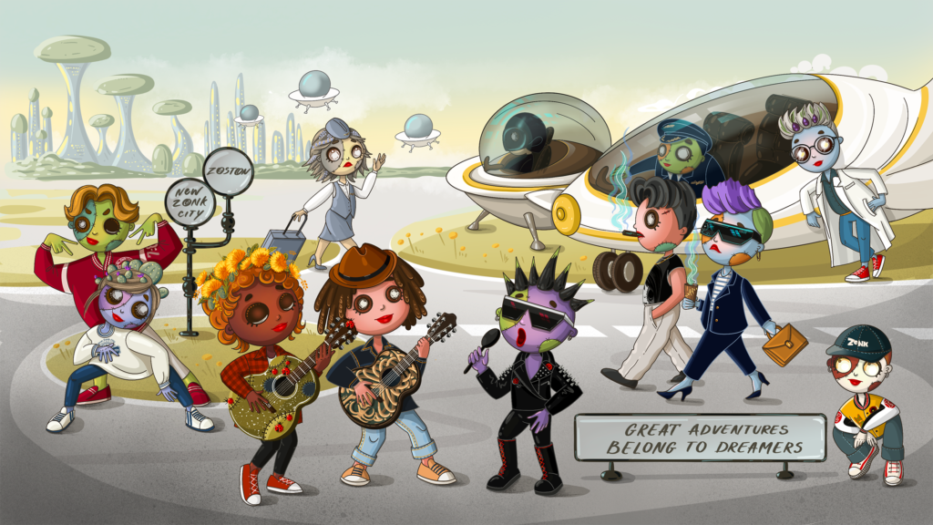

The Zombienaire Klub is not just another NFT project; it combines the allure of digital art, inviting enthusiasts to join a vibrant and imaginative utopia. Led by visionary Captain Joe (last name: Regular) and the ingenious Dr. Zonkers (last name: Bonkers) from the prestigious Zombie Institute of Technology, the Zombienaire Klub is set in a fantasy world known as Zombie Land. The community is to die for!

The collection consists of happy, sassy, and surreal zombie characters, each with distinct features, attitudes, and roles within their utopian society. From business professionals to dancers and service people, the diversity of these characters represents the core of Zombienaire Klub’s community-building values. And the best part about zombies? You don’t have to worry about life expectancy—they’ll show their cute, loving faces every time you refresh your Ethereum wallet.

**The future belongs to those who believe in the beauty of their dreams. Own a cute Zombienaire Klub NFT and step into a utopia where every corner promises magic and adventure.**

The NFT collection serves more than just aesthetic appeal. Each Zombienaire Klub NFT acts as a membership, granting holders access to a constantly evolving digital utopia. Just because they’re “dead” doesn’t mean they can’t evolve. The NFT membership unlocks access to the game currently in development, designed to immerse players in the unique world of Zombie Land, blending fantasy, futuristic elements, and entertainment. Zombienaire Klub focuses on creating lasting digital experiences where holders become part of an innovative digital landscape. You’ll be surprised how much the undead can enrich your life.

The collection drops on October 24, 2024. Stay tuned for updates by following [Zombienaire Klub](https://x.com/zombienaireklub" \t "_blank) on the company’s [Twitter account](https://x.com/zombienaireklub), aka “X” Who knows, maybe it’ll be called “Z” by then.

**Contact Information:-**

Dandelion Dreamer  
Tel: 1 6465699478,  
[web@dandelioninnolabs.io](mailto:web@dandelioninnolabs.io),  
Twitter/X: [@zombienaireklub](https://pr.report/3c6g),  
[https://zombienaireklub.xyz](https://pr.report/3c6h)

**SOURCE:**Zombienaire Klub