Software Requirement Specifications
Trackback Campus System Mobile App for Lost and Found Item Tracking



Submitted by
Muhammad Muneeb Altaf (S23BINFT1M01143)

Submitted to
Mr. Wahaj Ali

Department of Information Technology
Faculty of Computing
The Islamia University of Bahawalpur

Meeting Details
Sr No | Details | Date | Supervisor Signature
Summary
Here Every university campus deals with the same quiet, everyday problem things get lost, and there is no good way to find them again. A student misplaces their laptop charger in the library, someone leaves a jacket behind in the cafeteria, a set of keys goes missing somewhere between two buildings. The item might be sitting in a lost-and-found box twenty meters away, and the student who lost it will never know because nobody told them and there was no easy way to check.
Trackback Campus System was built to fix that. It is a mobile-accessible web application that gives students a simple, structured way to report items they have lost or found and then handles the hard part automatically. When a student submits a lost item report, the system immediately scans existing found reports for a possible match. When it finds one, both students get notified. No phone calls, no trips to the front desk, no hoping someone sees a post on a group chat before it disappears.
The platform follows a layered architecture. The frontend, built with HTML, CSS, and JavaScript, gives students a clean and mobile-friendly experience that works in any browser without requiring an app download. The middle-end, written in Python, houses the matching engine that compares lost and found reports based on item type, description, location, and date. The backend, also in Python, handles authentication, session management, and routing. Beneath it all, an SQLite3 database stores every user account, item report, match event, and notification in a lightweight, reliable structure.
Three types of users interact with the system. Registered students and campus staff are the primary users they post reports, receive notifications, and mark items as recovered when a return is made. Administrators manage the platform through a separate admin panel, reviewing content and keeping the system trustworthy. Guests can browse active found listings to see whether something they lost has been reported, which also gives them a reason to register.
This document the Software Requirements Specification for Trackback Campus System covers everything a development team needs to build and deliver the project.

Table of Contents
1. Introduction 5
1.1. Purpose 5
1.2. Scope 5
1.3. Product Perspective 6
1.4. User Characteristics 6
1.5. Similar apps and systems/Literature Review 7
1.6. Proposed Technologies 7
2. Requirements 8
2.1. Function Requirements 8
2.1.1. Sign Up 8
2.1.2. Login 8
2.1.3. Report Lost Item 9
2.1.4. Report Found Item 9
2.2. Non-Functional Requirements 10
3. Use Cases and Flow of Processes 11
3.1. Sign Up 11
3.2. Report Lost Item 13
3.3. Automated Matching and Notification 15
4. References 17

- Introduction
Most campuses handle lost and found the old-fashioned way — a box at the reception desk, a notice pinned to a board, or a post in a WhatsApp group that gets buried under fifty other messages within the hour. None of these methods are reliable. None of them scale. And most students do not even bother trying because they assume their item is already gone.
Trackback Campus System was built around a simple idea: what if finding a lost item was as easy as posting on social media? A student who loses something opens the app, describes what they lost, mentions where they last had it, and submits the report. A student who finds something does the same. The system then quietly does the work in the background — comparing posts, looking for matches, and sending a notification to both people the moment it finds one. No phone calls, no trips to the front desk, no hoping someone sees your post before it disappears.
The application is designed entirely for the campus context. It is lightweight, mobile-friendly, and built so that any student can use it without needing any instruction. Behind the scenes, an admin panel gives campus staff the visibility they need to keep the platform accurate and free of misuse.

  - Purpose
The purpose of Trackback Campus System is to create a structured digital platform that connects students who have lost items with students who have found them. Rather than relying on scattered social media posts or physical notice boards, the app centralizes all lost-and-found activity in one searchable, filterable, and verifiable place. The system also aims to reduce the burden on campus staff by automating the matching and notification process, and to give administrators the tools they need to keep the platform clean and trustworthy.

  - Scope
Trackback will be developed as a mobile application with a web-based admin interface. The scope of this project includes user registration and authentication, lost item reporting, found item reporting, automated item matching, in-app notification alerts, item browsing and filtering, and an admin panel for content moderation and activity monitoring.
The system is scoped to the university campus environment and will serve registered students and campus staff. Features such as GPS-based real-time tracking, integration with campus security cameras, inter-university item sharing, and a built-in chat system between users are considered out of scope for this release and may be explored in future versions.
  - Product Perspective
Trackback Campus System is a standalone application that fills a gap where no digital solution currently exists on campus. It follows a layered architecture with four clearly separated layers: the frontend mobile interface built with HTML, CSS, and JavaScript; the middle-end business logic layer in Python that handles the matching algorithm and notification triggers; the backend services layer in Python that manages authentication and data processing; and an SQLite3 database for persistent storage of all user and item data.
This separation ensures that each layer can be developed, tested, and maintained independently. The frontend communicates with the middle-end through defined API calls, which in turn communicates with the backend. The database sits beneath the backend and is never directly exposed to the frontend. This design also makes it straightforward to replace individual components in the future for example, migrating from SQLite3 to a more scalable database — without restructuring the entire system.

  - User Characteristics
The system is designed for three distinct types of users, each with different needs and access levels.
- Registered Student / Campus User: The primary user of the app. Students can create accounts, post lost or found item reports, browse existing posts, receive match notifications, and mark items as recovered. No technical background is assumed — the interface is designed to be as simple as posting on a social media feed.
- Administrator: A campus staff member or designated system manager with access to the admin panel. Administrators can view all posted content, remove items that violate platform guidelines, monitor activity, and manage user accounts. Basic computer literacy is expected.
- Guest / Unregistered Visitor: Someone who has not yet created an account. Guests can browse publicly listed found items but cannot post reports or receive notifications. This gives newcomers a reason to register without blocking access to genuinely helpful public information.

  - Similar apps and systems/Literature Review
Several existing platforms address lost-and-found management in various ways. Reviewing them reveals the same recurring gaps that Trackback is designed to close.
- iLost (iLost.com): A commercial platform used by airports and hotels. It is professional but built for large organizations with dedicated staff managing submissions it is not self-service and entirely unsuitable for a student community.
- Facebook / WhatsApp Groups: Many campuses use informal social media groups for this purpose. Posts get buried quickly, there is no search or matching capability, no moderation, and posting personal item details in open groups raises privacy concerns.
- FoundHub and Similar Campus Apps: A few universities have piloted lost-and-found apps, but most are region-specific, poorly maintained, or require institutional login systems that create friction. None implement automated matching between lost and found posts.
- Lostandfound.com: A broad public directory with no campus integration, no notification system, and no admin oversight difficult to use in a campus-specific context.
The common gap across all these solutions is the absence of a single platform that combines self-service reporting, automated matching, real-time notifications, and campus-specific administration. Trackback is designed to be exactly that.

  - Proposed Technologies
- Frontend (Mobile Interface): HTML, CSS, and JavaScript will be used to build a mobile-friendly interface that runs in a browser without requiring separate native builds for iOS and Android.
- Middle-end (Business Logic): Python will handle the item-matching algorithm that compares lost and found posts based on keywords, category, date, and location. Notification trigger logic also lives in this layer.
- Backend (Services and Authentication): Python will power user authentication, session management, data validation, and API routing between the frontend and the database.
- Database: SQLite3 will store all user profiles, item reports, match records, and notification logs. It is lightweight, serverless, and well-suited for a campus-scale deployment.
- Requirements
Trackback needs to support the full lifecycle of a lost-and-found item from the moment it is reported to the moment it is recovered and the case is closed. A student who has lost something should be able to open the app, create a post describing the item with its last known location and the date it went missing, and then wait for the system to notify them if a match appears. A student who has found something should be able to do the same in reverse post what they found and where, and let the system handle the matching.
The matching engine must compare both types of posts on relevant attributes and flag likely matches automatically. Administrators must be able to log in to a separate panel, review all content, remove misleading or inappropriate posts, and monitor the overall health of the platform. The system must send timely notifications when a match is detected, and every post, match event, and user action must be recorded for accountability.
  - Function Requirements
Authors will provide definite number of functional requirements in standard format. These requirements directly in the with functions which are already provided. The requirement format as following.
    - Sign Up
- Name: FR001
- Purpose: Allows a registered user to securely authenticate and access the system.
- User(s): Student, Campus Staff, Administrator
- Input:
  - Email Address: The email used during registration.
  - Password: The user's password.
- Output: The user is logged in and directed to the dashboard appropriate to their role.
    - Login
- Name: FR002
- Purpose: Allows a registered user to securely authenticate and access the system.
- User(s): Student, Campus Staff, Administrator
- Input:
  - Email Address: The email used during registration.
  - Password: The user's password.
- Output: The user is logged in and directed to the dashboard appropriate to their role.

Report Lost Item
- Name: FR003
- Purpose: Allows a user to post a report about an item they have lost on campus.
- User(s): Student, Campus Staff, Administrator
- Input:
  - Item Name and Category: e.g., "Water Bottle Personal Belongings."
  - Description: Color, brand, distinguishing features. Last Known Location: Where on campus the item was last seen.
  - Date Lost: When the item went missing.
  - Photo: An image of the item (optional but strongly encouraged).
- Output: The user is logged in and directed to the dashboard appropriate to their role.

Report Found Item
- Name: FR004
- Purpose: Allows a user to post a report about an item they have found on campus.
- User(s): Student, Campus Staff, Administrator
- Input:
  - Email Item Name and Category.
  - Description: What it looks like, any identifying features.
  - Location Found: Where on campus the item was discovered.
  - Date Found: When it was picked up.
  - Photo: An image of the found item.
- Output: The found item post is saved and published. The matching engine checks for existing lost reports that match.
    - Automated Item Matching
- Name: FR005
- Purpose: Automatically compares lost and found posts and identifies likely matches based on shared attributes.
- User(s): System (Middle-end Logic)
- Input:
  - Every new lost or found post triggers the matching algorithm.
- Output: If a potential match is detected, both the reporting user and the finding user receive an alert notification with details of the potential match.
  - Non-Functional Requirements
- Performance:
  - The item matching algorithm should complete and return results within 5 seconds of a new post being submitted, even during peak usage hours.
- Security:
  - All user passwords must be hashed before storage. Sessions must be managed with secure tokens. User-uploaded images must be validated to prevent malicious file uploads.
- Usability:
  - The mobile interface should be intuitive enough that a first-time user can submit a lost item report in under two minutes without any guidance. Core actions must require no more than three taps from the home screen.
- Scalability:
  - The system should comfortably support up to 5,000 registered users and 10,000 active posts without performance degradation. The architecture should allow a database migration to a more scalable engine without changes to the business logic layer.
- Reliability:
  - The system should maintain 99% uptime during university operating hours. If the matching engine fails, item posts should still be accepted and saved; matching can be re-run when the service recovers.
- Maintainability:
  - The codebase should be modular and well-commented so that individual layers (frontend, matching logic, backend, database) can be updated independently without breaking the rest of the system.

- Use Cases and Flow of Processes
The use cases below describe the key interactions between users and the Trackback system. Each is directly tied to a functional requirement and walks through the exact flow of events when a user initiates that action. Figure 1 (System Level Use Case Diagram) provides an overview of all actors and their relationships to the system's primary functions.
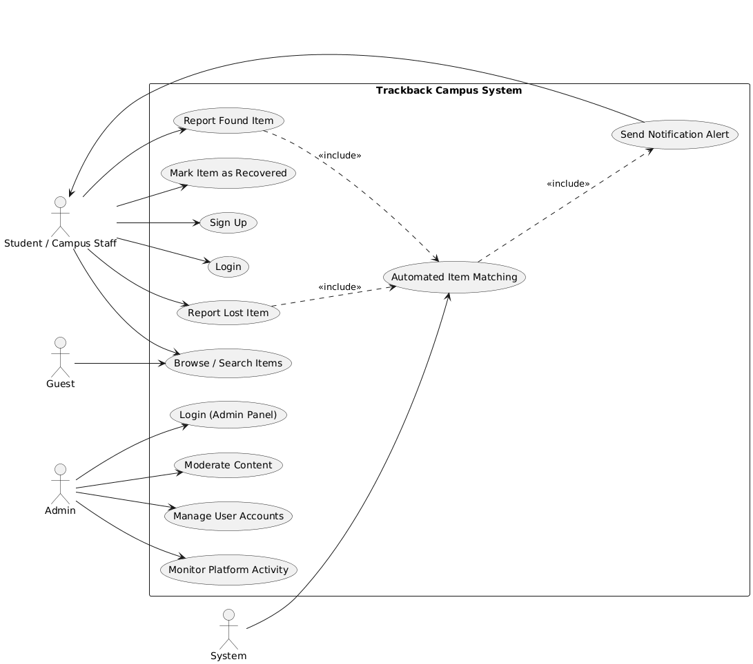

Figure 1: System Level Use Case Diagram
  - Sign Up
ID | UC001
Name | Sign Up
Description | A new user creates a Trackback account to access the platform's full features.
Requirement(s) | FR001
Actor(s) | Student, Campus Staff
Precondition | The user does not already have a Trackback account.
Postcondition | A new account is created and the user can log in immediately.
Basic Flow | Basic Flow  - User opens the Sign Up screen.  - User enters name, email, password, and phone number.  - User optionally uploads a profile photo.  - System validates inputs (email format, password strength).  - On successful validation, account is created and the user is redirected to the dashboard.
Diagrams
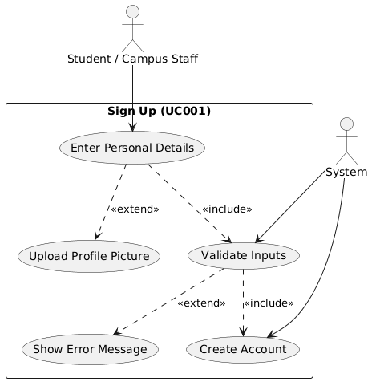
  - Report Lost Item
ID | UC002
Name | Report Lost Item
Description | A new user creates a Trackback account to access the platform's full features.
Requirement(s) | FR003, FR005, FR006
Actor(s) | Student, Campus Staff
Precondition | The user is logged in. The item has not already been reported.
Postcondition | The lost item post is live. The matching engine runs and sends a notification if a found post matches.
Basic Flow | Basic Flow  - User taps "Report Lost Item."  - User fills in item name, category, description, last known location, and date lost.  - User optionally uploads a photo.  - System saves the post and runs the matching algorithm.  - If a match is found, both users receive a notification.
Diagrams
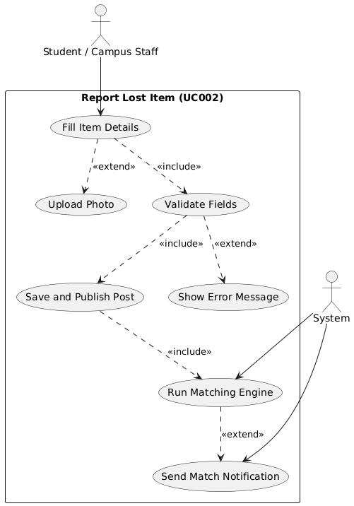
  - Automated Matching and Notification
ID | UC003
Name | Automated Item Matching
Description | The system compares a newly submitted post against existing posts of the opposite type and notifies both users if a probable match is found.
Requirement(s) | FR005, FR006
Actor(s) | System (Middle-end), Registered Student
Precondition | Both matched users receive an in-app notification with details of the potential match.
Postcondition | At least one lost post and one found post exist in the database.
Basic Flow | Basic Flow  - A new post (lost or found) is submitted.  - The matching engine retrieves posts of the opposite type.  - It compares item name, category, description keywords, location, and date range.  - Posts above the match threshold are flagged.  - Notifications are sent to both users.
Diagrams
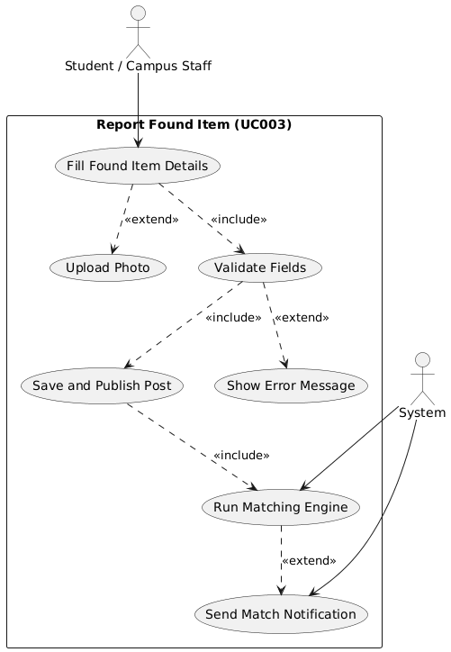

- References
- Elmasri, R., & Navathe, S. B. (2016). Fundamentals of Database Systems (7th ed.).
- Pearson. Grinberg, M. (2018). Flask Web Development: Developing Web Applications with Python (2nd ed.). O'Reilly Media. IEEE Computer Society. (2011).
- IEEE Std 830-1998: IEEE Recommended Practice for Software Requirements Specifications.
- IEEE. Lutz, M. (2013). Learning Python (5th ed.).
- O'Reilly Media. Mozilla Developer Network. (2024).
- HTML, CSS, and JavaScript Documentation. https://developer.mozilla.org Python Software Foundation. (2024).
- Python 3 Documentation. https://docs.python.org/3/
- SQLite Consortium. (2024). SQLite Documentation. https://www.sqlite.org/docs.html

