Software Design Document
Trackback Campus System Mobile App for Lost and Found Item Tracking



Submitted by
Muhammad Muneeb Altaf (S23BINFT1M01143)

Submitted to
Mr. Wahaj Ali

Department of Information Technology
Faculty of Computing
The Islamia University of Bahawalpur

Summery
Trackback Campus System is a mobile-accessible web application that solves the campus lost and found problem by connecting students who lose items with students who find them. The system follows a 4-layer architecture: a browser-based HTML/CSS/JS frontend, a Python middle-end housing the automated item matching engine, a Python backend handling authentication and routing, and an SQLite3 database for all persistent data. Design considerations prioritize mobile usability, modular layer separation, and automated matching without manual staff intervention.

Table of Contents
1. Application Architecture 4
2. Data Model Schema 8
3. User Interface 10

- Application Architecture
Authors The system does not follow MVC or MVVM. It follows a custom layered architecture with four independently maintainable layers.
- Frontend: HTML, CSS, JavaScript. Renders all screens in a mobile browser. Communicates with the middle-end via defined API calls. No native iOS or Android build required.
- Middle-end: Python. Contains the item matching engine. On every new lost or found post submission, it retrieves opposite-type posts from the database and compares them on item name, category, description keywords, location, and date range. If a match score exceeds a defined threshold, it flags the match and triggers notifications for both users.
- Backend: Python. Handles user authentication, session management with secure tokens, input validation, and API routing between the frontend and the database. The database is never directly exposed to the frontend.
- Database: SQLite3. Stores all user accounts, lost item reports, found item reports, match events, and notification logs. Designed to be replaceable with a more scalable engine without changes to the business logic layer.
Use Case Diagram
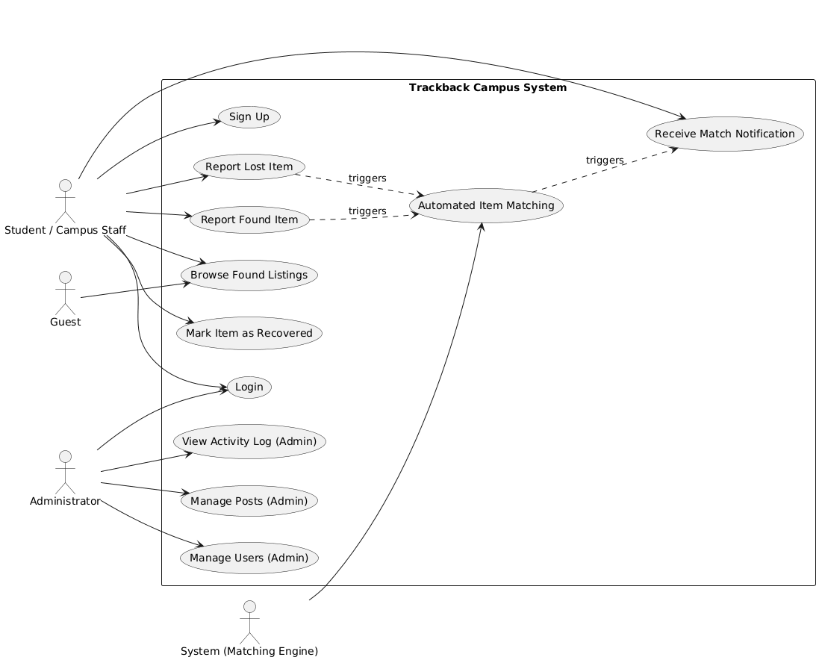
Controllers and their functions:
- AuthController: register(), login(), logout(), validateSession()
- ItemController: reportLostItem(), reportFoundItem(), getItemById(), updateItemStatus(), deleteItem()
- MatchController: runMatchEngine(), getMatchById(), listMatchesForUser()
- NotificationController: sendNotification(), markAsRead(), listNotificationsForUser()
- AdminController: listAllItems(), removeItem(), listAllUsers(), disableUser(), viewActivityLog()
- No external APIs are called. No third-party libraries beyond standard Python and browser-native JS are used in the core system.
- Coding conventions: snake_case for Python variables and functions, camelCase for JavaScript, PascalCase for class names, all files named in lowercase with underscores.
Sequence Diagram
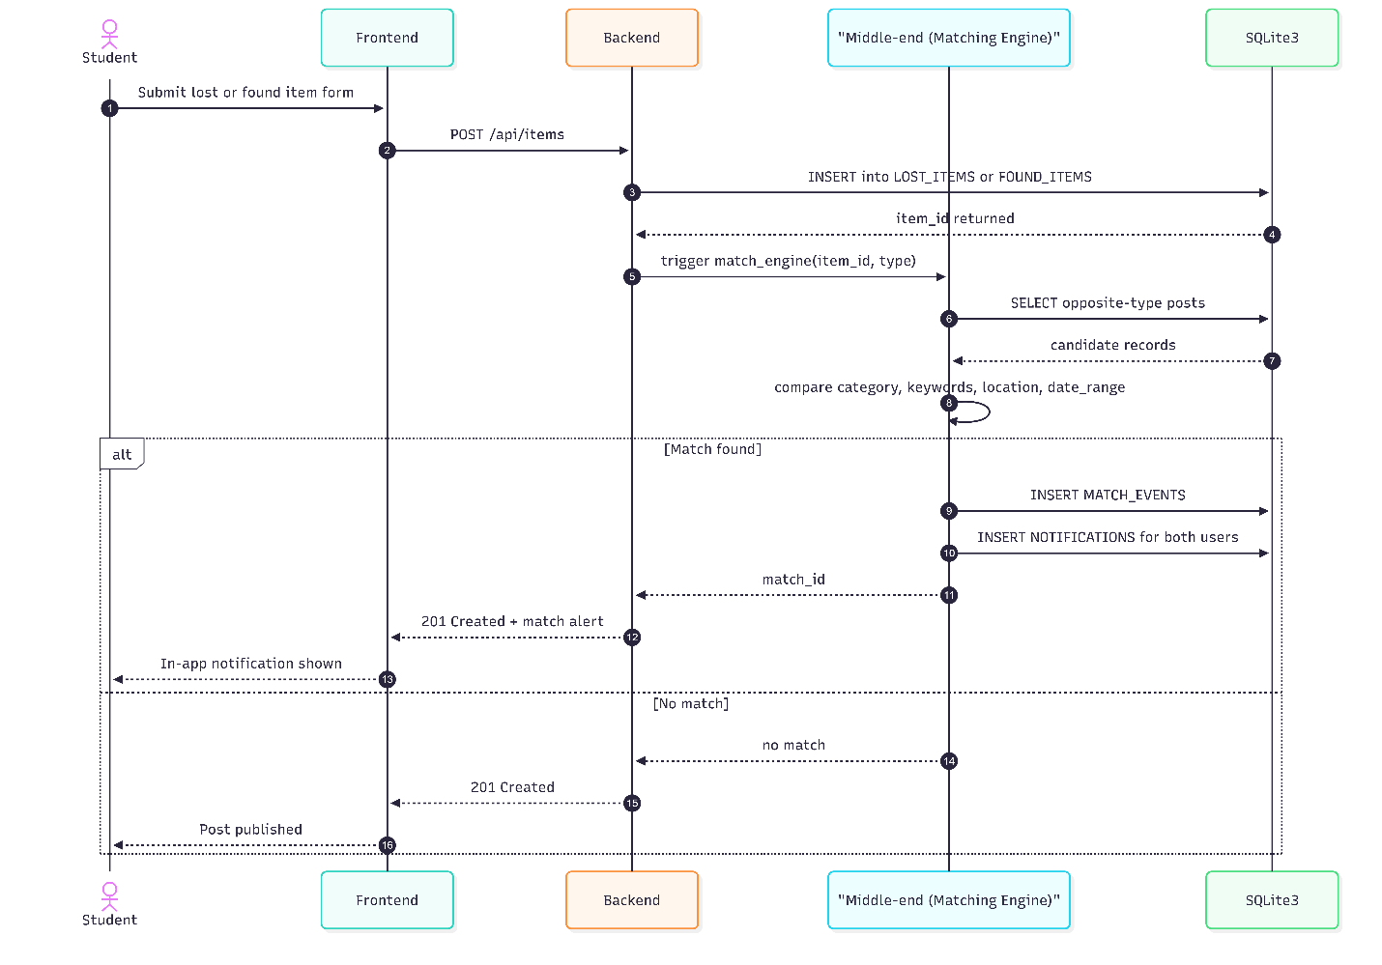

Class Diagram


- Data Model Schema
Five entities. Each described with fields and relationships.
- USERS: id (PK, uuid), name (string), email (string, unique), password_hash (string), role (enum: student / staff / admin), phone (string), profile_photo (string, nullable), created_at (timestamp). One user can have many lost item reports, many found item reports, and many notifications.
- LOST_ITEMS: id (PK, uuid), user_id (FK → USERS), item_name (string), category (string), description (text), last_known_location (string), date_lost (date), photo_url (string, nullable), status (enum: active / matched / recovered). Belongs to one user. Can participate in many match events.
- FOUND_ITEMS: id (PK, uuid), user_id (FK → USERS), item_name (string), category (string), description (text), location_found (string), date_found (date), photo_url (string, nullable), status (enum: active / matched / recovered). Belongs to one user. Can participate in many match events.
- MATCH_EVENTS: id (PK, uuid), lost_id (FK → LOST_ITEMS), found_id (FK → FOUND_ITEMS), score (float), matched_at (timestamp). Joins one lost item with one found item. Generates notifications.
- NOTIFICATIONS: id (PK, uuid), match_id (FK → MATCH_EVENTS), user_id (FK → USERS), is_read (boolean, default false), sent_at (timestamp). Belongs to one match event and one user.
ER Diagram

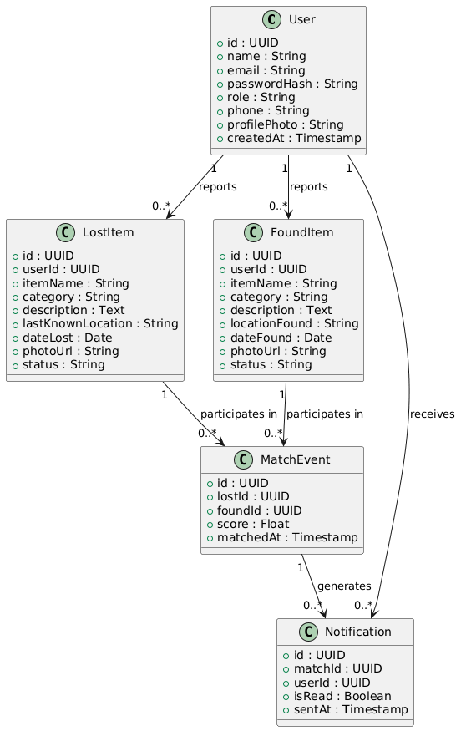
- User Interface
Design philosophy:
Mobile-first, browser-based, no app installation required. Interface mirrors a social media post flow so students need no instruction. Minimalist with no unnecessary elements. Core actions reachable within 3 taps from home screen. A first-time user can complete a lost item report in under 2 minutes.
Color scheme:
Not specified in the SRS. To be defined in development.
Font:
Not specified in the SRS. System-default sans-serif recommended for compatibility.
Screen constraints:
Responsive layout targeting mobile screen widths. Admin panel targets desktop/tablet.
Screens
Sign Up:
Shows registration form. Controls: text input for name, text input for email, password input, text input for phone number, file upload for profile photo (optional), submit button. Input constraints: email must be valid format, password must meet strength requirement, phone must be numeric.
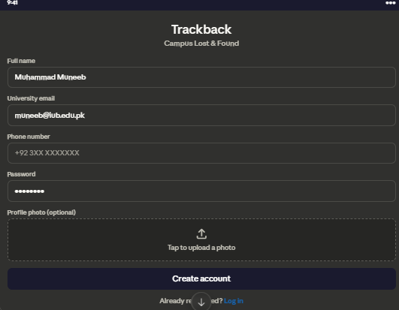
Login: Shows auth form. Controls: text input for email, password input, submit button. Input constraints: email must match a registered account.
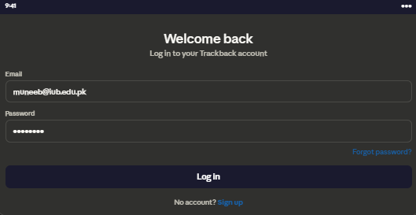

Home / Feed: Shows list of active found item posts. Controls: search bar, category filter dropdown, tap on item to view detail. Guests can view, cannot post.
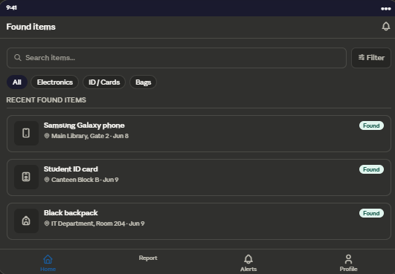
Report Lost Item: Shows empty report form. Controls: text input for item name, dropdown for category, text area for description, text input for last known location, date picker for date lost, file upload for photo (optional), submit button. Input constraints: item name and category are required, date cannot be in the future, photo must be an image file type.
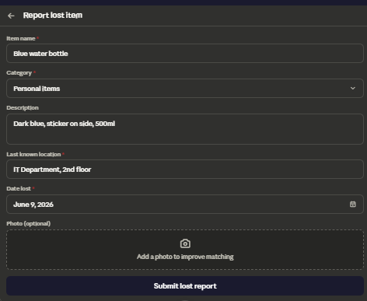
Report Found Item: Same structure as Report Lost Item with location found and date found replacing last known location and date lost. Photo strongly encouraged. Same input constraints apply.
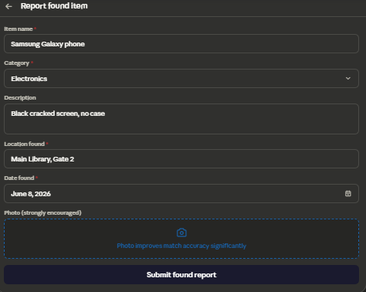
Notifications: Shows list of match alerts. Each alert displays the matched lost post and found post side by side. Controls: tap to expand, button to mark item as recovered.
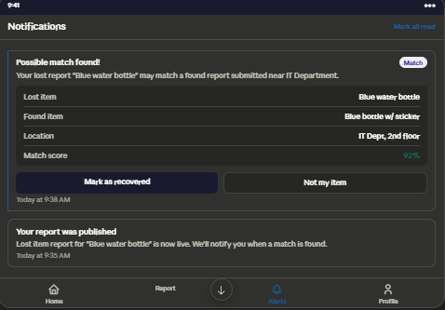
Admin Panel: Shows all posts, all users, match log, and activity stats. Controls: view post detail, remove post, disable user account, filter by date, filter by category. Accessible only to admin role.
