CLEAN UP BUG FIXES & RFQ NEW FEATURES FOR FRATEZONE TRACKER PLATFORM
Bug & Cleanup
- Outstanding customer support bug to be fixed
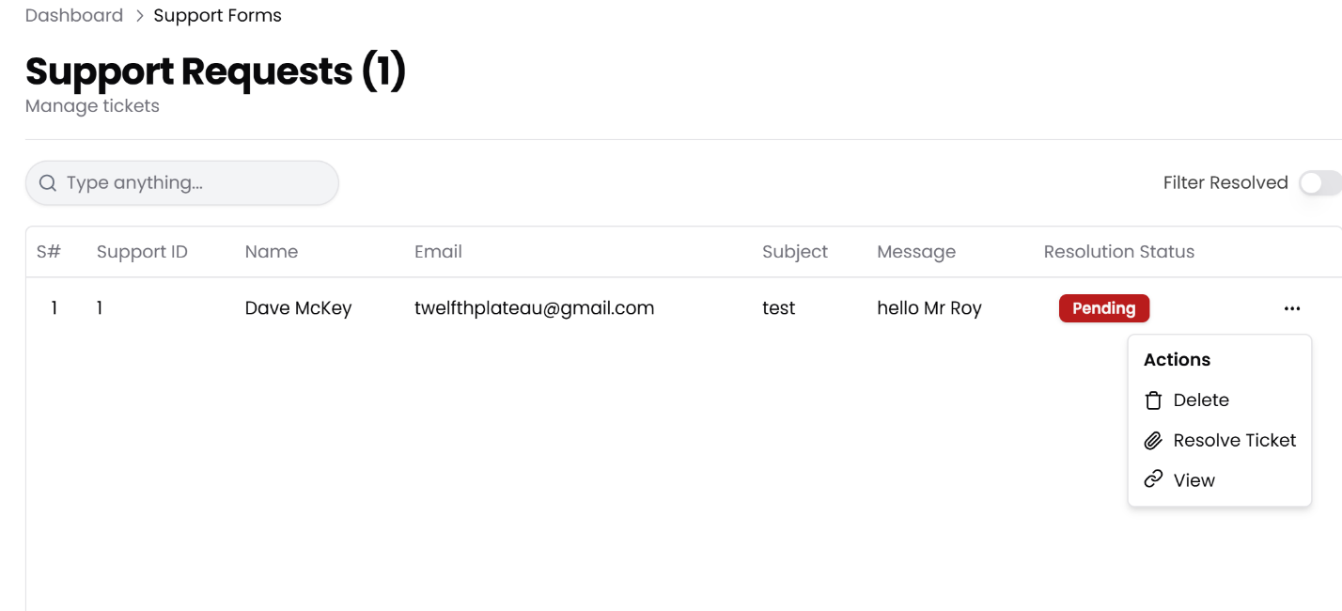

- Email notification - please remove all MAILINATOR.COM email addresses (fratezone.admin@mailinator.com and possibly others)
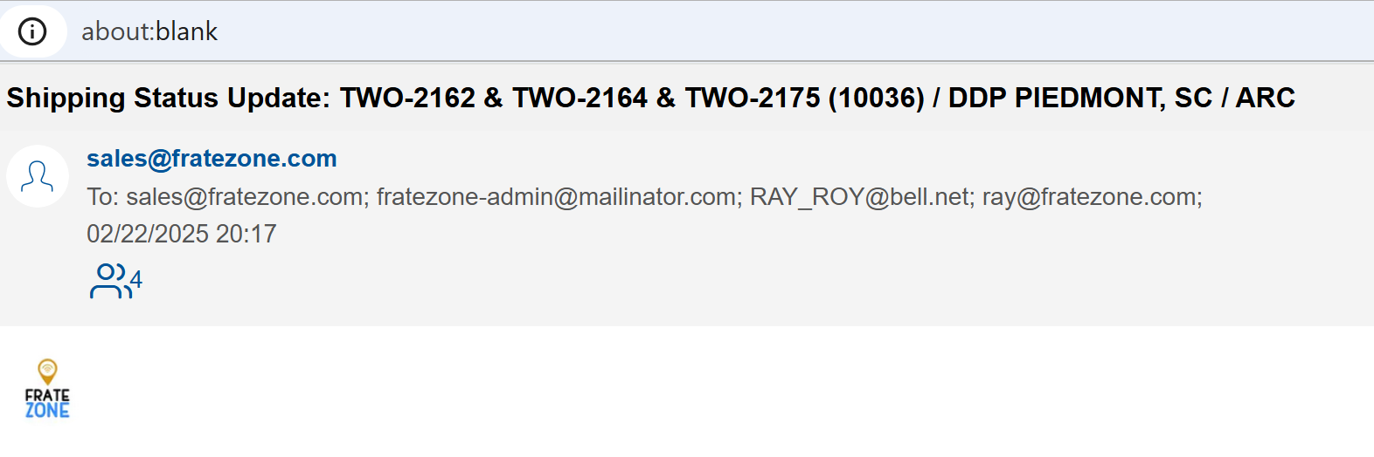

- Clean up Shipment Status Trigger points & Status Highlight Colours
- In Progress - black - waiting for initial API results after user enters new shipment to track
- Booked - grey - booked status starts when API comes back with results but NO green checkmarks (no confirmed activity with actual date)
- In Transit - blue - in transit status starts once the shipment shows it's first green checkmark (confirmed activity with an actual date)
- Discharged - yellow - when API reports a "DISCHARGED DATE" then this turn yellow
- Delivered - green - delivered status starts when someone manually enters a DELIVERY DATE (see feature below for MANUAL INPUT)
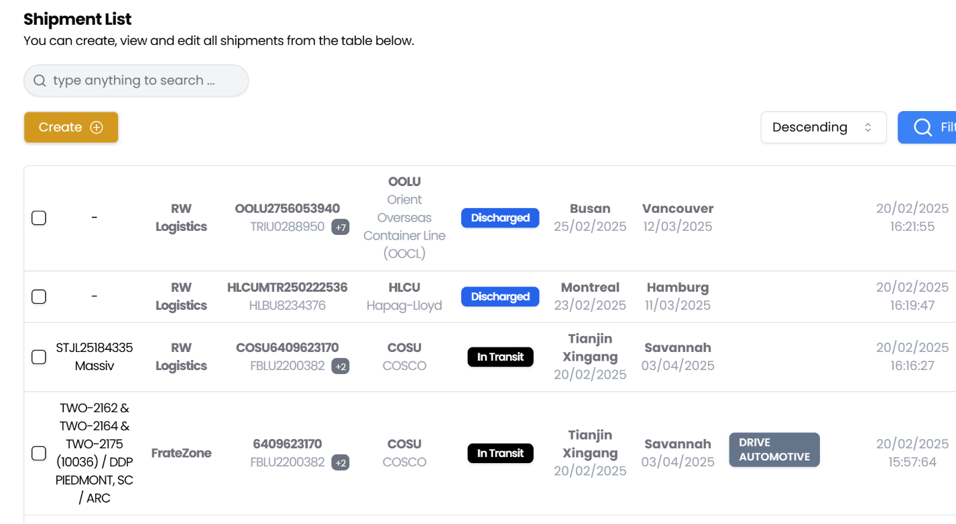

Please quote ...
- Add an option to allow user to manually input a DELIVERY DATE in the Milestone section and add the date in a new column the Container section (see screenshot below with the 5 KPI's)
- Add a dropdown for location list in the milestone (API events) - see screenshot
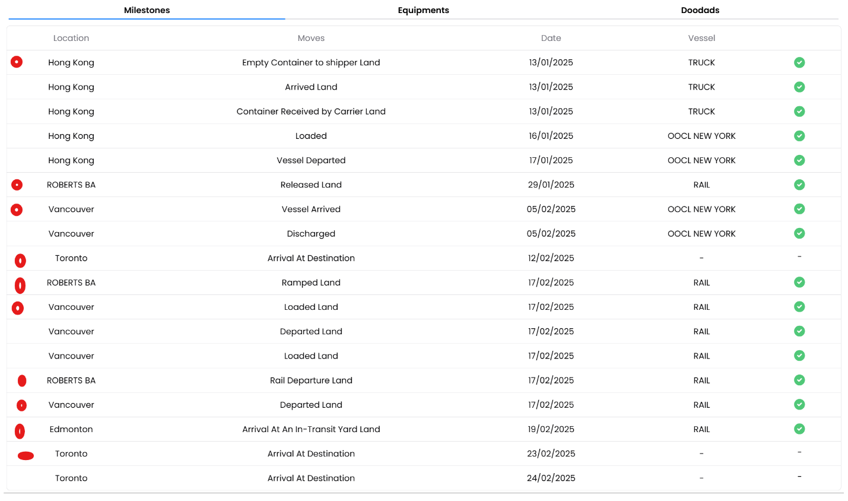

- Login screen needs a new look - see screenshot
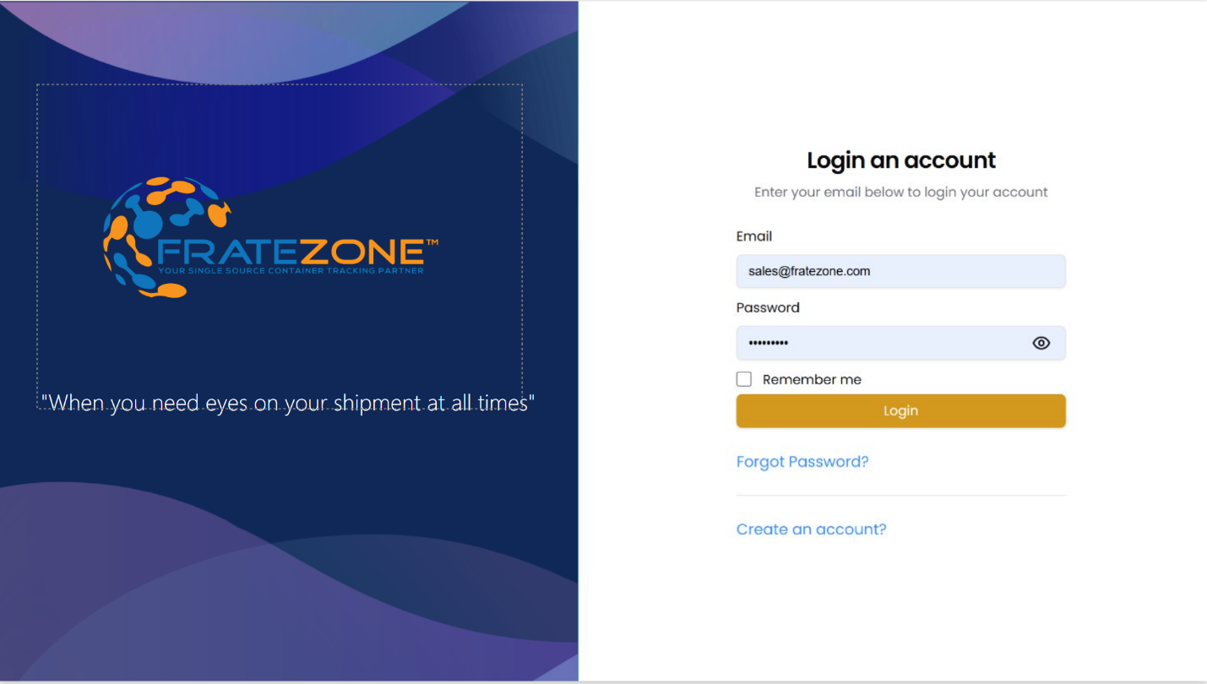

- Add a new option in the left menu called CHANGE LOG / UPDATES
Will need the following columns: DATE, TITLE, DESCRIPTION, EFFECTIVE DATE
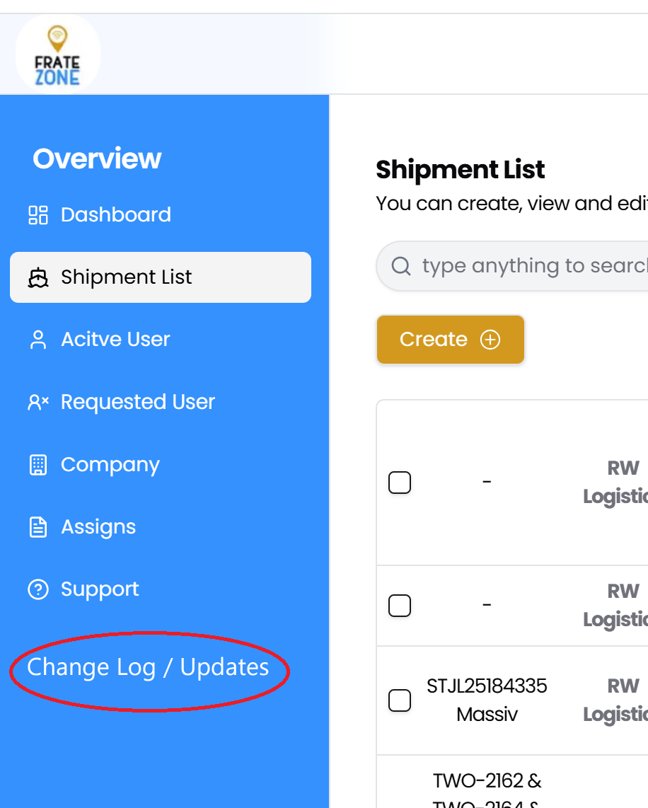

- Add 5 KPI's - see screenshot
KPI CALCAULATIONS
Port to Port: Vessel Arrival Date - Vessel Sailing Date + 1 day as the end date
Door to Door: Delivery Date - Empty to Shipper + 1 day as the end date
Empty-to-Shipper to Gate Out: Gate Out - Empty-to-Shipper + 1day as the end date
Empty-to-Shipper to Delivery Date: Delivery Date - Empty-to-Shipper + 1 day as end date
Gate Out to Empty Return: Empty return date - Gate Out date + 1 day as the end date
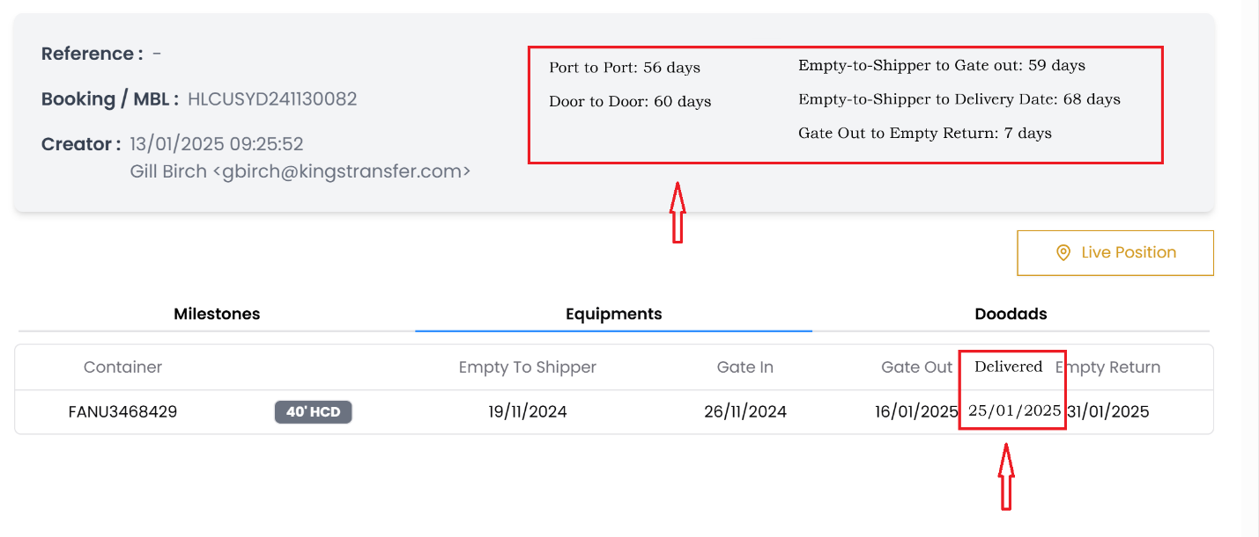

- Platform LOGO - please replace the old logo with the new logo (see attached AI file) - I can't open it but it should look like the PNG file below...


- Email notification - please replace the old logo with the new one.
