**HTML Structure**

* **Header Section**:
  + Contains a container-fluid with a row split into three columns.
  + The left column includes a menu button with an off-canvas sidebar. When clicked, the sidebar reveals navigation links like "Features," "About Us," and "Privacy Policy," as well as contact information (email, phone, and address). A close button is also provided in the sidebar.
  + The center column contains the main heading image for the site.
  + The right column displays a downloadable button for Apple's App Store.

**CSS Styling**

* **Background and Layout**:
  + Linear gradient background for the header and .section-1, creating a transition between two shades of blue.
  + Different styling properties are applied to elements for hover effects (e.g., sidebar menu items and buttons) and button sizes.
* **Sidebar Design**:
  + The sidebar is styled to appear from the left of the screen and is 1000px wide.
  + Specific text color and hover effects are defined for the sidebar menu items.
  + Email, phone, and address are displayed in the sidebar footer.
* **Responsive Design**:
  + Media queries control the layout of images and text across different screen sizes.
  + Elements like .image and .story shift positions or change opacity based on the screen's width.
* **Animations**:
  + The .mouse-icon is animated using a keyframe animation that moves it vertically.
  + Various elements (e.g., .image and .story) are hidden or shown based on the active class.
* **Grid and Lines**:
  + Sections like .outer-1, .outer-2, etc., are styled with specific heights, widths, and borders to create container grids.
  + A complex set of line elements (.line-1 to .line-13) are rotated at different angles to form a decorative design.

**Other Design Elements**

* Buttons styled for user interaction.
* Footer sections contain links and text with hover effects.
* Text sizes and font families are defined, with some sections using "Times New Roman."
* The document includes predefined elements that adjust based on device type and screen width, ensuring a responsive design.

This summary outlines the basic structure and design rules applied to this website's header, sidebar, and visual elements without delving into specific script functionality.

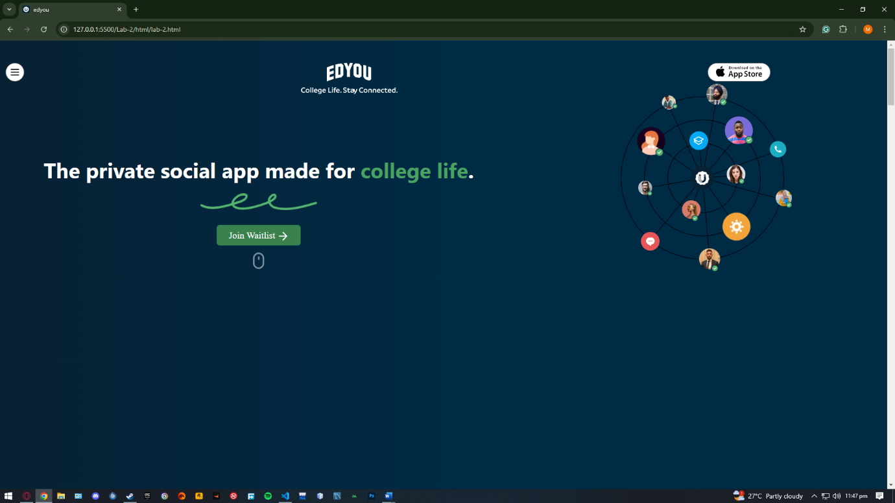

**Google Drive Link**: https://drive.google.com/drive/folders/1tK0O25hK0_1WUQWrU1xrOWUMHFj5pmbb?usp=drive_link