BrightMart Retail Warehouse Lab
Apache Airflow Orchestration Walkthrough for Windows, dbt Core, and Snowflake
Instructor-ready lab document and implementation guide
Version: 1.0 | Designed for the BrightMart SQLite -> Snowflake -> dbt Kimball warehouse case study
Teaching posture: start as a fresh dbt/Airflow developer, finish with production-style orchestration thinking.
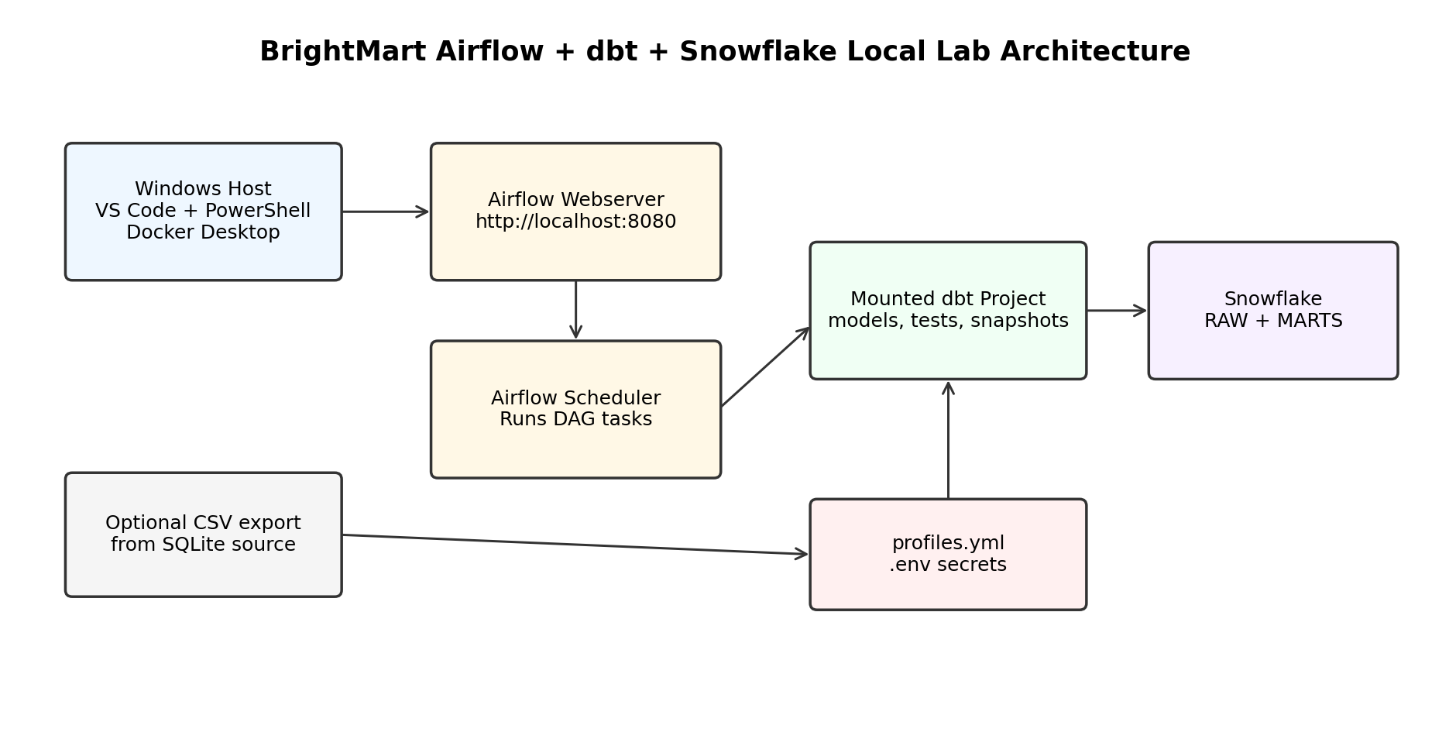

1. Purpose of This Final Lab Stage
The earlier BrightMart labs created a normalized SQLite retail source system, explored source data, designed a Kimball warehouse, loaded Snowflake RAW tables, and built a dbt project. This final stage adds orchestration with Apache Airflow. Students will learn how a data engineering team schedules, monitors, retries, and operationalizes the dbt warehouse pipeline.
- Understand the difference between transformation and orchestration.
- Run Airflow locally on Windows through Docker Desktop.
- Mount the BrightMart dbt project inside Airflow containers.
- Configure dbt credentials through profiles.yml and environment variables.
- Trigger dbt commands from Airflow DAG tasks.
- Monitor task logs, retries, failures, and DAG dependencies.
- Handle anomaly tests as a learning and production design topic.
- Package a local orchestration solution that students can run from VS Code.

2. Industry Context: Why Add Airflow?
dbt is responsible for transformation: SQL models, tests, snapshots, seeds, macros, documentation, and lineage. Airflow is responsible for orchestration: deciding when to run the work, in what order, with retries, logs, alerts, and dependency control. In industry, dbt and Airflow often work together: Airflow runs the data pipeline while dbt owns the warehouse transformation logic.
Tool | Main Responsibility | BrightMart Example
SQLite | Operational source simulation | Retail OLTP database with customers, products, sales, returns, inventory, and anomalies
Snowflake | Cloud data warehouse platform | RAW, STAGING, INTERMEDIATE, MARTS, and SNAPSHOTS schemas
dbt Core | Warehouse transformation and testing | Build staging models, dimensions, facts, snapshots, incremental facts, and tests
Apache Airflow | Pipeline orchestration | Schedule and monitor dbt debug, deps, run, test, snapshot, docs, and diagnostic tasks

3. Learning Outcomes
- Install and operate Airflow locally on Windows using Docker Compose.
- Explain Airflow concepts: DAG, task, operator, scheduler, webserver, metadata database, run, retry, schedule, catchup, and log.
- Explain how Airflow executes dbt commands through BashOperator.
- Configure secrets through .env and dbt profiles.yml without hard-coding credentials in DAGs.
- Run a beginner DAG and a full production-style DAG.
- Diagnose common failures: Docker not running, unhealthy containers, missing profiles.yml, Snowflake login failure, dbt model failure, failed tests, and DAG import errors.
- Design a classroom-to-industry progression: manual dbt commands first, then scheduled orchestration.

4. Prerequisites
Area | Requirement | Notes
Windows machine | Windows 10/11 recommended | Use PowerShell and VS Code terminal.
Docker Desktop | Installed and running | Use WSL2 backend. Allocate at least 4 GB RAM; 8 GB is better for smooth labs.
VS Code | Installed | Recommended extensions listed below.
Snowflake account | Database, warehouse, role, and user ready | Use the same BrightMart Snowflake environment from the previous setup document.
dbt project | BrightMart dbt project skeleton available | This package includes a copy under dbt/brightmart_retail.
Internet during setup | Needed for Docker image and pip dependencies | After the image is built, most work is local except Snowflake connectivity.

5. VS Code Extensions for This Orchestration Lab
Extension | Purpose in Lab
Python | Edit and validate Airflow DAG Python files.
Docker | Inspect containers, images, logs, and Compose services from VS Code.
YAML | Edit docker-compose.yml, profiles.yml, and dbt YAML files.
PowerShell | Run and edit Windows helper scripts.
Snowflake | Optional: query Snowflake objects directly from VS Code.
SQLite Viewer / SQLTools SQLite | Optional: revisit the original SQLite source database.
GitLens or Git Graph | Optional: teach source-control discipline.

6. Package Folder Structure
Open the package folder in VS Code. The folder is designed so students can see how a real local orchestration project is organized.
brightmart_airflow_orchestration_pack/
|-- BrightMart_Airflow_Orchestration_Walkthrough.docx
|-- README_AIRFLOW_PACKAGE.md
|-- docker-compose.yml
|-- Dockerfile
|-- requirements.txt
|-- .env.example
|-- .gitignore
|-- dags/
| |-- brightmart_simple_dbt_build.py
| |-- brightmart_full_dbt_orchestration.py
|-- dbt/
| |-- brightmart_retail/
| |-- dbt_project.yml
| |-- models/
| |-- snapshots/
| |-- seeds/
| |-- tests/
| |-- analyses/
| |-- macros/
|-- profiles/
| |-- profiles.yml
|-- scripts/
| |-- 00_prepare_folders.ps1
| |-- 01_build_and_start_airflow.ps1
| |-- 02_check_airflow.ps1
| |-- 03_run_dbt_debug_inside_airflow.ps1
| |-- 04_trigger_full_dag.ps1
| |-- 05_stop_airflow.ps1
| |-- 99_reset_airflow_lab.ps1
| |-- load_csv_to_snowflake.py
|-- sql/
| |-- 01_create_raw_tables.sql
| |-- 02_copy_into_raw_tables.sql
| |-- 03_quality_probe_queries.sql
|-- data/
| |-- exported_csv/
|-- diagrams/
|-- checklists/

7. Airflow Concepts Explained with BrightMart
Concept | Simple Explanation | BrightMart Lab Meaning
DAG | Directed Acyclic Graph: a workflow with tasks and dependencies. | The BrightMart DAG defines dbt tasks in the correct warehouse build order.
Task | One unit of work inside a DAG. | Run dbt debug, run staging models, run tests, run snapshots, generate docs.
Operator | A template for task behavior. | BashOperator runs dbt CLI commands inside the Airflow container.
Scheduler | Service that reads DAG files and schedules tasks. | Decides when the BrightMart DAG should run.
Webserver/UI | Browser interface for monitoring DAGs. | Students inspect DAG graph, grid, task logs, and status.
Metadata database | Stores DAG runs, task status, users, variables, and logs metadata. | Postgres service in Docker Compose.
Retry | Automatic re-run after temporary failure. | Useful for temporary Snowflake network or warehouse startup errors.
Catchup | Whether missed historical intervals are run. | Disabled in this lab to avoid many accidental backfills.
Schedule | When a DAG should run. | Simple DAG is manual; full DAG is daily.

8. Why Docker Desktop on Windows?
For Windows classrooms, Docker Desktop is the cleanest Airflow path because Airflow and many of its dependencies are Linux-oriented in practice. Docker gives every student the same environment: same Airflow version, same dbt version, same Python version, same folder mounts, and same commands. This avoids spending lab time debugging differences between local Python installations.
- Students still use VS Code on Windows.
- Airflow services run inside Linux containers.
- The dbt project folder is mounted into the containers.
- PowerShell scripts wrap the Docker Compose commands.
- Snowflake credentials are stored in .env, not in DAG code.

9. Step-by-Step Setup on Windows

9.1 Open the package in VS Code
# In PowerShell
cd C:\path\to\brightmart_airflow_orchestration_pack
code .

9.2 Prepare folders and create .env
.\scripts\00_prepare_folders.ps1

This creates required folders and copies .env.example to .env if .env does not already exist.

9.3 Fill Snowflake values in .env
DBT_SNOWFLAKE_ACCOUNT=your_account_identifier
DBT_SNOWFLAKE_USER=your_user_name
DBT_ENV_SECRET_SNOWFLAKE_PASSWORD=your_password
DBT_SNOWFLAKE_ROLE=TRANSFORMER
DBT_SNOWFLAKE_WAREHOUSE=BRIGHTMART_WH
DBT_SNOWFLAKE_DATABASE=BRIGHTMART_DB
DBT_SNOWFLAKE_SCHEMA=ANALYTICS

Do not commit .env to Git. It is already listed in .gitignore.

9.4 Build and start Airflow
.\scripts\01_build_and_start_airflow.ps1

This command builds the custom Airflow image, initializes the metadata database, creates the admin user, and starts webserver and scheduler containers.

9.5 Open Airflow UI
http://localhost:8080
Username: airflow
Password: airflow

9.6 Confirm containers are healthy
.\scripts\02_check_airflow.ps1

9.7 Confirm dbt can connect from inside Airflow
.\scripts\03_run_dbt_debug_inside_airflow.ps1

10. Configuration Files Explained

10.1 Dockerfile
The Dockerfile extends the Apache Airflow image and installs dbt plus the Snowflake connector. This is cleaner than installing Python packages at container startup because the image is built once and reused.
FROM apache/airflow:2.10.5-python3.11

ARG AIRFLOW_VERSION=2.10.5
COPY requirements.txt /requirements.txt

# Keep the Airflow package aligned with the base image while adding dbt and Snowflake tooling.
RUN pip install --no-cache-dir "apache-airflow==${AIRFLOW_VERSION}" -r /requirements.txt

10.2 requirements.txt
The requirements file pins the dbt/Snowflake packages used by the lab. Pinning versions makes classroom delivery more repeatable.
dbt-core==1.9.4
dbt-snowflake==1.9.2
snowflake-connector-python==3.12.4

10.3 docker-compose.yml
The compose file runs three main services: Postgres metadata database, Airflow webserver, and Airflow scheduler. It uses LocalExecutor for classroom simplicity. The dbt project, profiles, scripts, SQL, and data folders are mounted inside the Airflow container.
Important mapped paths:
./dags -> /opt/airflow/dags
./dbt -> /opt/airflow/dbt
./profiles -> /opt/airflow/profiles
./scripts -> /opt/airflow/scripts
./sql -> /opt/airflow/sql
./data -> /opt/airflow/data

10.4 profiles/profiles.yml
The dbt profile reads Snowflake values from environment variables. This keeps credentials out of the dbt project and out of Airflow DAG files.
brightmart_retail:
target: "{{ env_var('DBT_TARGET', 'dev') }}"
outputs:
dev:
type: snowflake
account: "{{ env_var('DBT_SNOWFLAKE_ACCOUNT') }}"
user: "{{ env_var('DBT_SNOWFLAKE_USER') }}"
password: "{{ env_var('DBT_ENV_SECRET_SNOWFLAKE_PASSWORD') }}"
role: "{{ env_var('DBT_SNOWFLAKE_ROLE') }}"
database: "{{ env_var('DBT_SNOWFLAKE_DATABASE') }}"
warehouse: "{{ env_var('DBT_SNOWFLAKE_WAREHOUSE') }}"
schema: "{{ env_var('DBT_SNOWFLAKE_SCHEMA') }}"
threads: 4
client_session_keep_alive: false
query_tag: "brightmart_airflow_dbt_lab"

11. DAG 1: Beginner dbt Build DAG
This DAG is designed for first exposure. It has a simple chain: debug, deps, build, docs generate.
Task | Command | Why it matters
dbt_debug | dbt debug | Confirms Snowflake connection and profile configuration.
dbt_deps | dbt deps | Installs packages from packages.yml, such as dbt_utils.
dbt_build | dbt build | Runs seeds, snapshots, models, and tests in dependency order.
dbt_docs_generate | dbt docs generate | Creates manifest and catalog files for documentation.

# Trigger from Airflow UI:
DAGs -> brightmart_simple_dbt_build -> Trigger DAG

# Or trigger from PowerShell:
docker compose exec airflow-scheduler airflow dags trigger brightmart_simple_dbt_build

12. DAG 2: Full BrightMart dbt Orchestration DAG
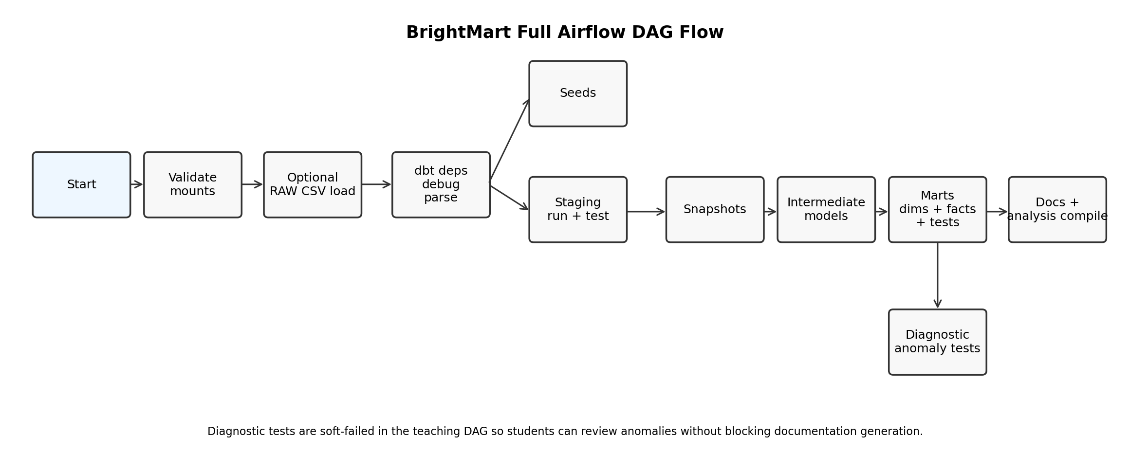
The full DAG teaches the proper operational sequence. It separates layers so students can see exactly where a failure occurs.
Stage | Airflow Task/Group | dbt or Script Action
Preflight | validate_container_mounts | Confirms dbt project and profiles.yml are mounted correctly.
Optional Load | optional_load_raw_csv_to_snowflake | Loads exported CSV files to Snowflake RAW only when enabled.
Dependency Setup | dbt_deps | Installs dbt packages.
Connection Check | dbt_debug | Checks Snowflake connection.
Parse Check | dbt_parse | Validates project syntax and model graph.
Seeds | dbt_seed | Loads seed CSVs such as normalization/rule catalogs.
Staging | run_staging_models + test_staging_models | Builds and validates source-cleaning views.
Snapshots | run_snapshots | Tracks changing customer/product attributes.
Intermediate | run_intermediate_models | Builds reusable joins and business logic.
Marts | run_dimension_models + run_fact_models + test_mart_models | Builds Kimball dimensions/facts and validates them.
Diagnostics | run_diagnostic_tests_soft_fail | Runs anomaly tests without blocking the learning DAG.
Docs | compile_analysis_sql + generate_dbt_docs | Compiles analytical SQL and generates dbt docs artifacts.

13. How to Run the Full DAG
# Option 1: From Airflow UI
DAGs -> brightmart_full_dbt_orchestration -> Trigger DAG

# Option 2: From PowerShell
.\scripts\04_trigger_full_dag.ps1

14. How to Read Airflow Logs Like a Data Engineer
- Open the DAG run in Grid view.
- Click a task box.
- Click Logs.
- Find the exact dbt command printed at the top of the task.
- Scroll to the first error, not only the final error.
- For dbt failures, check whether the issue is connection, compilation, model SQL, test failure, or missing dependency.
- For Snowflake failures, check role, warehouse, database, schema, and grants.
- For package failures, rebuild the image or run dbt deps again.
Log Symptom | Likely Cause | Action
No module named dbt | Custom image not built or wrong image running | Run docker compose build, then restart containers.
Could not find profile named brightmart_retail | profiles.yml missing or profile name mismatch | Check profiles/profiles.yml and dbt_project.yml profile value.
Env var required but not provided | .env missing Snowflake variable | Fill .env and restart containers.
Incorrect username or password | Snowflake credentials wrong | Verify user/password and account identifier.
Object does not exist or not authorized | Role/grant/schema mismatch | Check Snowflake role, warehouse, database, RAW schema, and MART schemas.
Compilation Error | Jinja, ref/source, YAML, macro, or syntax issue | Run dbt parse and inspect compiled error.
Test failed | Data quality rule violation | Open dbt test log and inspect failing rows.

15. Anomaly and Test Case Handling in Airflow
The BrightMart source database intentionally contains anomalies. In a beginner lab, this is valuable because students learn to detect and explain issues. In production, some tests should hard-fail the pipeline, while others should be diagnostic alerts.
Test Type | Example | Recommended Airflow Behavior
Hard-fail structural test | unique, not_null, relationships on mart keys | Fail the DAG because warehouse integrity is broken.
Accepted values test | payment method or order status domain | Usually fail the DAG unless unknown values are intentionally captured.
Reconciliation test | Order header total equals sum of line totals | Fail or quarantine depending on business tolerance.
Diagnostic anomaly test | Invalid email, negative discount, quantity <= 0 | In this teaching DAG, soft-fail and review logs; in production, route to exception table or fail.
Freshness check | RAW sales_orders updated within expected interval | Fail or warn depending on SLA.

16. Optional RAW CSV Loading from Airflow
The recommended classroom sequence is to load Snowflake RAW tables manually first, then use Airflow to orchestrate dbt. However, the package also includes an optional CSV loader to show how ingestion can be placed before transformation.
# To enable optional raw CSV loading:
# 1. Export SQLite tables to CSV using the previous dbt package script.
# 2. Copy CSV files into data/exported_csv.
# 3. Set this in .env:
LOAD_RAW_FROM_CSV=true
LOAD_MODE=replace

# The DAG task optional_load_raw_csv_to_snowflake will then run:
python /opt/airflow/scripts/load_csv_to_snowflake.py

For production, prefer a managed loading approach such as external stages, Snowpipe, cloud object storage, or a dedicated ingestion tool. The included loader is a teaching aid.

17. Student Walkthrough: Fresh Developer to Professional Thinking
Level | What Student Does | Professional Concept Learned
Beginner | Starts Airflow and opens UI | Orchestration needs services: scheduler, webserver, metadata database.
Beginner | Runs dbt debug task | Operational pipelines need connection validation.
Beginner | Runs simple dbt build DAG | One command can execute a dbt project, but logs are still task-level.
Intermediate | Runs full DAG with separated layers | Layered failure isolation: staging vs marts vs tests.
Intermediate | Reviews diagnostic test logs | Data quality must be visible and traceable.
Advanced | Explains soft-fail vs hard-fail tests | Production pipelines use severity, SLA, and exception handling.
Advanced | Changes schedule and retry policy | Operational SLAs require scheduling and resilience.
Advanced | Explains secret management concerns | Credentials must not be stored in code or Git.

18. Lab Delivery Plan: 3 to 4 Hours
Time | Activity | Instructor Focus
0:00-0:20 | Explain orchestration vs transformation | Airflow does not replace dbt; it schedules and monitors dbt.
0:20-0:50 | Folder structure and configuration | Dockerfile, compose, .env, profiles.yml, dags.
0:50-1:20 | Build/start Airflow | PowerShell scripts, Docker containers, UI login.
1:20-1:50 | Run dbt debug from Airflow container | Profiles, env vars, Snowflake connectivity.
1:50-2:30 | Trigger simple DAG | Observe task logs and dependencies.
2:30-3:15 | Trigger full DAG | Layered orchestration and failures.
3:15-3:45 | Discuss anomaly tests | What should fail, warn, quarantine, or alert?
3:45-4:00 | Student deliverables | Screenshots and explanation.

19. Student Deliverables
- Screenshot of Docker Desktop or docker compose ps showing Airflow containers.
- Screenshot of Airflow UI with both BrightMart DAGs visible.
- Screenshot of successful dbt_debug task log.
- Screenshot of simple DAG run status.
- Screenshot of full DAG graph or grid view.
- Screenshot or written explanation of diagnostic anomaly test behavior.
- One paragraph explaining the difference between dbt and Airflow.
- One paragraph explaining why credentials should be stored in .env/profiles.yml and not in DAG files.
- One proposed production improvement: alerting, external stage loading, Slack/email notifications, Airflow connections, or CI/CD.

20. Instructor Marking Rubric
Component | Marks
Docker Desktop and Airflow setup evidence | 15
Correct .env and profiles.yml configuration understanding | 10
Successful dbt debug from Airflow container | 15
Successful simple DAG execution | 15
Full DAG execution and log interpretation | 20
Anomaly/test-case explanation | 15
Professional improvement suggestion | 10
Total | 100

21. Production Discussion: How This Would Change in Industry
Classroom Lab | Production Direction
Local Docker Compose | Managed Airflow, Astronomer, MWAA, Cloud Composer, Kubernetes, or enterprise Airflow.
.env file for secrets | Secret manager, Airflow connections, Vault, cloud secret store, or CI/CD secret variables.
LocalExecutor | Celery/Kubernetes executor or managed equivalent.
Manual trigger and daily schedule | SLA-based schedules, event-driven triggers, datasets, or upstream sensors.
Soft-failed diagnostics | Clear severity model: fail, warn, quarantine, alert, and incident escalation.
Local docs artifact | Published documentation site or object-store artifact.
Manual package refresh | CI/CD pipeline, branch protections, code review, and automated testing.

22. Troubleshooting Appendix
Problem | Command / Check | Fix
Airflow UI does not open | docker compose ps | Wait for health checks, check port 8080, restart Docker Desktop.
Webserver container restarting | docker compose logs airflow-webserver | Allocate more RAM to Docker; rebuild image if package install failed.
Scheduler not detecting DAG | docker compose logs airflow-scheduler | Check Python syntax/import errors in dags folder.
dbt not installed in container | docker compose exec airflow-scheduler dbt --version | Run docker compose build and restart.
Snowflake connection fails | dbt debug log | Fix .env variables and Snowflake grants. Restart containers after .env changes.
dbt packages missing | dbt deps task log | Check packages.yml and internet access.
Tests fail | dbt test task log | Inspect failing rows; decide whether cleaning, accepted values, or exception handling is needed.
Need clean restart | .\scripts\99_reset_airflow_lab.ps1 | Reset only after saving screenshots and logs if needed.

23. Useful Commands Cheat Sheet
# Build custom image
docker compose build

# Initialize Airflow metadata DB and admin user
docker compose up airflow-init

# Start Airflow services
docker compose up -d

# Stop Airflow services but keep metadata volume
docker compose down

# Destroy and reset local Airflow metadata volume
docker compose down --volumes --remove-orphans

# View container status
docker compose ps

# View scheduler logs
docker compose logs --tail=100 airflow-scheduler

# Open a shell inside scheduler container
docker compose exec airflow-scheduler bash

# Run dbt debug inside container
cd /opt/airflow/dbt/brightmart_retail
dbt debug --profiles-dir /opt/airflow/profiles --target dev

# Trigger a DAG from CLI
airflow dags trigger brightmart_full_dbt_orchestration

24. References Used for This Walkthrough
Apache Airflow official documentation: Running Airflow in Docker, Docker Compose quick-start, local learning caveats, Docker memory recommendation, and custom image guidance.
dbt official documentation: command reference, profiles.yml configuration, and environment variable handling.
Snowflake and dbt integration references from the earlier BrightMart setup material.

25. Material Inventory Included in the ZIP
File / Folder | Purpose
BrightMart_Airflow_Orchestration_Walkthrough.docx | Main instructor walkthrough document.
docker-compose.yml | Runs Airflow webserver, scheduler, and Postgres metadata database.
Dockerfile | Builds custom Airflow image with dbt and Snowflake packages.
requirements.txt | Python package pins.
.env.example | Template for Airflow and Snowflake variables.
profiles/profiles.yml | dbt profile for Snowflake using env vars.
dags/brightmart_simple_dbt_build.py | Beginner DAG.
dags/brightmart_full_dbt_orchestration.py | Full orchestration DAG.
scripts/*.ps1 | Windows helper scripts for setup, start, check, trigger, stop, reset.
scripts/load_csv_to_snowflake.py | Optional raw CSV loader.
dbt/brightmart_retail | BrightMart dbt project skeleton.
sql/*.sql | Snowflake RAW DDL and quality probe SQL files.
checklists/*.md | Student and instructor operational checklists.
diagrams/*.png | Architecture and DAG flow diagrams.

