Submitted By:
Name: Muneeb nawaz
Sap ID: 66134
Class / Section: BSAI_3_1
Subject: Coal
Date of Submission:
9 September 2025

Institution Name:
Riphah International University Islamabad
Question # 1
dosseg
.model
.stack 100h
.data
.code
Main proc
mov cx,10
mov dx,48
L1:
mov ah,2
int 21h
add dx,1
Loop L1
mov ah,4ch
int 21h
main endp
end main

Output
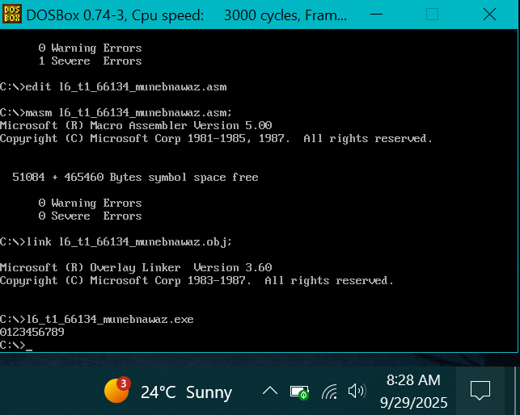

Question # 2
dosseg
.model small
.stack 100h
.data
.code
main proc
mov cx,10 ; 10 numbers print karne hain
mov dx,57 ; ASCII '9' = 57

L1:
mov ah,2 ; DOS service: display character
int 21h
sub dx,1 ; har step par ek kam karo
loop L1

mov ah,4ch ; exit to DOS
int 21h
main endp
end main
Output
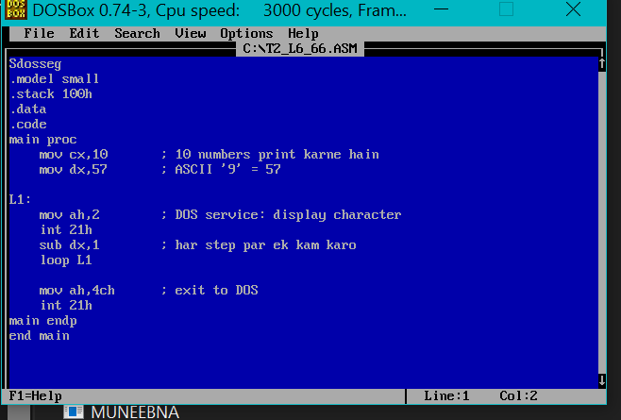
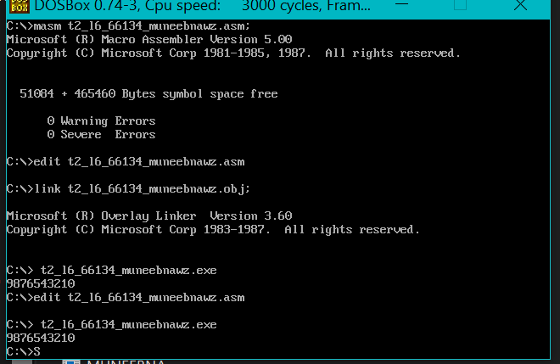
Question # 3
dosseg
.model small
.stack 100h
.data
.code
main proc
mov cx,26 ; 26 small alphabets
mov dx,97 ; ASCII 'a' = 97

L1:
mov ah,2 ; DOS function: display character
int 21h
add dx,1 ; next alphabet
loop L1

mov ah,4ch ; exit program
int 21h
main endp
end main
Output
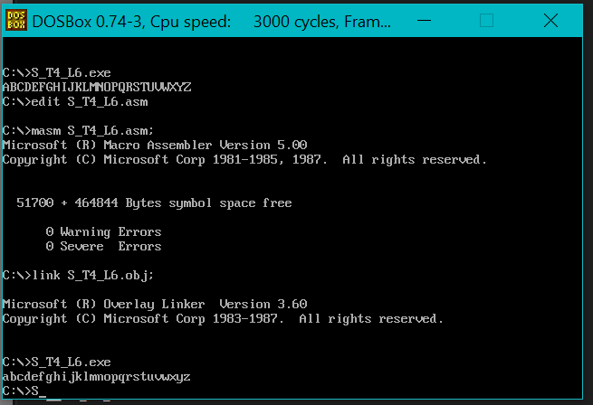
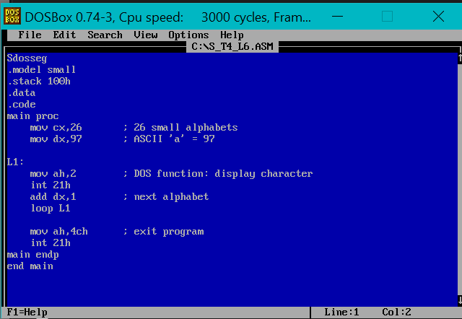
Question # 4
dosseg
.model small
.stack 100h
.data
.code
main proc
mov cx,26 ; 26 alphabets
mov dx,65 ; ASCII 'A' = 65

L1:
mov ah,2 ; DOS function: display character
int 21h
add dx,1 ; next character
loop L1

mov ah,4ch ; exit to DOS
int 21h
main endp
end main
Output
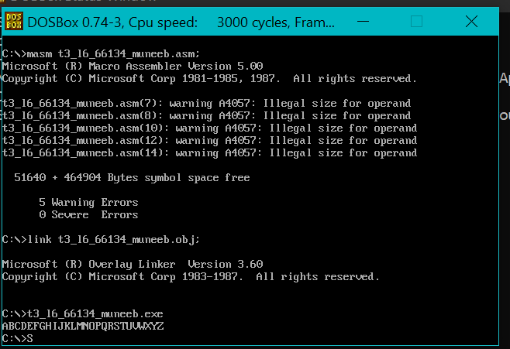
Question # 5
dosseg
.model small
.stack 100h
.data
.code
main proc
; Print A to Z
mov cx,26 ; total 26 letters
mov dx,65 ; ASCII of 'A'

CAP_LOOP:
mov ah,2 ; print character
int 21h
add dx,1 ; next letter
loop CAP_LOOP

; Go to new line
mov ah,2
mov dl,13 ; carriage return
int 21h
mov dl,10 ; line feed
int 21h

; Print a to z
mov cx,26 ; total 26 letters
mov dx,97 ; ASCII of 'a'

SMALL_LOOP:
mov ah,2 ; print character
int 21h
add dx,1 ; next letter
loop SMALL_LOOP

; Exit program
mov ah,4ch
int 21h
main endp
end main
Output
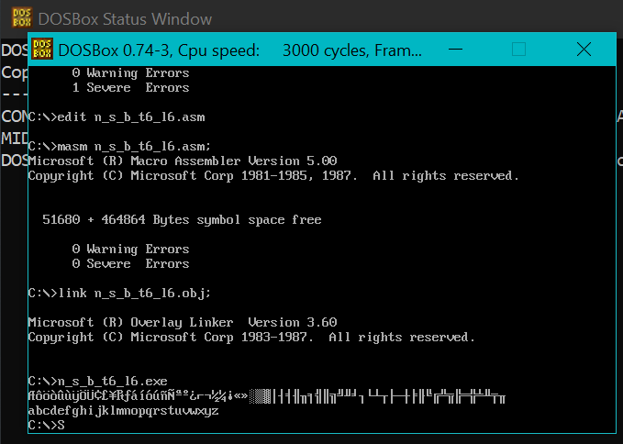

Question # 6
dosseg
.model small
.stack 100h
.data
msgEven db ' is Even$'
msgOdd db ' is Odd$'
msgAsk db 'Enter a number (0-9): $'

.code
main proc
mov ax, @data
mov ds, ax

; Ask user
mov dx, offset msgAsk
mov ah, 9
int 21h

; take input (single digit 0–9)
mov ah, 1
int 21h
sub al, 30h ; convert ASCII to number
mov bl, al ; store number
; print number again
mov dl, bl
add dl, 30h ; convert to ASCII
mov ah, 2
int 21h

; check even/odd
mov al, bl
and al, 1
jz print_even ; if zero → even

print_odd:
mov dx, offset msgOdd
mov ah, 9
int 21h
jmp done

print_even:
mov dx, offset msgEven
mov ah, 9
int 21h

done:
; exit
mov ah, 4Ch
int 21h
main endp
end main
Output
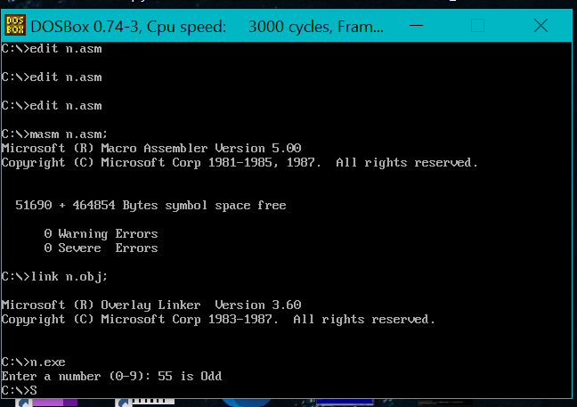
Question # 7
.model small
.stack 100h

.data
evenMsg db 'Even$'
oddMsg db 'Odd$'

.code
main:
mov ax, @data
mov ds, ax

; Read a character from the user
mov ah, 1 ; Function to read character
int 21h ; Result in AL (ASCII of character)

sub al, '0' ; Convert ASCII to digit
mov ah, 0 ; Clear AH before division (AX = number)
mov bl, 2
div bl ; AL / BL, remainder in AH

cmp ah, 0 ; If remainder is 0, number is even
je even

odd:
mov ah, 9
lea dx, oddMsg
int 21h
jmp exit

even:
mov ah, 9
lea dx, evenMsg
int 21h

exit:
mov ah, 4Ch
int 21h
end main
Output
