NAME MUNEEB NAWAZ
SAPID 66134
Coal lab7

Question # 1
org 100h ; starting point of .com program

mov ax, 5 ; load 5 into AX
mov bx, 2 ; load 2 into BX
mov cx, ax ; copy AX into CX
jmp calculate ; jump to calculate section

modify:
sub ax, bx ; subtract BX from AX
mov dx, ax ; copy result to DX
jmp finish ; jump to finish

calculate:
add ax, bx ; add BX to AX
jmp modify ; jump to modify section

finish:
ret ; return to DOS
What is happening in this code?
In this assembly code, we are performing simple arithmetic operations using registers. First, the program loads the values 5 and 2 into the AX and BX registers. Then, it jumps to the "calculate" section, where it adds AX and BX. After that, the program jumps to the "modify" section, subtracts BX from AX, and stores the final result (5) in the DX register. Finally, the program ends using the RET instruction.

Output

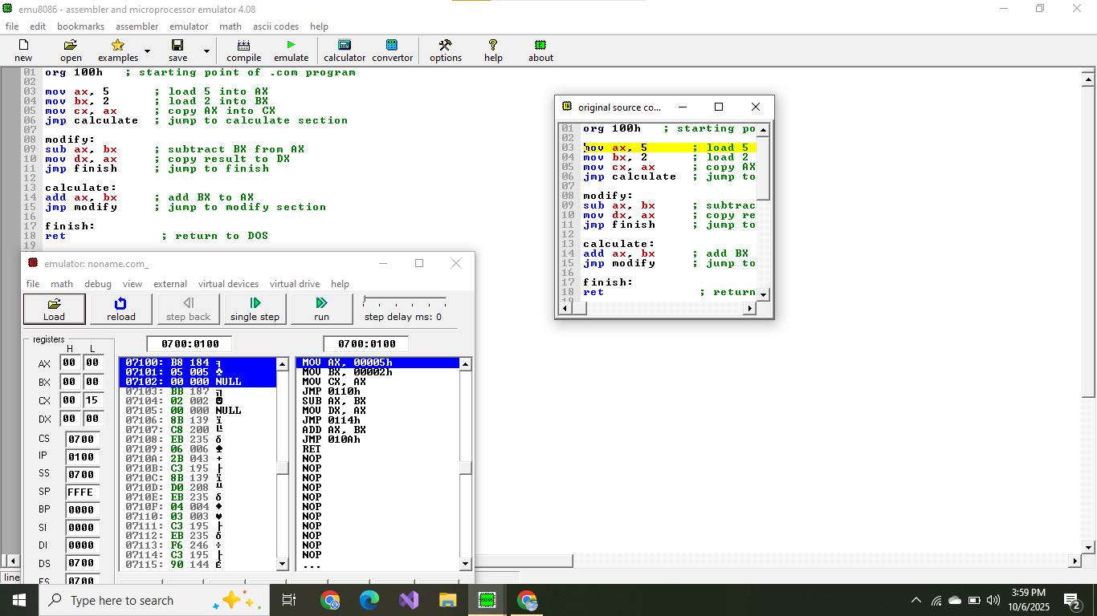
Question # 2
org 100h

mov ax, 0 ; start with AX = 0
mov bx, 8 ; BX = 8 (limit value)
mov cx, 1 ; CX = 1 (will store sum)
jmp loop_start ; jump to loop_start label

increment:
inc ax ; increase AX by 1
add cx, ax ; add AX to CX

loop_start:
cmp ax, bx ; compare AX and BX
jl increment ; jump to increment if AX < BX

ret ; end program
what is happening in this code?
In this program, we start with AX = 0 and BX = 8. The loop keeps increasing AX by 1 each time and adds it to CX. This means CX stores the total sum of all numbers from 1 to 8. When AX becomes equal to BX (8), the program stops, and CX holds the final result 37.
Output
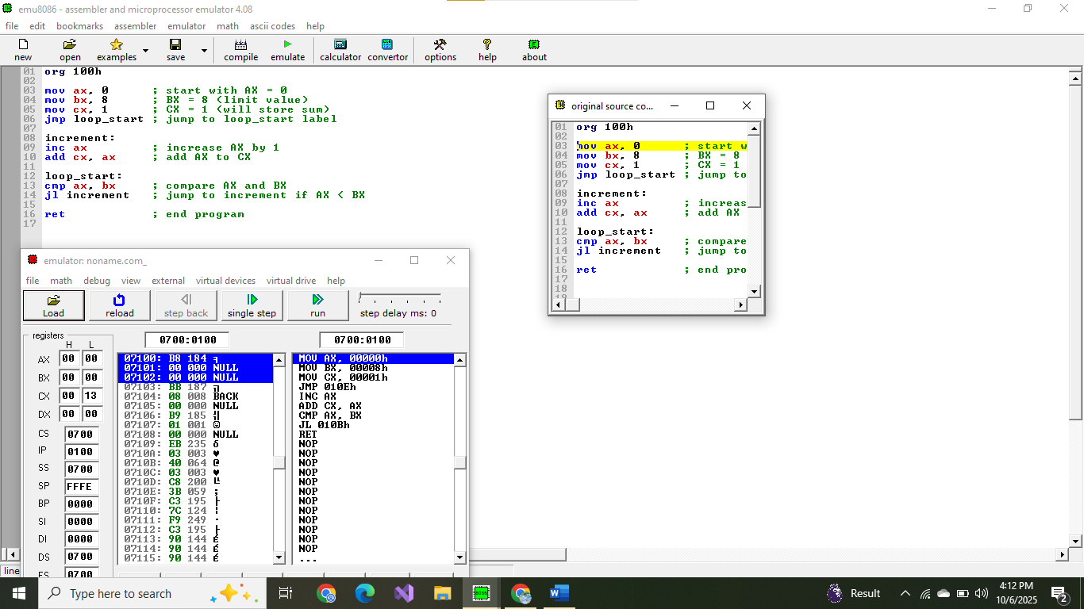
Question # 3
org 100h

mov ax, 10 ; Dividend = 10
mov bx, 3 ; Divisor = 3
mov dx, 0 ; Initialize DX = 0 (will count quotient)
jmp division ; Jump to division process

done:
mov cx, ax ; Store remainder in CX
mov ax, dx ; Move quotient into AX
jmp end_program ; Jump to end

division:
sub ax, bx ; Subtract divisor from dividend
inc dx ; Increase quotient count
cmp ax, bx ; Compare remainder with divisor
jge division ; If remainder >= divisor, continue loop
jmp done ; Otherwise, go to done

end_program:
ret ; End of program
what is hapning is this code?
In this assembly program, we are performing division of 10 by 3 using repeated subtraction. Each time the divisor (3) is subtracted from the dividend (10), the quotient counter (DX) increases by 1. When AX becomes smaller than BX, the loop stops. The quotient (3) is stored in AX, and the remainder (1) is stored in CX.
Output
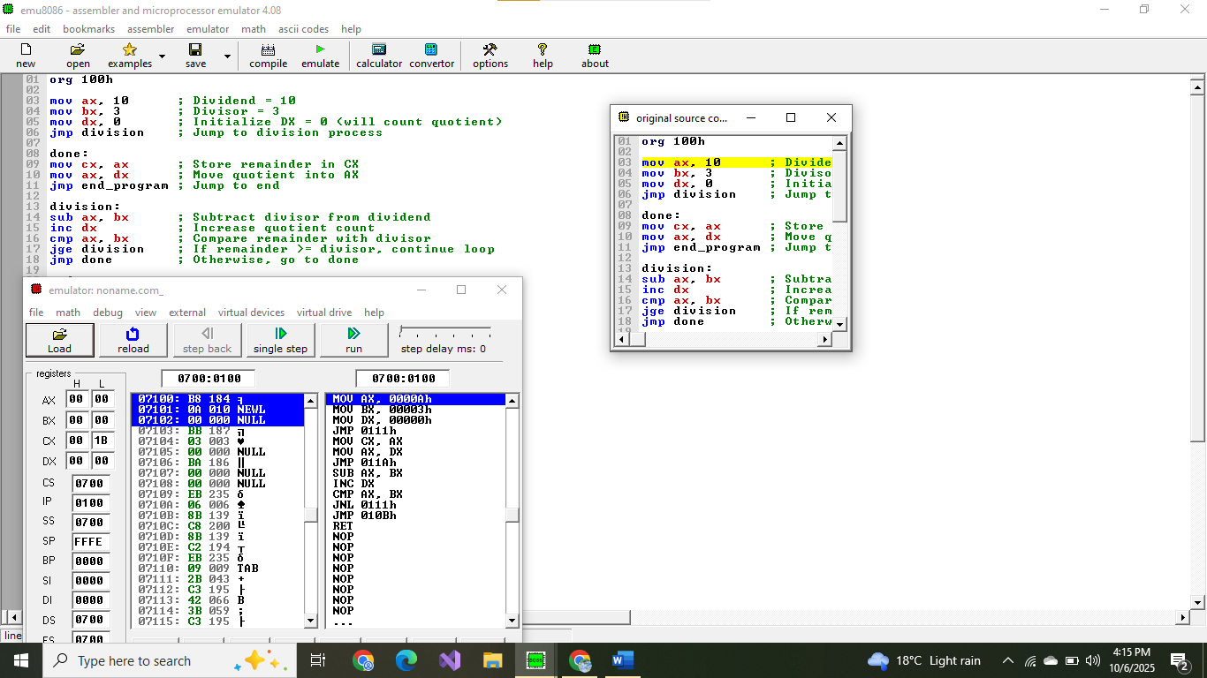
Question # 4
org 100h

mov ax, 0FFFFh ; Load AX with FFFFh (65535 in decimal)
mov bx, 1 ; Load BX with 1
mov cx, 5 ; CX = 5 (loop counter)
jmp shift_loop ; Jump to the shift loop

exit:
mov dx, ax ; Copy final AX value into DX
ret ; End program

shift_loop:
add ax, ax ; Shift left by adding AX to itself
add bx, bx ; Shift left BX too
dec cx ; Decrease counter
jnz shift_loop ; Jump again if CX != 0
jmp exit ; Exit loop
What is happening in this code?
In this program, we start with AX = FFFFh and BX = 1. The loop doubles both AX and BX five times, which is the same as shifting their bits left by five positions. Each addition doubles the value stored in the registers. Finally, the result from AX is stored in DX, and the program ends.

Output
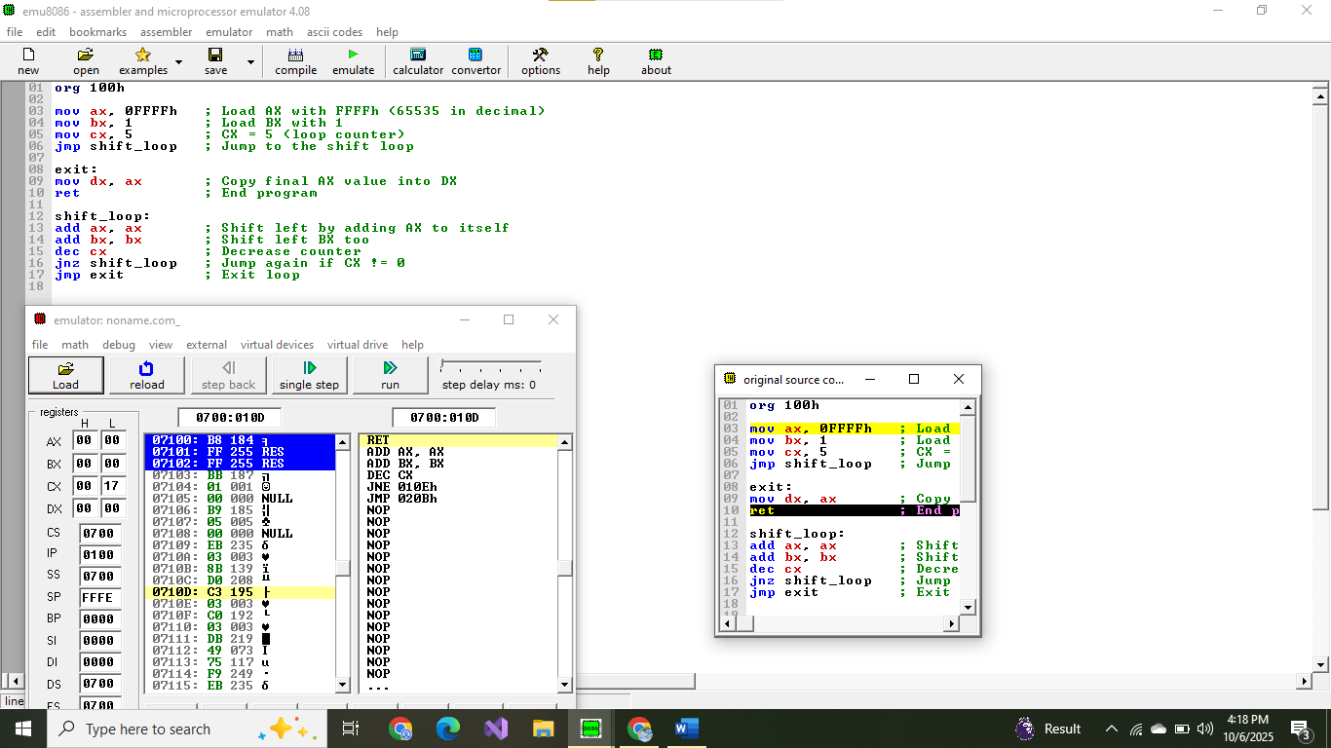
Question # 5
org 100h

mov ax, 9 ; AX = 9
mov bx, ax ; BX = AX (9)
dec bx ; BX = 8
mov cx, 0 ; initialize CX = 0
jmp check ; jump to check label

process:
dec ax ; decrease AX by 1
add cx, ax ; add AX value to CX

check:
cmp ax, 0 ; compare AX with 0
jg process ; if AX > 0, go back to process
mov dx, cx ; move total sum to DX

ret ; end program
What is happening in this code?
In this program, AX starts with 9 and is repeatedly decreased by 1 in each loop. Every time, the value of AX is added to CX, which collects the total sum. The loop continues until AX becomes 0. Finally, the result (sum = 36) is stored in DX before the program ends.
Output
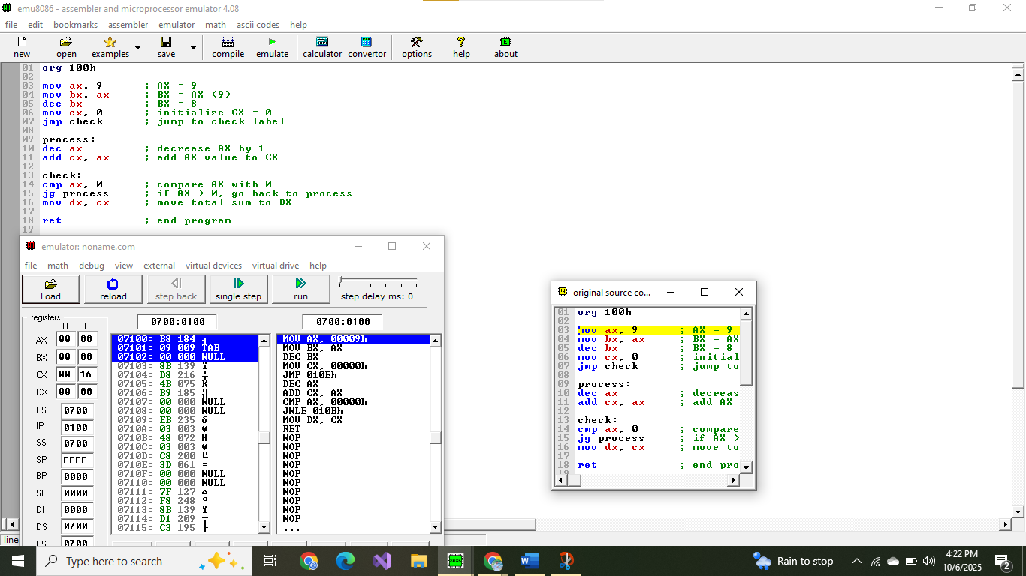
Question # 6
org 100h

mov ax, 0 ; first Fibonacci number
mov bx, 1 ; second Fibonacci number
mov cx, 7 ; how many Fibonacci numbers to generate
jmp fibonacci ; jump to fibonacci section

stop:
mov dx, bx ; move the last Fibonacci value into DX
ret ; end program safely

fibonacci:
mov si, ax ; store old AX (previous number) in SI
mov ax, bx ; AX = BX (move next number)
add bx, si ; BX = BX + SI (next Fibonacci term)
dec cx ; decrease counter
jnz fibonacci ; if CX != 0, repeat loop
jmp stop ; else go to stop
What is happening in this code?
In this assembly program, we calculate Fibonacci numbers using addition. The program starts with 0 and 1, then repeatedly adds the two previous numbers to get the next one. The loop runs seven times, updating AX and BX each time. Finally, the last Fibonacci number (13) is stored in DX, and the program ends.
Output
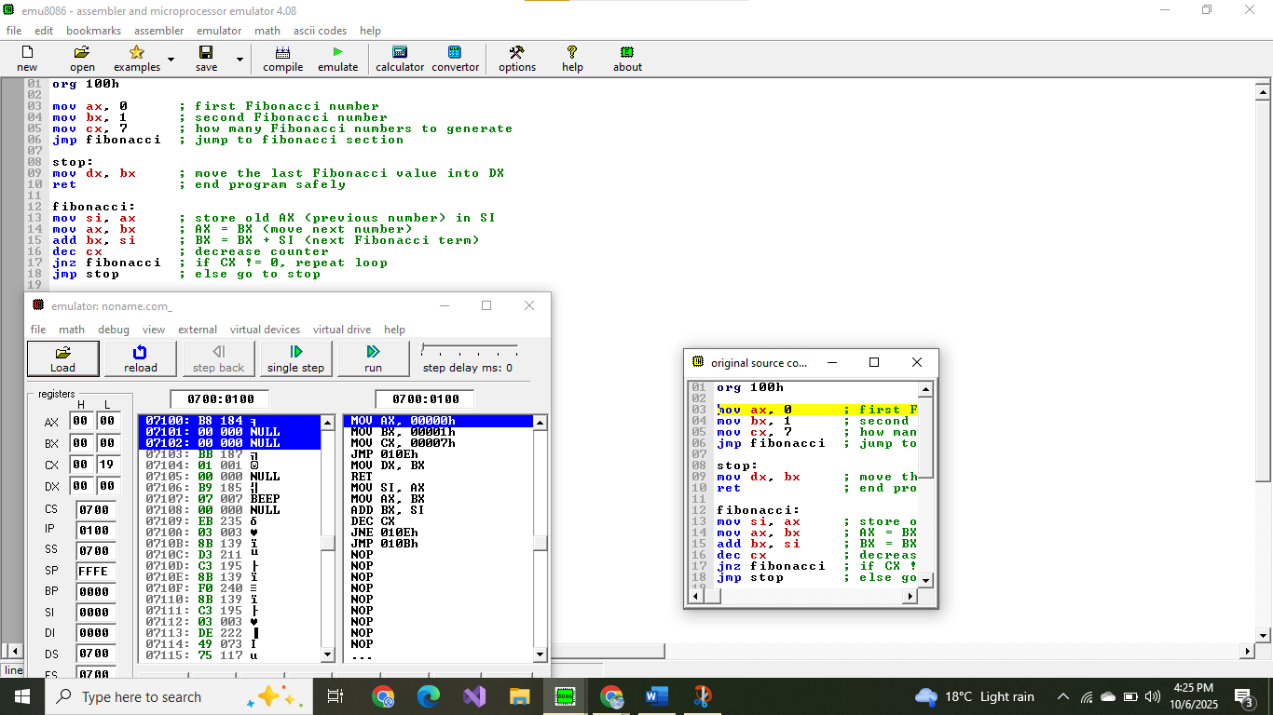
Question # 7
org 100h

mov ax, 0F0F0h ; actually loads F0F0h into AX (due to 16-bit register)
add al, 0Fh ; add 15 to lower 8 bits (AL)
add ah, 0F0h ; add 240 to higher 8 bits (AH)
add ax, 0F0F0h ; add F0F0h again to AX (will overflow 16-bit)

ret

What is happening in this code?
In this program, AX is first loaded with the hexadecimal value F0F0h. Then, 15 is added to the lower byte (AL), and 240 is added to the higher byte (AH). After that, the program adds the full 16-bit value F0F0h again to AX. Because AX is only 16 bits, the result overflows and wraps around to the final value D1EFh.
Output
