Submitted By:
Name: Muneeb nawaz
Sap ID: 66134
Class / Section: BSAI_3_1
Subject: coal
Date of Submission:
10 October 2025

Institution Name:
Riphah International University Islamabad

Question # 1
Code
dosseg
.model small
.stack 100h
.data
array db 'a','b','c'
.code
main proc
mov ax,offset array
mov cx,3
l1:
mov dx,[si]
mov ah,2
int 21h
inc si
loop l1
mov ah,4ch
int 21h
main endp
end main
Output
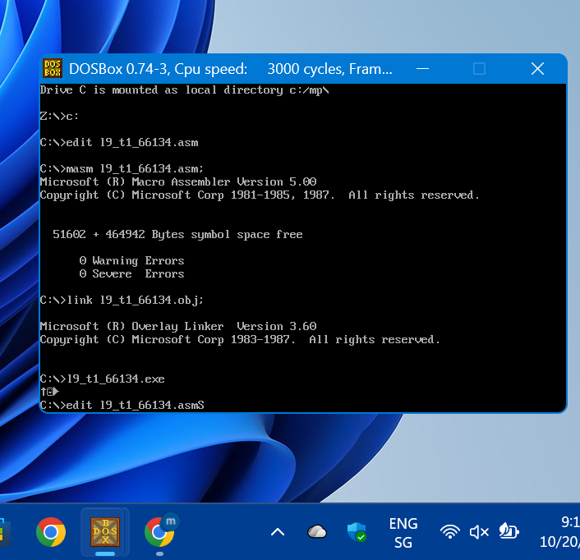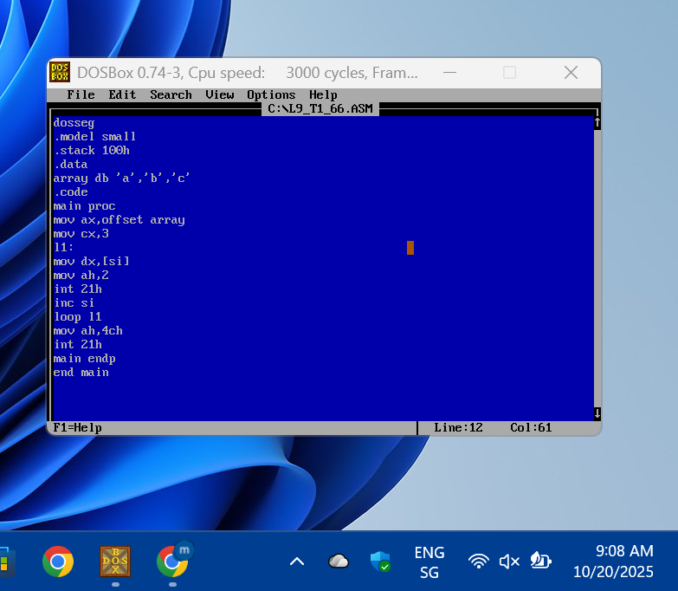

Question # 2
Code
dosseg
.model small
.stack 100h
.data
array db 100 dup('$')
.code
main proc
mov ax,@data
mov ds,ax
mov si,offset array
l1:
mov ah,1
int 21h
cmp al,13
je program
mov [si],al
inc si
jmp l1
program:
mov dx,offset array
mov ah,9
int 21h
mov ah,4ch
int 21h
main endp
end main
Output
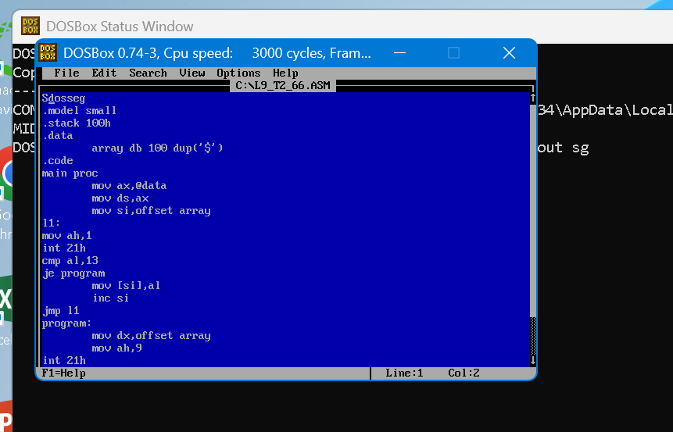
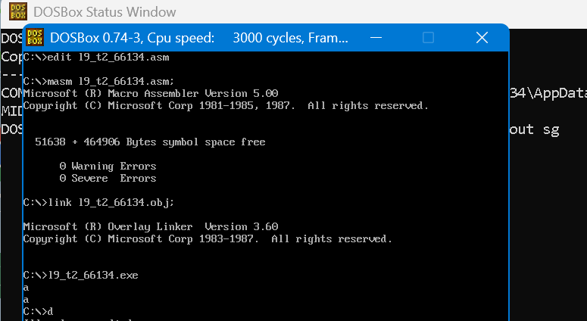
Question # 3
code
dosseg
.model small
.stack 100h
.data
.code
main proc
mov ax,'1'
mov bx,'2'
push ax
push bx
pop ax
pop bx
mov dx,ax
mov ah,2
int 21h
mov dx,bx
mov ah,2
int 21h
mov ah,4ch
int 21h
main endp
end main
output
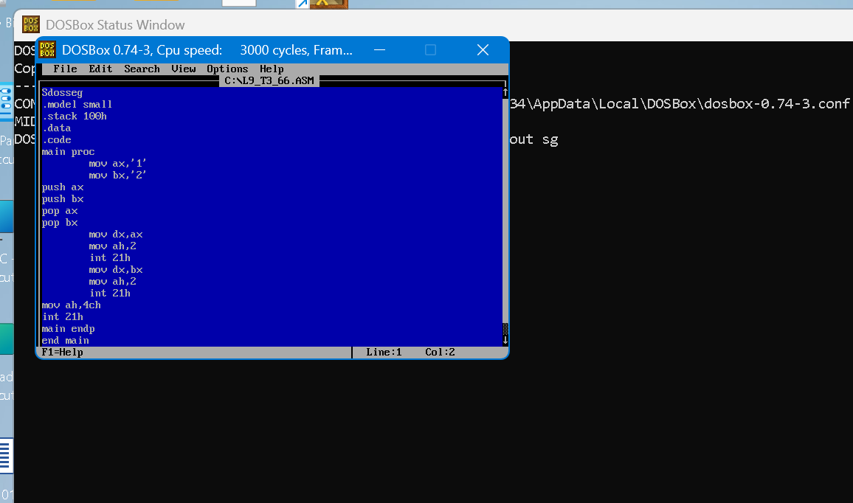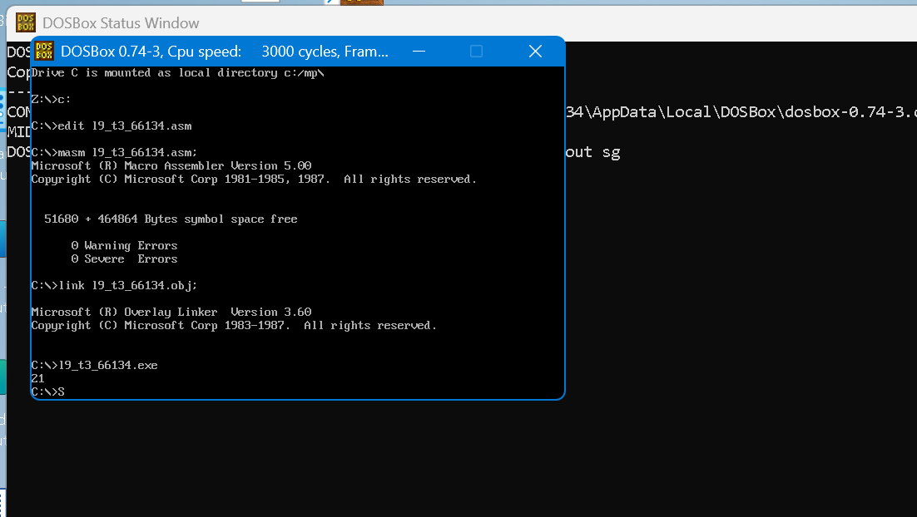
Question # 4
dosseg
.model small
.stack 100h
.data
string db'ali$'
.code
main proc
mov ax,@data
mov ds,ax
mov si,offset string
mov cx,3
l1:
mov bx,[si]
push bx
inc si
loop l1
mov cx,3
l2:
pop dx
mov ah,2
int 21h
loop l2
mov ah,4ch
int 21h
main endp
end main
Output
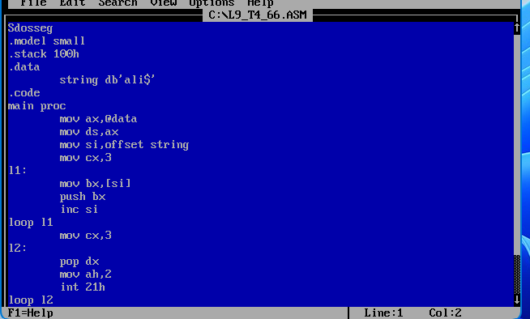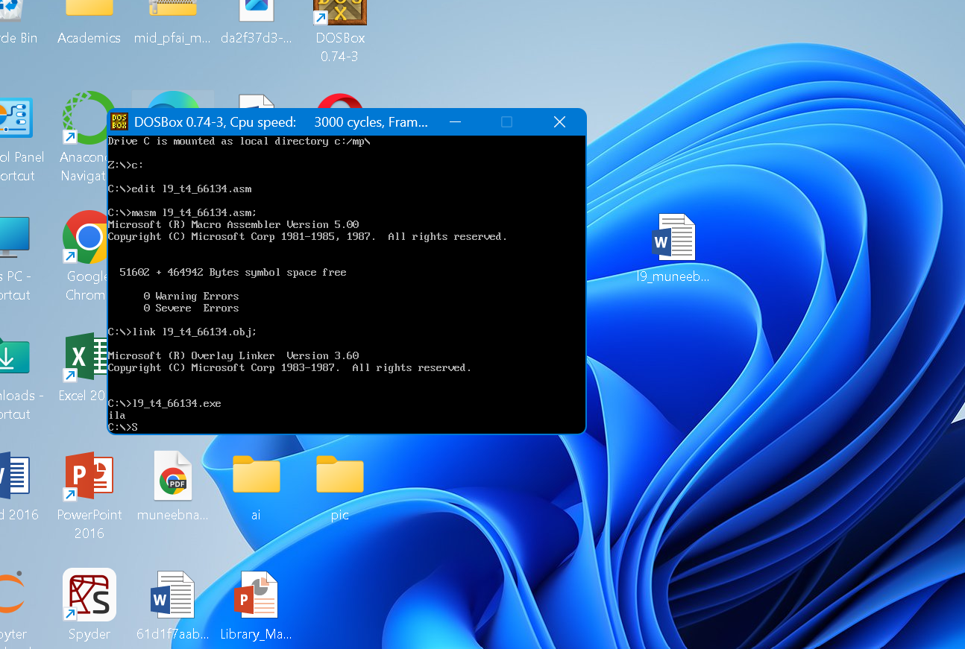
Question # 5
.model small
.stack 100h
.data
.code
main proc
mov bx, 5
mov cx, 5

outer_loop:
push cx
mov cx, bx

inner_loop:
mov dl, '*'
mov ah, 2
int 21h
loop inner_loop

mov dl, 13
mov ah, 2
int 21h
mov dl, 10
mov ah, 2
int 21h

dec bx
pop cx
loop outer_loop

mov ah, 4Ch
int 21h
main endp
end main
Output
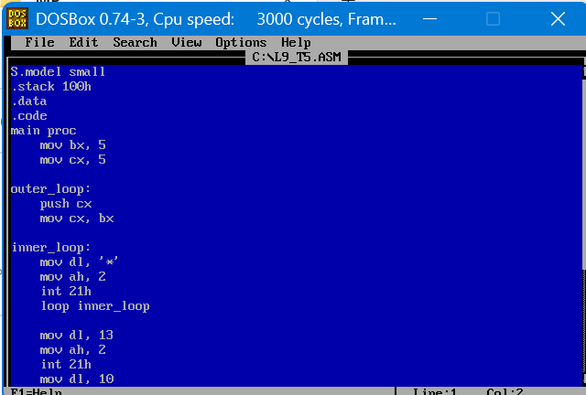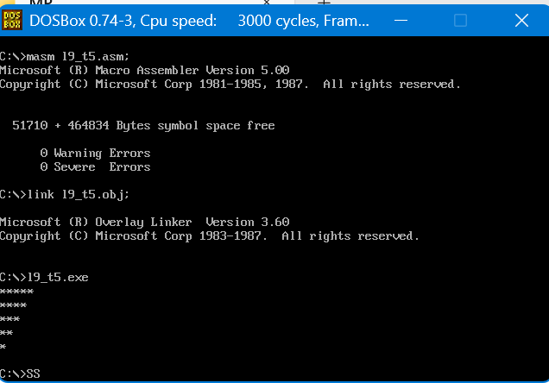
Question # 6
.model small
.stack 100h
.data
.code
main proc
mov bx, 1
mov cx, 5

outer_loop:
push cx
mov cx, bx

inner_loop:
mov dl, 'x'
mov ah, 2
int 21h
loop inner_loop

mov dl, 13
mov ah, 2
int 21h
mov dl, 10
mov ah, 2
int 21h

inc bx
pop cx
loop outer_loop

mov ah, 4Ch
int 21h
main endp
end main
Output
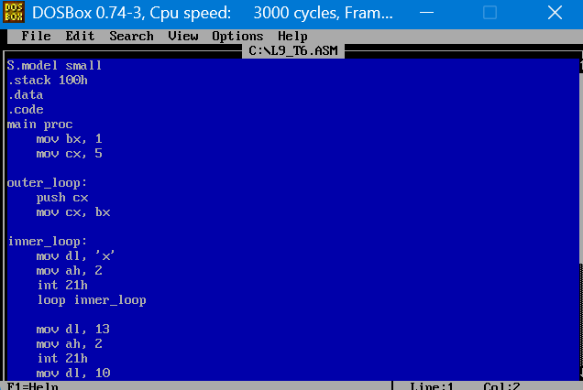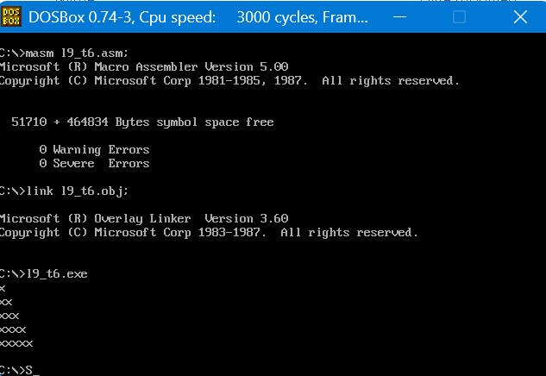Question # 7
.model small
.stack 100h
.data
.code
main proc
mov bx, 1
mov cx, 5

outer_loop:
push cx
mov cx, bx
mov dl, 'A'

inner_loop:
mov ah, 2
int 21h
inc dl
loop inner_loop

mov dl, 13
mov ah, 2
int 21h
mov dl, 10
mov ah, 2
int 21h

inc bx
pop cx
loop outer_loop

mov ah, 4Ch
int 21h
main endp
end main
Output

