Submitted By:
Name: Muneeb nawaz
Sap ID: 66134
Class / Section: BSAI_3_1
Subject: coal
Date of Submission:
13 /11/ 2025

Institution Name:
Riphah International University Islamabad

Question # 1
Code
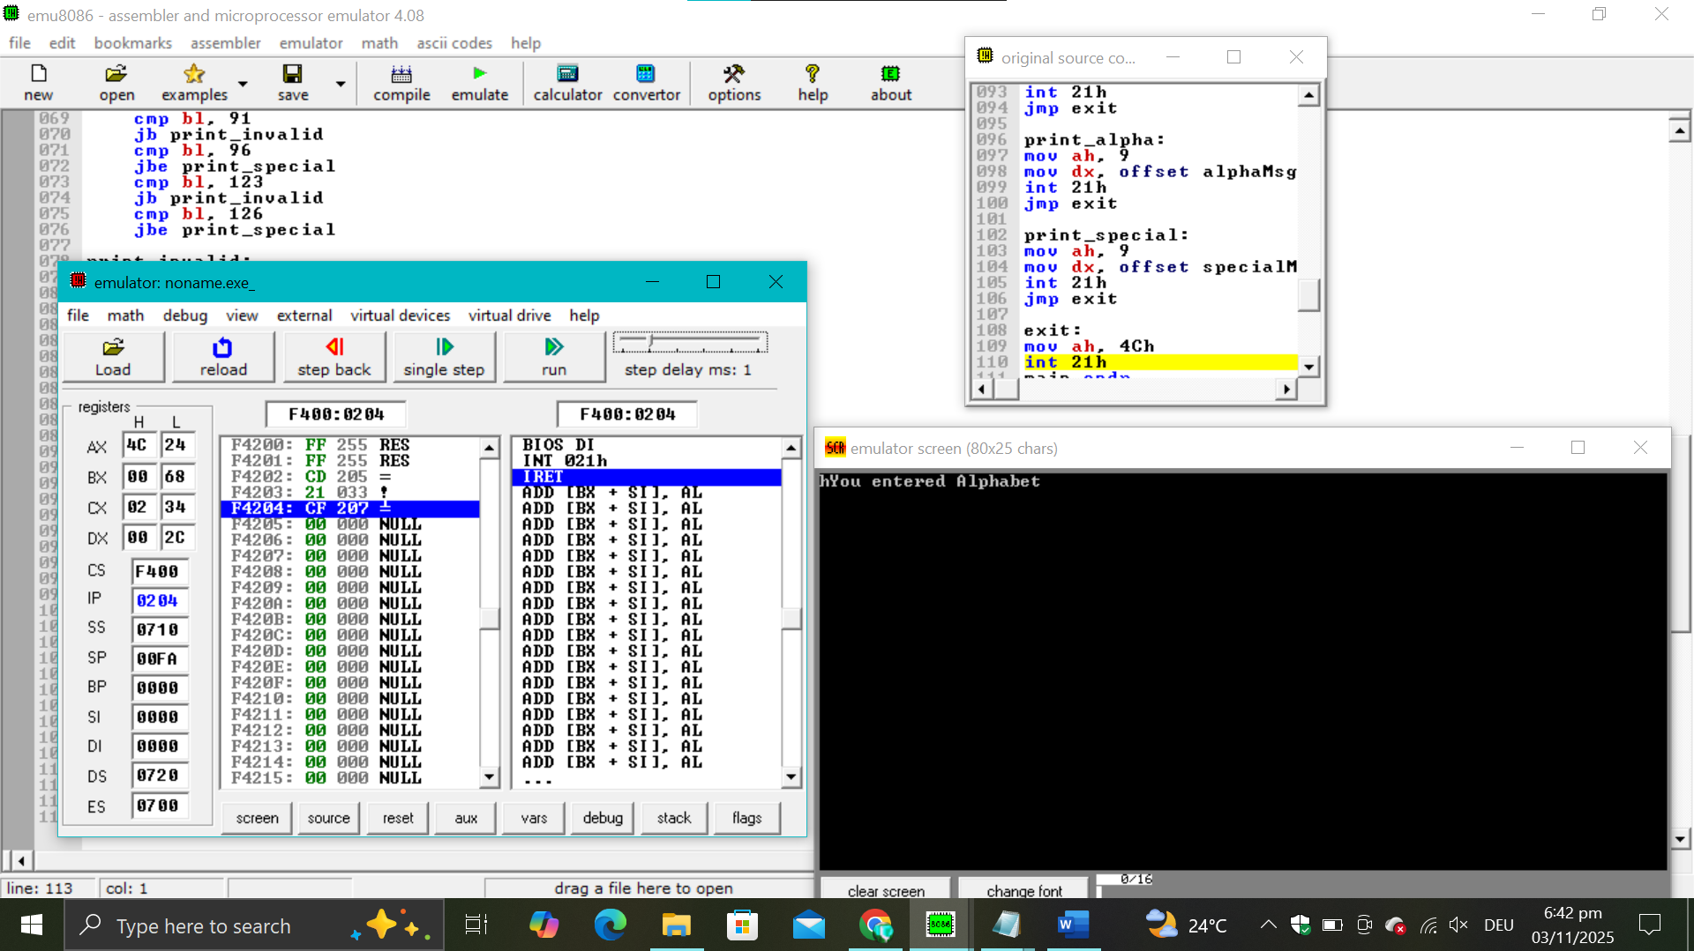
Code 2
org 100h
.data
a db "ali"
.code
mov ax,@data
mov ds,ax
mov si,offset a
mov cx,6
l1:
mov bx,[si]
push bx
inc si
loop l1
mov cx,4
l2:
pop dx
mov ah,2
mov dl,dl
int 21h
loop l2
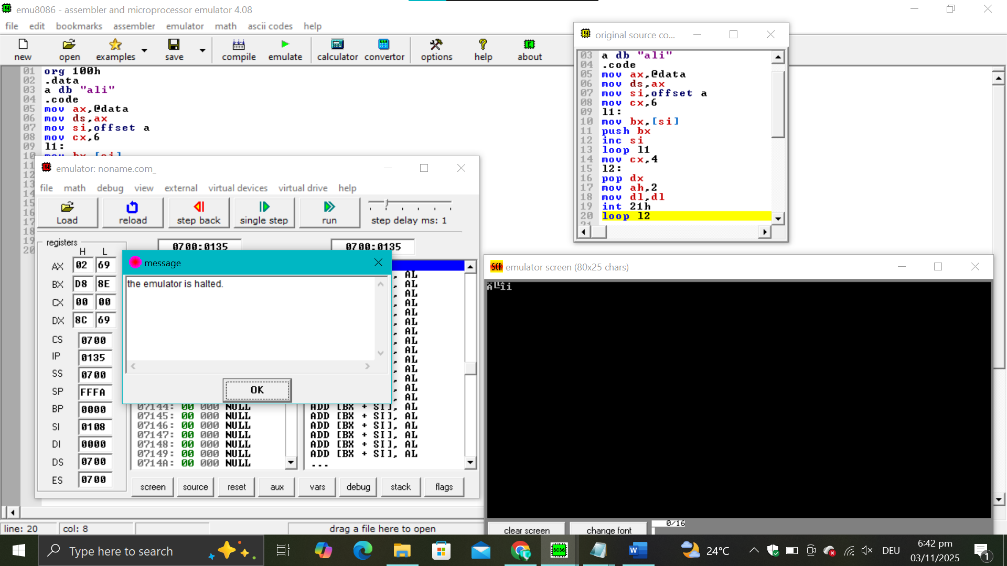
Code 3
.model small
.stack 100h
.code
main proc
mov cx, 0

input_loop:
mov ah, 1
int 21h
cmp al, 13
je reverse_start
push ax
inc cx
jmp input_loop

reverse_start:
mov ah, 2
mov dl, 10
int 21h

cmp cx, 0
je exit

reverse_loop:
pop dx
int 21h
loop reverse_loop

exit:
mov ah, 4Ch
int 21h
main endp
end main
OUTPUT
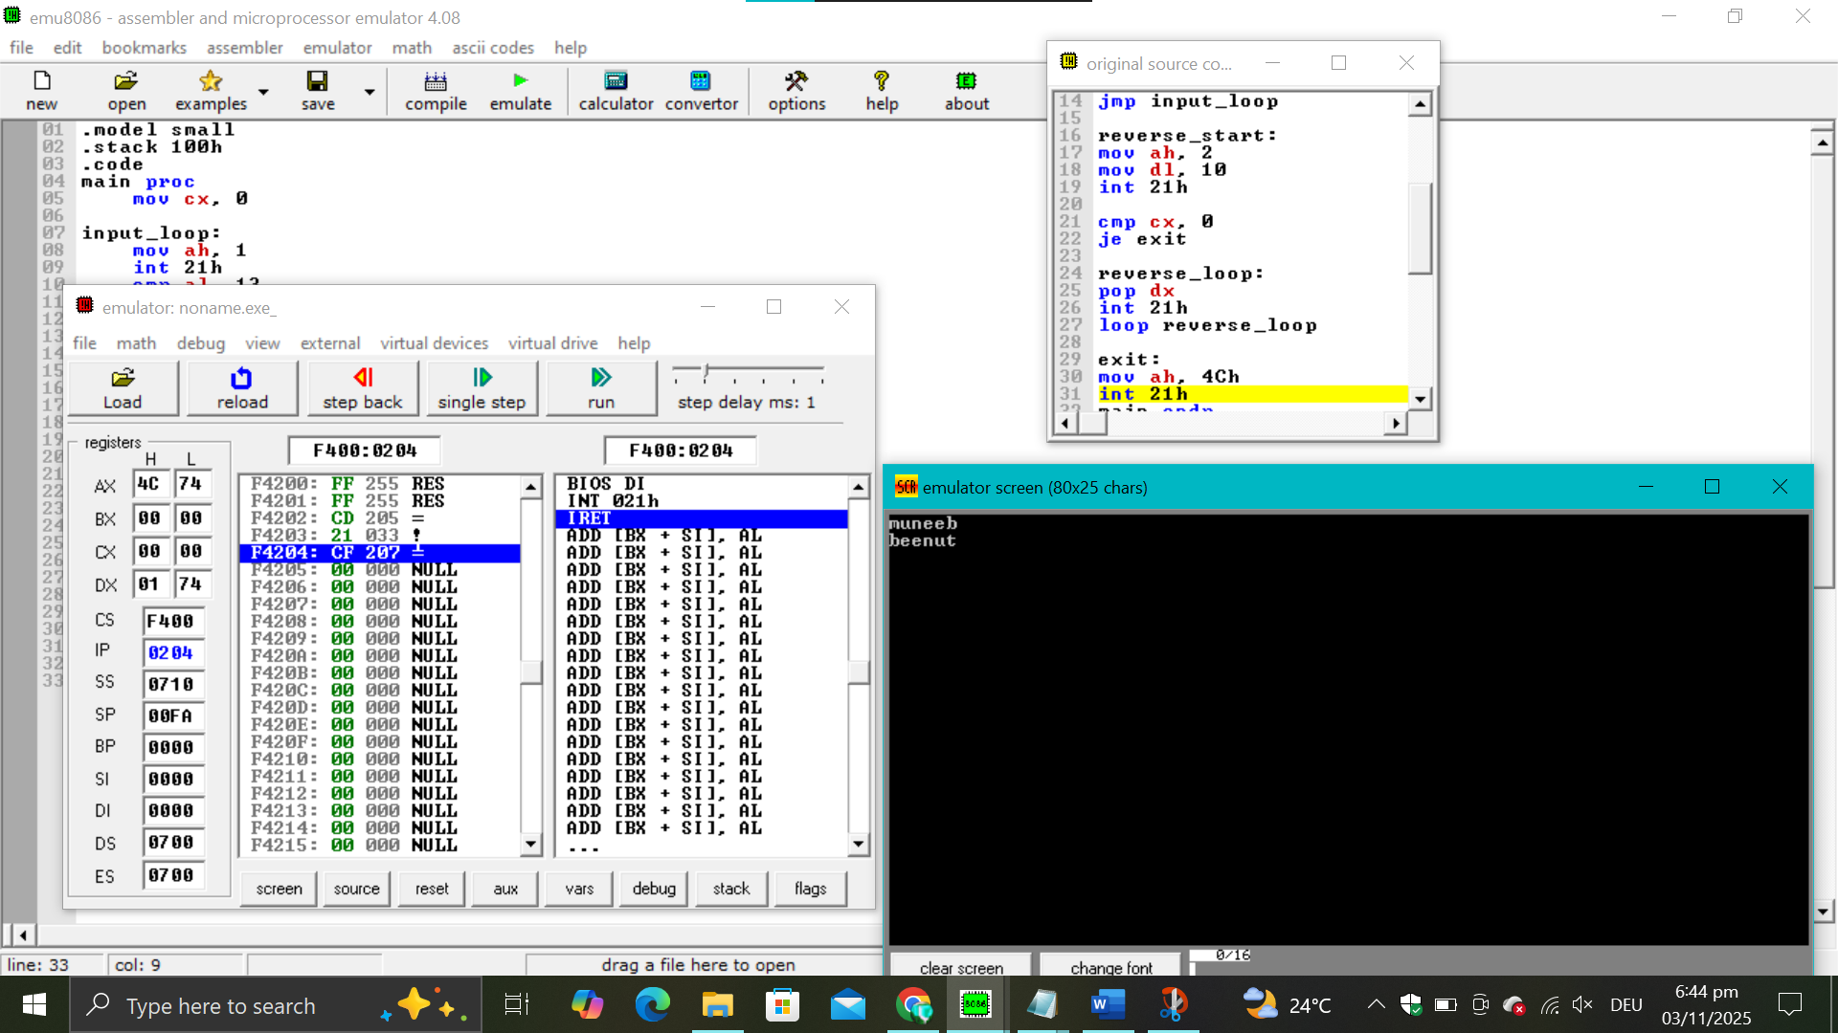
Code 4
.model small
.stack 100h
.data
vowelMsg db 'You entered Vowel$'
numMsg db 'You entered Numeric Value$'
alphaMsg db 'You entered Alphabet$'
specialMsg db 'You Entered Special Symbol$'
invalidMsg db 'Please Enter a valid value$'

.code
main proc
mov ax, @data
mov ds, ax

; Take input
mov ah, 1
int 21h
mov bl, al ; Store input in BL

; Check for vowel (A, E, I, O, U, a, e, i, o, u)
cmp bl, 'A'
je print_vowel
cmp bl, 'E'
je print_vowel
cmp bl, 'I'
je print_vowel
cmp bl, 'O'
je print_vowel
cmp bl, 'U'
je print_vowel
cmp bl, 'a'
je print_vowel
cmp bl, 'e'
je print_vowel
cmp bl, 'i'
je print_vowel
cmp bl, 'o'
je print_vowel
cmp bl, 'u'
je print_vowel

; Check for numeric (0–9)
cmp bl, '0'
jb check_alpha
cmp bl, '9'
jbe print_num

check_alpha:
; Check for alphabet (A–Z, a–z)
cmp bl, 'A'
jb check_special
cmp bl, 'Z'
jbe print_alpha
cmp bl, 'a'
jb check_special
cmp bl, 'z'
jbe print_alpha

check_special:
; Check for special symbols (basic range)
cmp bl, 33 ; '!' to '/'
jb print_invalid
cmp bl, 47
jbe print_special
cmp bl, 58 ; ':' to '@'
jb print_invalid
cmp bl, 64
jbe print_special
cmp bl, 91 ; '[' to '`'
jb print_invalid
cmp bl, 96
jbe print_special
cmp bl, 123 ; '{' to '~'
jb print_invalid
cmp bl, 126
jbe print_special

print_invalid:
mov ah, 9
mov dx, offset invalidMsg
int 21h
jmp exit

print_vowel:
mov ah, 9
mov dx, offset vowelMsg
int 21h
jmp exit

print_num:
mov ah, 9
mov dx, offset numMsg
int 21h
jmp exit

print_alpha:
mov ah, 9
mov dx, offset alphaMsg
int 21h
jmp exit

print_special:
mov ah, 9
mov dx, offset specialMsg
int 21h
jmp exit

exit:
mov ah, 4Ch
int 21h
main endp
end main
Output
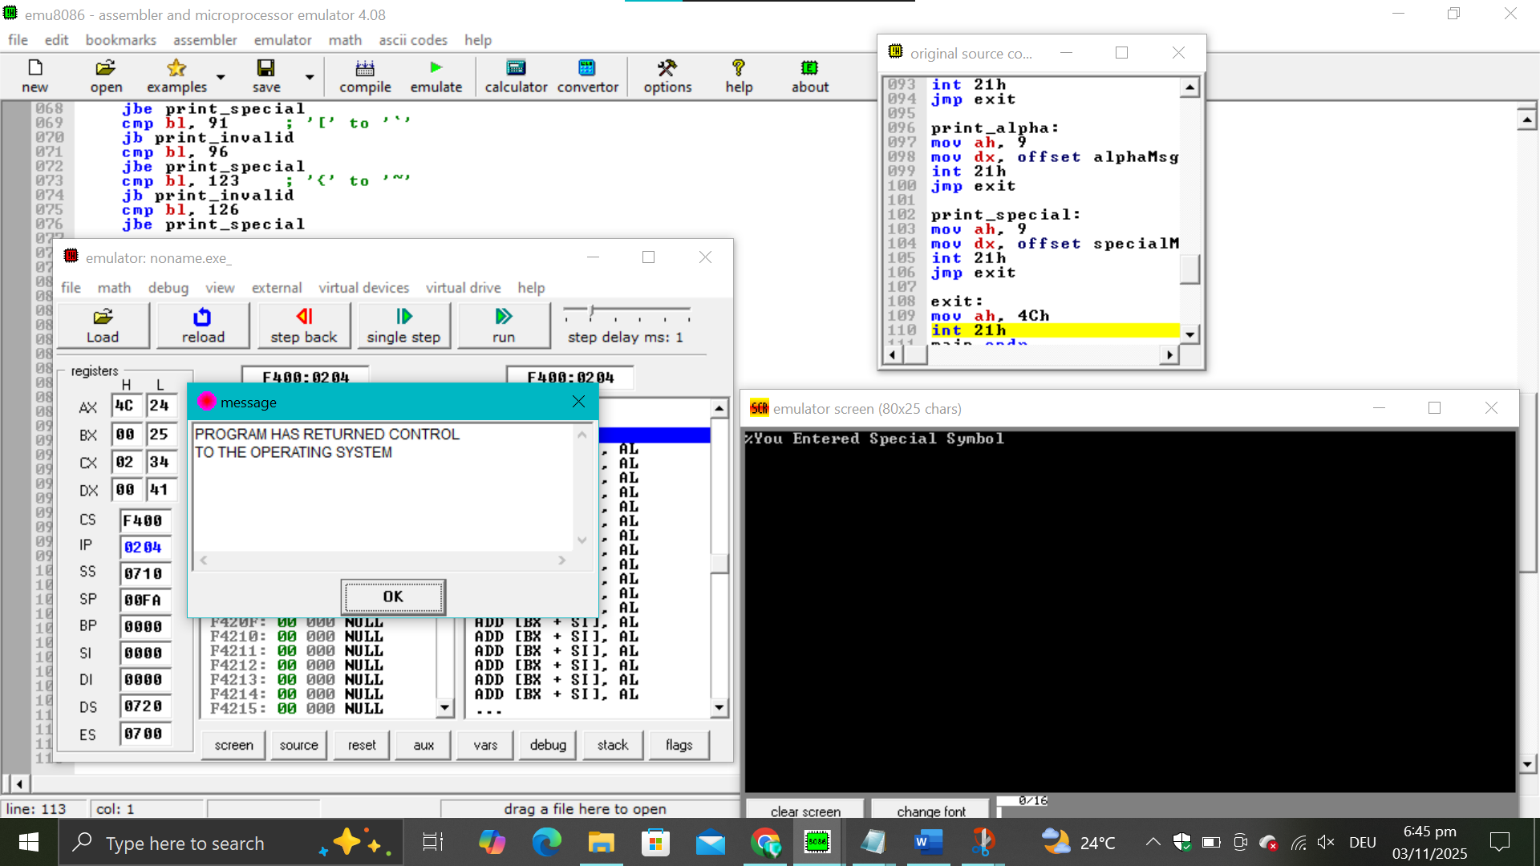
Code

; You may customize this and other start-up templates;
; The location of this template is c:\emu8086\inc\0_com_template.txt

org 100h
.data
a db 11001010b
.code
mov ax,@data
mov ds,ax
mov bl,a
shl bl,1
shl bl,2
shl bl,3
shr bl,2
shr bl,3

ror bl,2
ror bl,1
rol bl,2
rol bl,3

ret

