Lab Report

Title of the Lab Task:
Lab # 12
Course Name:
COAL
Submitted by:
Name: Muneeb Nawaz
Sap ID: 66134
Semester: 3th Semester]
Date of Submission:
10/11/2025
Question # 1
.model small
.stack 100h

.data
rem db ?
quo db ?

.code
main proc
mov ax, 26
mov bl, 5
div bl

mov quo, al
mov rem, ah

mov dl, quo
add dl, 48
mov ah, 2
int 21h

mov dl, rem
add dl, 48
mov ah, 2
int 21h

mov ah, 4Ch
int 21h
main endp
end main
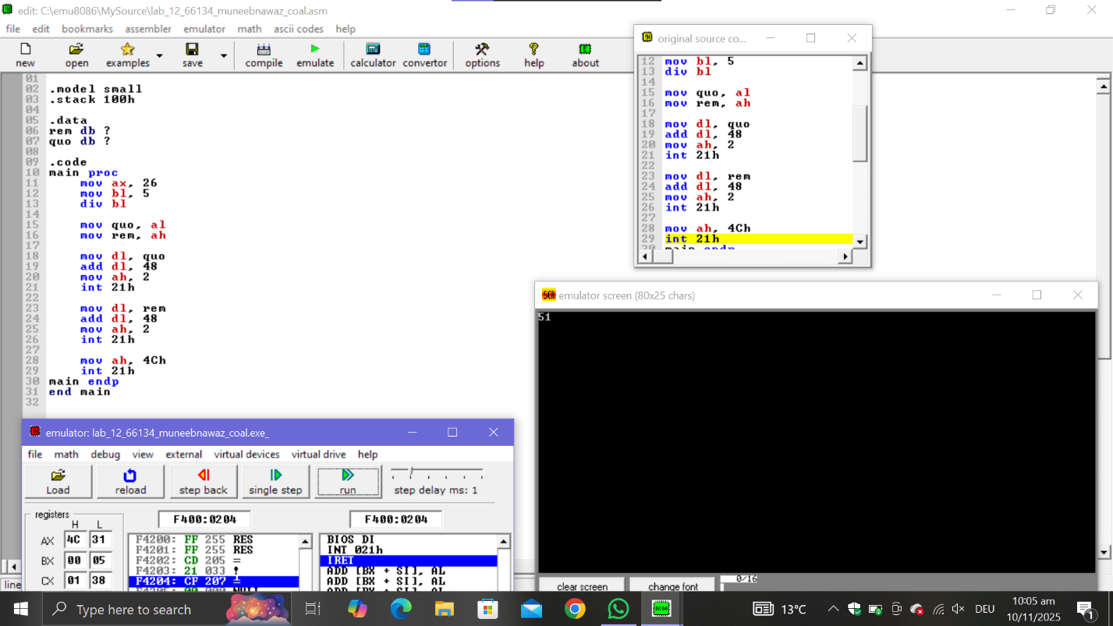

Question # 2

org 100h

.model small
.stack 100h

.data

.code
main proc
mov al, 2
mov bl, 3
mul bl

mov dx, ax
add dx, 48
mov ah, 2
int 21h

mov ah, 4Ch
int 21h
main endp
end main

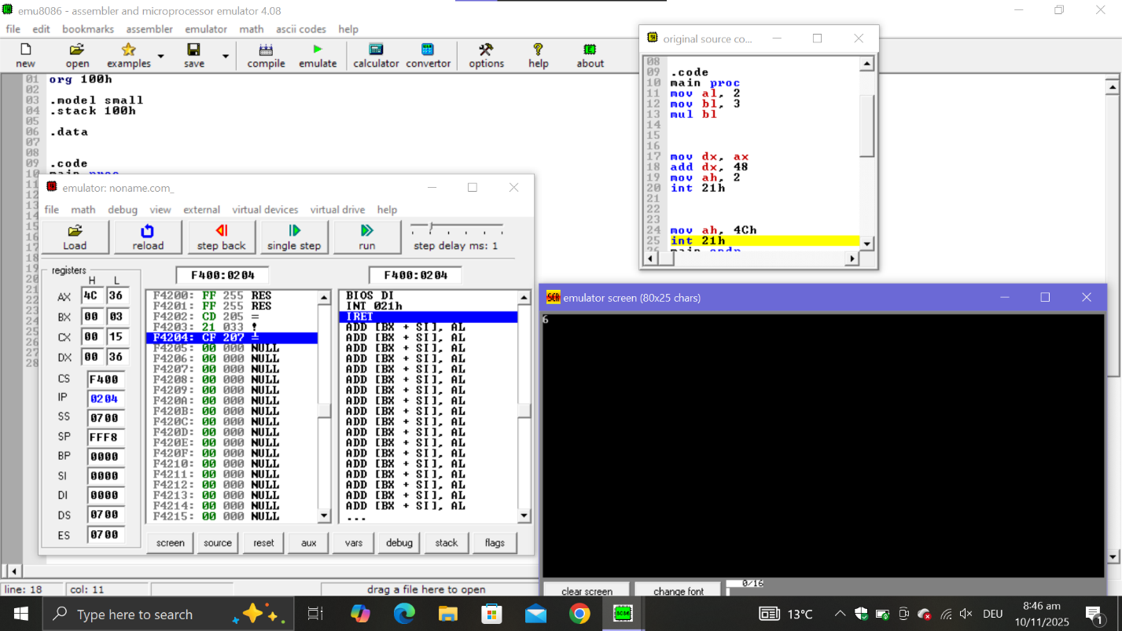

Question # 3

.model small
.stack 100h

.data
digits db '0123456789', '$'
alphabets db 'ABCDEFGHIJKLMNOPQRSTUVWXYZabcdefghijklmnopqrstuvwxyz', '$'
msg_num db 13,10, 'You entered a NUMBER$', 13,10, '$'
msg_alpha db 13,10, 'You entered a LETTER$', 13,10, '$'
msg_special db 13,10, 'You entered a SPECIAL SYMBOL$', 13,10, '$'

.code
main proc
mov ax, @data
mov ds, ax

mov ah, 1
int 21h
mov bl, al

lea si, digits
check_digit:
mov al, [si]
cmp al, '$'
je check_alpha
cmp bl, al
je is_number
inc si
jmp check_digit

check_alpha:
lea si, alphabets
next_alpha:
mov al, [si]
cmp al, '$'
je special_symbol
cmp bl, al
je is_letter
inc si
jmp next_alpha

is_number:
lea dx, msg_num
mov ah, 9
int 21h
jmp exit

is_letter:
lea dx, msg_alpha
mov ah, 9
int 21h
jmp exit

special_symbol:
lea dx, msg_special
mov ah, 9
int 21h

exit:
mov ah, 4Ch
int 21h

main endp
end main

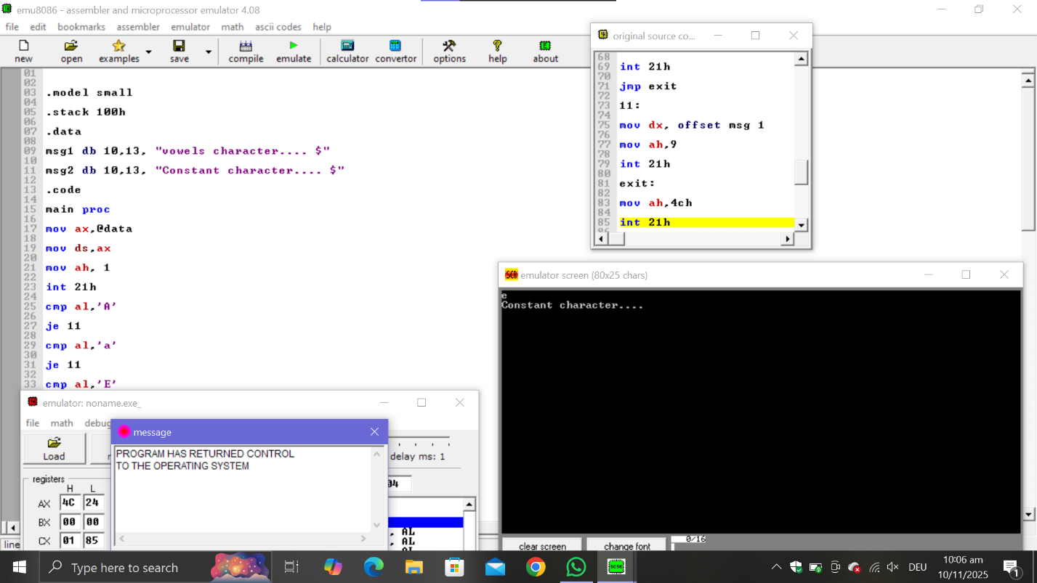

Question # 4

.model small

.stack 100h

.data

msg1 db 10,13, "vowels character.... $"

msg2 db 10,13, "Constant character.... $"

.code

main proc

mov ax,@data

mov ds,ax

mov ah, 1

int 21h

cmp al,'A'

je 11

cmp al,'a'

je 11

cmp al,'E'

je 11

cmp al,'e'

je 11

cmp al,'I'

je 11

cmp al,'i'

je 11

cmp al,'O'

je 11

cmp al,'o'

je 11

cmp al,'U'

je 11

cmp al,'u'

je 11

mov dx, offset msg2

mov ah,9

int 21h

jmp exit

11:

mov dx, offset msg 1

mov ah,9

int 21h

exit:

mov ah,4ch

int 21h

main endp

end main

