

CSCL2201-COMPUTER ORGANIZATION AND ASSEMBLY LANGUAGE

PROJECT REPORT

MEDICAL STORE BILLING MANAGEMENT SYSTEM

GROUP MEMBERS
A)KULSOOM JAWED(2312151)
B)ANCHAL BAI(2312145)
C)MUHAMMAD MUNEEB(2312160)
BSCS 3B(SEMESTER:FALL2024)

SUBMITTED TO:
SIR MUBEEN AHMED KHAN
LAB ENGINEER
SIR WASEEM RAUF

Table of Contents

MOTIVATION………………………………………………………………………….3
INTRODUCTION 3
DESCRIPTION 4
CONCEPTS IMPLEMENTED WITH SOURCE CODE……………………5
• MACRO 5
• PROCEDURE 6
• LOOP 6
• JUMP 7
• STACK 8

PROJECT FEATURES 10
Section 2.02 REFRENCES 15

MOTIVATION

We decided to make a project on MEDICAL MANAGEMENT SYSTEM that functions according to the need of user. The motivation behind it was to bring the hardcoded paper pharmacy billing on an interactive software. It is the user friendly.

INTRODUCTION

This project is about the billing system of pharmacy. We have done this project in computer organization in assembly language from software emu8086. The pharmacy management system is easy for use so the user can do pharmacy actions without ambiguities. The medical management system project highly minimizes time and resource by which, searching the medicine data you can get the data in quickest time and eliminating wasting of time as well.

DESCRIPTION

To get into the program, first we have to enter the correct password and if
wrong password is entered by user, then it will print “Incorrect password”.

After entering the correct password, following options will be displayed on the screen.

Press 1 to buy medicine
- Press 2 to see medicines statistics.
- Press 3 to show amount earned today
- Press 4 to exit

USER SELECTION:
- If the user will enter any other option so it will print “wrong input”
message.
- If the user will press 1 so it will show medicines available in medical store along with the price list.
- If the user will press 2 so it will show the amount every of medicines and vaccines sold out today.
- If the user will press 3 it will show how many amounts have today. If press 4 so it will exit the system.

CONCEPTS IMPLEMENTED(WITH SOURCE CODES)

Macros
Procedures Loop
Jumps Stack
Arithmetic Operations

- MACROS

We used macros in our code to save our time and shorten the number of code lines. It increases the efficiency at work also.
Two macros are used:
- Display macro
- newLine macro
Macros is used to avoid the repetitive tasks.

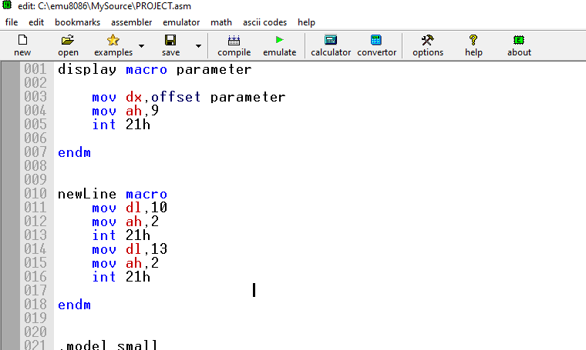

Procedures

  - We use different procedures in our program.
  - In main proc all the code is written.
  - In the main procedures other procedures are created
  - Procedures are identified by a name.

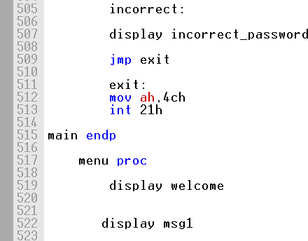
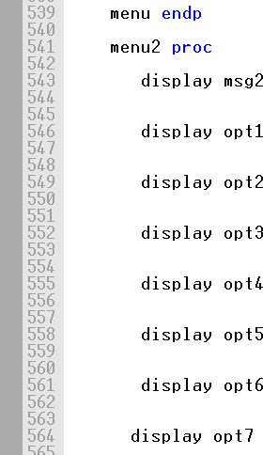
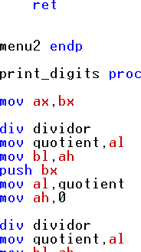

LOOP

  - We use loops in our program for perform the tasks within while.
  - LOOP is use to take the password from the user in this piece of code.

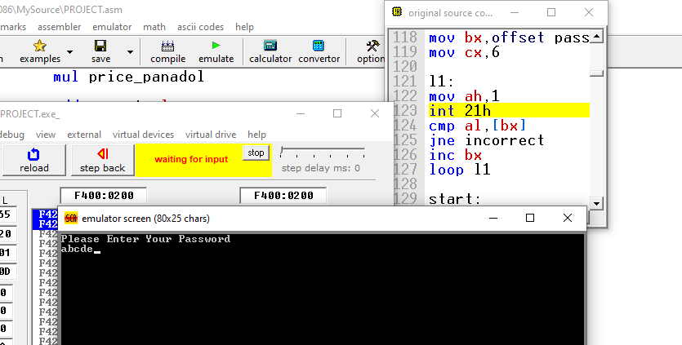

JUMPS

- Conditional jumps je , jne
Jumps equal is performed by a set of jump instructions depending upon the condition.
Cmp is used for comparing the input and then conditional jump will work.

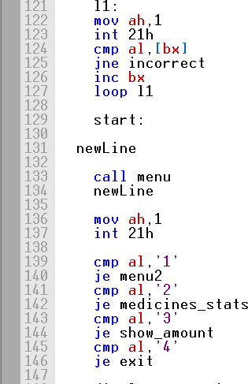

- Unconditional jump jmp
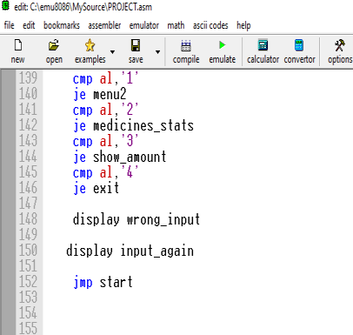
In any wrong input jmp will go to the start label.

STACKS

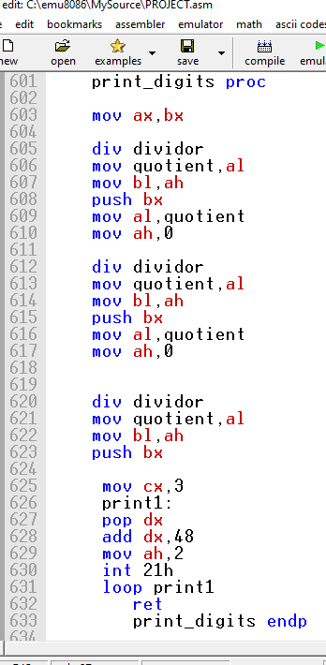
We used push and pop in this part of our code.

FLOW CHART

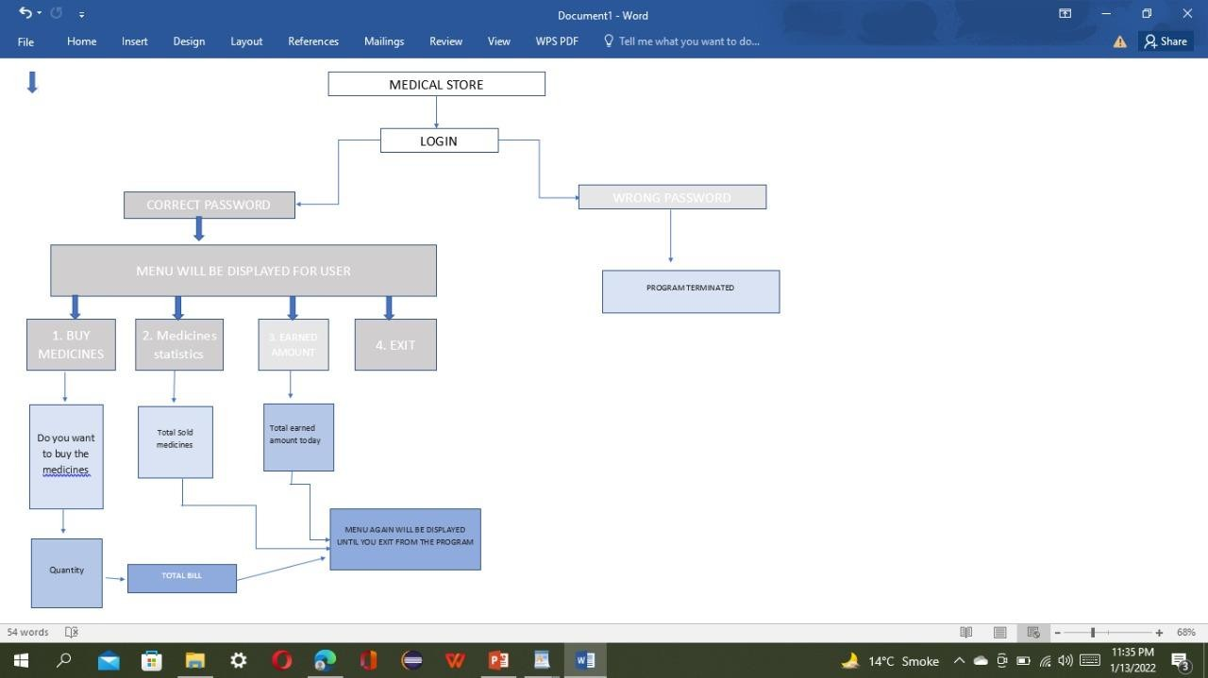

PROJECT FEATURES:

STEP 1:

- Firstly, the program will ask the password . If wrong password would enter the program will show wrong input and it will stop .
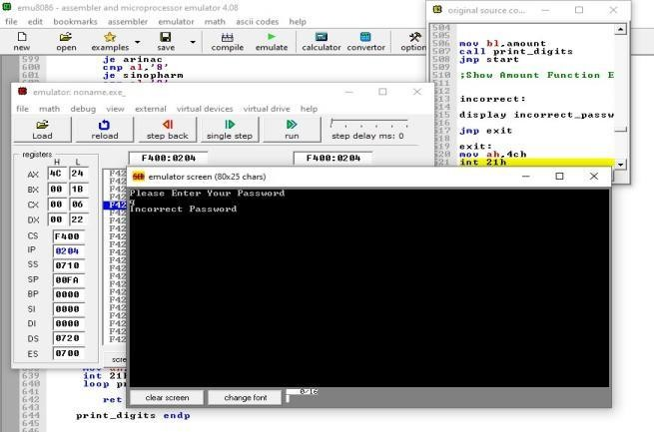

- If the password is correct then the following options will be displayed for selections .
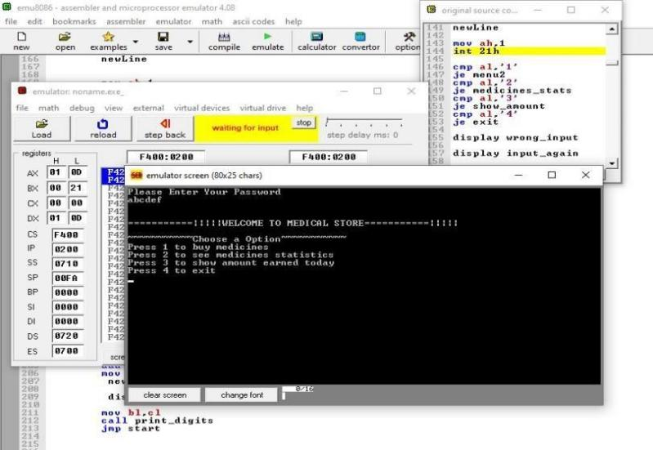

STEP 2: GET ACCESS AFTER ENTERING THE CORRECT PASSWORD

As the user press 1 to buy the medicines, the medicines name will be displayed along with their prices.
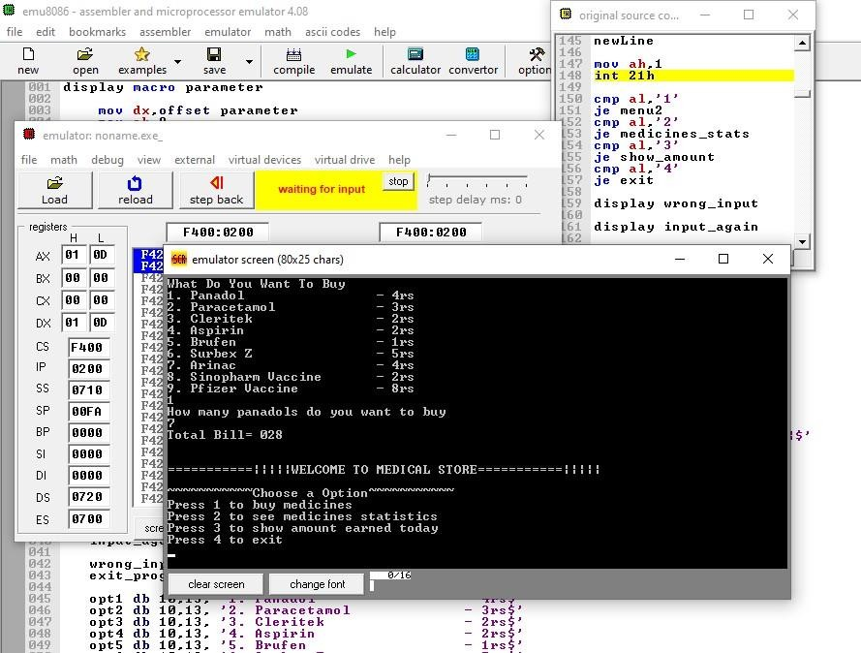

- As the user will select the medicine which he wants to buy , the program will ask the quantity and then price will be calculated.
Same for others medicines program will run respectively . Then again following options will be displayed.

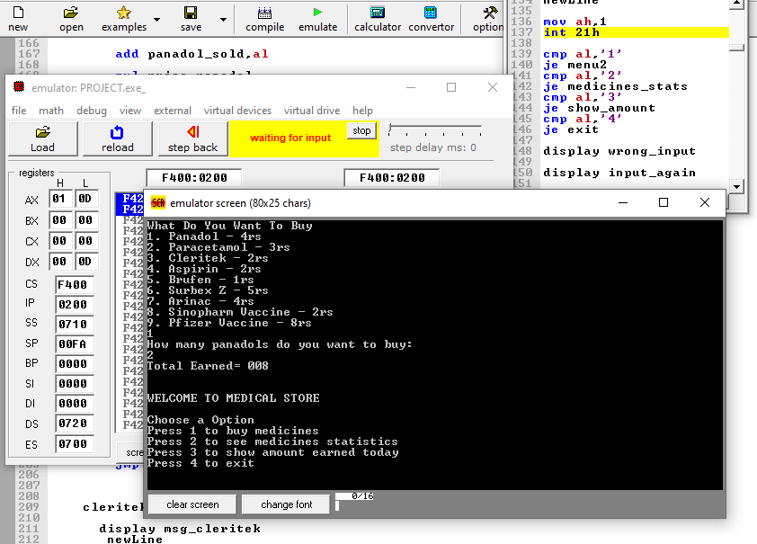

- When option 2 is pressed , to see the medical statistics . Following details of the sold medicines will be shown .
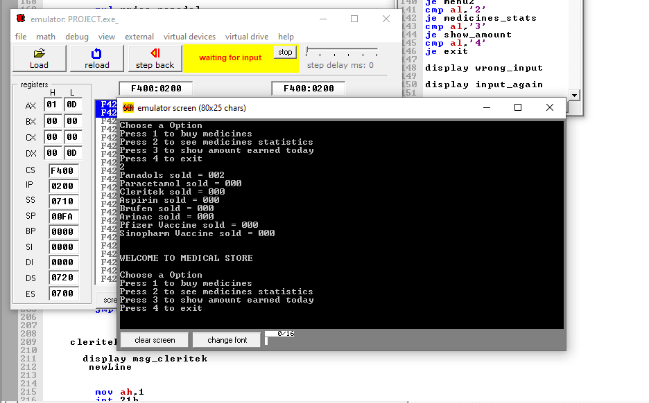

- Option 3 will show the total earned amount of the day
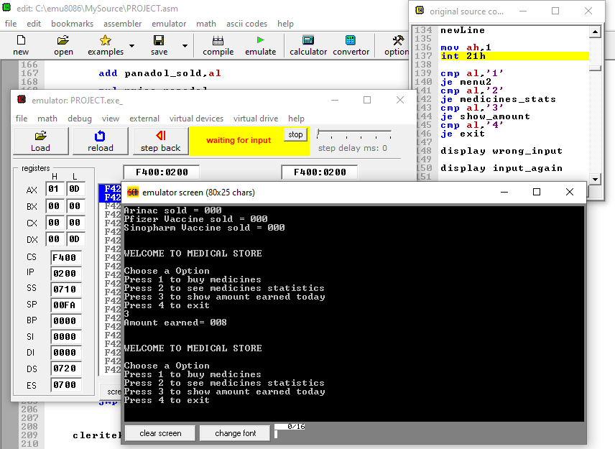

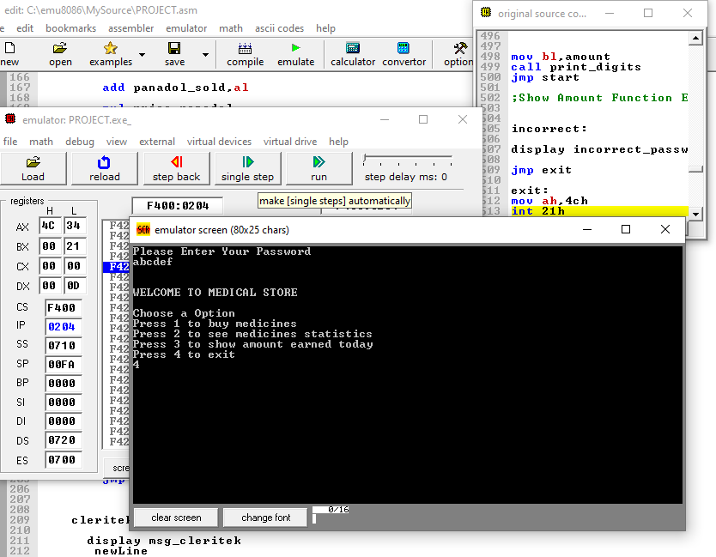
Press 4 for exit will terminate the program

HURDLES

We faced a few limitations when we started to attempt the coding. The first one was to implement the loops, jump conditions and labels in the right spots so that we had proper functioning code. The use of registers in the correct order was also a difficulty but we utilized the best of our time to rectify the mistakes we were making in the first place. We tried our best to develop this project as good as we can.

CONCLUSION

We tired our best to give our best for this project. We all worked in group and share ideas with each other. This Medical store helps to maintain the system efficient and more useful and reliable.

REFRENCES

https://www.tutorialspoint.com/assembly_programming/assembly_tutorial.pdf

