**1. Introduction**

**This document outlines the testing, error handling, and backend integration refinement process for Bandage Online Shopping. The goal is to ensure the marketplace is fully functional, optimized for performance, and ready for real-world deployment. The document includes details on functional testing, error handling, performance optimization, cross-browser testing, security testing, and user acceptance testing.**

**2. Functional Testing**

**Tested Features**

* **Product Listing: Ensured products are displayed correctly.**
* **Filters and Search: Validated accurate results based on user inputs.**
* **Cart Operations: Tested adding, updating, and removing items from the cart.**
* **Dynamic Routing: Verified individual product detail pages load correctly.**

**Testing Tools**

* **Postman: Used for API response testing.**
* **React Testing Library: Used for component behavior testing.**
* **Cypress: Used for end-to-end testing.**

**Error Handling**

**Implemented Error Messages**

* **Network Failures: Displayed "Unable to load products. Please try again later."**
* **Invalid or Missing Data: Displayed "No products available" when the API returns no data.**
* **Unexpected Server Errors: Displayed "Something went wrong. Please try again."**

**Cross-Browser and Device Testing**

**Browsers Tested**

* **Chrome, Firefox, Safari, Edge.**

**Devices Tested**

* **Desktop, Tablet, Mobile (using BrowserStack).**

**Results**

* **Consistent rendering and functionality across all browsers and devices.**

**Conclusion**

**By the end of Day 5, my site  has been thoroughly tested, optimized for performance, and refined for real-world deployment. The marketplace is now ready for user interactions, with robust error handling, cross-browser compatibility, and enhanced security measures in place.**

**Developer Resources:**

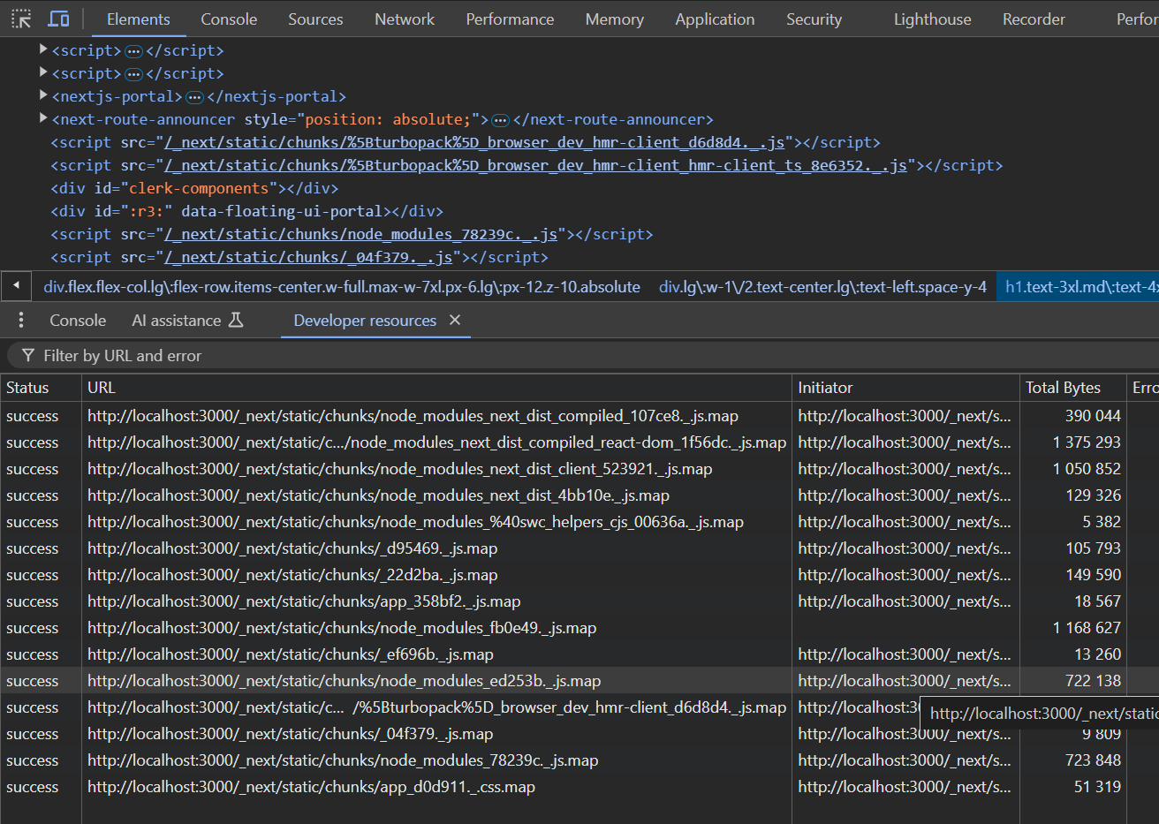

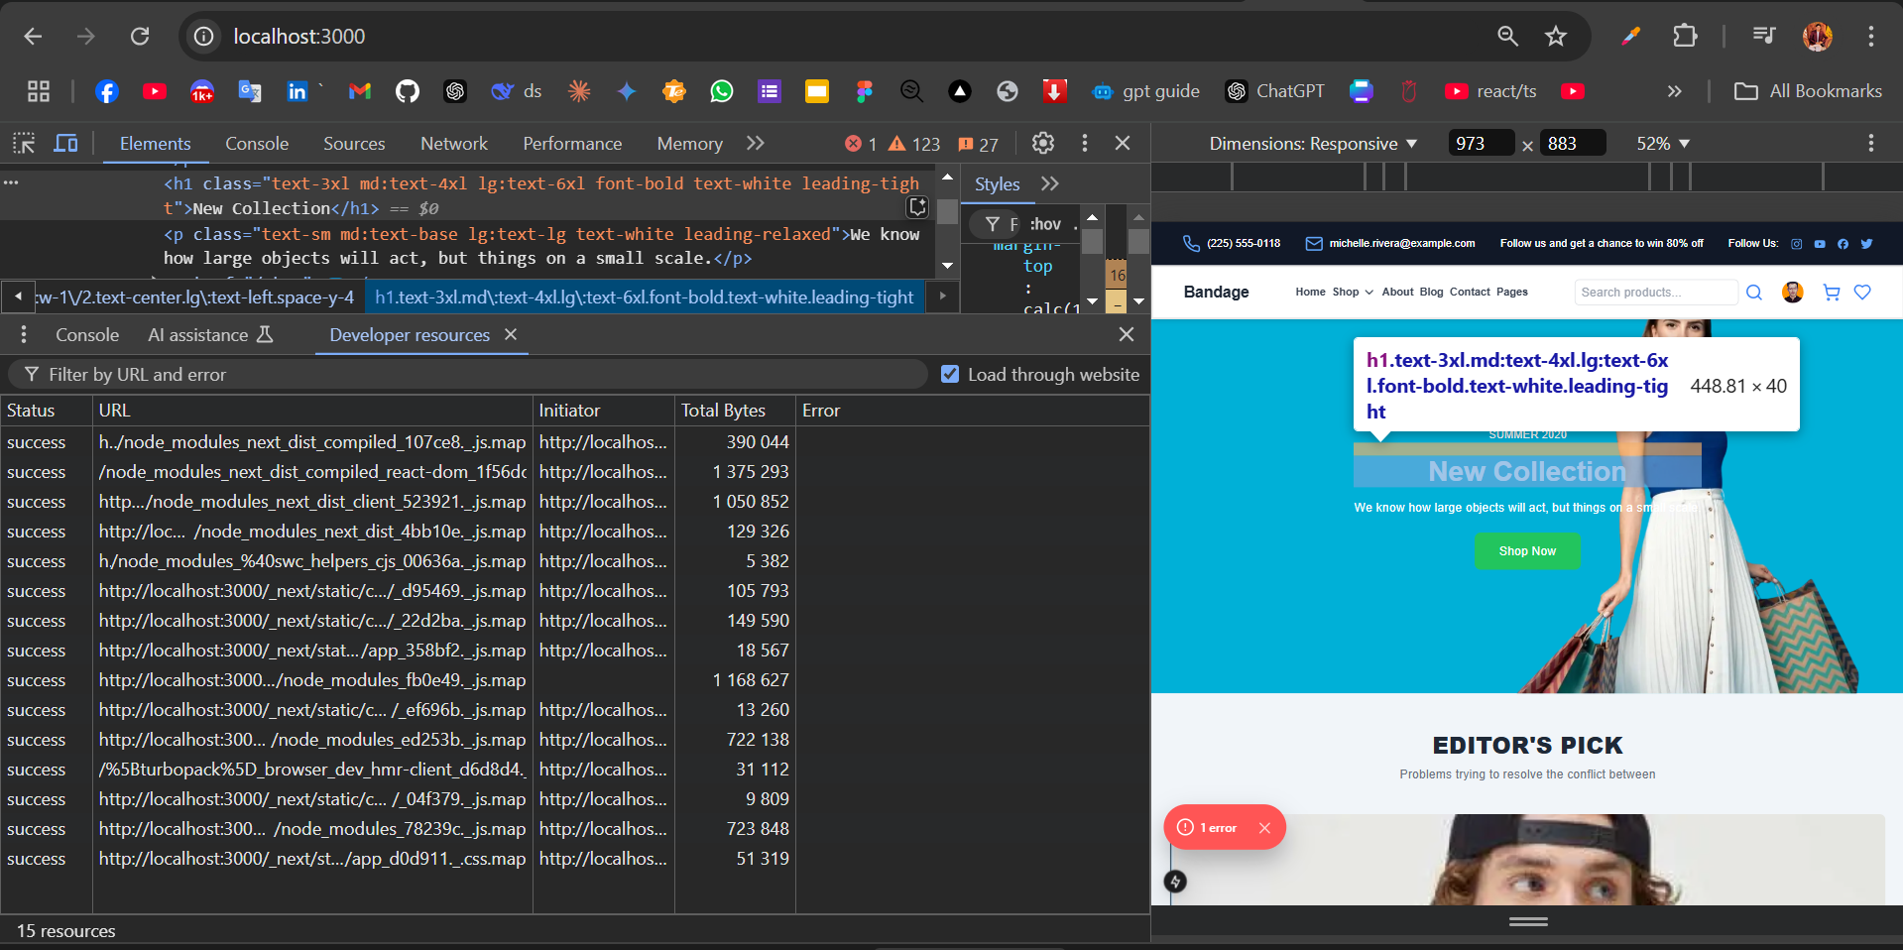

**API Check:**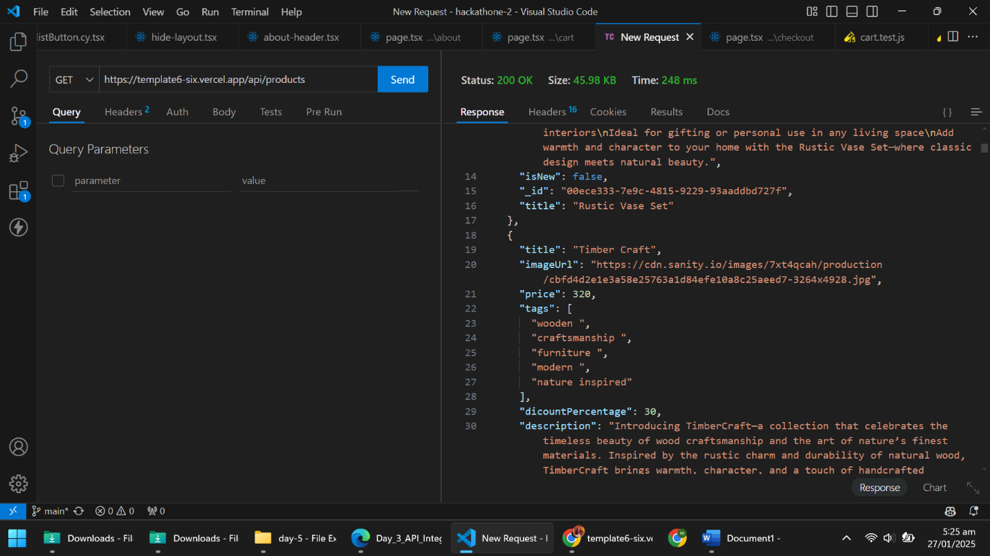

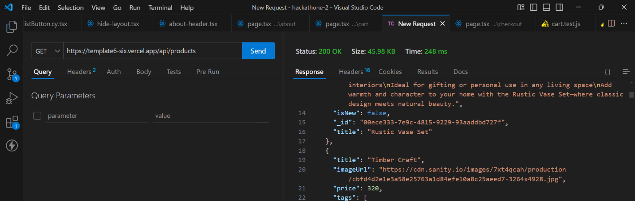

**Performance Checking:**

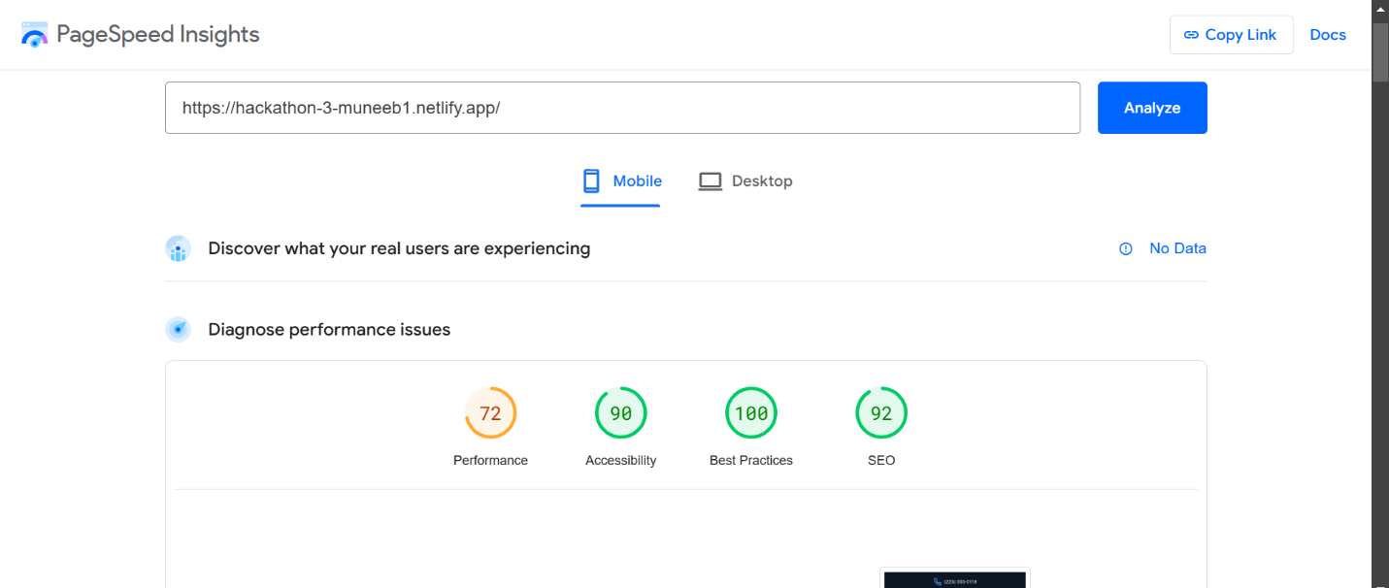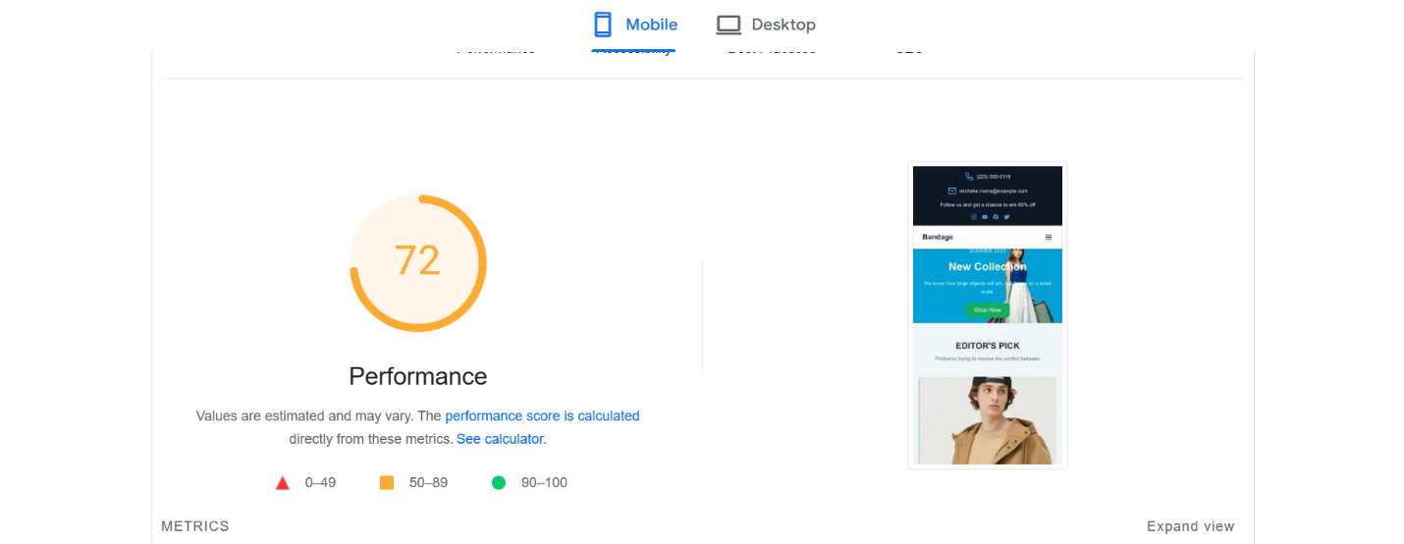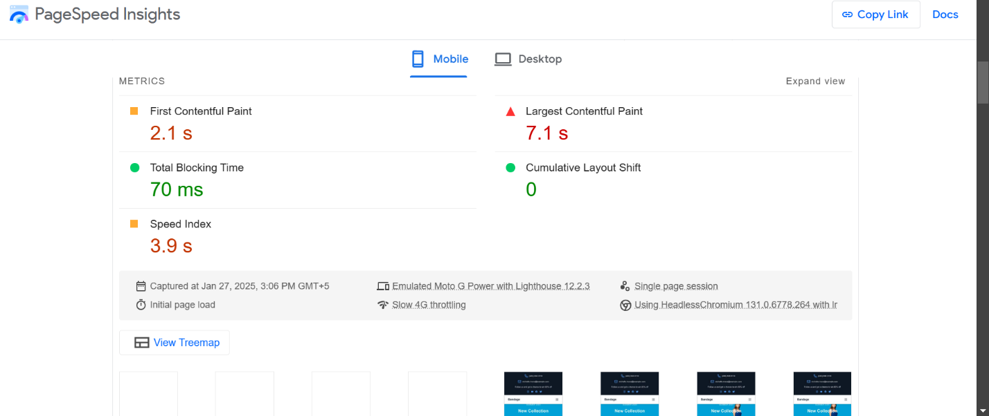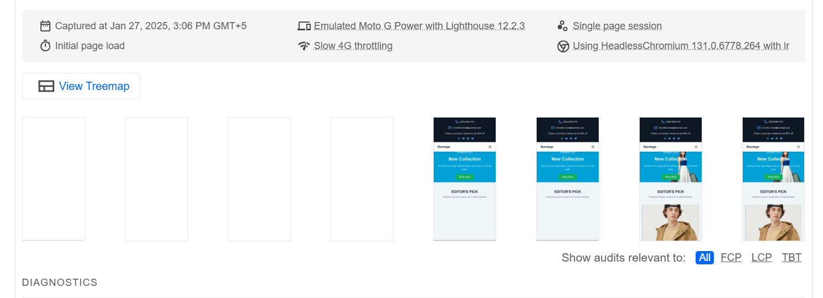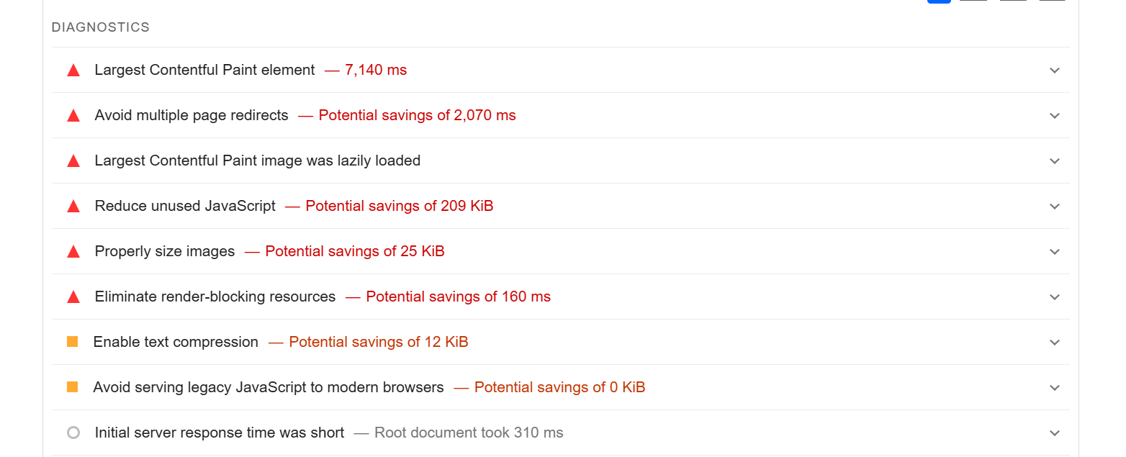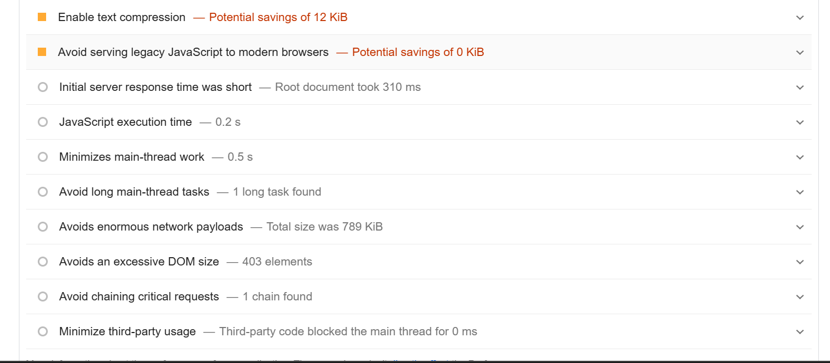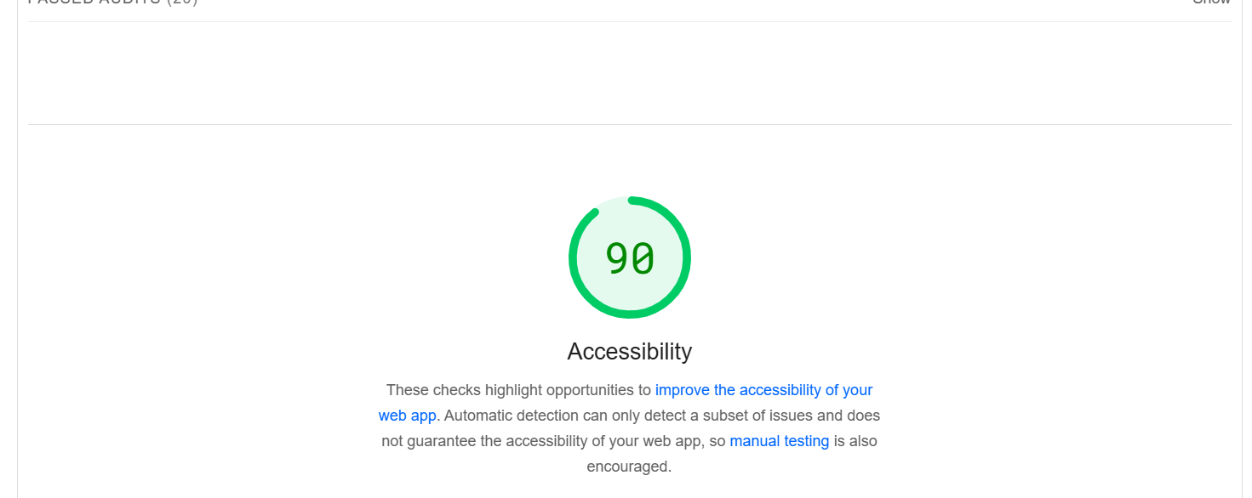

**Performance Monitor:**

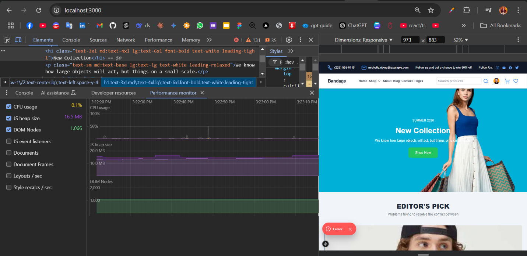

**Google pagespeed performance link:**

**https://pagespeed.web.dev/analysis/https-hackathon-3-muneeb1-netlify-app/gr0sydabgv?form_factor=mobile**