SMART PARKING GATE SYSTEM

1. INTRODUCTION

In this project, we are going to design a Smart Parking Gate System using Arduino, Ultrasonic Sensor, IR Sensors, Servo Motor, and a 16x2 LCD display. The system automatically detects vehicles using an ultrasonic sensor, opens the gate with a servo motor, and counts the number of vehicles entering and exiting through IR sensors. The current parking status and available slots will be displayed on the LCD. When the parking area becomes full, a buzzer alert is triggered and prevents the gate from opening further.

2. PROJECT AIM

Manual parking gates require human supervision, which may cause errors, delays, and inefficiency.
The aim of this project is to design a fully automated parking gate system that can:
- Detect vehicles automatically
- Count them accurately
- Manage available parking slots
- Control the gate automatically

The system uses Arduino, Ultrasonic Sensor, IR sensors, Servo Motor, LCD, and Buzzer to automate parking efficiently.

3. OBJECTIVES OF THE PROJECT

- Automatically detect when a vehicle approaches the gate
- Open and close the gate using Servo Motor
- Count vehicles entering and exiting the parking area using IR sensors
- Display total vehicles and remaining slots on a 16x2 LCD display
- Trigger a buzzer alert when parking reaches maximum capacity
- Prevent gate opening when parking is full

Project Limitation: This system controls only one gate and can count vehicles up to a predefined maximum capacity.

4. HARDWARE–SOFTWARE REQUIREMENTS FOR THE PROJECT
HARDWARE REQUIRED

Table 1: Hardware Required

S.N. | Component Name | Description
1 | Arduino UNO R3 | Development Board
2 | Ultrasonic Sensor HC-SR04 | Detects approaching vehicles
3 | IR Sensors | Count vehicles entry/exit
4 | Servo Motor SG90 | Open/close gate
5 | LCD Display 16x2 | Display parking status
6 | Piezo Buzzer | Alert when parking is full
7 | Potentiometer 10K | Adjust LCD contrast
8 | Power Supply 5V DC | Arduino & modules
9 | Jumper Wires | Connections
10 | Breadboard | Circuit assembly

Software Required

- Arduino IDE
- Compatible C/C++ environment for programming Arduino

5. MODULES DETAILS
5.0 Arduino UNO R3

The Arduino Uno is a small and easy-to-use microcontroller board designed for building electronics projects. It uses an ATmega328P chip that can control various sensors, motors, and other components. The board connects to a computer through a USB cable and is programmed using the Arduino IDE, which is simple to learn. Because of its flexibility and beginner-friendly design, the Arduino Uno is widely used by students, hobbyists, and makers.

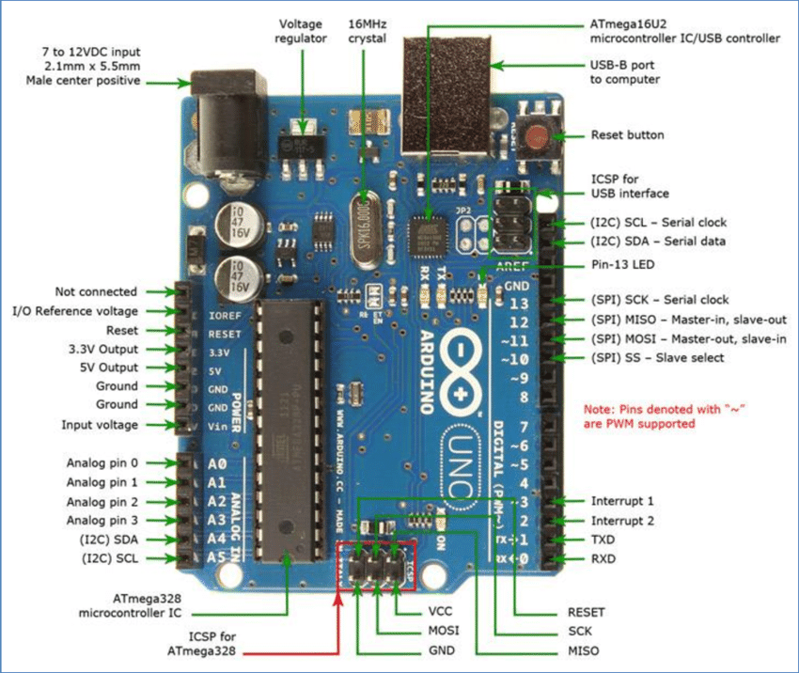

5.1 Ultrasonic Sensor (HC-SR04)

The ultrasonic sensor detects approaching vehicles by measuring distance. When the vehicle comes within a predefined range, Arduino triggers the servo motor to open the gate.

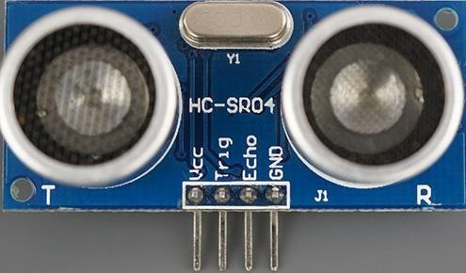
Figure 01: Ultrasonic Sensor HC-SR04

Features

- Operating Voltage: 5V
- Range: 2cm–400cm
- Quick response, high accuracy

5.2 IR Sensor Module:

IR sensors are used for vehicle counting: one sensor counts entry, and the other counts exit. This ensures accurate real-time parking data.

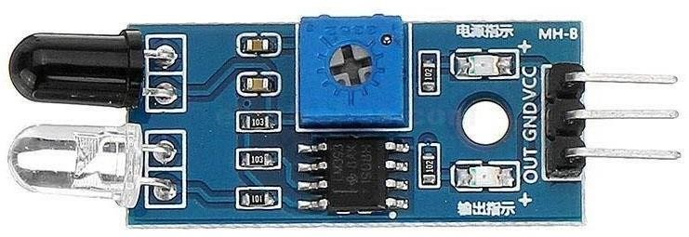
Figure 02: IR Sensor Module:

5.3 Servo Motor (SG90)

The servo motor opens and closes the parking gate automatically. Arduino controls its rotation between 0° and 90°, depending on vehicle detection

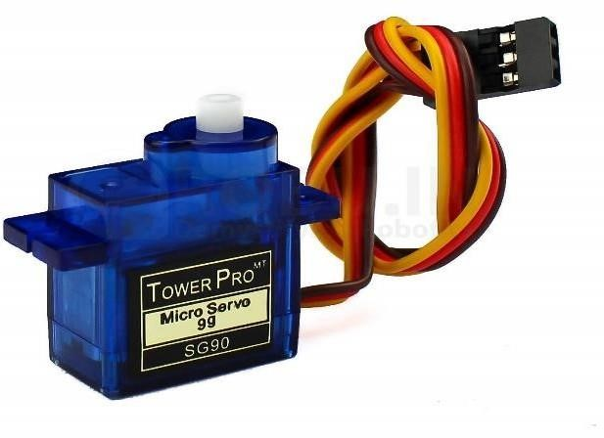
Figure 03: Servo Motor SG9

5.4 LCD Display (16x2)

The LCD displays parking information such as: total vehicles, remaining slots, and parking full status. A potentiometer is used for contrast adjustment.
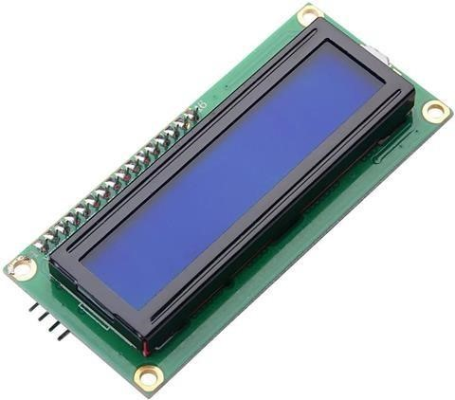
Figure 04: 16x2 LCD Display

5.5 Buzzer Module

The buzzer alerts when the parking area reaches full capacity or if a vehicle tries to enter when slots are full.
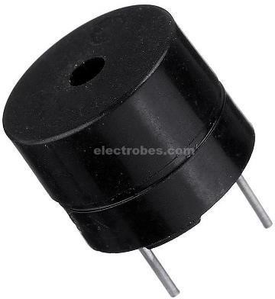
Figure 05: Piezo Buzzer

6. FEATURES

- Operating Voltage: 5V
- Automatic vehicle detection
- Gate control using Servo Motor
- Real-time vehicle counting with IR sensors
- LCD displays live parking status
- Buzzer alert for full parking
- Low energy consumption
- Fast, reliable, and efficient system

7. UTILIZATION OF THE PROJECT

- Detect vehicles automatically at the gate
- Count vehicles entering and exiting the parking area using IR sensors
- Display total parked vehicles and available slots on LCD
- Activate buzzer and stop gate when parking is full
- Reduce human effort, improve traffic flow, enhance security, and organize parking efficiently

