SMART ATTENDANCE SYSTEM

1. INTRODUCTION
This project is a Smart Attendance System using Arduino and RFID. It helps to make attendance marking easy and automatic. The system uses an Arduino Uno to control all parts, an RC522 RFID module to scan student cards, and a 16x2 LCD display to show the student’s name and ID. A buzzer and LED give signals when a card is scanned. This project saves time, reduces errors, and makes attendance marking faster and smarter for schools and colleges. It also improves security by allowing only authorized cards to mark attendance. The system can store data on a computer for record keeping. Overall, it is a modern and reliable solution for managing daily attendance.
2. PROJECT AIM
The Smart Attendance System using Arduino and RFID saves time by marking attendance in seconds and reduces errors compared to manual methods. It is easy to use, contactless, and efficient, making it suitable for classrooms, offices, and workplaces with many people. Each RFID card has a unique ID, ensuring reliability and preventing fake attendance. The system is also expandable, allowing additional features like data storage or mobile alerts to be added in the future.
3. OBJECTIVES OF THE PROJECT
- Detect student presence using an RFID card scanned by the RC522 RFID module.
- Read the unique ID of each RFID card and send it to the Arduino for verification.
- Display student name and ID on a 16×2 LCD module when a valid card is detected.
- Produce a sound alert using a buzzer and light an LED when attendance is marked.
- Show error or invalid card message on the LCD if an unknown card is scanned.
PROJECT LIMITATIONS

The system works only with RFID cards, requires power, reads one card at a time, and cannot verify the student physically.
4. HARDWARE-SOFTWARE REQUIREMENTS FOR THE PROJECT
HARDWARE REQUIRED

Table 01: Hardware Required
S.N. | COMPONENTS NAME | DESCRIPTION
1 | Arduino Board | Arduino UNO R3 Development Board
2 | RFID Module | RC522 RFID Module
3 | RFID Cards/Tags | Unique ID cards for students
4 | LCD Display | JHD162A 16x2 LCD Display
5 | Buzzer | Active buzzer for alert sound
6 | LED | Indicator LED for successful scan
7 | Jumper Wires | Connecting wires for circuits
8 | Breadboard | For easy connections and testing
9 | Arduino Power Supply | DC Adapter

5. MODULES DETAILS
RFID Reader Module (RC522)
The RFID RC522 module is a highly efficient, low-cost, contactless identification device designed to work with RFID cards and tags using 13.56 MHz frequency.
The module is built around the MFRC522 chip, which integrates all the essential circuitry and communication interfaces required to interact with microcontrollers like Arduino, making it ideal for attendance systems, access control, and identity authentication.
Let’s explore the important features, capabilities, and hardware elements of the module.
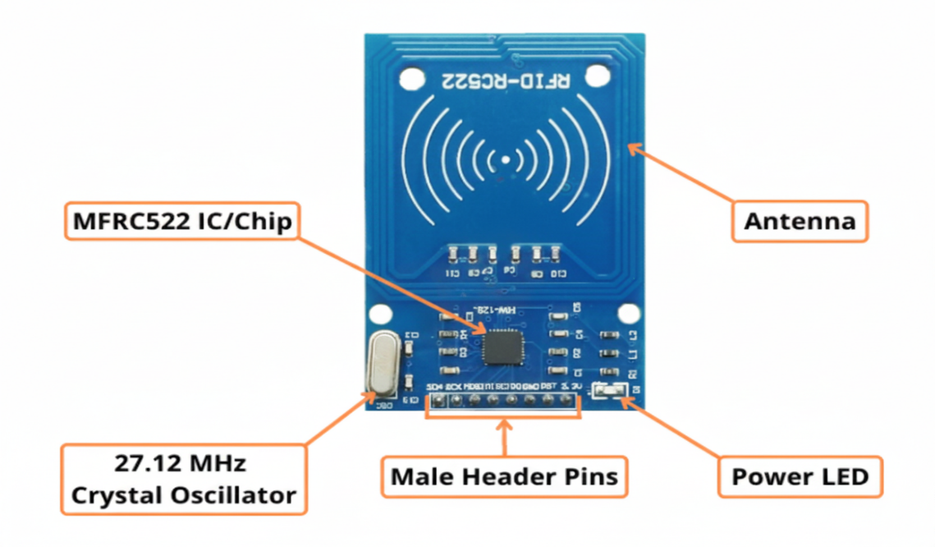
The RC522 RFID module packs a lot of useful features into a small board. Some of them are listed below:
- Works with RFID cards/tags)
- Communicates with Arduino and other microcontrollers via SPI interface
- Can read and write data to RFID cards or tags
- Built-in MFRC522 chip handles card detection and data processing
- Short reading distance: typically 2–5 cm, ideal for contactless applications
- Comes with 8 male header pins for easy connection to breadboard or Arduino
- Built-in antenna coil for transmitting and receiving signals
- Power LED indicates module is ON and receiving power
- I/O LED blinks when a card is detected
- Operates at 3.3V DC, low power consumption
- Compact and easy to use in attendance systems, access control, and security projects

MFRC522 IC / Chip
The MFRC522 is the main chip used in the RC522 RFID module. It works at 13.56 MHz and can read and write data from RFID cards or tags. Each RFID card has a unique ID, which the MFRC522 detects and sends to the Arduino.
MFRC522 Crystal Oscillator (27.12 MHz)
The MFRC522 chip requires a 27.12 MHz external crystal oscillator to work properly. This crystal provides a stable and precise clock signal that allows the chip to read RFID cards accurately and communicate with the Arduino through SPI. The 27.12 MHz frequency is chosen because it matches the timing requirements of the MFRC522’s radio communication circuits, ensuring reliable card detection, data reading, and processing.
Male Header Pins of RC522 RFID Module
The RC522 RFID module comes with 8 male header pins that allow you to easily connect the module to an Arduino or breadboard. These pins are arranged in a single row and usually include the following connections:
- SDA (SS) – Chip select pin for SPI communication
- SCK – Serial clock pin for SPI
- MOSI – Master Out Slave In pin for SPI
- MISO – Master In Slave Out pin for SPI
- IRQ – Interrupt pin (optional)
- GND – Ground pin
- RST – Reset pin
- 3.3V – Power supply pin
Power LED of RC522 RFID Module
The Power LED on the RC522 RFID module is a small indicator light that turns ON when the module is powered.
Antenna of RC522 RFID Module
The antenna on the RC522 RFID module is a small copper coil printed on the PCB (circuit board). It is used to transmit and receive radio signals between the RFID module and the RFID cards or tags.
- When an RFID card comes near the module, the antenna generates an electromagnetic field that powers the card and allows it to send its unique ID back to the module.
- The antenna is responsible for the communication range of the module, which is usually 2–5 cm for the RC522.
- It is built-in on the module, so you do not need to connect an external antenna.
- A good antenna design ensures reliable reading of cards and stable communication with the Arduino.

6. FEATURES
- Operating Voltage is +5V (powered by Arduino).
- Can detect student presence using RFID cards or tags.
- Displays student name and ID on a 16×2 LCD screen.
- Buzzer produces a sound when attendance is marked.
- LED indicator lights up for successful scanning.
- Works contactless, so students just bring the card near the reader.
- Can reject unknown or invalid cards and display an error message.
- Fast and accurate attendance marking, suitable for schools and colleges.
- Easy to connect with Arduino and other modules using male header pins.

7. UTILIZATION OF THE PROJECT
- This system automatically records attendance when a student scans their RFID card.
- The system uses an RC522 RFID module and Arduino to identify students.
- The 16×2 LCD display shows the student’s name and ID instantly.
- A buzzer and LED provide confirmation when attendance is marked successfully.
- The system prevents manual errors and makes attendance faster and more accurate.
- It is useful for schools, colleges, and offices where many people need to mark attendance every day.

